Quality Control Project

309657009 邱泓儒

library(qcc)  
setwd("C:/Users/ray98/Desktop/project/class/qc")  
dt <- read.csv("water_potability.csv")  
dt <- dt[1:2000,]  
dt <- dt[sample(2000),]

## Data cleaning

# use the Turbidity variable  
tur <- dt$Turbidity[1:2000]  
  
# check if there is NA  
which(is.na(dt$Turbidity))

## integer(0)

# check the assumptions for control chart  
hist(tur, breaks = 20, main = "Histogram of Turbidity", xlab = "Turbidity")

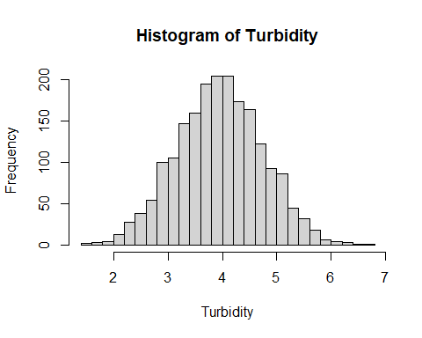

shapiro.test(tur)

##   
## Shapiro-Wilk normality test  
##   
## data: tur  
## W = 0.99949, p-value = 0.9036

par(mfrow=c(1,3))  
plot(dt$Hardness[1:2000], dt$Turbidity[1:2000], pch = 20, cex = 0.5, ylab = "Turbidity", xlab = "Hardness")  
plot(dt$Solids[1:2000], dt$Turbidity[1:2000], pch = 20, cex = 0.5, ylab = "Turbidity", xlab = "Solids")  
plot(dt$ph[1:2000], dt$Turbidity[1:2000], pch = 20, cex = 0.5, ylab = "Turbidity", xlab = "ph")

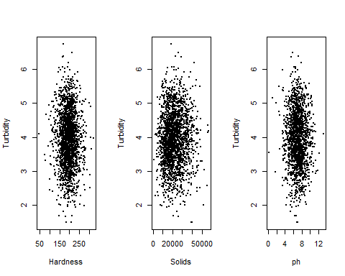

## X bar-S chart

tur <- matrix(dt$Turbidity[1:2000], ncol = 5)  
par(mfrow=c(1,1))  
obj <- qcc(tur[1:50,], type="xbar", newdata=tur[51:400,], std.dev = "UWAVE-SD")

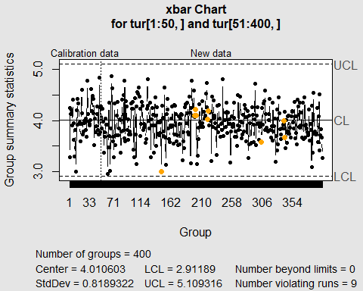

obj <- qcc(tur[1:50,], type="S", newdata=tur[51:400,])

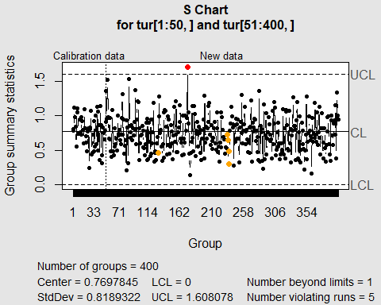

## X bar-R chart

obj <- qcc(tur[1:50,], type="xbar", newdata=tur[51:400,], std.dev = "UWAVE-R")

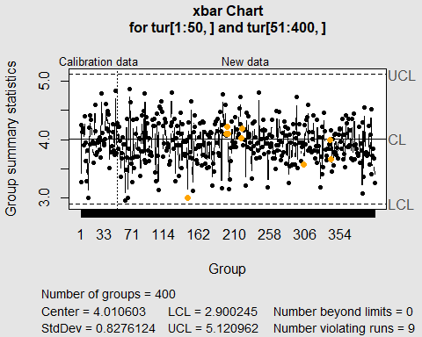

obj <- qcc(tur[1:50,], type="R", newdata=tur[51:400,])

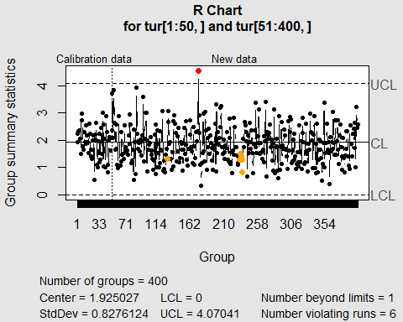

## p chart

pot <- matrix(dt$Potability[1:2000], ncol = 20)  
pot <- as.data.frame(pot)  
pot$defect <- 20-rowSums(pot)  
pot$size <- 20  
with(pot, qcc(pot$defect[1:20], pot$size[1:20], type = "p", newdata=pot$defect[21:100], newsizes=pot$size[21:100]))

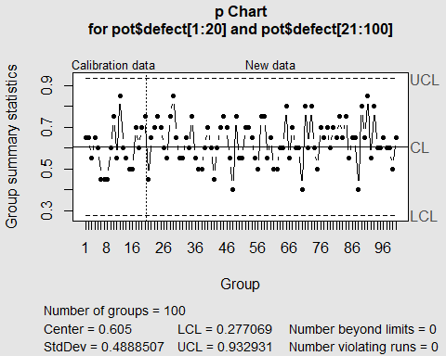

## List of 15  
## $ call : language qcc(data = pot$defect[1:20], type = "p", sizes = pot$size[1:20], newdata = pot$defect[21:100], newsizes = pot$size[21:100])  
## $ type : chr "p"  
## $ data.name : chr "pot$defect[1:20]"  
## $ data : num [1:20, 1] 13 13 11 13 12 9 9 9 12 15 ...  
## ..- attr(*, "dimnames")=List of 2  
## $ statistics : Named num [1:20] 0.65 0.65 0.55 0.65 0.6 0.45 0.45 0.45 0.6 0.75 ...  
## ..- attr(*, "names")= chr [1:20] "1" "2" "3" "4" ...  
## $ sizes : num [1:20] 20 20 20 20 20 20 20 20 20 20 ...  
## $ center : num 0.605  
## $ std.dev : num 0.489  
## $ newstats : Named num [1:80] 0.45 0.65 0.7 0.75 0.7 0.6 0.55 0.75 0.85 0.65 ...  
## ..- attr(*, "names")= chr [1:80] "21" "22" "23" "24" ...  
## $ newdata : num [1:80, 1] 9 13 14 15 14 12 11 15 17 13 ...  
## $ newsizes : num [1:80] 20 20 20 20 20 20 20 20 20 20 ...  
## $ newdata.name: chr "pot$defect[21:100]"  
## $ nsigmas : num 3  
## $ limits : num [1:100, 1:2] 0.277 0.277 0.277 0.277 0.277 ...  
## ..- attr(*, "dimnames")=List of 2  
## $ violations :List of 2  
## - attr(*, "class")= chr "qcc"

## CUSUM chart

q <- cusum(tur[1:50,], newdata=tur[51:400,], se.shift = 1)

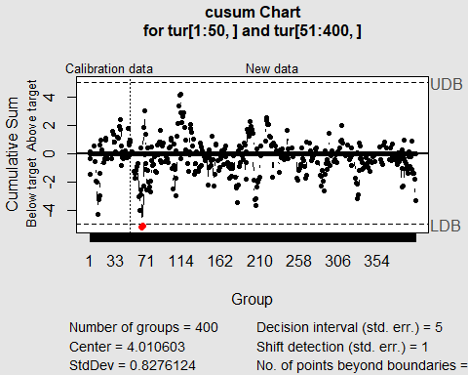

## EWMA chart

q <- ewma(tur[1:50,], lambda=0.2, nsigmas=3, newdata=tur[51:400,])

