

GPU CUDA Image Filters

ECEN 5593



May 9, 2017

Rahul yamasani

rahul.yamasani@colorado.edu

**NOTE**: All the relevant files for this Checkpoint are listed in Yamasani_CheckP3_Filters.rar

**Part A:**

The code is run using the command **filter --file lena.bmp --out sobel.bmp--filter sobel**

The following picture illustrates that CPU_sobel.bmp is generated.

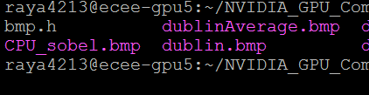

**Part B:**

1. Execution time for Sobel Filter (3x3)

|  |  |  |  |
| --- | --- | --- | --- |
| **Input Size** | **GPU Execution Time** | **CPU Execution Time** | **Speedup** |
| lena.bmp | 0.0830 | 2.6450 | 31.867 |
| dublin.bmp | 0.9640 | 63.574001 | 65.948 |

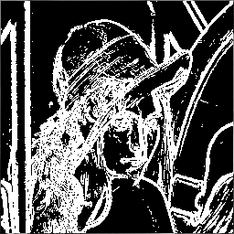

Sobel filter: lena.bmp

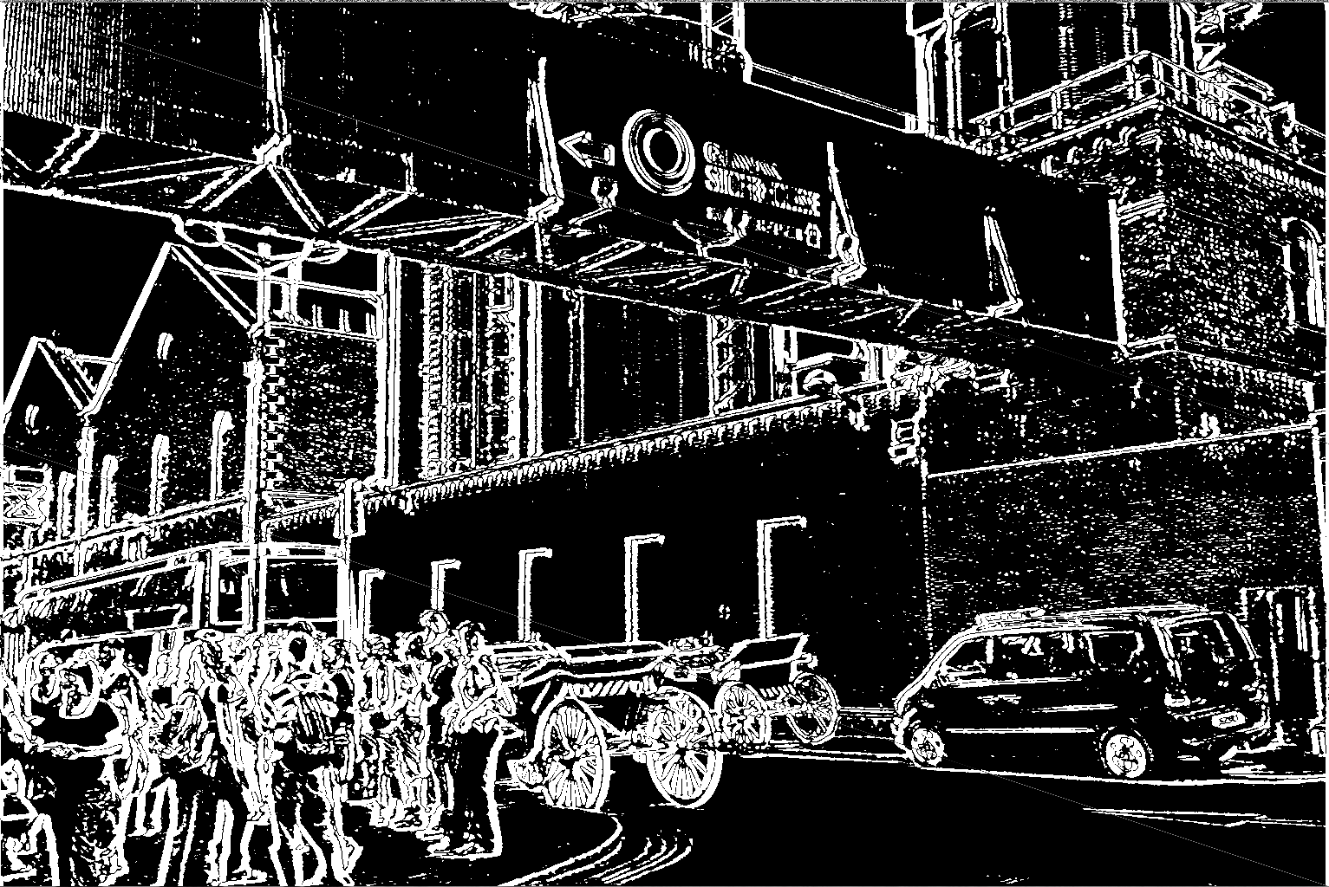

Sobel filter: dublin.bmp

1. Execution time for Average Filter (3x3)

|  |  |  |  |
| --- | --- | --- | --- |
| **Input Size** | **GPU Execution Time** | **CPU Execution Time** | **Speedup** |
| lena.bmp | 0.0840 | 2.6440 | 31.4761 |
| dublin.bmp | 0.8740 | 63.575001 | 72.7402 |

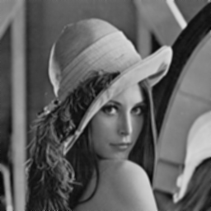

Average filter:lean.bmp

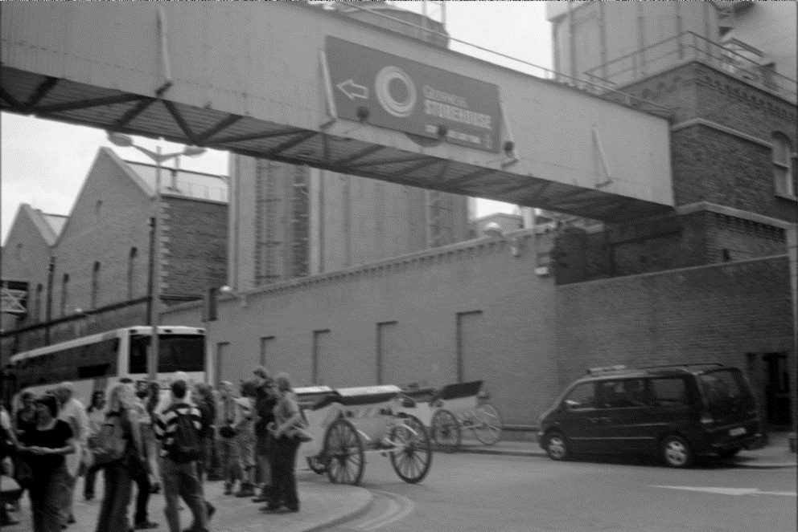

Average filter: Dublin.bmp

1. Execution time for Boost filter (3x3)

|  |  |  |  |
| --- | --- | --- | --- |
| **Input Size** | **GPU Execution Time** | **CPU Execution Time** | **Speedup** |
| lena.bmp | 0.0830 | 2.6450 | 31.8674 |
| dublin.bmp | 0.9420 | 63.613998 | 67.5307 |

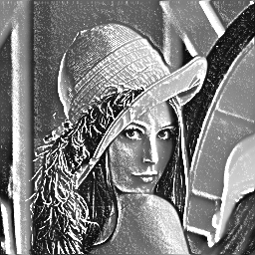

Boost filter: lena.bmp

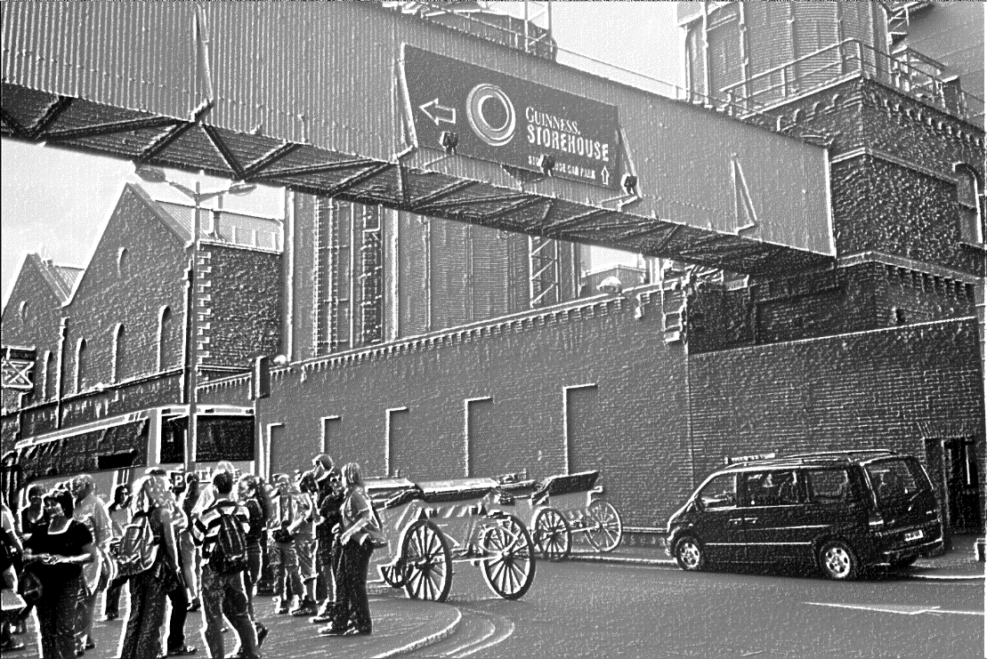

Boost filter: dublin.bmp

1. Sobel filter with 5*5 kernel: The Filter radius is changed to 2. The EDGE_VALUE_THRESHOLD is changed to 800

Execution time for Sobel filter (5x5)

|  |  |  |  |
| --- | --- | --- | --- |
| Input Size | 3x3 GPU Execution Time | 5x5 GPU Execution Time | Speedup |
| lena.bmp | 0.0830 | 0.147 | 1.7710 |
| dublin.bmp | 0.9640 | 2.427 | 2.5176 |

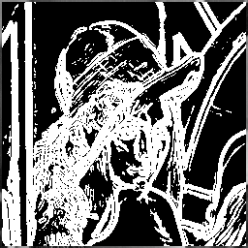

Sobel filter5by5: lean.bmp

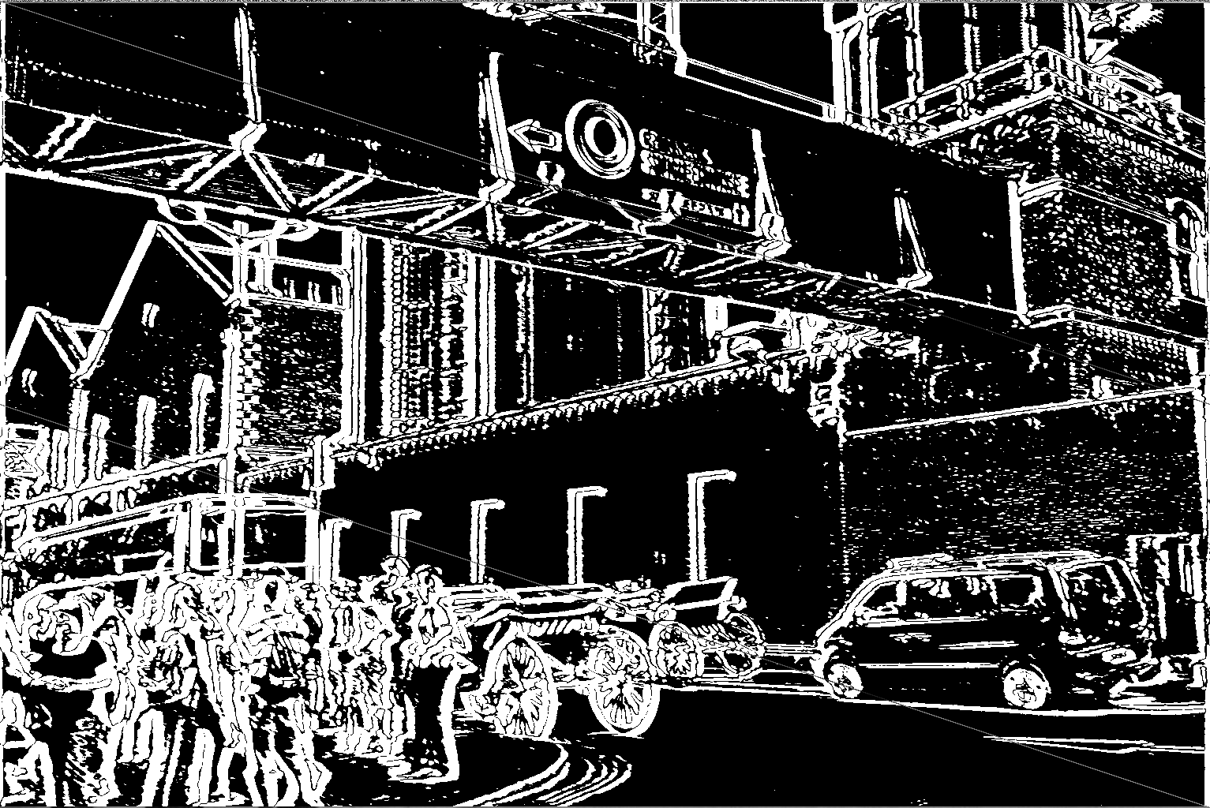

Sobel filter5by5: dublin.bmp

**Reference:**

1. Video Lectures
2. Code provided in Requirements