**Compte rendu SAE SQL / BD :**

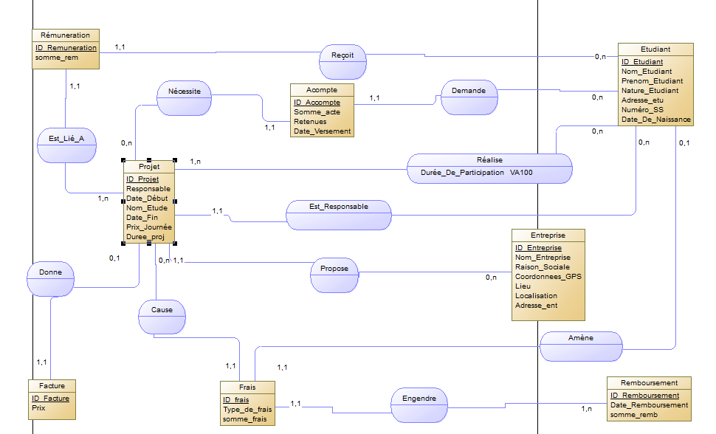Voici à quoi ressemble le MCD fait :

Voici la commande fournie par Power AMC pour la création SQL : voir fichier txt ci-joint.

Voici les valeurs rentrées :

insert into ENTREPRISE values ('ENT1','GOOGLE','RS1','001','NOVOSSIBIRSK','Nord','3 rue du plomb');

insert into ENTREPRISE values ('ENT2','AMAZON','RS2','002','CALUIRE','Sud','43 centre commercial de l arbre vert');

insert into ENTREPRISE values ('ENT3','FACEBOOK','RS3','003','VILLEURBANNE','Ouest','91 allée des sous marins');

insert into ENTREPRISE values ('ENT4','APPLE','RS4','004','CALIFORNIA','Est','341 avenue de la salade');

insert into ENTREPRISE values ('ENT5','MICROSOFT','RS5','005','CALIFORNIA','Est','Bat C rue du real madrid');

insert into ENTREPRISE values ('ENT6','FNAC','RS6','006','BARBES','Est','23 rue Hippolyte Blot');

insert into ETUDIANT values ('ETU1','FRA1','Martiniere','Diderot','NA2','13 avenue du cache-cou','SS1','25/12/2003');

insert into ETUDIANT values ('ETU2','FRA2','Mozart','Amadeus','NA1','15 rue de la TN','SS2','14/02/2004');

insert into ETUDIANT values ('ETU3','FRA3','Shakespeare','Hippolyte','NA2','288 allée de la canette','SS3','23/04/1998');

insert into ETUDIANT values ('ETU4','FRA4','Newton','Isaac','NA2','Batiment C route de l accomplissement du destin','SS4','02/01/1846');

insert into ETUDIANT values ('ETU5','FRA5','Eden','Martin','NA1','13 rue du feu follet','SS5','25/01/2003');

insert into ETUDIANT values ('ETU6','FRA6','Merlin','Rayane','NA1','Stade de France','SS6','13/08/2004');

insert into ETUDIANT values ('ETU7','FRA7','Benjemia','Anis','NA2','23 avenue de la chaussette rose','SS7','28/07/2000');

insert into ETUDIANT values ('ETU8','FRA8','Blot','Hyppolite','NA1','22 avenue de la chaussette rose','SS8','23/06/2003');

insert into ETUDIANT values ('ETU9','FRA9','Heraud','Noah','NA2','1er avenue de la honte','SS9','06/06/2007');

insert into ETUDIANT values ('ETU10','FRA10','Benzema','Karim','NA1','3 centre du penalty','SS10','27/10/1978');

insert into ACOMPTE values ('AC1','PR1','ETU1',45,'RE1','14/05/2021');

insert into ACOMPTE values ('AC2','PR2','ETU2',56,'RE2','16/08/2021');

insert into ACOMPTE values ('AC3','PR3','ETU3',600,'RE3','22/12/2022 ');

insert into ACOMPTE values ('AC4','PR4','ETU4',254,'RE4','29/01/2021');

insert into FACTURE values ('FAC1','PR1',34);

insert into FACTURE values ('FAC2','PR2',12);

insert into FACTURE values ('FAC3','PR3',39);

insert into FACTURE values ('FAC4','PR4',3);

insert into FRAIS values ('FRA1','PR1','RMB1','ETU1','TYPE0',345);

insert into FRAIS values ('FRA2','PR2','RMB2','ETU2','TYPE0',567);

insert into FRAIS values ('FRA3','PR3','RMB3','ETU3','TYPE2',876);

insert into FRAIS values ('FRA4','PR4','RMB4','ETU4','TYPE5',132);

insert into FRAIS values ('FRA5','PR5','RMB5','ETU7','TYPE2',23);

insert into PROJET values ('PR1','ENT1','ETU1','FAC1','Anis',01/01/2022,'SCIENCE',’05/05/2022’,13,125);

insert into PROJET values ('PR2','ENT2','ETU2','FAC2','Hippolyte',03/01/2022,'ASTRONOMIE',’10/07/2022’,14,189);

insert into PROJET values ('PR3','ENT3','ETU3','FAC3','Rayane',15/12/2021,'ASTROLOGIE',’17/12/2021’,15,368);

insert into PROJET values ('PR4','ENT4','ETU7','FAC4','Rayane',’20/05/2021’,'BASE DE DONNEES',29/12/2021,16,224);

insert into REALISE values ('PR1','ETU1',30);

insert into REALISE values ('PR2','ETU2',30);

insert into REALISE values ('PR3','ETU7',100);

insert into REALISE values ('PR4','ETU4',60);

insert into REMBOURSEMENT values ('RMB1','30/05/2022',345);

insert into REMBOURSEMENT values ('RMB2','23/05/2022',567);

insert into REMBOURSEMENT values ('RMB3','12/05/2022',876);

insert into REMBOURSEMENT values ('RMB4','09/05/2022',123);

insert into REMUNERATION values ('REM1','ETU1', 'PR1',1580);

insert into REMUNERATION values ('REM2','ETU2', 'PR2',2590);

insert into REMUNERATION values ('REM3','ETU3', 'PR3',4920);

insert into REMUNERATION values ('REM4','ETU7', 'PR4',3330);

commit;

**Partie 2 :**

D.

1. SELECT id_projet, nom_etude FROM projet WHERE date_fin < CURRENT_DATE;
2. SELECT id_projet, nom_etude FROM projet WHERE date_fin > CURRENT_DATE AND date_debut < CURRENT_DATE;
3. SELECT projet.id_projet, projet.nom_etude FROM projet JOIN realise ON projet.id_projet = realise.id_projet JOIN etudiant ON realise.id_etudiant = etudiant.id_etudiant
4. SELECT id_etudiant, COUNT(*) FROM realise GROUP BY id_etudiant;