DIY Satellite Rotator
Hardware Assembly, Arduino Setup and SatNOGS Configuration

Overview
This guide shows how to build a low-cost satellite rotator. Two servo motors point an antenna in azimuth (compass direction) and elevation (angle above the horizon). An Arduino Nano receives position commands from SatNOGS or any Hamlib-compatible tracking software and drives the servos.
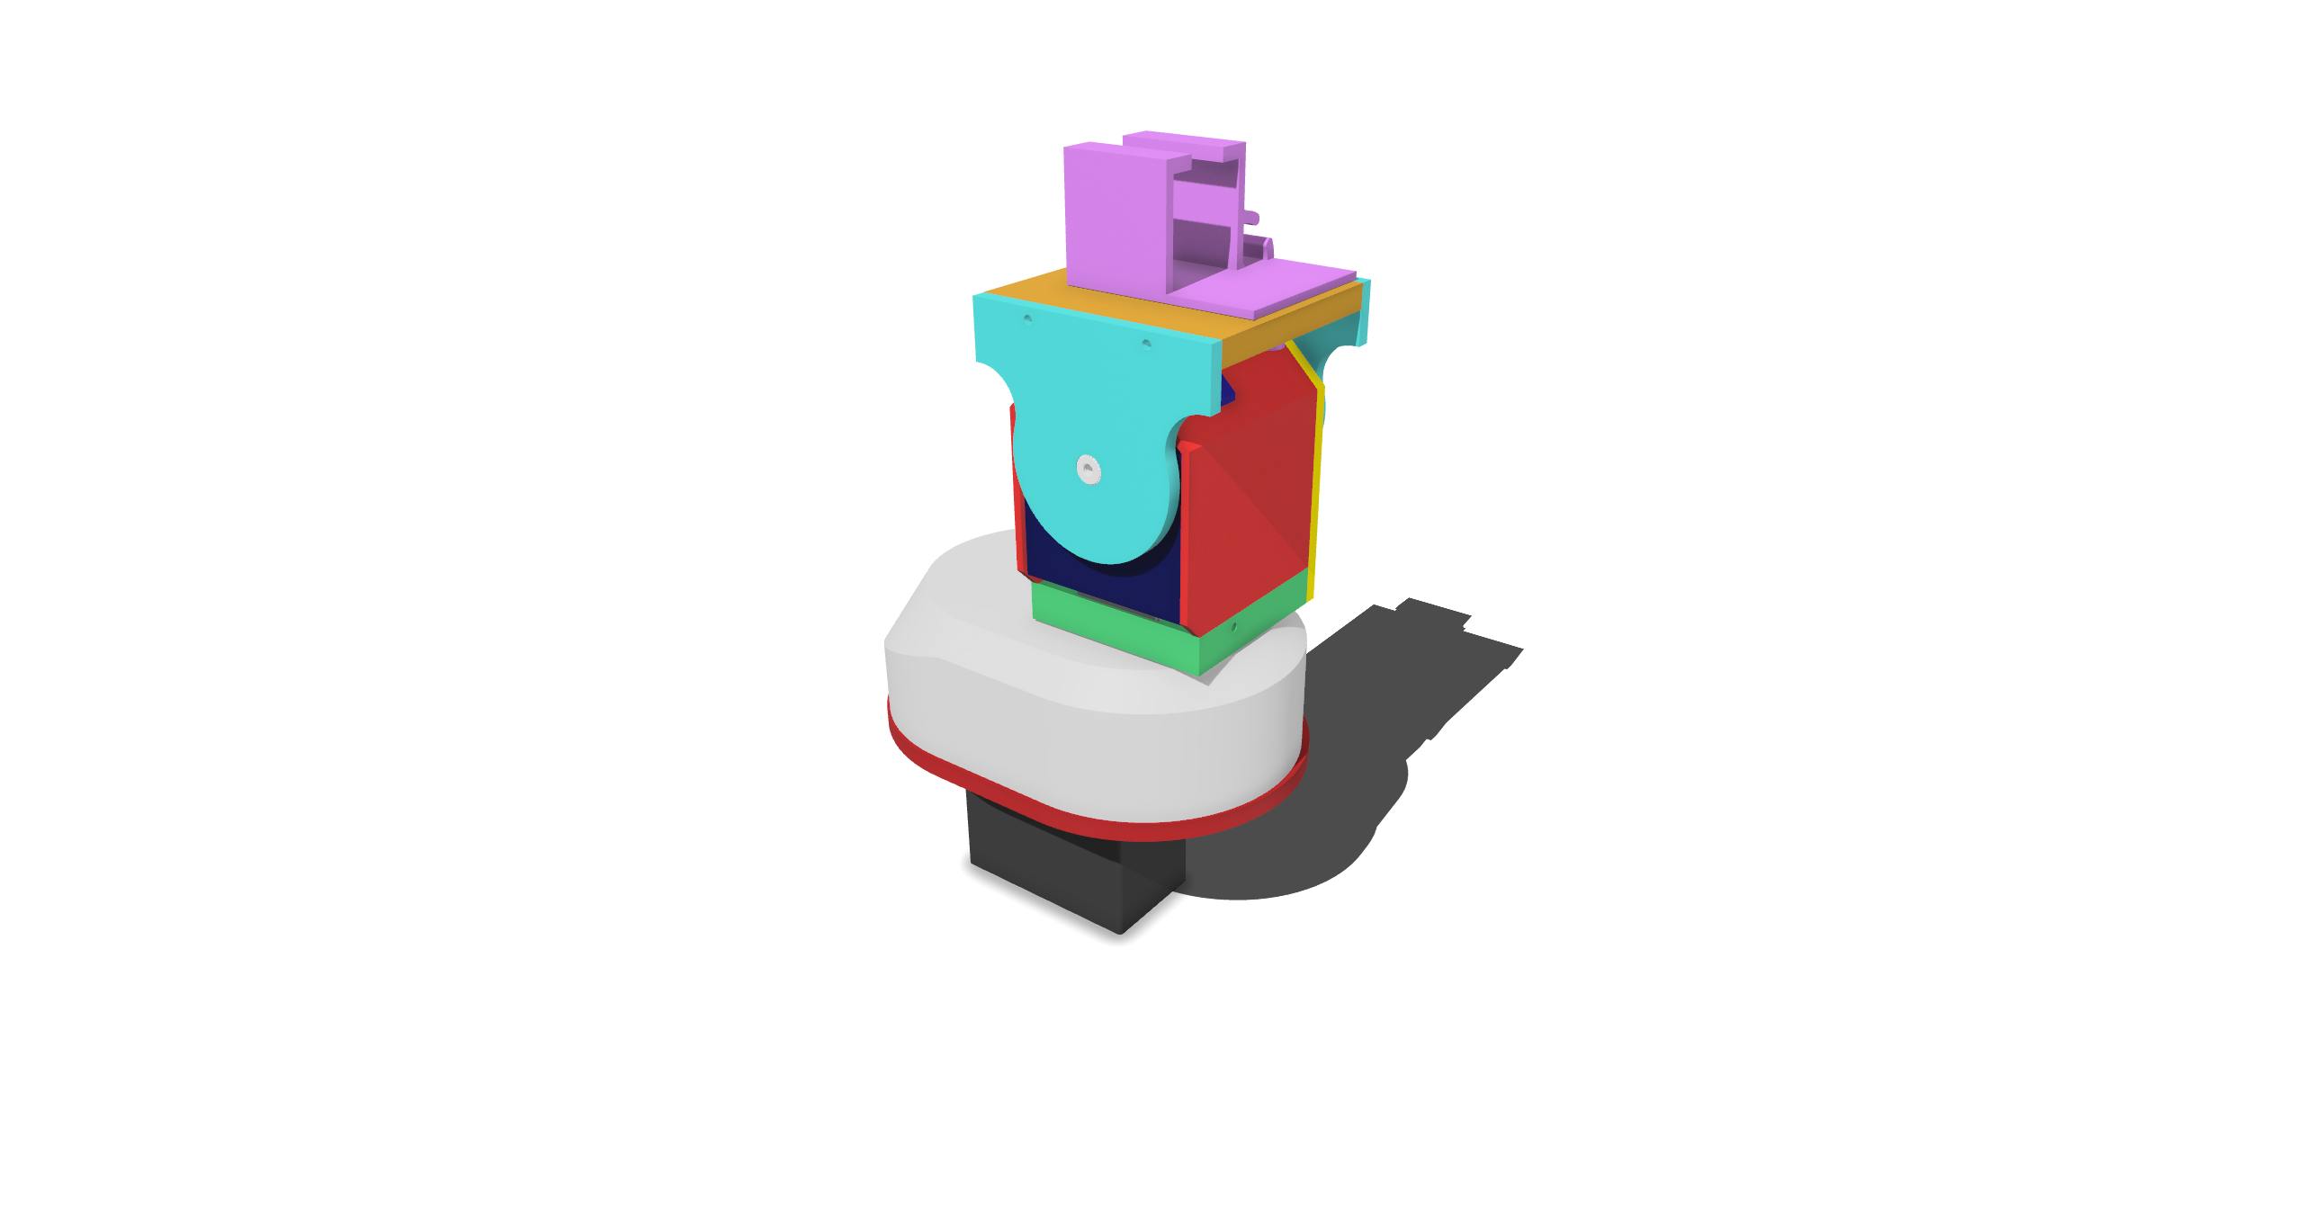
Figure: the assembled rotator with the enclosure in place.
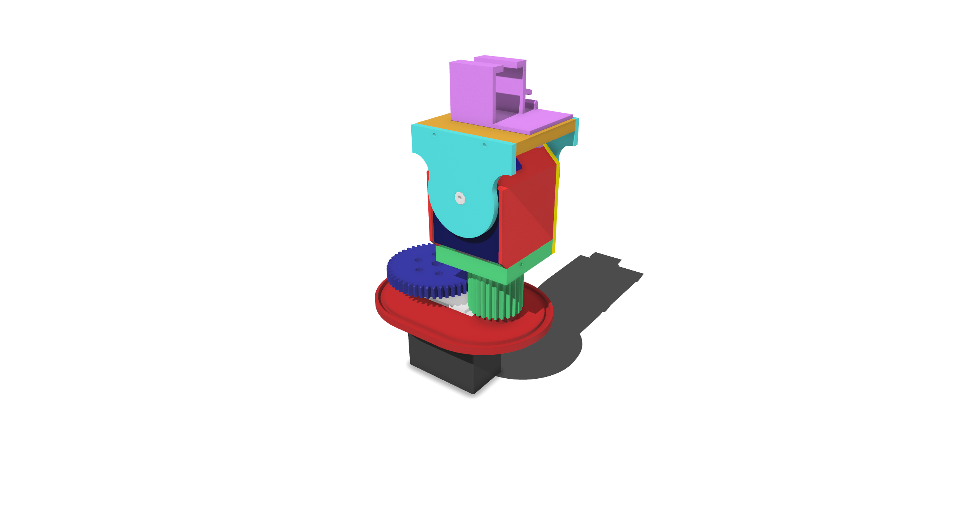
Figure: the same assembly without the top casing, showing the gears.

Parts and Fasteners
Item | Quantity | Used in steps
M2x10 screws | 12 | 4 (4 screws), 9 (2), 10 (2), 13 (4)
Servo + horn and hardware kit (eg. DS3225, DS3225 Pro, MG996R. Note that DS3225/Pro is IP66 water and dust resistant while MG996R is not) | 2 | 1, 5, 6, 7, 14b
3D printed components (see the 3D Printed Parts table) | 15 parts | All
Superglue and sandpaper | As needed | 2
Servos (the same model for azimuth and elevation) | 2 | 1, 3, 8, 12
Arduino Nano, USB cable, Raspberry Pi or Linux device running SatNOGS, SDR | 1 each | Part 2 and Part 3
Extra Wire (24/0.20 / 18 AWG) | 4m | Electrical wiring
Soldering equipment | 1 | Soldering for the electrical circuit
3D Printed Parts (file names as they appear in the parts download)
Part file | Qty | Used in steps
AzServoCasing.stl | 1 | 1
ElRod.stl | 1 | 2, 16
AzMount.stl | 1 | 2, 3, 4, 15, 16
LargeGear.stl | 1 | 5, 6, 7, 14b
SmallGearBase.stl | 1 | 8, 9, 10
ServoBrace.stl | 1 | 9
RearPlate.stl | 1 | 10
ElServoCover.stl | 1 | 11
ElServoFrontPlate.stl | 1 | 12
AntennaMountPlate.stl | 1 | 13
ElArmSidePlate_x2.stl | 2 | 13, 14a, 14b
ElRotatorPin.stl | 1 | 14a
AzProtectionCover.stl | 1 | 15
COTSAntennaBracket.stl | 1 | 17

Full Exploded Model


Part 1: Hardware Assembly
Follow the steps in order. Each step includes a reference image. The 12 M2x10 screws are used in steps 4, 9, 10 and 13. Both servos are the same model.

Step 1: Slide the motor into the casing
Parts used: AzServoCasing
Slide the servo motor into the casing until it sits fully in place.
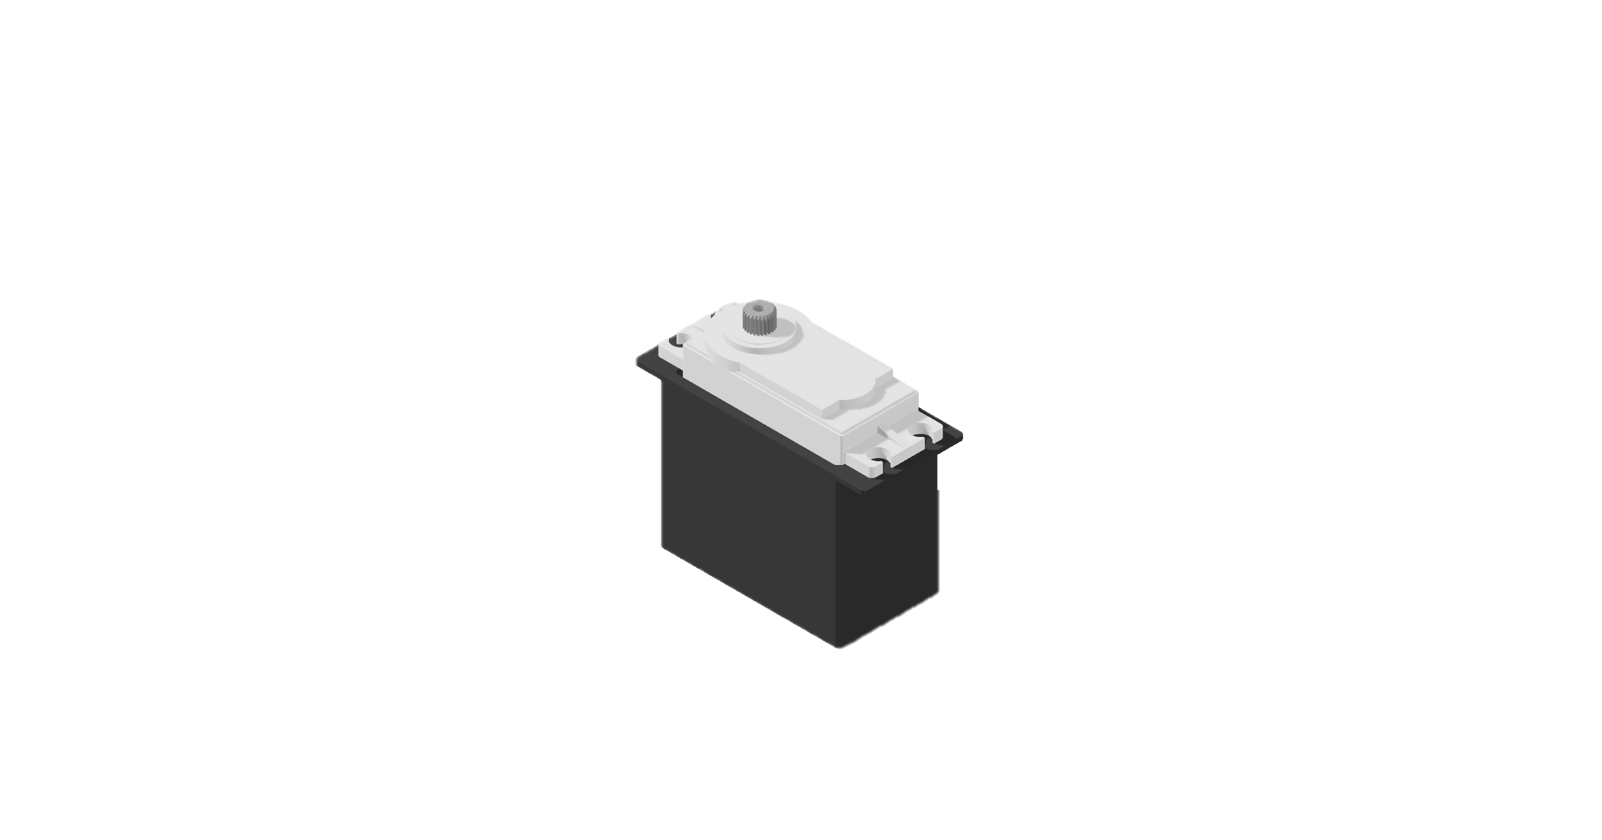

Step 2: Superglue the rod in
Parts used: ElRod, AzMount
Before gluing, sand the rod and its hole so the rod is smooth and moves freely.
Superglue the rod in place and keep glue off any moving surfaces.
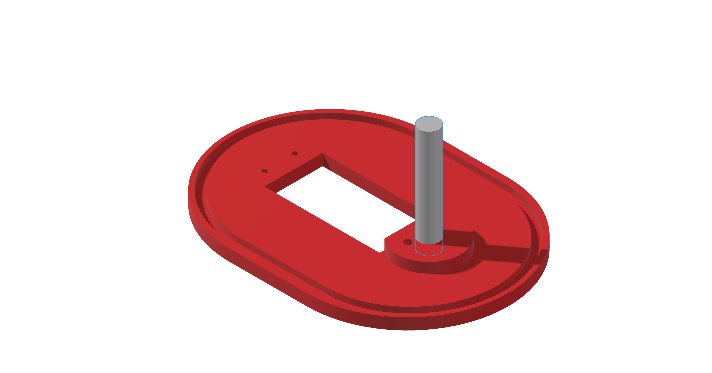

Step 3: Place the mount on the servo and servo case
Parts used: AzMount
Place the mount onto the servo and the servo case.
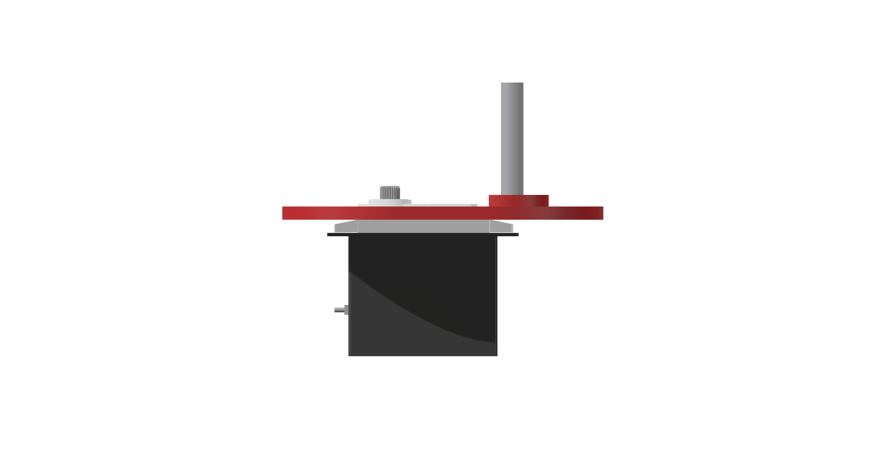

Step 4: Insert 4 M2x10 screws into the marked holes
Parts used: AzMount
Insert 4 M2x10 screws into each marked hole.
Tighten each screw until it is flush with the base and has passed through the red base plate.


Step 5: Line up the servo horn on the larger gear
Parts used: LargeGear
Line up the servo horn supplied with the servo onto the larger gear.
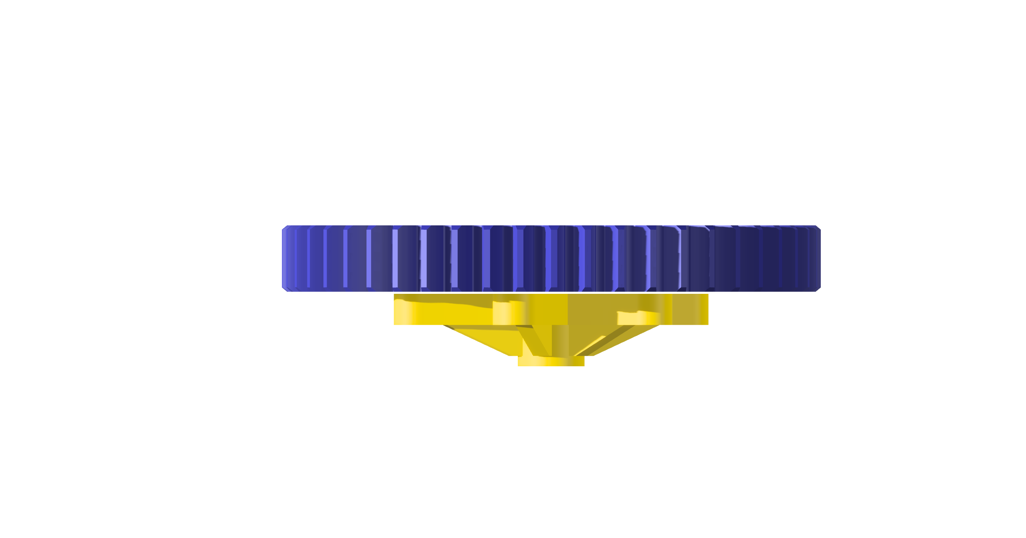

Step 6: Insert 2 screws through the gear
Parts used: LargeGear
Insert 2 screws on opposite sides of the servo horn, passing through any two holes in the gear.


Step 7: Install the mounted arm assembly
Parts used: LargeGear
Install the mounted arm assembly onto the servo.
Use the screw included with the servo in the centre of the large gear. Tighten until there is no slip.
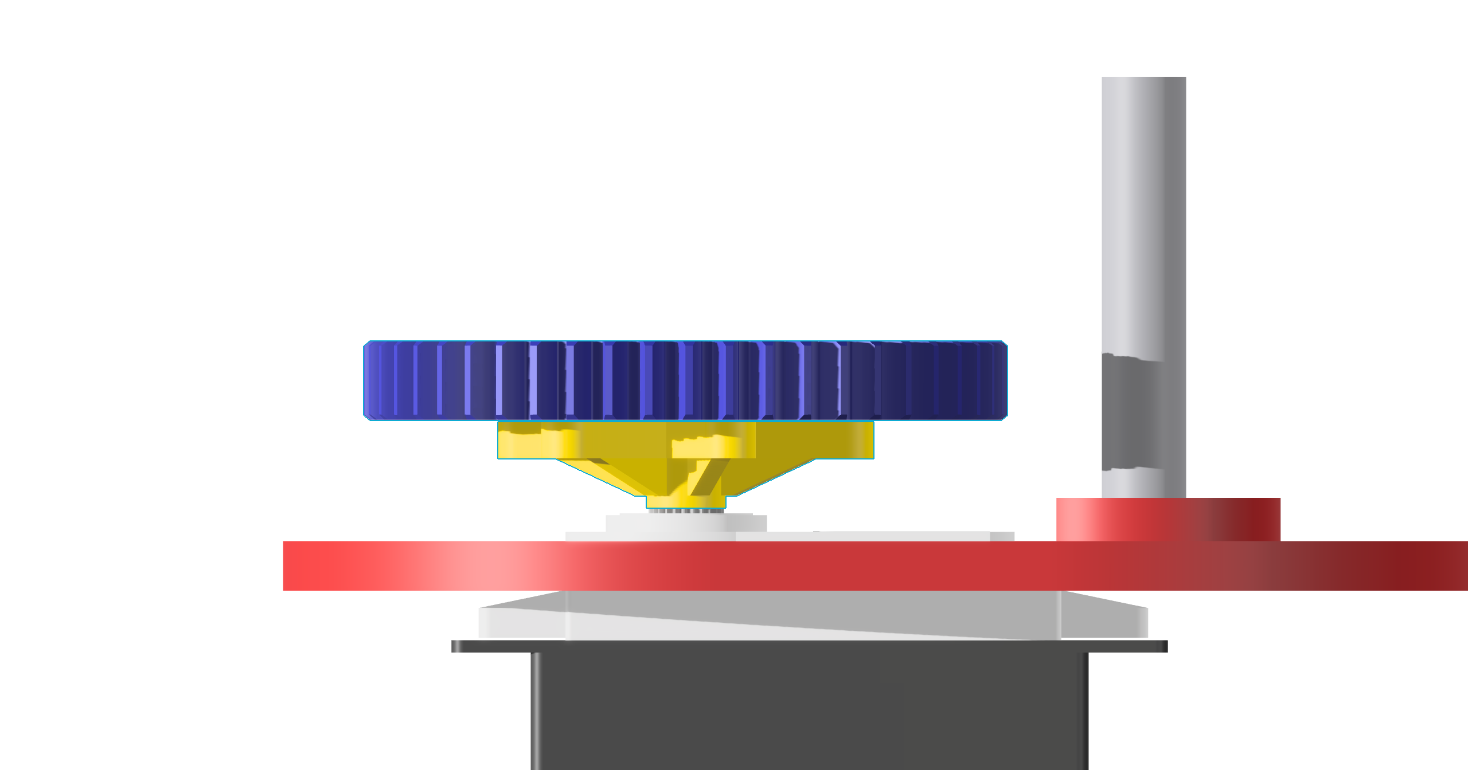

Step 8: Push-fit the servo into the smaller gear base
Parts used: SmallGearBase
Push-fit the servo into the hole in the smaller gear's base until it clips in securely and sits flush with the base.
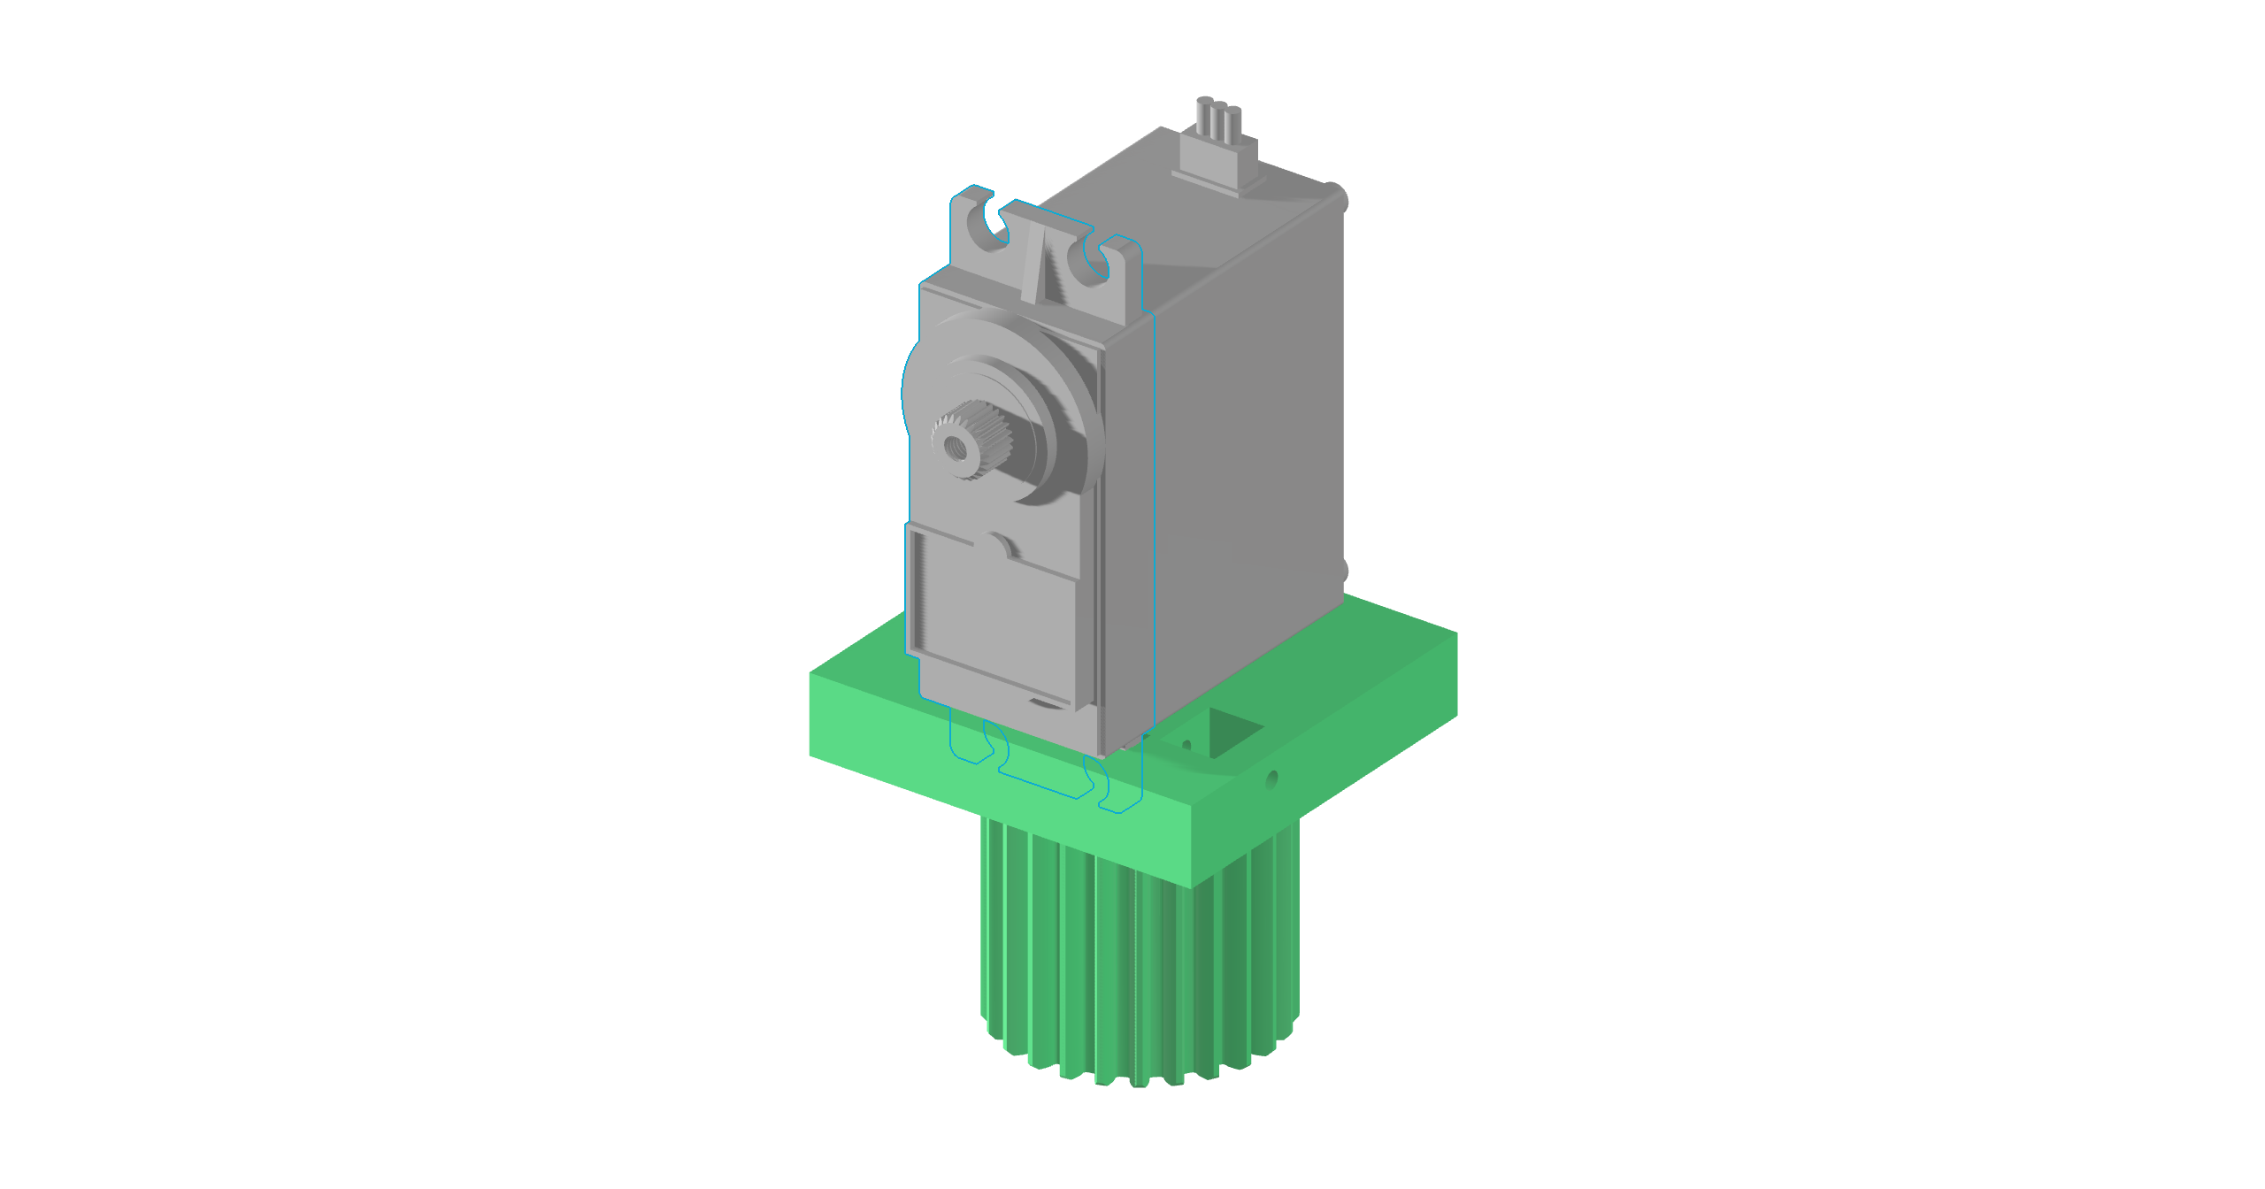

Step 9: Fit the servo brace and secure with 2 screws
Parts used: ServoBrace, SmallGearBase
Push-fit the servo brace into the holes on the smaller gear base.
Insert 2 M2x10 screws into the holes in the side until they are flush.
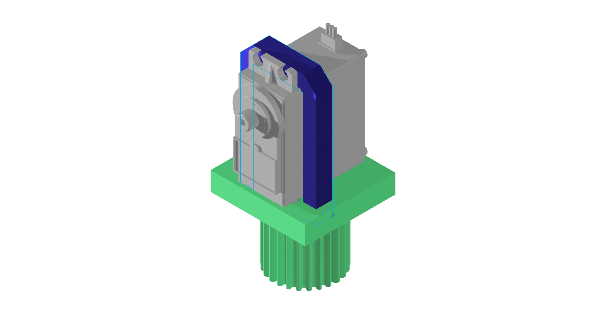

Step 10: Mount the rear plate
Parts used: RearPlate, SmallGearBase
Mount the rear plate on the back of the smaller gear.
Secure it with 2 M2x10 screws.
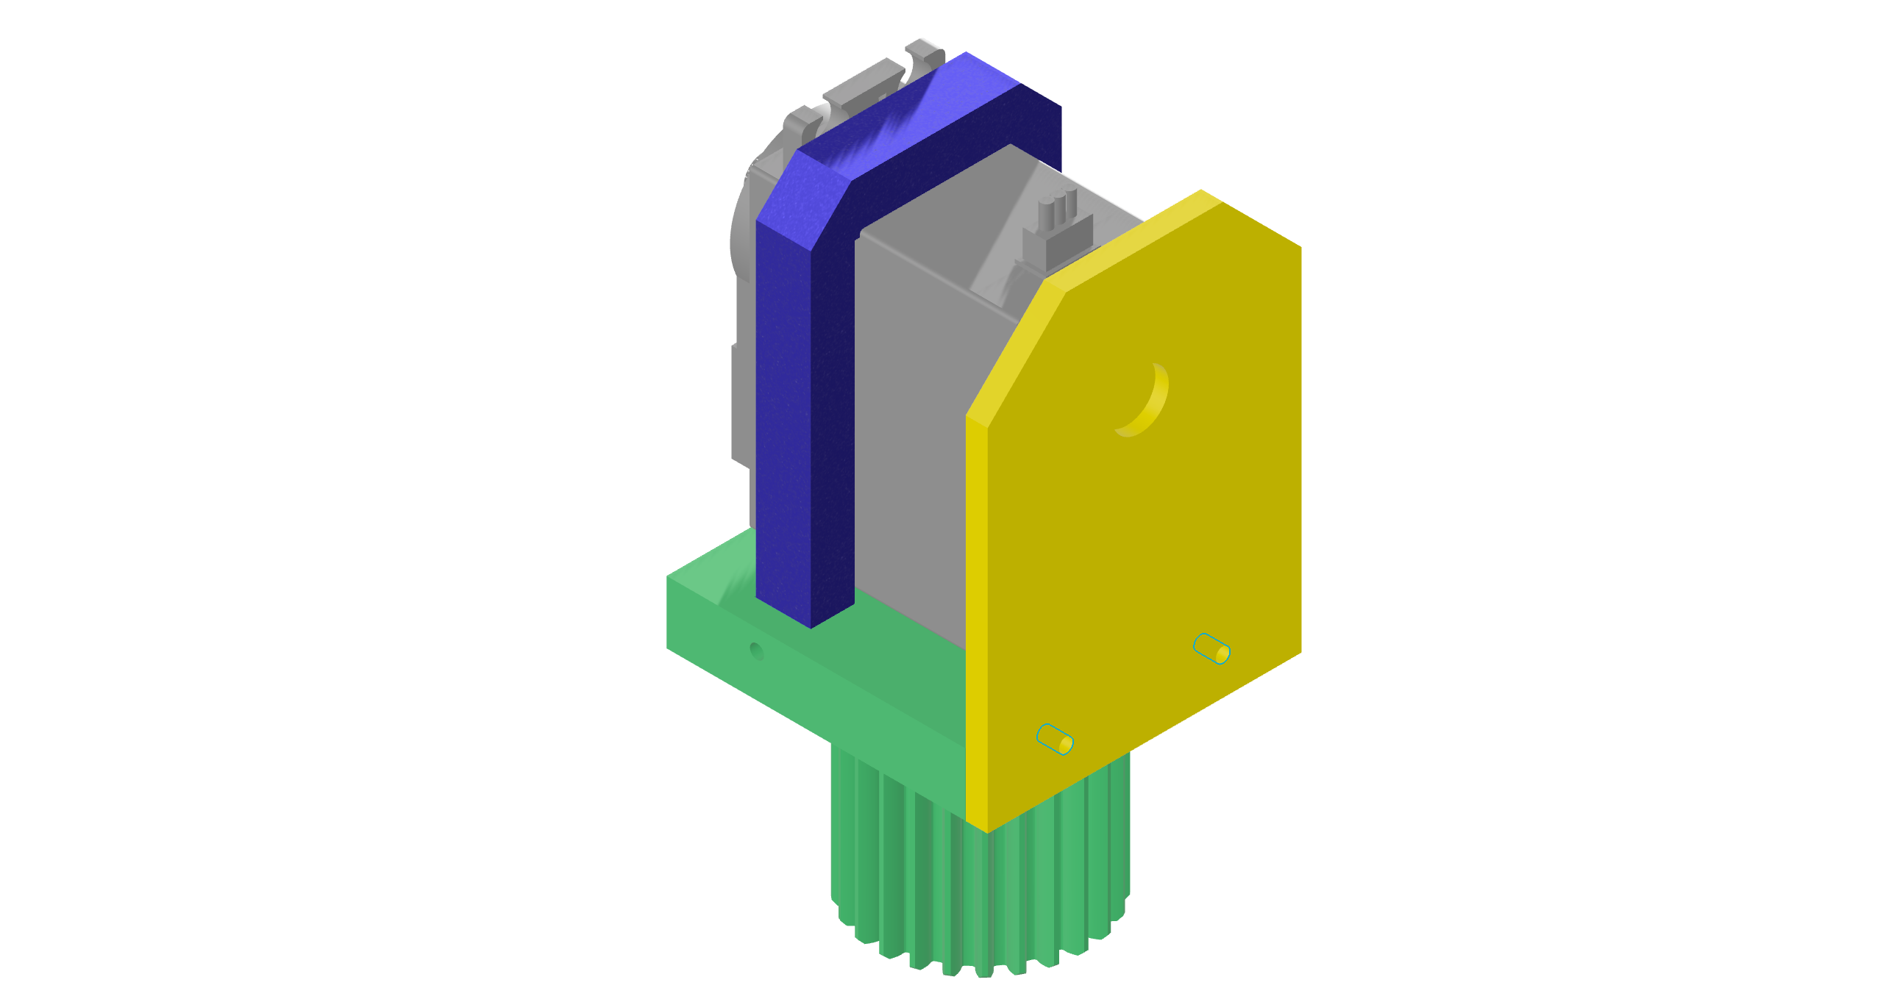

Step 11: Slide the elevation servo cover into the main shroud
Parts used: ElServoCover
Slide the elevation (EL) servo cover into the main shroud.
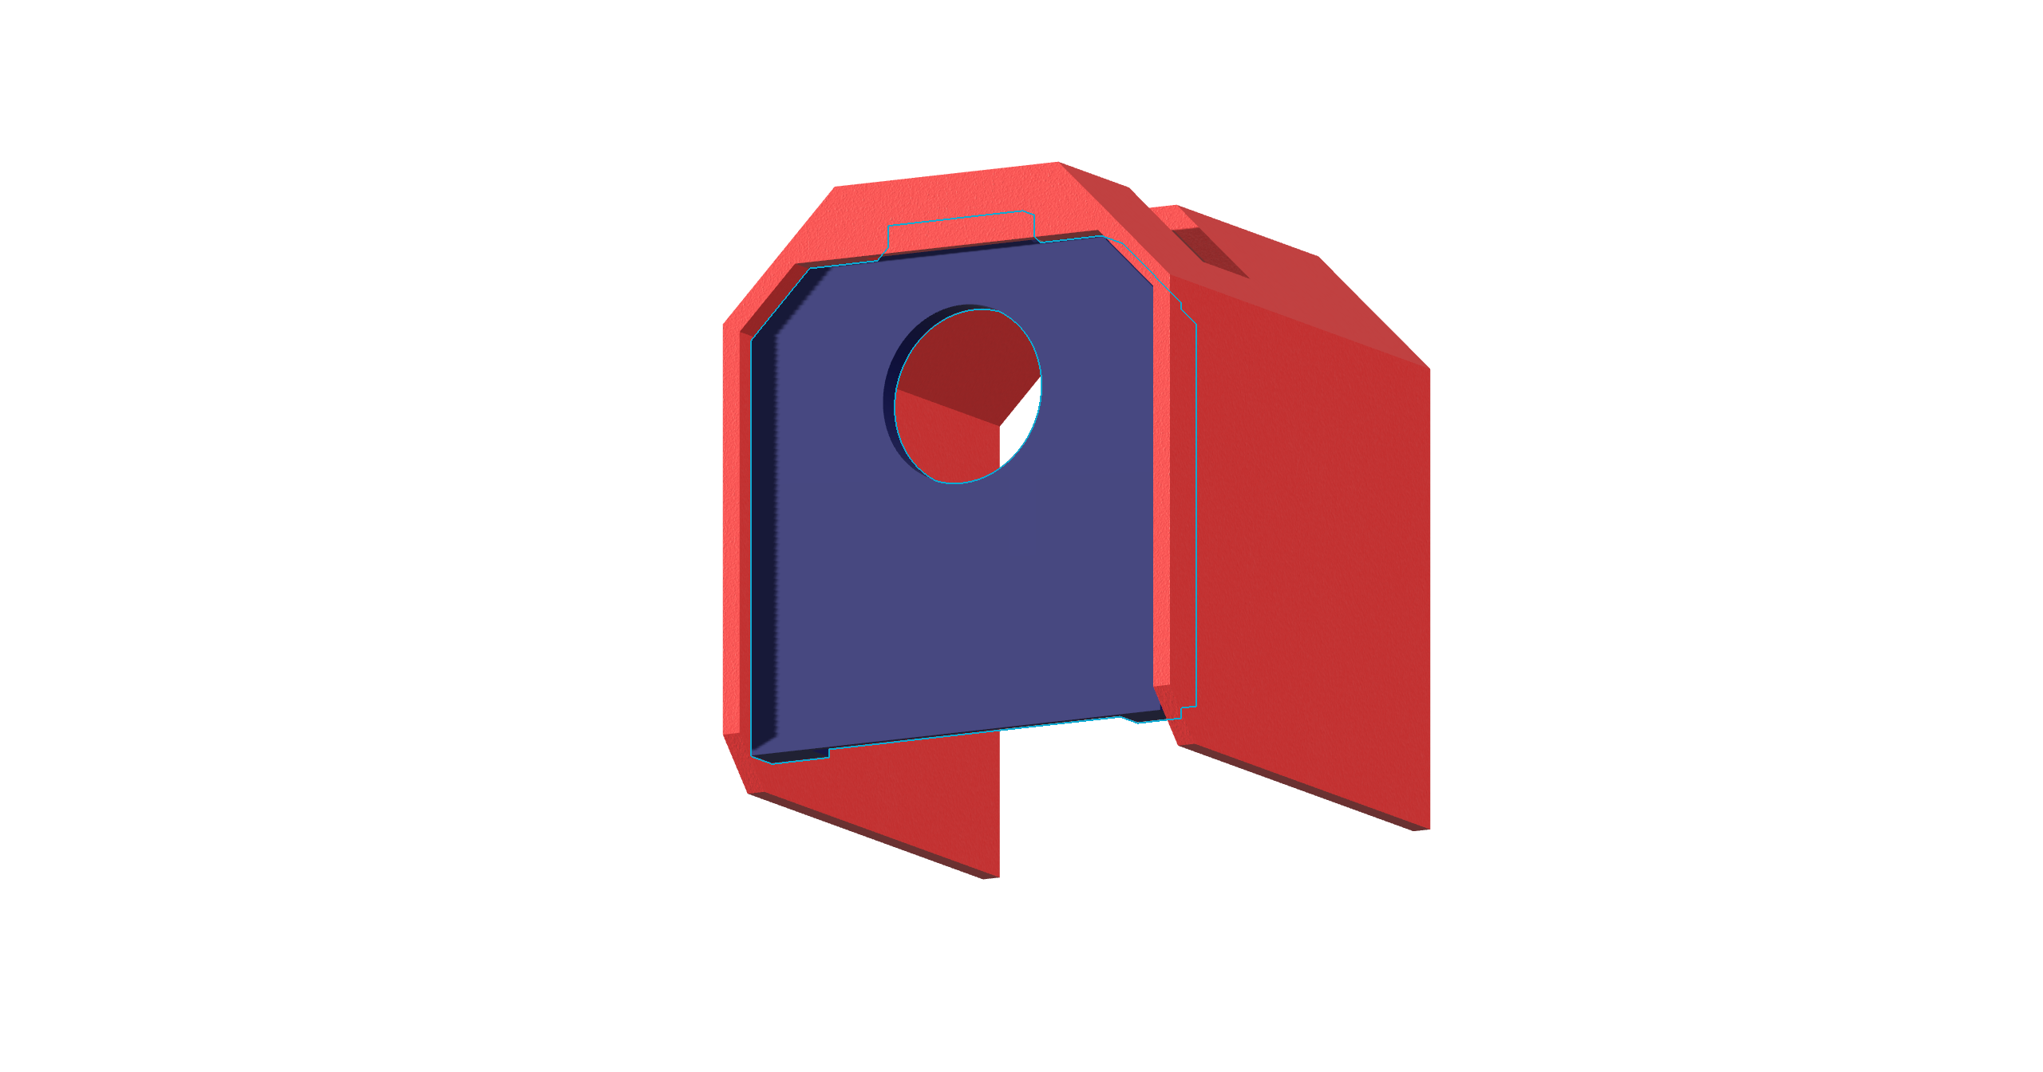

Step 12: Fit the elevation motor housing
Parts used: ElServoFrontPlate
Slide the elevation motor housing over the servo.
Push until it clicks into the servo's mounting holes.
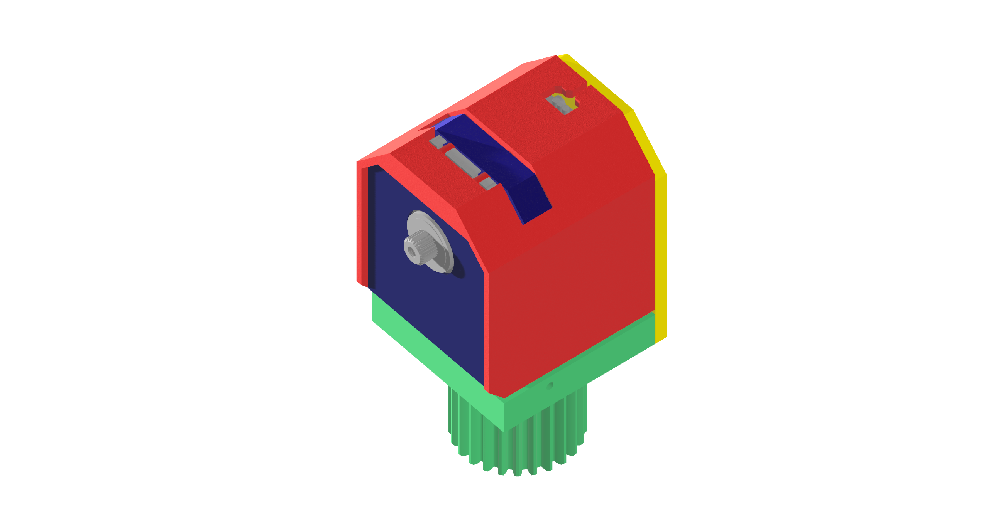

Step 13: Assemble the antenna arm
Parts used: AntennaMountPlate, ElArmSidePlate_x2
Assemble the antenna arm.
Use 4 M2x10 screws to secure it until flush.
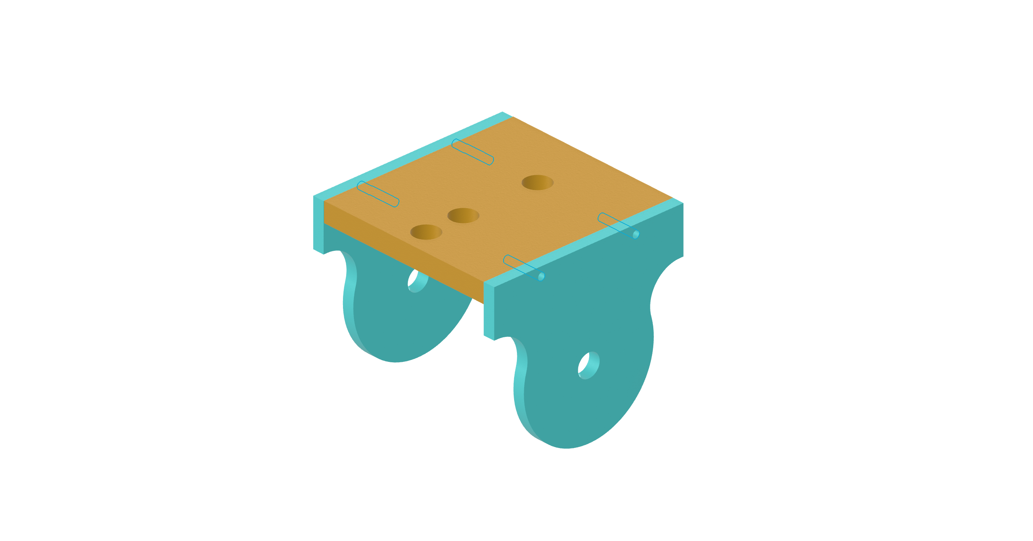

Step 14a: Fit the small rotator pin
Parts used: ElRotatorPin, ElArmSidePlate_x2
Place the small rotator pin inside the notch in the arm piece.
Push it through the other hole on the elevation arm until it clicks in and sits fully flush.


Step 14b: Fit the elevation arm to the servo gear
Parts used: ElArmSidePlate_x2, LargeGear
Put the elevation arm over the servo gear, making sure it goes all the way through.
Use the included servo screw to tighten until the arm does not slip when rotated.
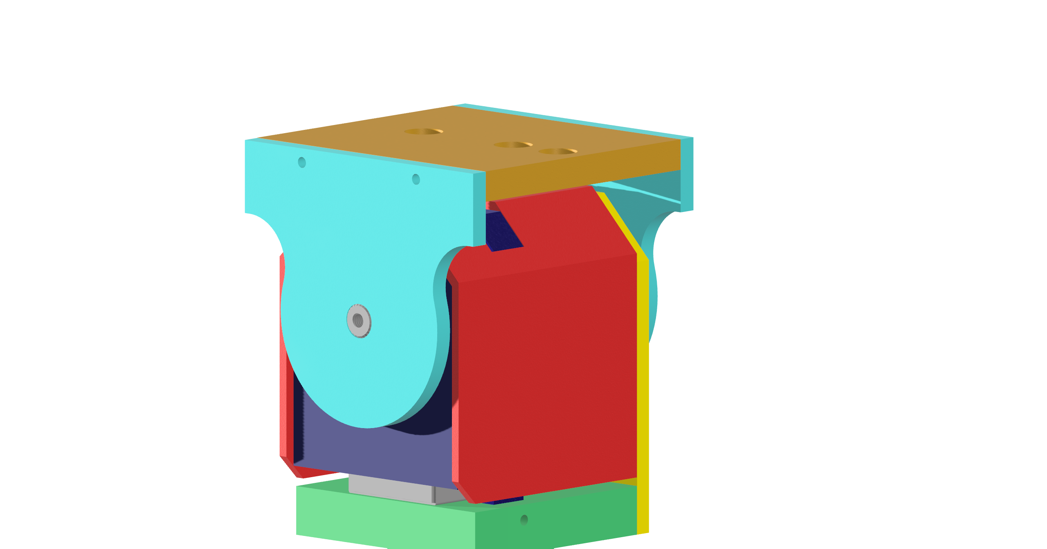

Step 15: Slide the AZ protection cover onto the base plate
Parts used: AzProtectionCover, AzMount
Slide the azimuth (AZ) protection cover over the base plate until it slots into the ridge in the base plate.
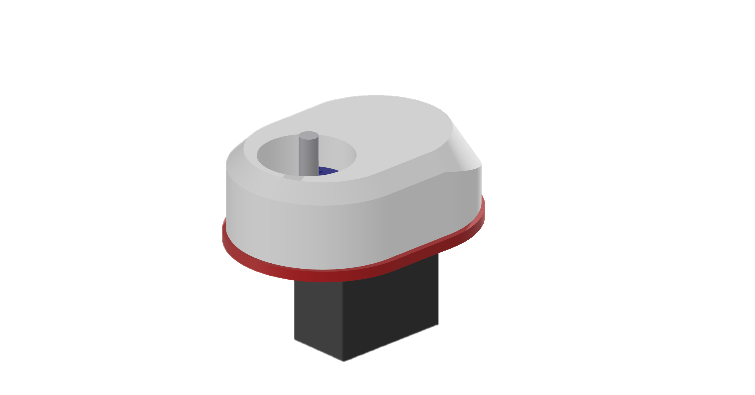

Step 16: Fit the elevation assembly onto the pin and base plate
Parts used: AzMount, ElRod
Slide the entire elevation assembly onto the pin and the base plate.
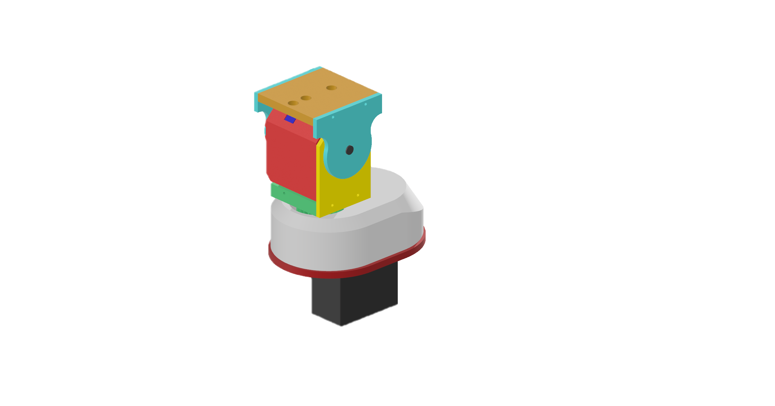

Step 17: Slide the antenna mount bracket into the positioning holes
Parts used: COTSAntennaBracket
Slide the antenna mount bracket into the positioning holes.


You have now completed assembly!
Screw the entire module onto a ¼ inch threaded tripod for mounting and insert your antenna into your bracket.

Part 2: Electrical Circuit
The image below shows the circuit wiring required for the rotator controller to function. Note that you will need to plug the Arduino in via its micro-USB port to the Raspberry Pi.
Additionally you can choose how to supply the servo’s with 5v 3A power (either through an external supply or by cutting open an old USB cable, and soldering the positive and negative leads to the servo VCC and GND.

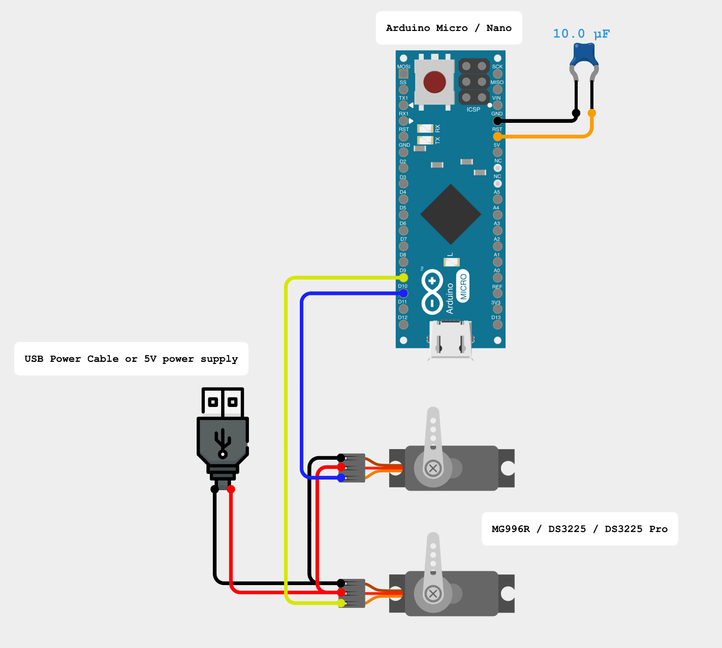

Part 3: Arduino Setup
Use your main computer for this part, not the Raspberry Pi.

Step 1: Connect the Arduino
Plug the Arduino Nano into your computer’s USB port with a micro USB cable and open the Arduino IDE.

Step 2: Install the Servo library
The code uses the Servo library, which is built into the Arduino IDE. No extra installation is needed.

Step 3: Copy the tracking code
Paste the code in section 2.1 into a new sketch.

Step 4: Select the board and port
Choose Tools > Board > Arduino Nano. Set Processor to the variant that matches your board (commonly ATmega328P or the Old Bootloader variant). Choose the correct port under Tools > Port.

Step 5: Upload
Click Upload and wait for it to finish.
Verification: The bottom of the IDE shows "Done uploading" with no red error text.

2.1 Tracking code
#include <Servo.h>

Servo altServo; // Motor 1: Altitude
Servo azServo; // Motor 2: Azimuth (2:1 geared)

// Pin assignments
const int MOTOR2_PIN = 10; // Azimuth
const int MOTOR1_PIN = 9; // Altitude

const int SERVO_MIN_US = 800;
const int SERVO_MAX_US = 2200;

// Current servo positions (used for the deadband check)
int currentServoAz = 90;
int currentServoAlt = 90;

// Current real-world positions (reported back when polled)
float currentRealAz = 180.0;
float currentRealAlt = 0.0;

void setup() {
Serial.begin(9600);
Serial.setTimeout(10); // Stops serial reads from slowing the loop

altServo.attach(MOTOR1_PIN, SERVO_MIN_US, SERVO_MAX_US);
azServo.attach(MOTOR2_PIN, SERVO_MIN_US, SERVO_MAX_US);

// Starting position: azimuth 180 (south), altitude 0 (horizon)
moveToRealAngles(180, 0);
}

void loop() {
if (Serial.available() > 0) {
String inputString = Serial.readStringUntil('\n');
inputString.trim();

int azIndex = inputString.indexOf("AZ");
int elIndex = inputString.indexOf("EL");

if (azIndex != -1 && elIndex != -1) {
// A movement command contains numbers after AZ and EL
if (elIndex - azIndex > 3) {
float targetRealAz = inputString.substring(azIndex + 2, elIndex).toFloat();
float targetRealAlt = inputString.substring(elIndex + 2).toFloat();
moveToRealAngles((int)targetRealAz, (int)targetRealAlt);
}
// An empty poll ("AZ EL") gets the current position back
else {
Serial.print("AZ");
Serial.print(currentRealAz);
Serial.print(" EL");
Serial.println(currentRealAlt);
}
}
}
}

void moveToRealAngles(int targetAz, int targetAlt) {
// Altitude: real 0 (horizon) = servo 90; real 70 (highest) = servo 20
int constrainedAlt = constrain(targetAlt, 0, 70);
int servoAlt = 90 - constrainedAlt;

// Azimuth: 360 real degrees = 180 servo degrees (2:1 gearing)
int servoAz = targetAz / 2;

// Deadband: ignore moves smaller than 2 degrees to stop jitter
if (abs(servoAz - currentServoAz) <= 2 && abs(servoAlt - currentServoAlt) <= 2) {
return;
}

currentServoAz = constrain(servoAz, 0, 180);
currentServoAlt = constrain(servoAlt, 20, 90);
currentRealAz = targetAz;
currentRealAlt = targetAlt;

int targetAzPulse = map(currentServoAz, 0, 180, SERVO_MIN_US, SERVO_MAX_US);
int targetAltPulse = map(currentServoAlt, 0, 180, SERVO_MIN_US, SERVO_MAX_US);

azServo.writeMicroseconds(targetAzPulse);
altServo.writeMicroseconds(targetAltPulse);
}

2.2 How the code works
Section | What it does
setup() | Attaches both servos and moves the antenna to its resting position.
loop() | Waits for a command on the serial port and either moves or reports position.
moveToRealAngles() | Converts real angles into servo angles, applies limits, and writes the pulses.
Deadband check | Skips moves smaller than 2 degrees to prevent servo jitter.
Altitude limits | Limits altitude to 0 to 70 degrees to protect the mechanism.

Note: After powering the Arduino and the servo’s you should see them move to a specific angle. Gently loosen the elevation arm screw and rotate the arm until the antenna is horizontal, then retighten it. Then slide the elevation assembly off the pin and face it so the front of the antenna points away from the large gear.
When using the antenna and rotator, for initial setup, you must make sure that when powered on, the antenna faces south at its neutral position.

Part 4: Raspberry Pi or Linux Setup with SatNOGS
These steps apply to a Raspberry Pi or to any Linux device running SatNOGS.

Step 1: Connect the hardware
Plug the Arduino into a USB port on the Pi or Linux device. If you use a USB galvanic isolator, place it between the computer and the Arduino.

Step 2: Add your user to the serial group (Linux devices only)
Serial ports belong to the dialout group on most Linux systems. Run the command below, then log out and back in.
sudo usermod -aG dialout $USER

Step 3: Identify the serial port
ls /dev/ttyUSB* /dev/ttyACM*

Verification: The output shows a path such as /dev/ttyUSB0 or /dev/ttyACM0. Write it down for the next step. If nothing appears, unplug and replug the Arduino, then run the command again.

Step 4: Open the rotator settings
sudo satnogs-setup

Navigate to Rotator (or Advanced > Rotator Configuration) and set these values:
Setting | Value | Reason
SATNOGS_ROT_MODEL | ROT_MODEL_EASYCOMM2 | Selects the Easycomm II protocol used by the Arduino code
SATNOGS_ROT_BAUD | 9600 | Must match Serial.begin(9600) in the Arduino code
SATNOGS_ROT_PORT | Your port, for example /dev/ttyUSB0 | Tells the software where the Arduino is connected
SATNOGS_ROT_THRESHOLD | 2 | Sends a command only after the satellite moves at least 2 degrees

Step 5: Apply the configuration
Press Back, then select Apply. The system takes about a minute to rebuild the configuration.
Verification: The menu closes and returns you to the command prompt. This means the satnogs-client service restarted.

Step 6: Test the connection
Stop the automated client so it does not send commands during the test.
Write the following command into the raspberry Pi’s terminal:
sudo systemctl stop satnogs-client

Send a manual command with the Hamlib utility. Replace ttyUSB0 if your port differs.
rotctl -m 202 -r /dev/ttyUSB0 -s 9600 P 360 70

Verification: The antenna moves to azimuth 360 and altitude 70. Return it to the resting position:
rotctl -m 202 -r /dev/ttyUSB0 -s 9600 P 180 0

Step 7: Restart the automated client
sudo systemctl start satnogs-client

Safety: The rotator moves during these tests. Keep hands and cables clear before sending any command.
Tip: Model number 202 is Hamlib's Easycomm II rotator model. It must match the protocol set in SatNOGS.

Using the Rotator with SATNOGS

After the setup detailed above, simply schedule a pass on the SATNOGS network with the Arduino connected to the raspberry Pi’s USB port, and the servo motors connected to an external USB port or power supply (not on the Raspberry Pi).

Troubleshooting
Symptom | Likely cause | Fix
No port appears in ls /dev/tty* | Cable is power-only, or the Arduino is not detected | Use a data cable, then replug and check again
Permission denied on the port (Linux) | User is not in the dialout group | Run sudo usermod -aG dialout $USER, then log out and back in
Antenna does not move | Wrong port, wrong baud rate, or servos not powered | Check SATNOGS_ROT_PORT and SATNOGS_ROT_BAUD, and confirm the servo power supply
Antenna moves the wrong way | Servo horn or wiring is reversed | Reverse the angle conversion in the Arduino code and re-upload
Antenna jitters constantly | Commands are too frequent or the deadband is too small | Keep SATNOGS_ROT_THRESHOLD at 2 and increase the deadband in the code if needed
Altitude stops at 70 degrees | Software limit in the Arduino code | This is intended. Change constrain(targetAlt, 0, 70) only if your mechanism allows more travel
rotctl reports a timeout | Another program holds the port, or the client is still running | Stop satnogs-client and close other serial programs

Glossary
Term | Meaning
Azimuth | Compass direction of the antenna, in degrees clockwise from north
Altitude (elevation) | Angle of the antenna above the horizon, from 0 to 90 degrees
Servo | A motor that moves to a set angle when given a control pulse
Serial port | A USB data connection, shown as /dev/ttyUSB0 or /dev/ttyACM0 on Linux
Baud rate | Speed of serial communication, in bits per second. Both ends must match
Hamlib | Open-source library and rotctl utility for controlling rotators
Easycomm II | A simple text protocol for sending azimuth and elevation commands
Deadband | A small range of movement ignored to prevent constant small adjustments
Gearing (2:1) | The servo turns 1 degree for every 2 degrees of antenna movement, so the code maps 360 antenna degrees to 180 servo degrees
SatNOGS | Open-source ground station network that tracks and records satellite signals

