**Software Requirements Specification (SRS) Document – Version 2**

Team 36

Talib Siddiqui, Khushi Wadhwa, Yash Shivare, Rayaan Khan

**Brief problem statement**

Create a mobile application based on the Amita care website, ie, https://www.amitacare.com/.

The user should first log in/Register with his credentials.

The user can get a preliminary diagnosis

s based on his symptoms using the Knidian (Symptom Checker) AI

Our app allows the user to book a therapy session, choose the Therapist/Doctor by looking at profiles of all the available doctors, and choose the one best suited for their needs.

If the user has provided his ABHA number at registration , his preliminary diagnosis and appointment are added to his medical history stored in the government database

**Users profile**

1. Patients: The patients using the app can get a preliminary diagnosis, and book an appointment with their preferred doctor

2. Doctor: the doctors can use this to check their patient’s medical history so that they can plan a session that helps them best. Moreover, whenever a client books a session

**Project Modules**

➢ User Interface Module:

This module will provide a user interface for the patients to enter their symptoms and get a preliminary diagnosis. It will also allow users to schedule an appointment with a doctor.

Features :

•Login/registration (R1)

•Book an Appointment(R1)

➢ Symptom Checker Module:

This module will provide the app’s core functionality, which is to diagnose the symptoms based on the user's input. It will analyze the user's symptoms and compare them to a database of known illnesses to generate a list of possible diagnoses.

Features :

•Knidian Symptom checker(R1)

➢ Database Module:

This module will store the database of illnesses, including their symptoms, causes, and treatments. The database will be used by the Symptom Checker module to diagnose the symptoms. (R1)

➢ Appointment Scheduler Module:

Requirements Page 1

This module will allow patients to schedule appointments with doctors. It will check the availability of doctors and clinics and provide the user with a list of available times.

Features:

• Checking doctors& patients calenders (R2)

• Confirming Booking via email(R2)

➢ Doctor Module:

This module will provide information about the doctors who work with the app. It will store their names, contact information, specialties, and availability.

Features

• Info about doctors(R1)

➢ User Profile Module:

This module will store user data such as name, contact information, and medical history.

Features :

• User Profile – automatically updates when a new appointment is booked(R2)

**Feature requirements (described using use cases)**

| **No.** | **User Case Name** | **Description** | **Release** |
| --- | --- | --- | --- |
| 1. | Log in / Register | The user needs to first Login, or register(if he doesn’t have an account) to access our app | R1 |
| 2. | Edit User Profile | The user can edit his profile in the profile page | R1 |
| 3. | Get Preliminary Prognosis | The user can enter his symptoms, and get a preliminary diagnosis. This is done using the Knidian Symptom Checker AI. | R1 |
| 4. | See Doctors Details | The user can go through the data of the doctors , and choose the one they feel fits their requirements the best.They can consider factors such as Education , Specialization and Experience | R1 |
| 5. | Make Appointment | The user can Make an appointment with any of the doctors they like.The confirmation of the appointment is sent in the form of an email to the user.This new appointment is then shown in the list of upcoming appointments of the user. | R2 |
| 6. | Online Session | Our app enables users to have online therapy sessions with the therapist they made an appointment with. As our app focuses towards the specially-abled , the Ui is simple and easy to use. |  |

Requirements Page 2

| 7. | Payment | The user can make an online payment for the appointment | R2 |
| --- | --- | --- | --- |
| 8. | Cancel Appointment | The user can cancel an upcoming appointment if he wishes to do so. | R2 |
| 9. | Log Out | The user can Log out if he is done using our app. | R2 |

**UML Case Diagram**

Requirements Page 3

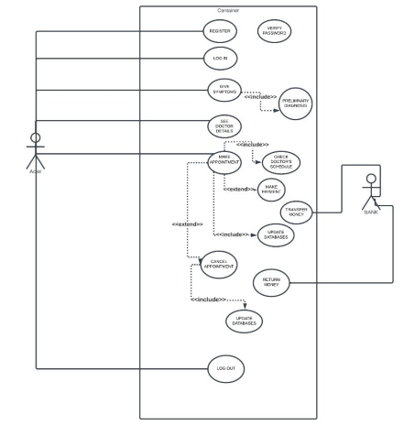Requirements Page 4