[**Big Data Technologies (CSP-554-03)**](https://blackboard.iit.edu/webapps/blackboard/execute/courseMain?course_id=_138946_1)

**TRINADH RAYALA(A20528281)**

1) Hadoop Cluster Connection with git by using ssh key pair

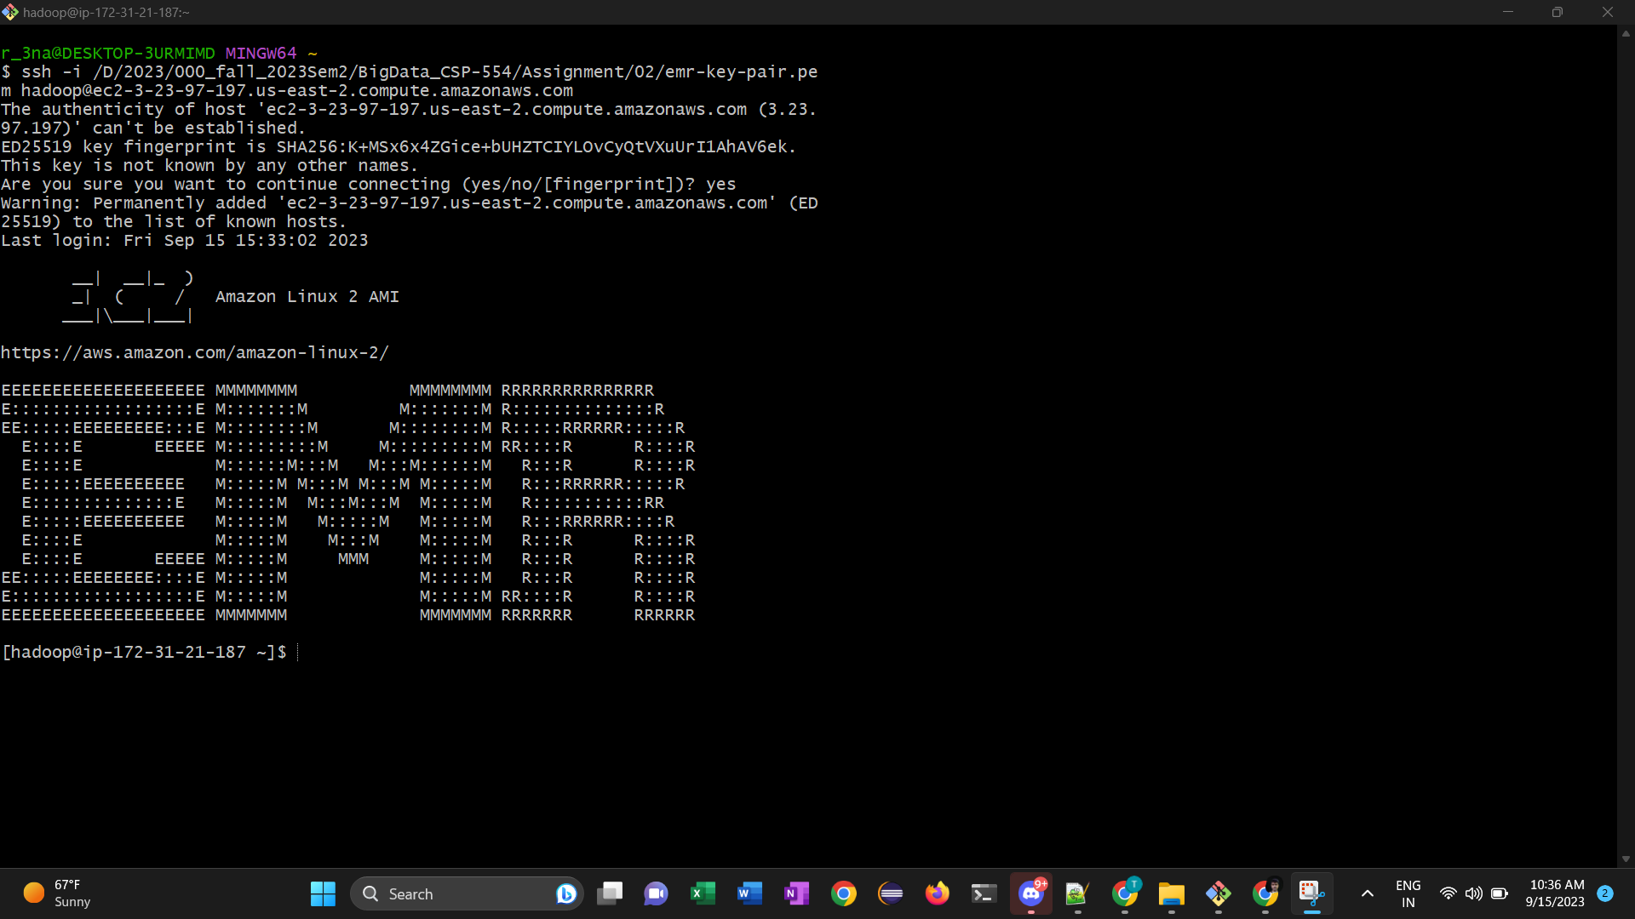

“trinadh.txt”(myName.txt) file copied to Hadoop cluster

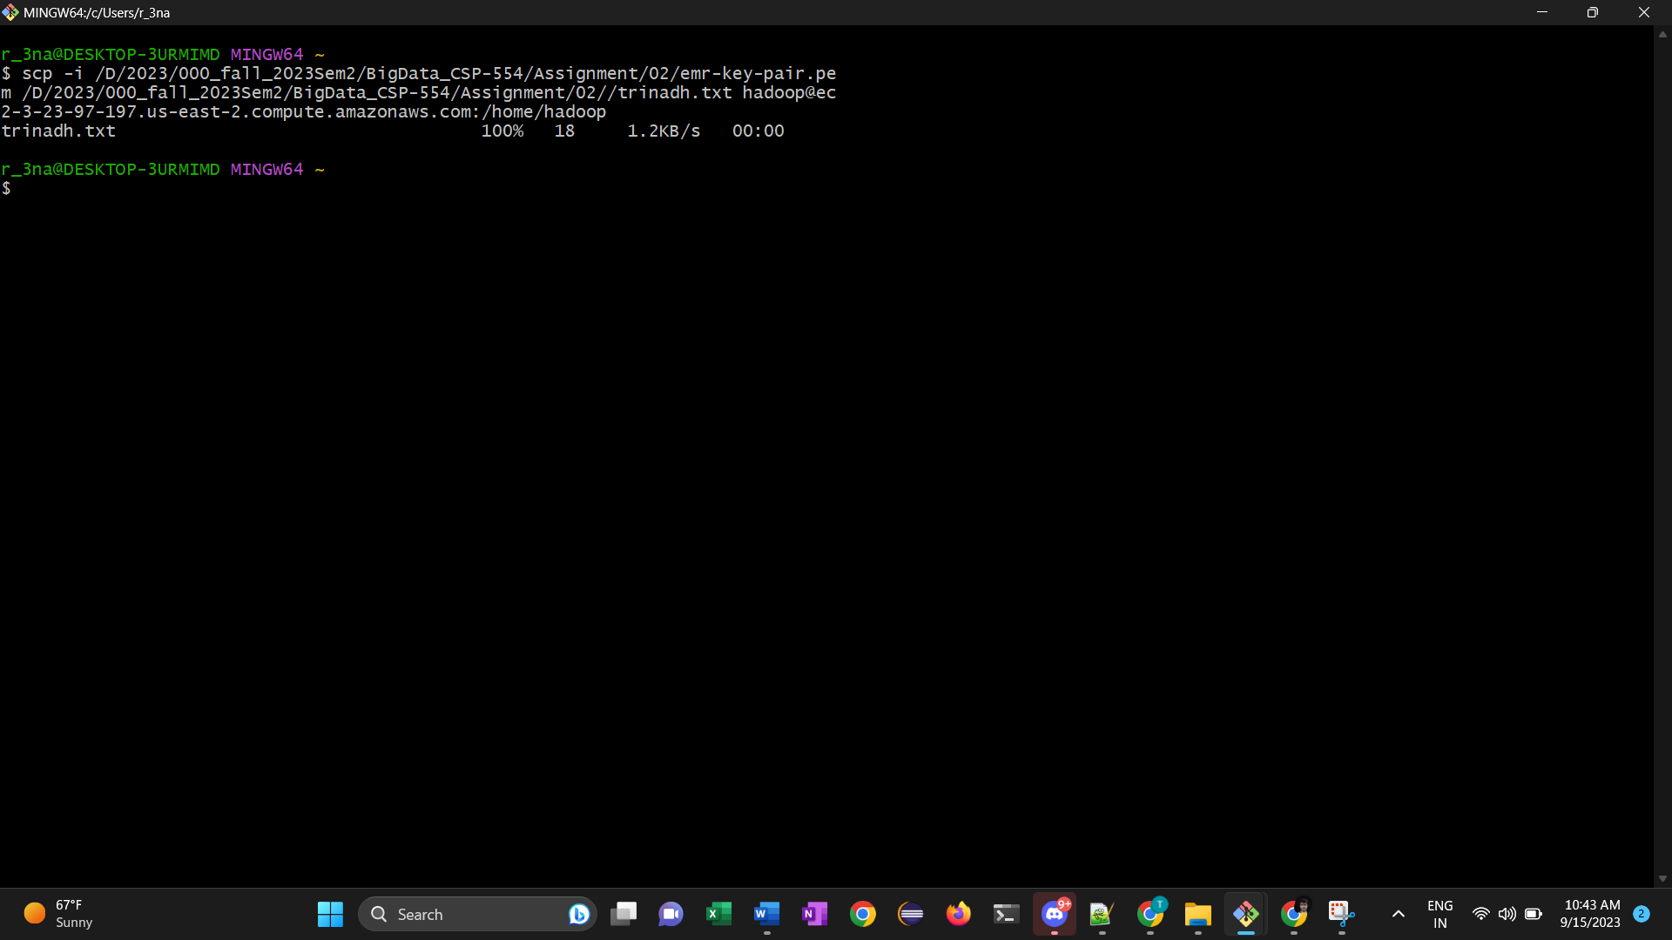

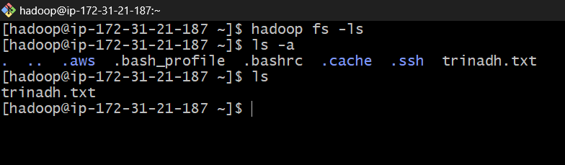

Uploaded A20528281.txt(“myid.txt”) file into the s3 storage bucket(trinadhbucket)

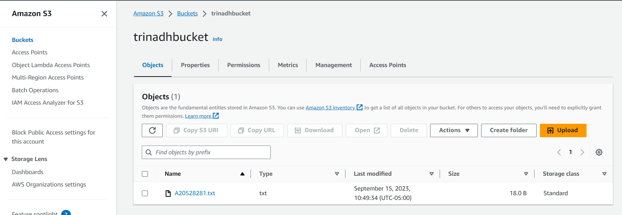

**Commands**

9) to list the files or directories : **“Hadoop fs -ls /”**

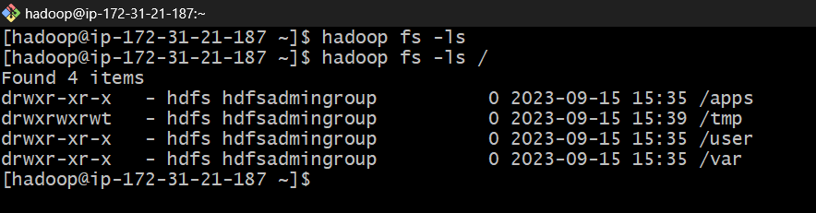

10)find the files under user directory : **hadoop fs -ls /user**

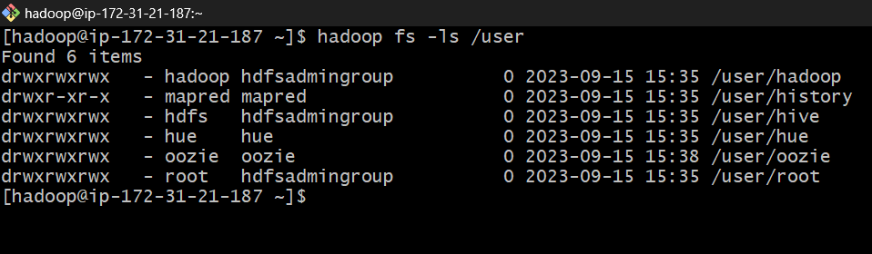

11)To create csp554 folder under user directory : **hadoop fs -mkdir /user/csp554**

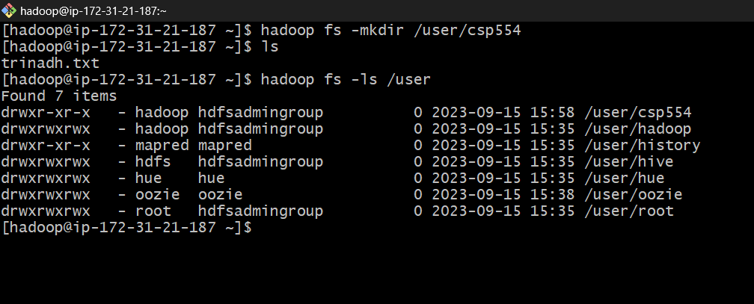

12) **hadoop fs -mkdir /user/csp554-2**

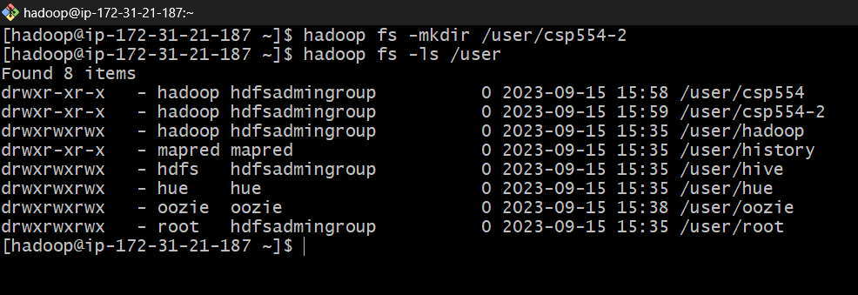

13**) Hadoop fs -put /home/Hadoop/trinadh.txt /user/csp554**

**Hadoop fs sourceLocation to destinationLocation**

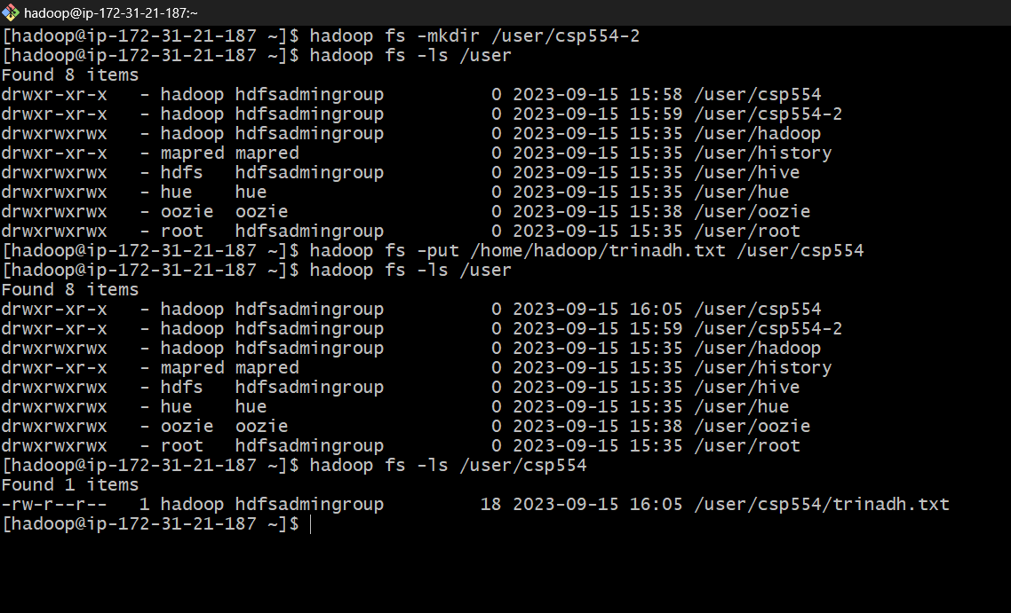

14)**Hadoop fs -cp /user/csp554/trinadh.txt /user/csp554-2**



15)**aws s3 cp s3://trinadhbucket/A20528281.txt /hom/Hadoop/A20528281.txt**

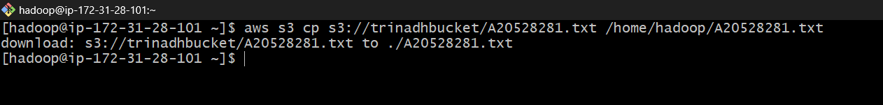

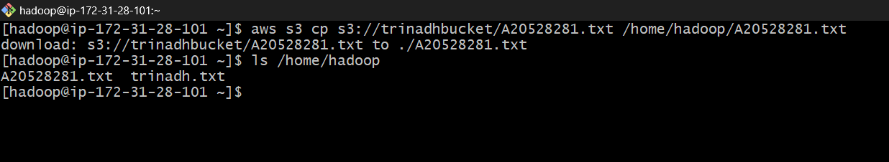

**16) hadoop fs -cp s3://trinadhbucket/A20528281.txt hdfs:///user/csp554-2**

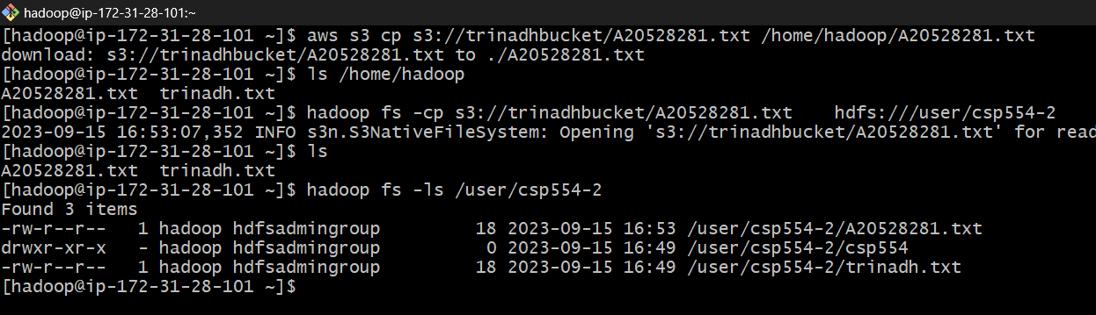

**17)Hadoop fs -cat /user/csp554-2/A20528281.txt**



**18)Hadoop fs -rm /user/csp554-2/A20528281.txt**

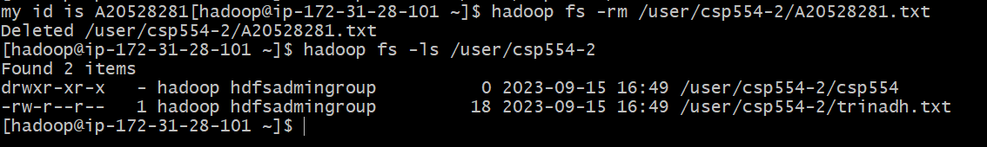

Thank you,

Trinadh Rayala,

trayala@hawk.iit.edu

A20528281.