**BIG DATA TECHNOLOGES**

A20528281 **HOMEWORK_3 Solutions** TRINADH RAYALA

5)WordCount.py : OUTPUT

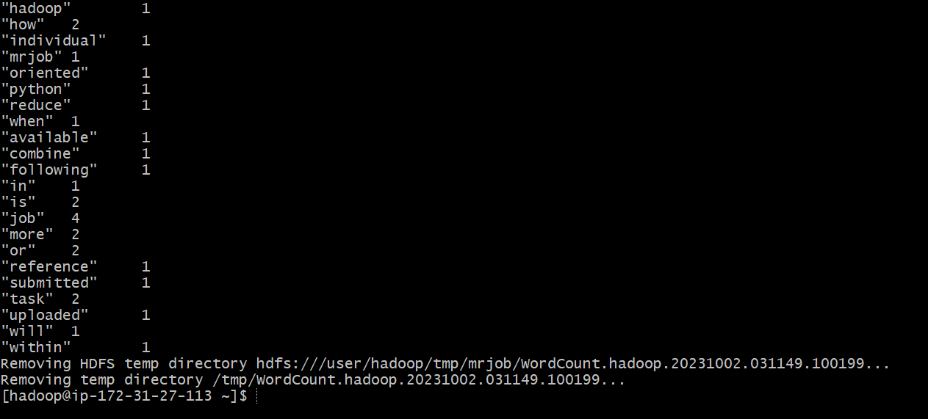

7)WordCount2.py :

PROGRAM :

from mrjob.job import MRJob

import re

PATTERN = re.compile(r"[\w']+")

class WordGroupCounter(MRJob):

def mapper(self, _, record):

for term in PATTERN.findall(record):

group_key = "a_to_n" if 'a' <= term[0].lower() <= 'n' else "other"

yield group_key, 1

def combiner(self, group_key, totals):

yield group_key, sum(totals)

def reducer(self, group_key, totals):

yield group_key, sum(totals)

if __name__ == '__main__':

WordGroupCounter.run()

OUTPUT

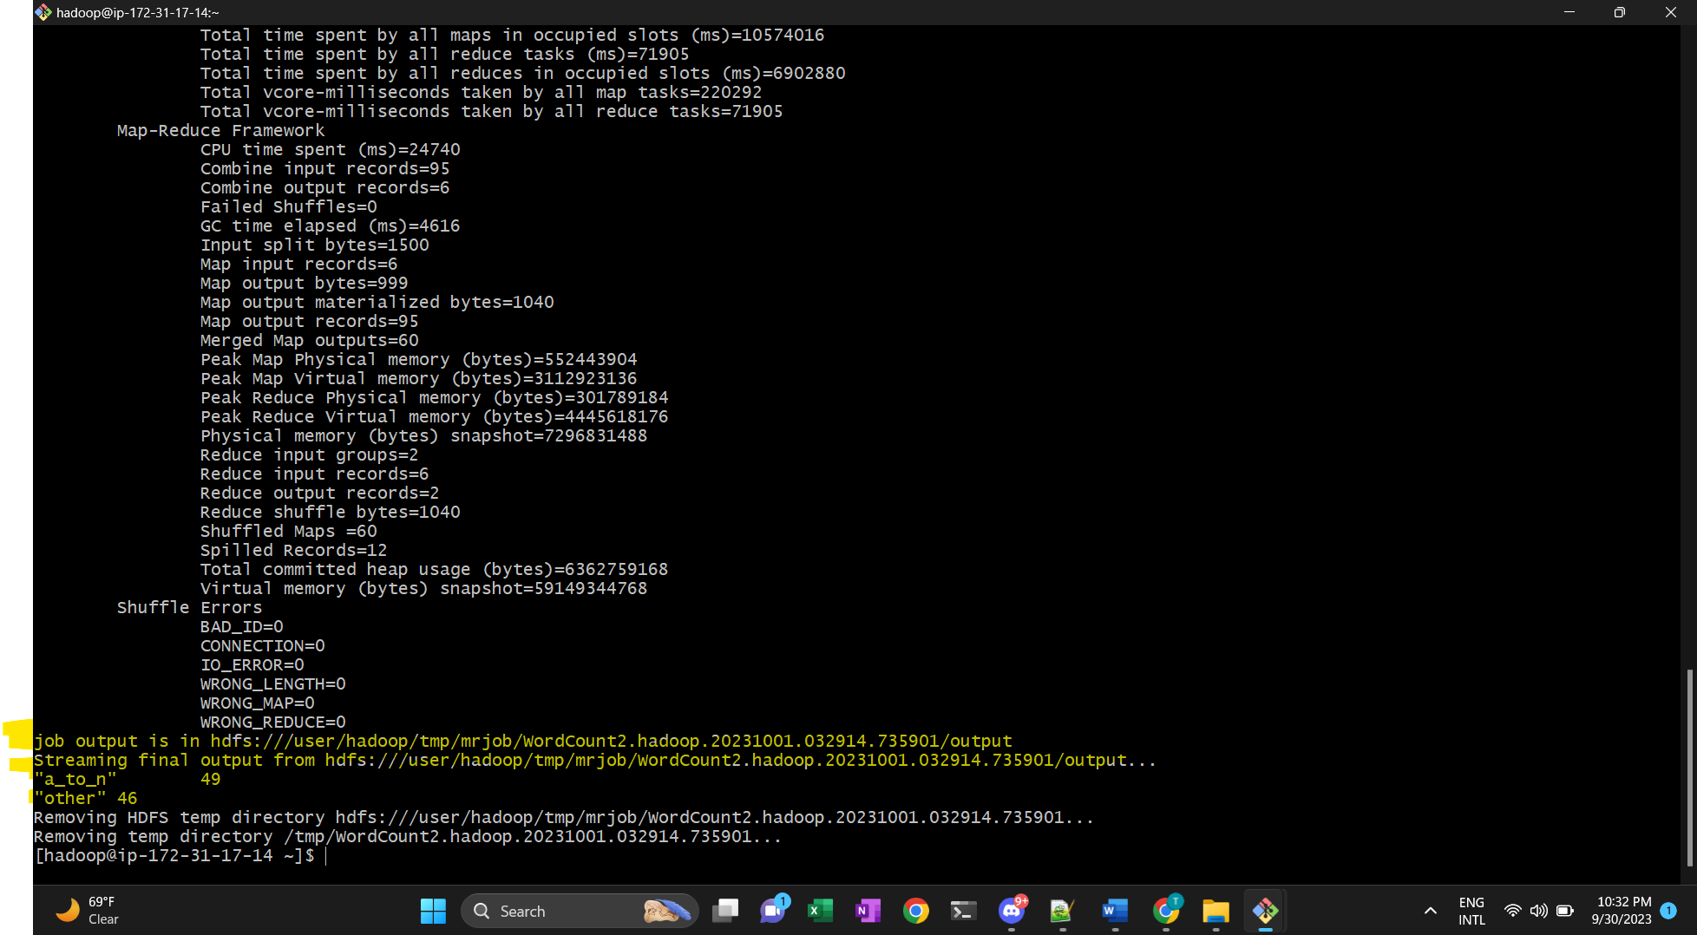

9)Salaries.py : OUTPUT

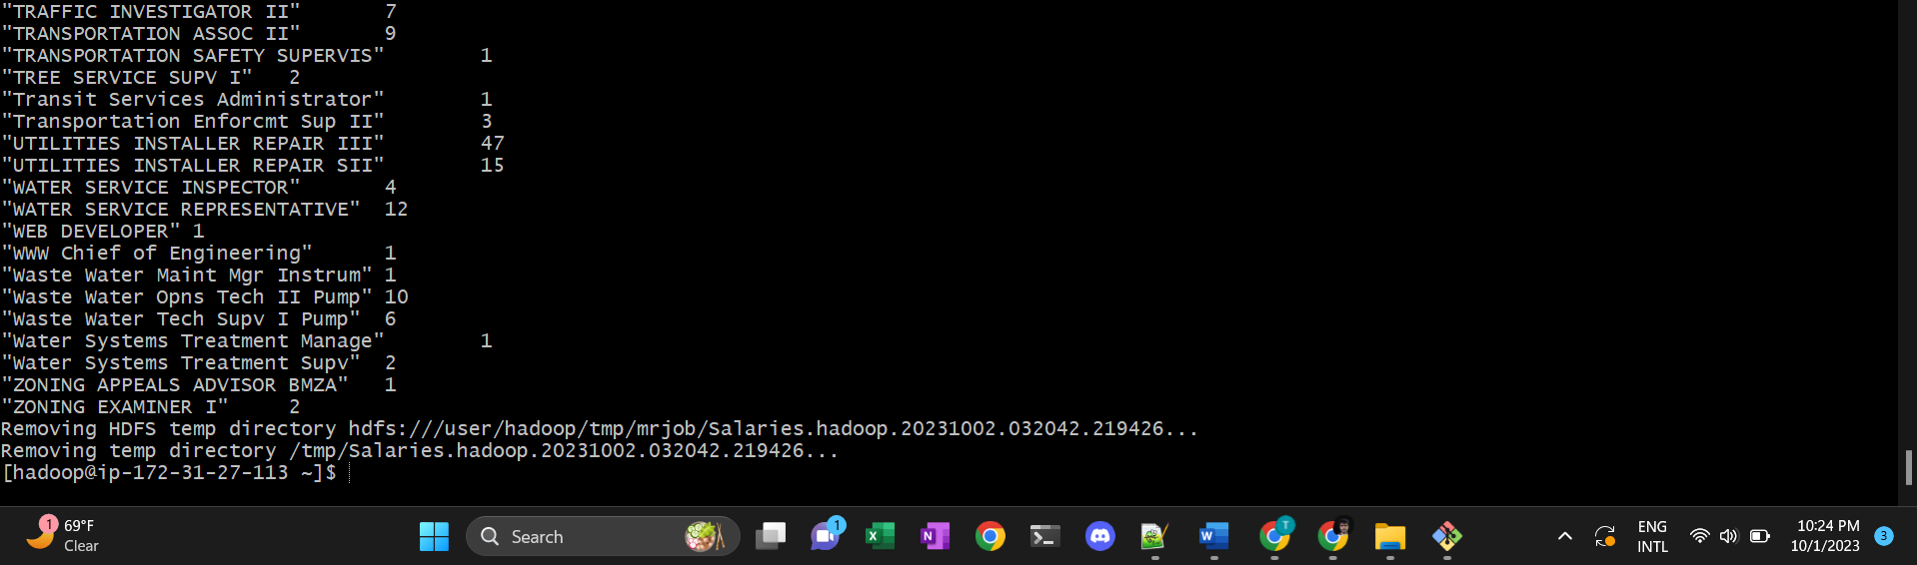

**11)Salaries2.py :**

PROGRAM :

from mrjob.job import MRJob

class MRSalaryClassification(MRJob):

def mapper(self, _, record_line):

try:

(employee_name, position_title, org_id, organization, join_date, yearly_pay, total_pay) = record_line.split('\t')

processed_salary = float(yearly_pay.replace(",", "").replace("$", ""))

if processed_salary >= 100000:

yield "High", 1

elif 50000 <= processed_salary < 100000:

yield "Medium", 1

else:

yield "Low", 1

except Exception as processing_error:

print(f"Error processing record: {record_line}. Error: {processing_error}")

def combiner(self, salary_category, category_counts):

yield salary_category, sum(category_counts)

def reducer(self, salary_category, category_counts):

yield salary_category, sum(category_counts)

if __name__ == '__main__':

MRSalaryClassification.run()

OUTPUT :

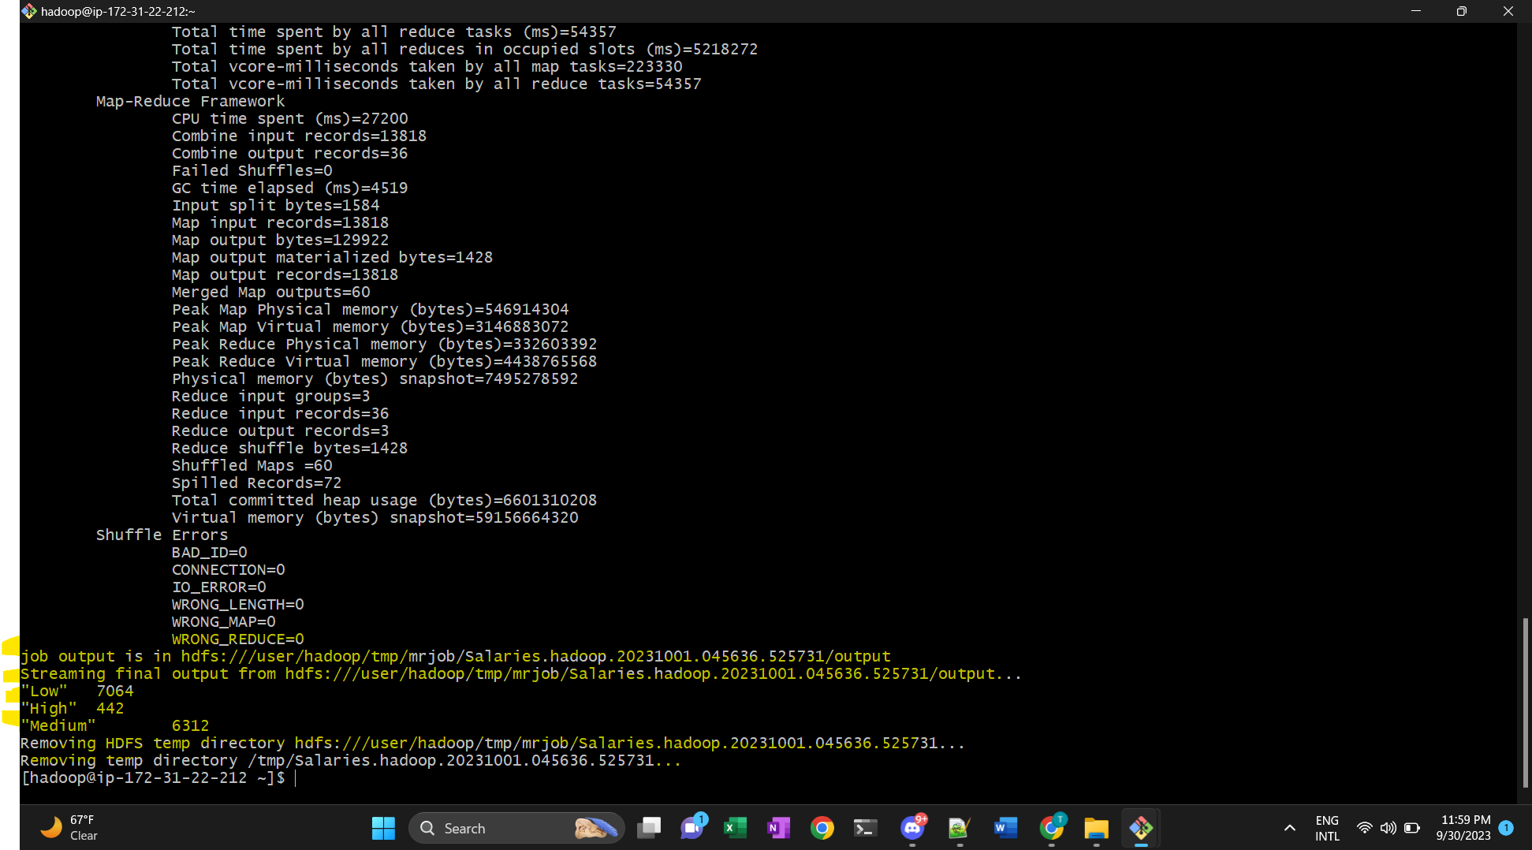

13) program to perform the task of outputting a count of the number of movies each user (identified via their user id) reviewed.

PROGRAM :

from mrjob.job import MRJob

from mrjob.step import MRStep

class MovieReview(MRJob):

def steps(self):

return [MRStep(mapper=self.distribute_data, reducer=self.collate_data)]

def distribute_data(self, _, entry):

user_id, film_id, _, _ = entry.split(',')

yield user_id, 1

def collate_data(self, user_id, occurrences):

yield user_id, sum(occurrences)

if __name__ == '__main__':

MovieReview(args=[data_source]).run()

OUTPUT :

