Exercise 1:

**Commands -> foodratings = LOAD 'foodratings7936.txt'**

**USING PigStorage(',')**

**AS (name:chararray, f1:int, f2:int, f3:int, f4:int, placeid:int);**

**-> food_ratings = FOREACH foodratings GENERATE name as name, f1 as f1, f2 as f2, f3 as f3, f4 as f4, placeid as placeid;**

**->DUMP food_ratings;**

Magic Number:

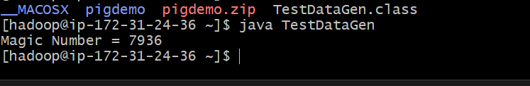

Output:

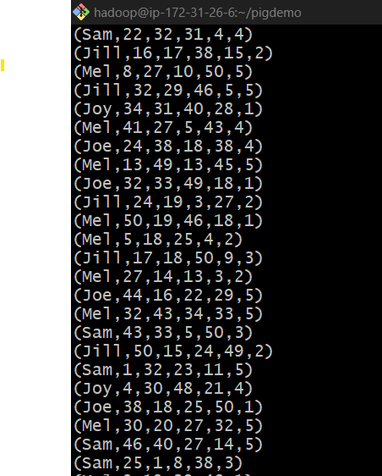

Command -> DESCRIBE food_ratings;

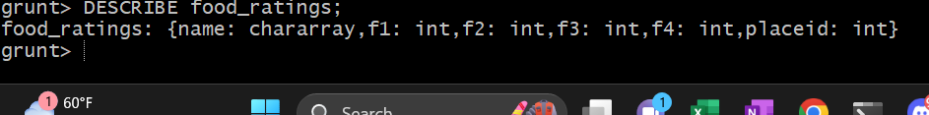

Exercise 2 :

**Command -> food_ratings_subset = FOREACH food_ratings GENERATE name, f4;**

**->STORE food_ratings_subset INTO '/user/hadoop/fr_subset' USING PigStorage();**

**->output = LIMIT food_ratings**_**subset 6;**

**->DUMP output;**

Output:

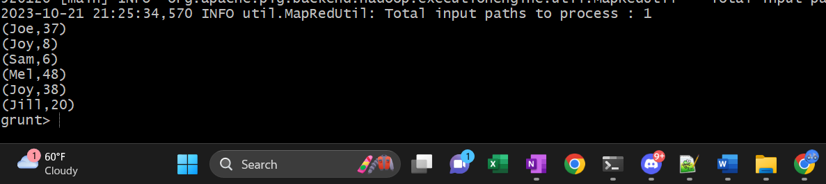

Exercise 3

Commands ->

f2_stats = FOREACH (GROUP food_ratings ALL) GENERATE

MIN(food_ratings.f2) AS f2_min,

MAX(food_ratings.f2) AS f2_max,

AVG(food_ratings.f2) AS f2_avg;

f3_stats = FOREACH (GROUP food_ratings ALL) GENERATE

MIN(food_ratings.f3) AS f3_min,

MAX(food_ratings.f3) AS f3_max,

AVG(food_ratings.f3) AS f3_avg;

food_ratings_profile = JOIN f2_stats BY f2_min, f3_stats BY f3_min;

final_output = FOREACH food_ratings_profile GENERATE

f2_min, f2_max, f2_avg, f3_min, f3_max, f3_avg;

DUMP final_output;



Exercise 4

Commands ->

food_ratings_filtered = FILTER food_ratings BY (f1 < 20) AND (f3 > 5);

final_output = LIMIT food_ratings_filtered 6;

DUMP final_output;

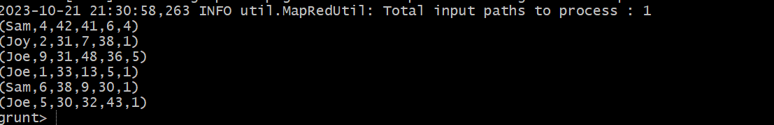

Exercise 5

Commands ->

food_ratings_2percent = SAMPLE food_ratings 0.02;

final_output = LIMIT food_ratings_2percent 10;

DUMP final_output;

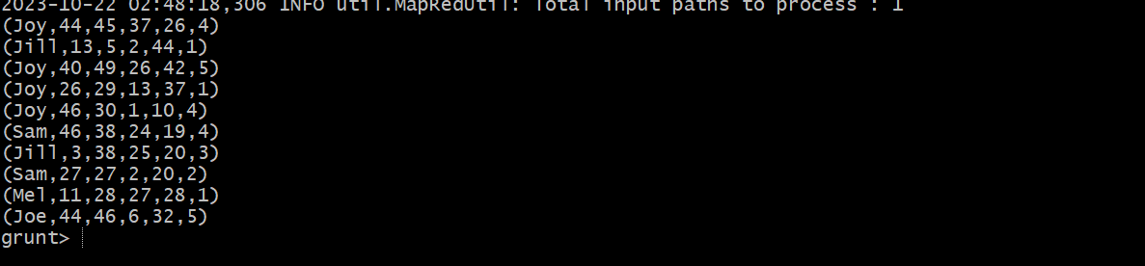

Exercise 6:

Commands->

food_places = LOAD 'foodplaces7936.txt' USING PigStorage(',') AS (placeid: int, placename: chararray);

DESCRIBE food_places;

food_ratings_w_place_names = JOIN food_ratings BY placeid, food_places BY placeid;

final_output = LIMIT food_ratings_w_place_names 6;

DUMP final_output;

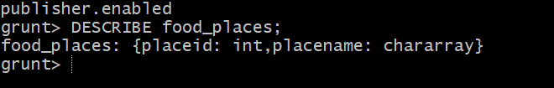

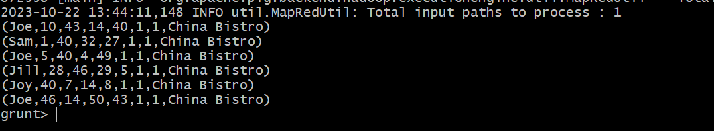

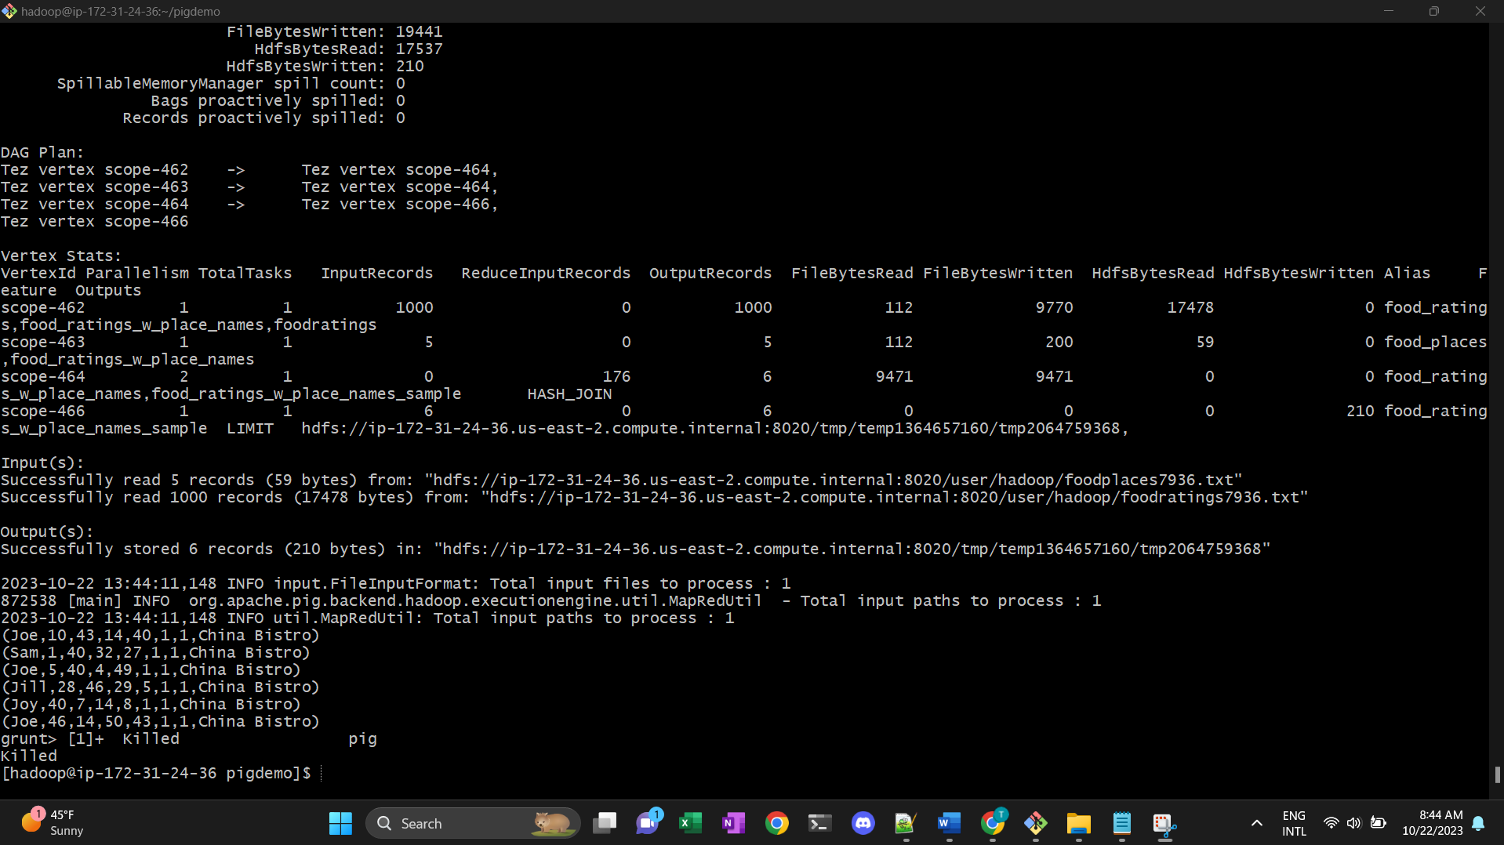

Exercise 7:

1. A
2. C
3. B
4. B
5. B
6. A