**ASSIGNMENT : 06TH**

Magic num : 24046

Exercise : 1 :

Print the first 5 records of RDD by “take(5)”

The following is the Command:

hdfs dfs -put foodratings24046.txt /user/hadoop

ex1RDD = sc.textFile("/user/hadoop/foodratings24046.txt")

record = ex1RDD.take(5) for rc in record: print(repr(rc))

result :

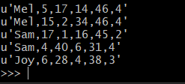

Exercise : 2

each record of this new RDD has 6 fields, each a string, by splitting apart each record on “,” boundaries from the ex1RDD

The following is the command:

ex2RDD = ex1RDD.map(lambda record: record.split(','))

record = ex2RDD.take(5)

for rc in record:

 print(repr(rc))

result:

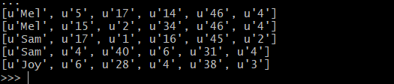

Exercise : 3:

another RDD called ex3RDD from ex2RDD where each record of this new RDD has its third column converted from a string to an integer

The following is the command:

ex3RDD = ex2RDD.map(lambda line: [line[0], line[1], int(line[2]), line[3], line[4],line[5]])

ex3 = ex3RDD.take(5)

for rc in ex3:

 print(repr(rc))

Result:

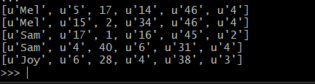

Exercise : 4:

another RDD called ex4RDD from ex3RDD where each record of this new RDD is allowed to have a value for its third field that is less than 25 (<25).

The following is the command :

ex4RDD = ex3RDD.filter(lambda line: line[2] < 25)

ex4 = ex4RDD.take(5)

for ln in ex4:

 print(repr(ln))

Result:

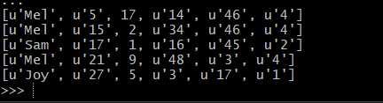

Exercise : 5

another RDD called ex5RDD from ex4RDD where each record is a key value pair where the key is the first field of the record and the value is the entire record

The following is the command :

ex5RDD = ex4RDD.map(lambda record: (record[0], tuple(record)))

ex5 = ex5RDD.take(5)

for rc in ex5:

 print(repr(rc))

Result :

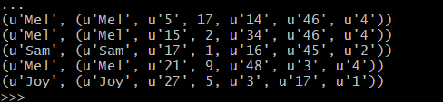

Exercise : 6:

another RDD called ex6RDD from ex5RDD where the records are organized in ascending order by key

Result:

