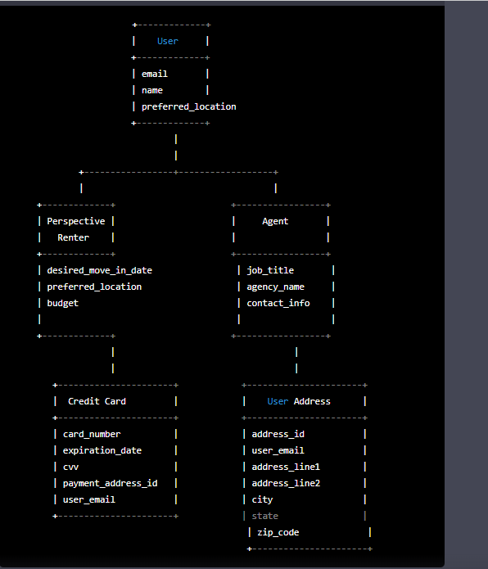

The diagram shows three main entities: **User**, **Perspective Renter**, and **Agent**. Each of them has a relationship with **User Address** entity. **Perspective Renter** has a one-to-many relationship with **Credit Card** entity.

**User** entity has a one-to-one relationship with both **Perspective Renter** and **Agent** entities. Both **Perspective Renter** and **Agent** entities have a many-to-one relationship with **User** entity.

**Agent** entity has three attributes: **job_title**, **agency_name**, and **contact_info**.

**Perspective Renter** entity has three attributes: **desired_move_in_date**, **preferred_location**, and **budget**.

**Credit Card** entity has four attributes: **card_number**, **expiration_date**, **cvv**, and **payment_address_id**.

**User Address** entity has five attributes: **address_id**, **user_email**, **address_line1**, **address_line2**, **city**, **state**, and **zip_code**.

All entities are connected with a solid line indicating the relationship. Attributes of each entity are listed below the entity name.

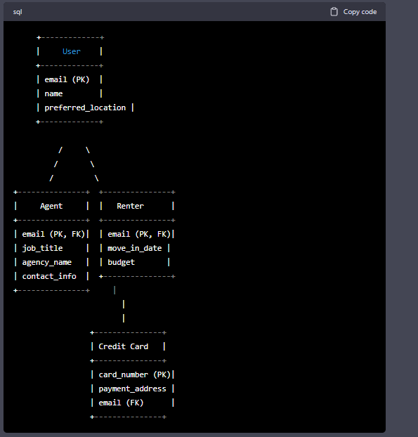

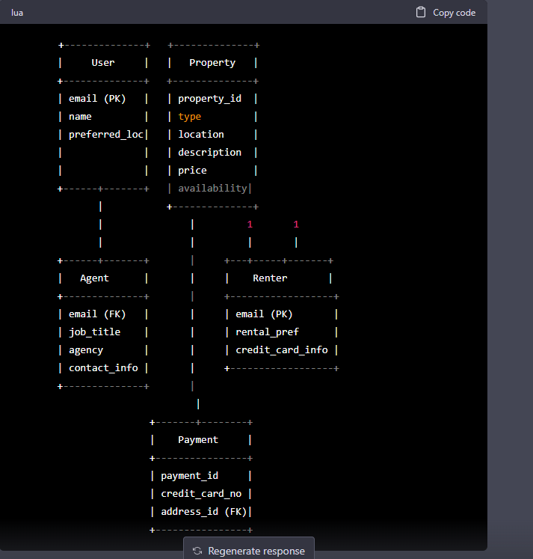

In this diagram, we have four main entities: User, Property, Agent, and Renter. User is the parent entity, which can be either an Agent or a Renter. Agent has a foreign key (email) that references the User entity's primary key (email). Renter has a one-to-many relationship with Payment entity, as a Renter can have multiple credit cards. Payment entity has a foreign key (address_id) that references the Address entity's primary key (address_id).

Property has a one-to-many relationship with Booking entity, as one property can have multiple bookings. Booking entity has a foreign key (renter_email) that references the Renter entity's primary key (email).

Payment entity has a one-to-many relationship with Address entity, as a payment card can have multiple addresses.

The ER Diagram also shows the attributes of each entity, along with their primary keys (PK) and foreign keys (FK).

User

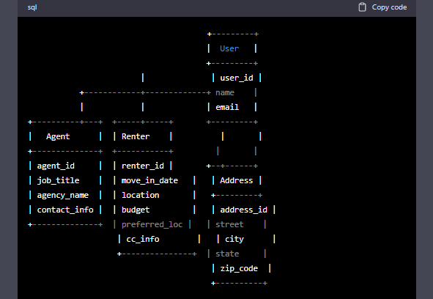

Property

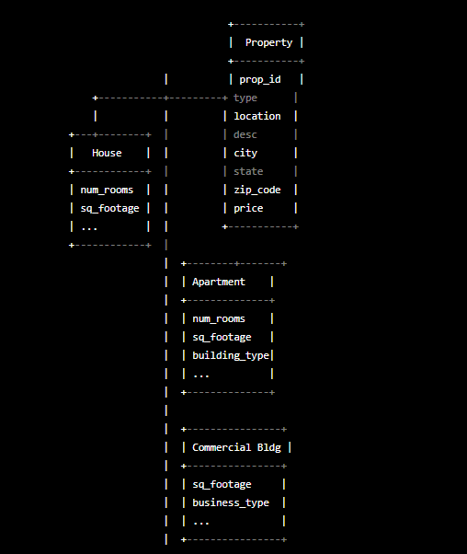

Booking

