Tuesday, 28 February 2023  **Course Content**

1) architecture

2)Angular Features we learn

Basics : Components,Data Binding, Routing, Modules,

Features : Forms and Validation, Rest API Calls , Dependency Injection

3)Steps to install required Softwares.

3.1) installed node

3.2)installed Angular cli by run angular cmd in windwos cmd (run as administration)

3.3)

4)run cli commands like ng help,ng build,ng lint,ng test, ng e2e, ng serve

5)Creating and Launching Angular Application with Angular CLI (attached trouble shoots also in ths document)

6)

1) Architecture

Angular Application

TypeScript

Database

Restful API

Spring Boot on Java

2)Angular Features we learn

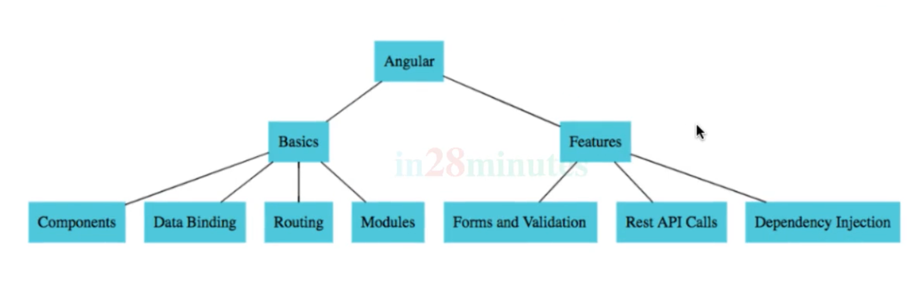

3)Steps to install required Softwares.

3.1) download and install Node, inbuilt npm (node package manager) also there in the Node itself

Check properly download and installed

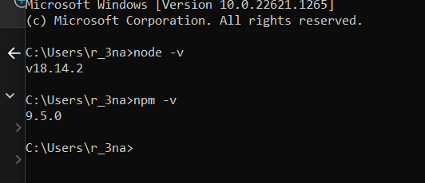

Commands to check properly download and installed is

node -v

npm -v

3.2) download Angular CLI (command line interface)

Which is used to develop the angular projects

====🡺 now run cmd as run as administrator

Npm is like consider as maven

Where maven downloads dependencies, plugins for our java project

So, Angular CLI almost like a maven plugin

We are using npm to download it for us

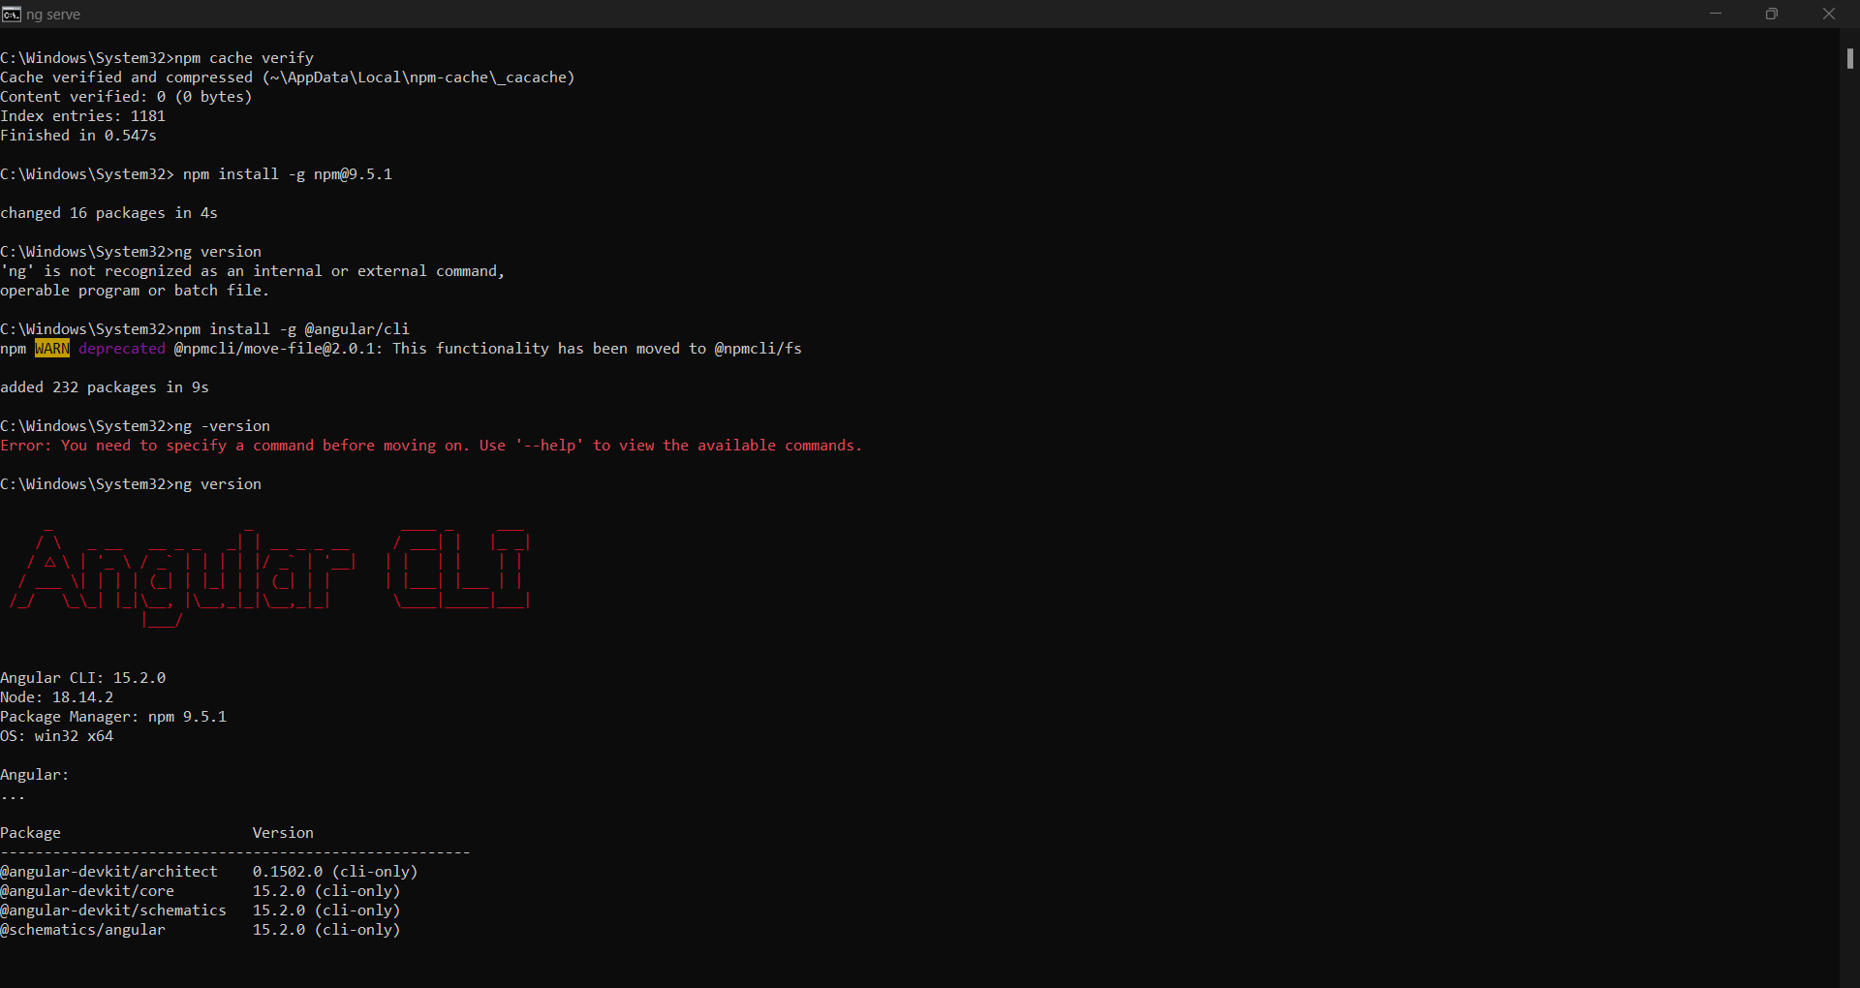

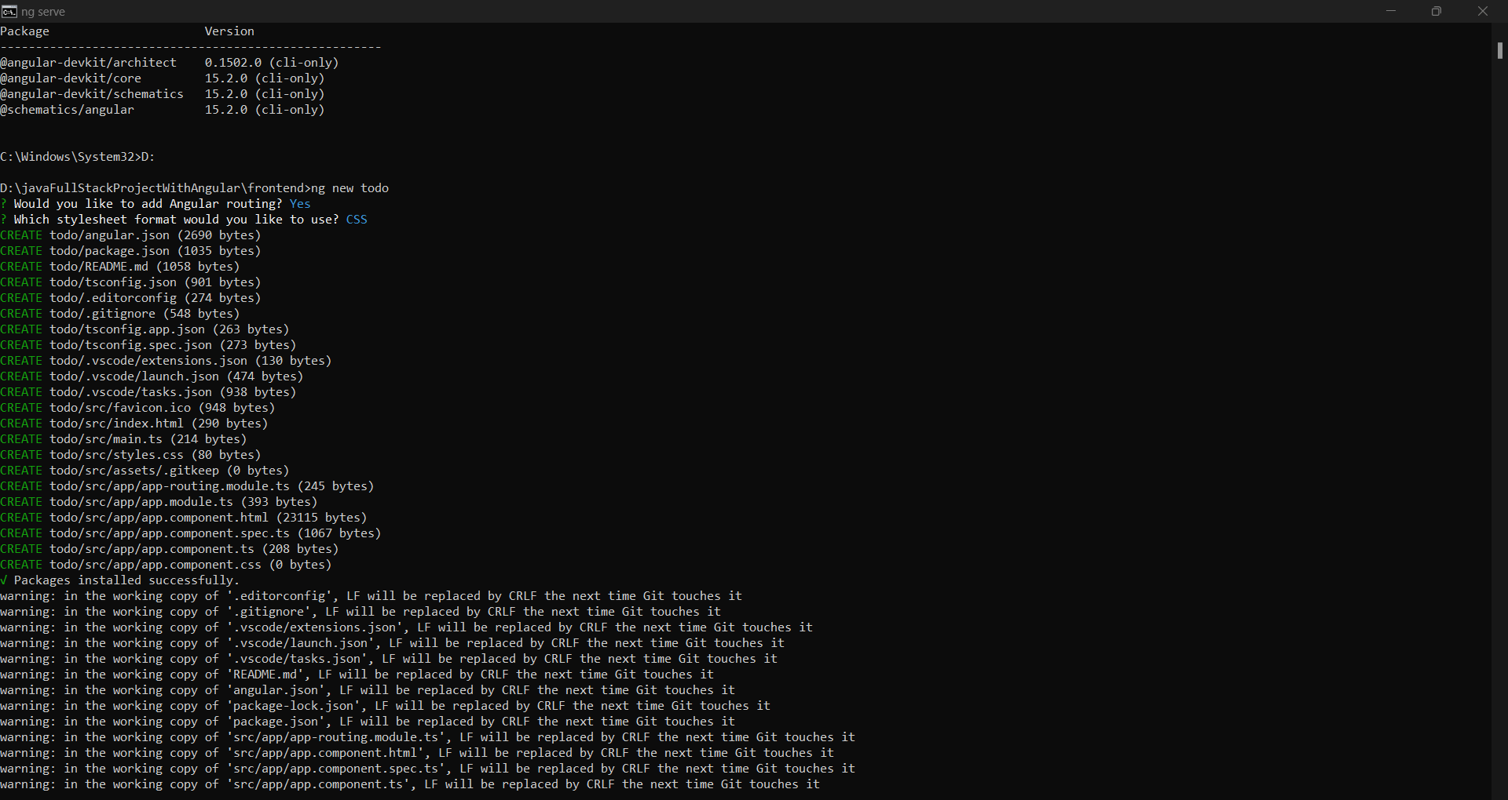

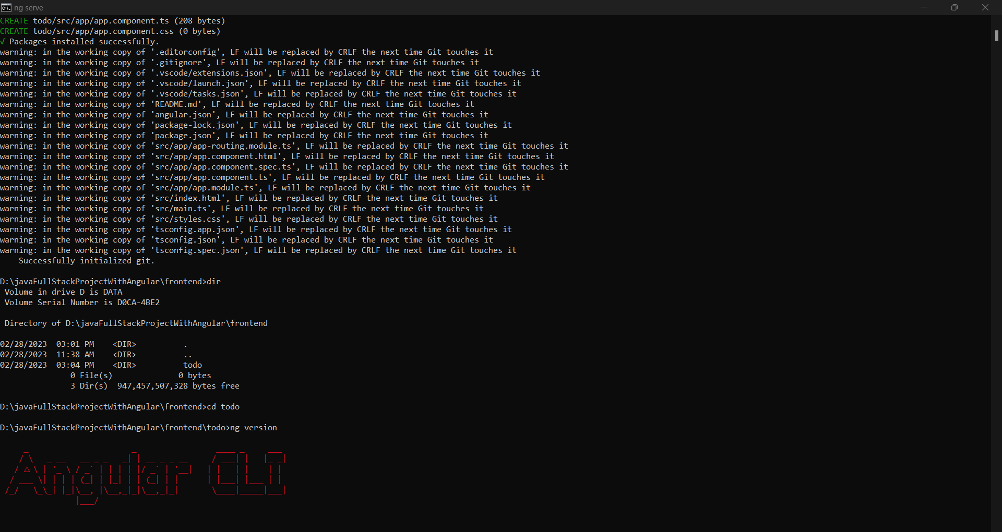

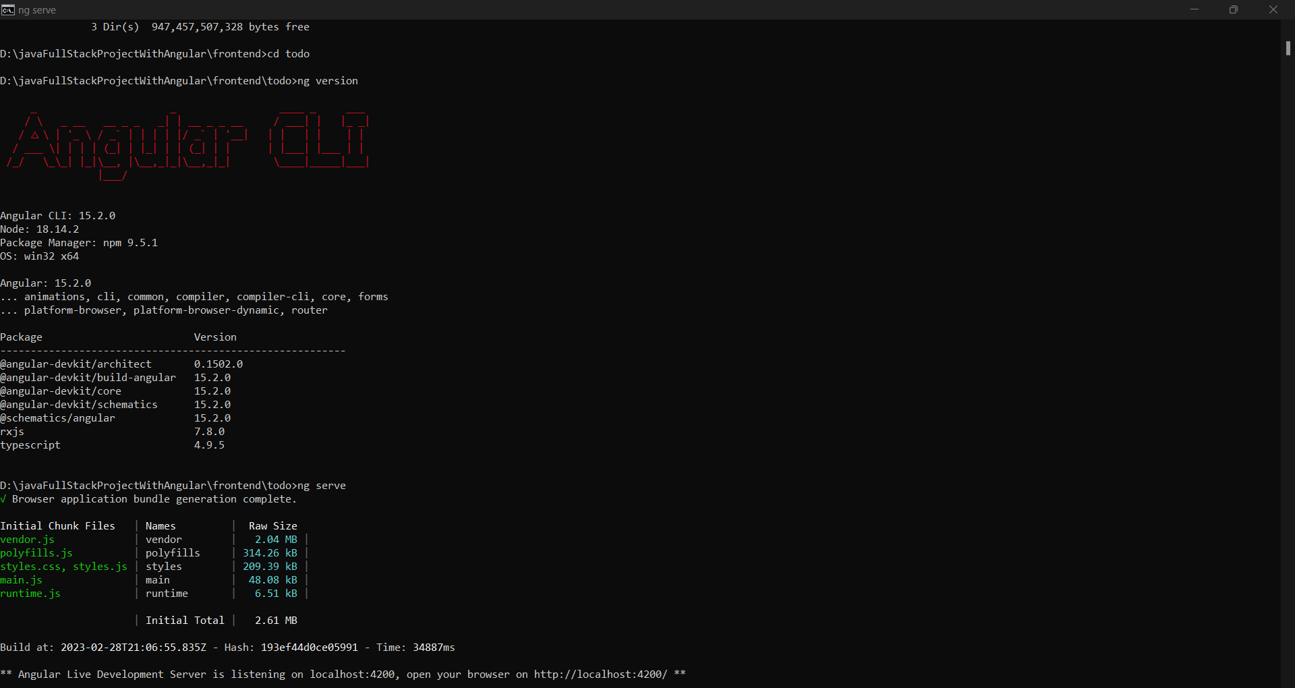

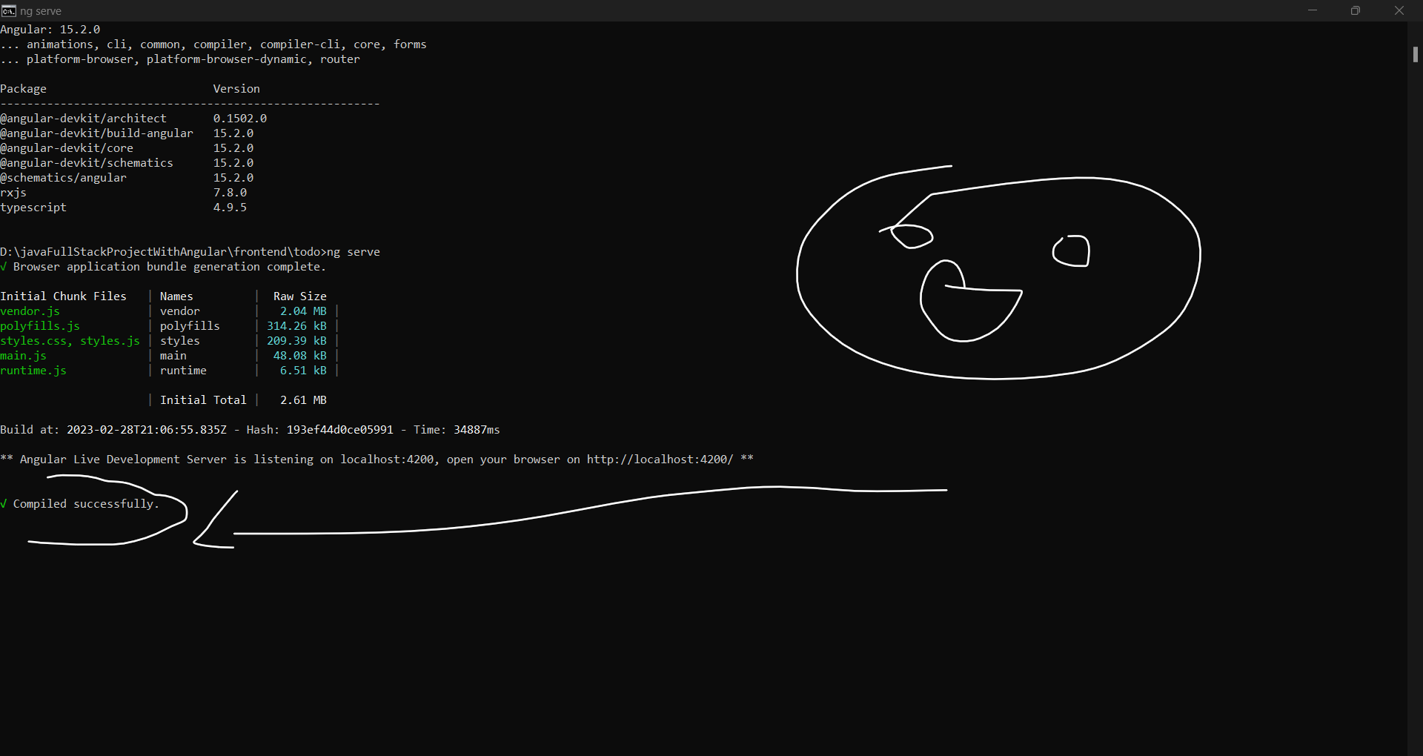

===*** check whether angular cli is configured correctly or not

Note : npm install -g npm @versionMentionedForParticularVersion

>ng version

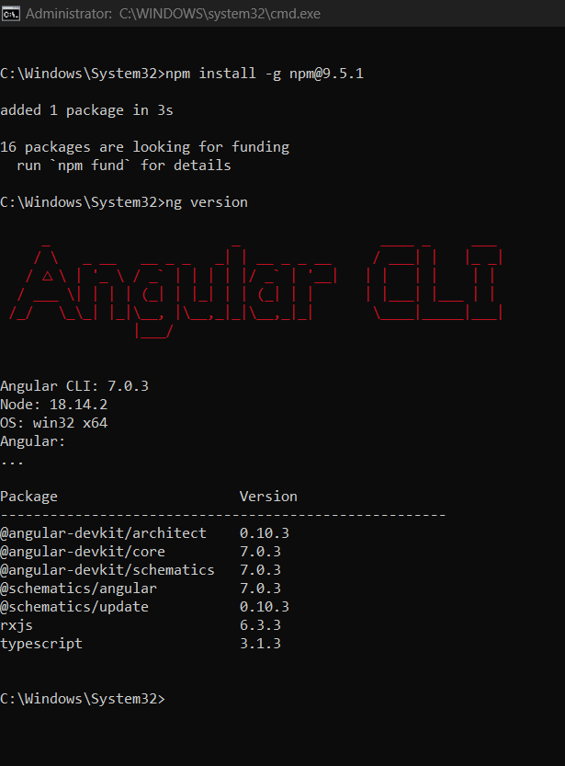



5)Creating and Launching Angular Application with Angular CLI

Command to create new project

Firstly go to the location where we need to create the project in the windows/system location

ng new “projectName”

after this command I have faced some trouble shoots so that I am using these commands to resolve the issues.

Issue/ Error I got

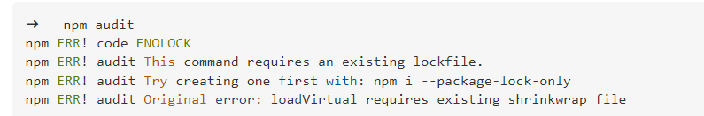

Then I used the following commands to resolve the issues

* 1)npm i --package-lock-only
* 2)npm cache clean --force
* 3)npm fund
* 4)npm audit fix --force

Finally I found 0 vulnerabilities.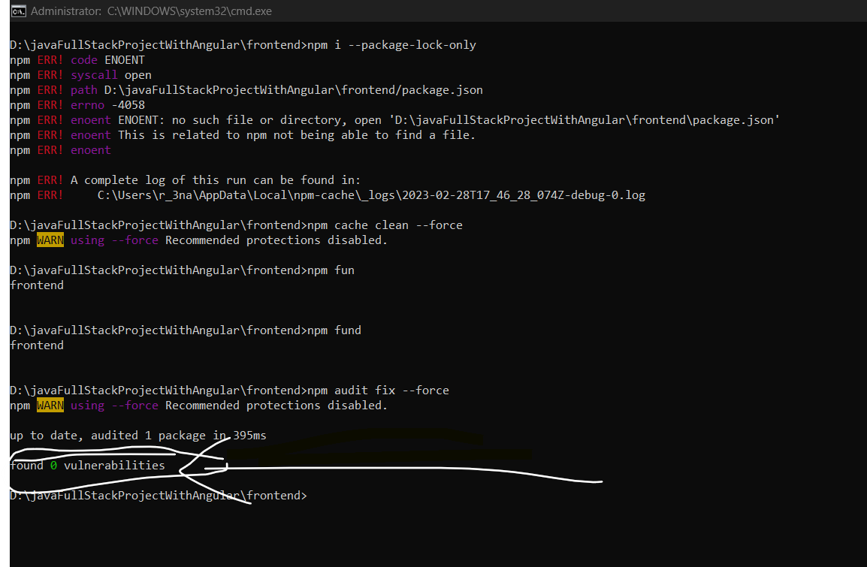

To run the project use ng serve command IFF in that particular direction only.

Note : In windows dir is worked as ls

After run ng serve it gives the following errors . please see the following image .

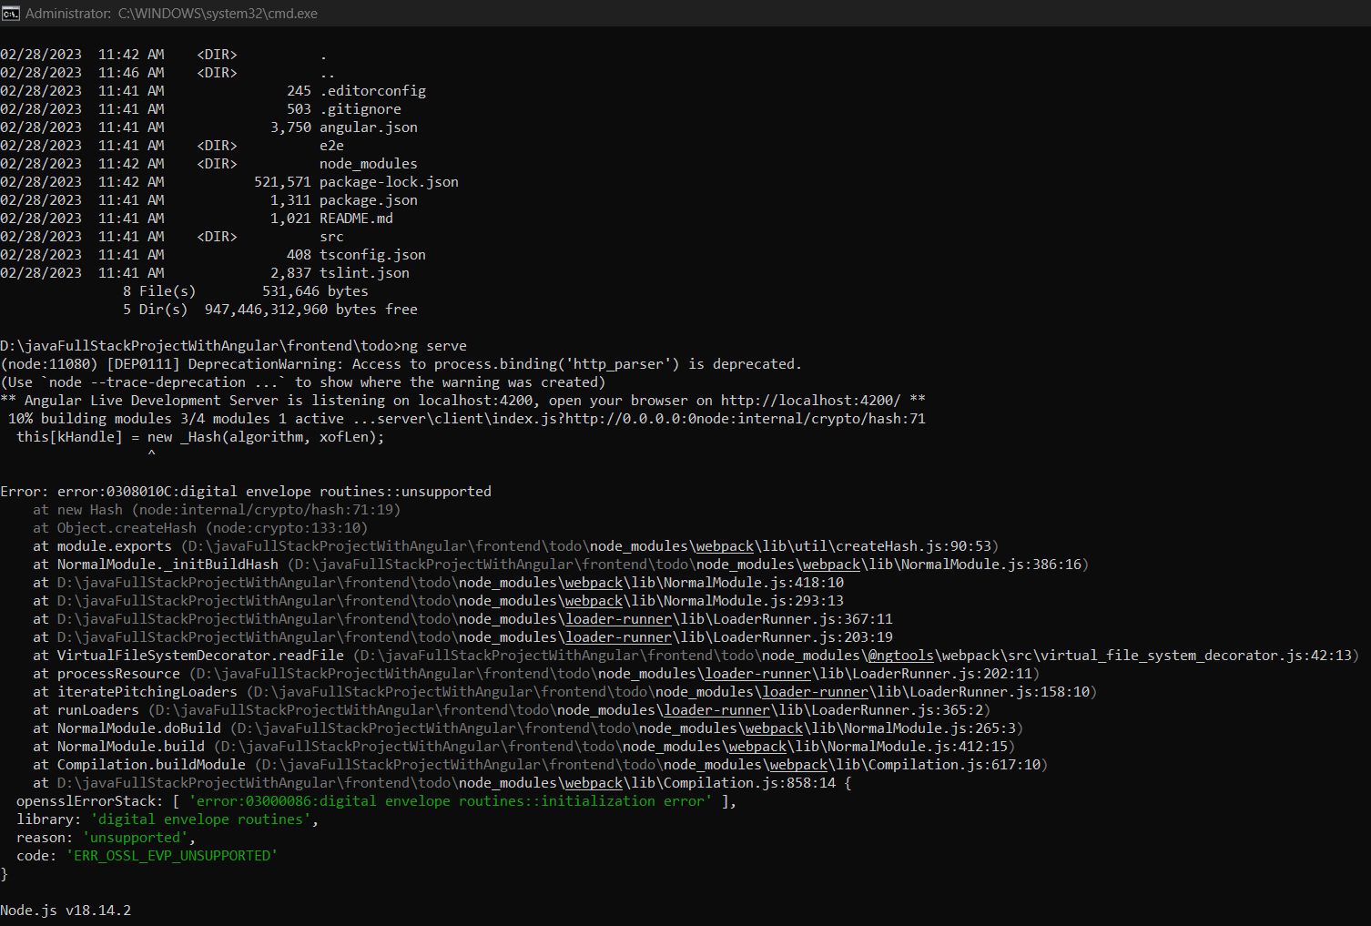

Getting : npm WARN using --force Recommended protections disabled

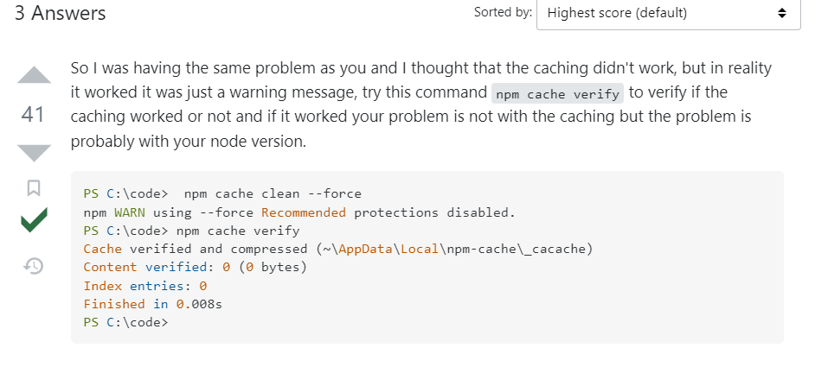

Npm cache clean –force or npm cache clean –f

How to downgrade Angular CLI version? and install new one

Step 1 : npm uninstall -g @angular/cli

Step 2: npm cache clean

Step 3 : very weather its clean or not using the following command

Npm cache verify

Step 4: npm install -g @angular/cli

After created a project go to the project and install node modules

For that type command

npm install

for me it’s throwing the following issues , please go through the following images

this command works properly as it’s syntax is :

npm install --legacy-peer-deps

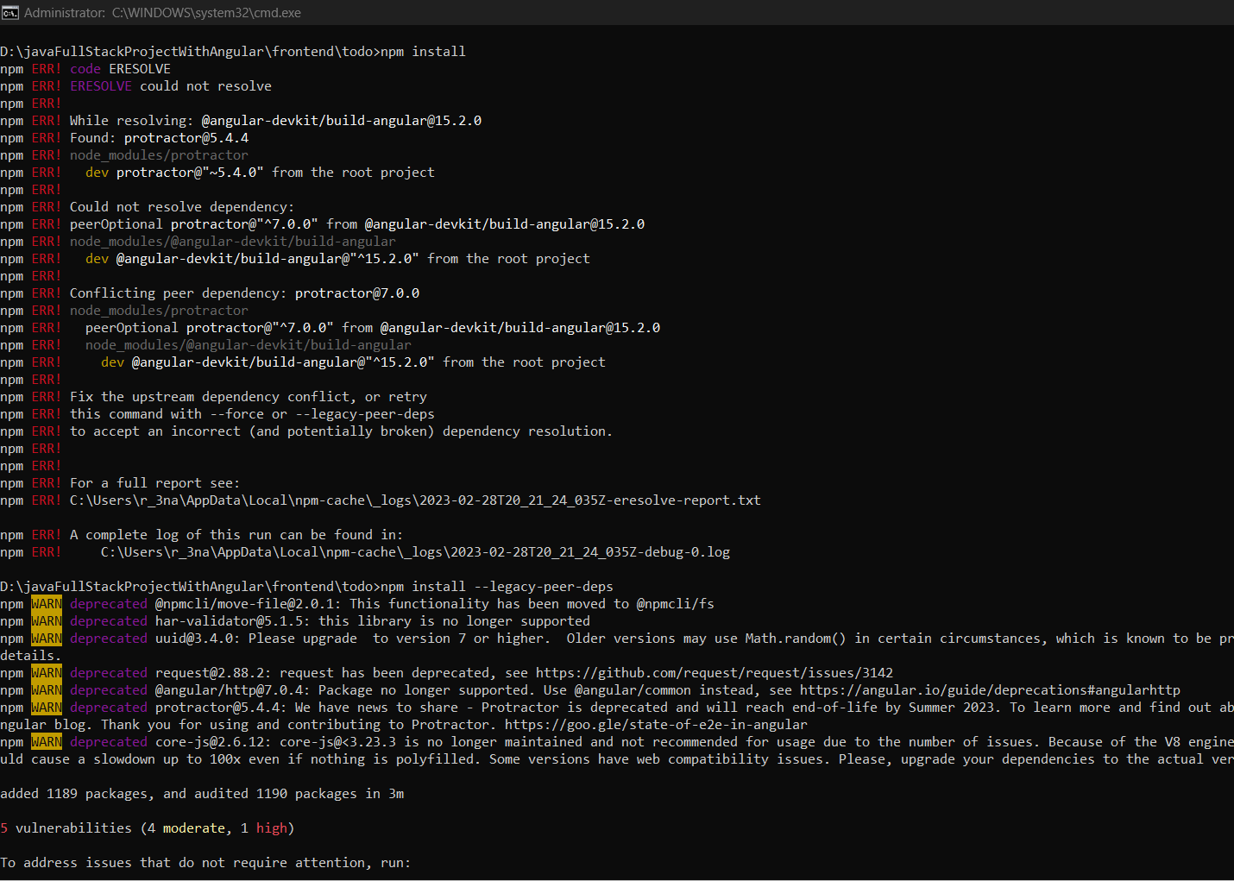

How to uninstall/upgrade Angular CLI?

