SPRING MVC FOR BEGINNERS – BUILD JAVA WEB APP IN 25 STEPS

STEP 1)CREATED SIMPLE SERVLET IN JAVA THAT ACCEPTS THE REQUEST FROM BROWSER AND SIMPLY DISPLAY THE MESSAGE. INCLUDED MAVEN

STEP 2)CONFIGURE SPRING MVC,MAVEN

2.1 CHECKING WHETHER THE LOGIN USER IS VALID OR NOT

IF THE USER IS VALID PRINT THE SOME MESSAGE

ELSE DISPLAY INVALID USER TO THE AND ROUTE THE JSP HOME PAGE

To run maven project

Tomcat7:run

netstat -ano|findstr “8080” to check what are the port numbers are in using by tomcatserver.

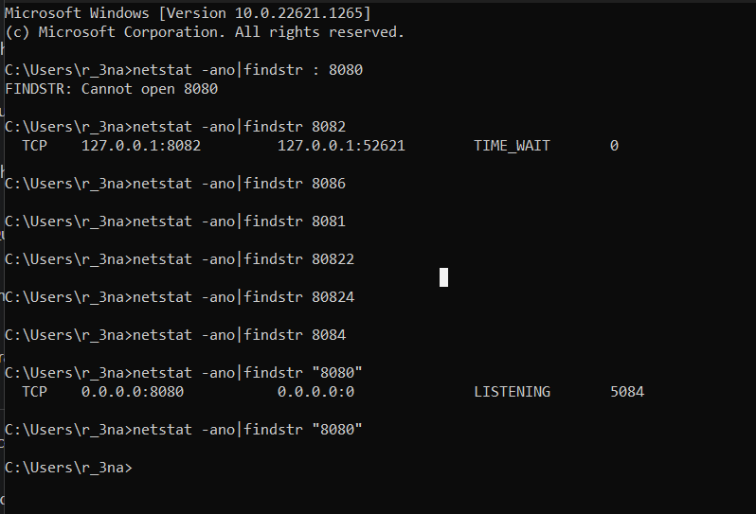

========================================🡺

STEP 1: **********************************************************************************

Created a simple servlet that is listening from the following address

If we call the address it simply prints the html message in the webbrowser

1. /first-web-application/src/main/java/webapp/LoginServlet.java
2. /first-web-application/src/main/webapp/WEB-INF/web.xml
3. /first-web-application/pom.xml

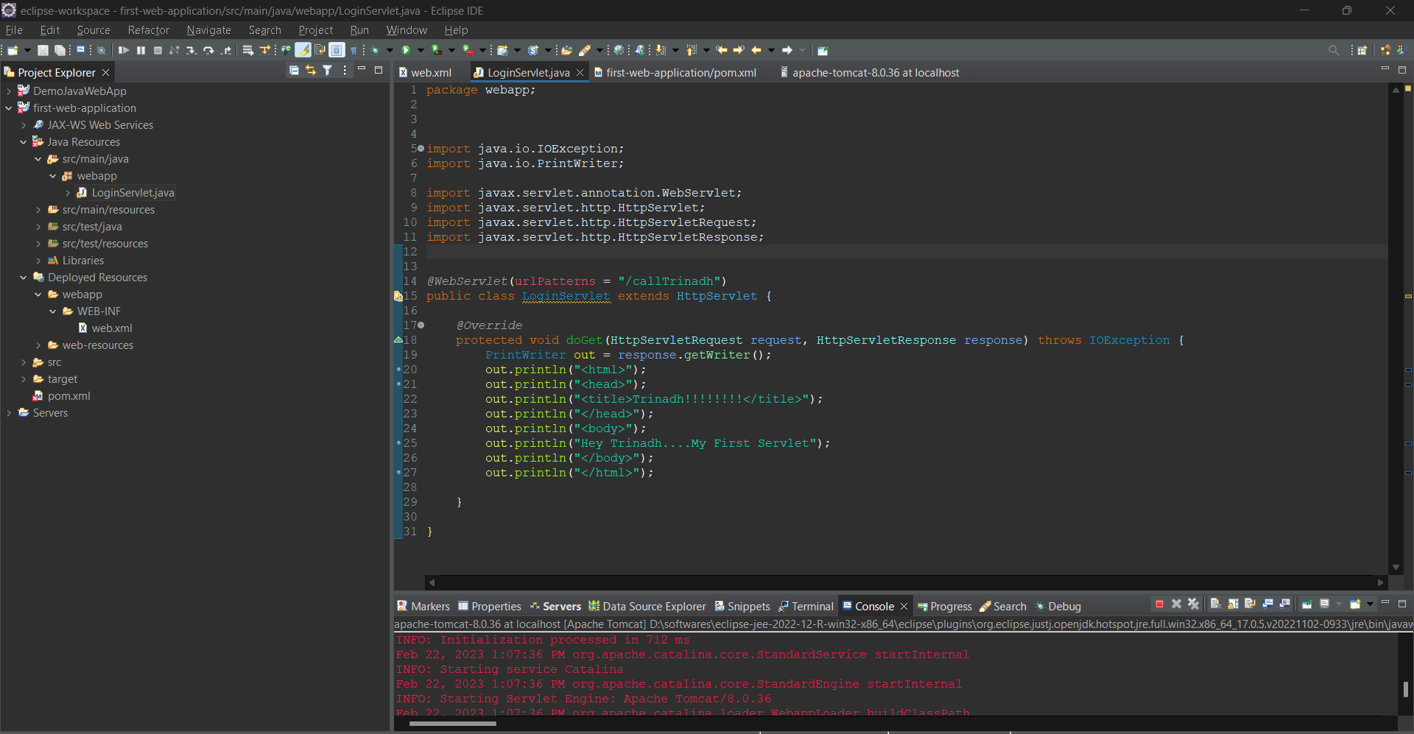

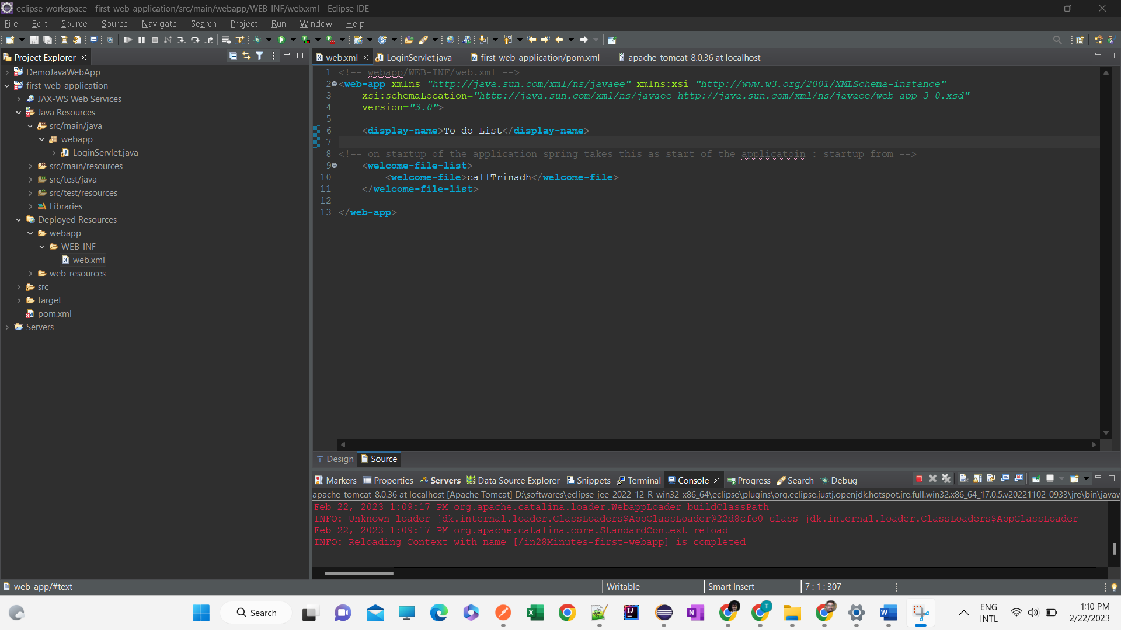

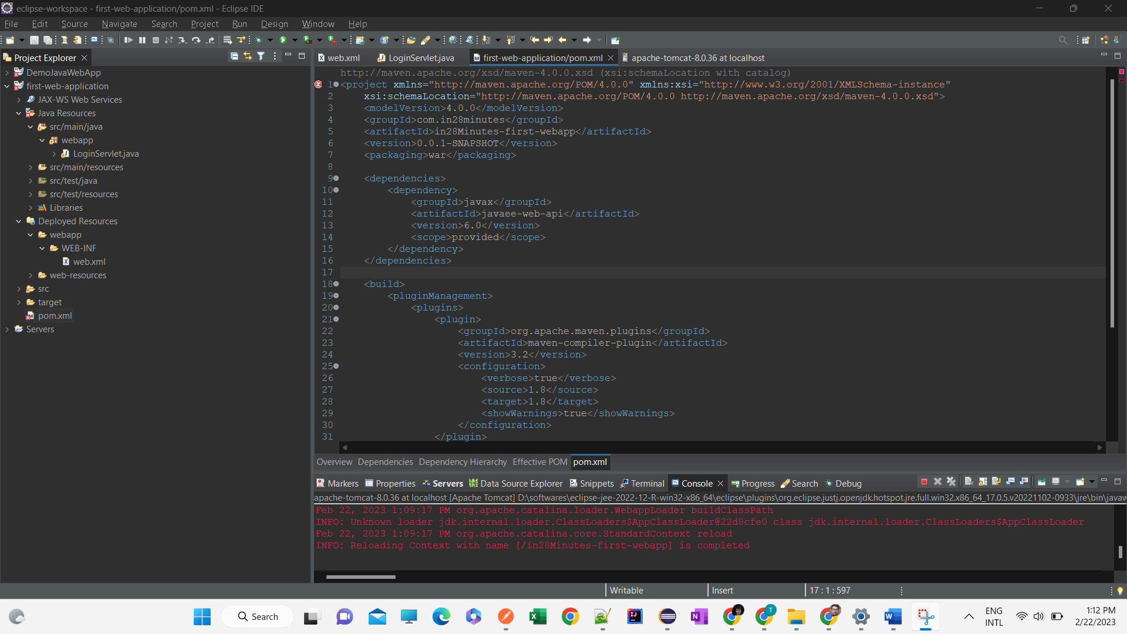

1. /first-web-application/pom.xml

<project xmlns="http://maven.apache.org/POM/4.0.0" xmlns:xsi="http://www.w3.org/2001/XMLSchema-instance"

xsi:schemaLocation="http://maven.apache.org/POM/4.0.0 http://maven.apache.org/xsd/maven-4.0.0.xsd">

<modelVersion>4.0.0</modelVersion>

<groupId>com.in28minutes</groupId>

<artifactId>in28Minutes-first-webapp</artifactId>

<version>0.0.1-SNAPSHOT</version>

<packaging>war</packaging>

<dependencies>

<dependency>

<groupId>javax</groupId>

<artifactId>javaee-web-api</artifactId>

<version>6.0</version>

<scope>provided</scope>

</dependency>

</dependencies>

<build>

<pluginManagement>

<plugins>

<plugin>

<groupId>org.apache.maven.plugins</groupId>

<artifactId>maven-compiler-plugin</artifactId>

<version>3.2</version>

<configuration>

<verbose>true</verbose>

<source>1.8</source>

<target>1.8</target>

<showWarnings>true</showWarnings>

</configuration>

</plugin>

<plugin>

<groupId>org.apache.tomcat.maven</groupId>

<artifactId>tomcat7-maven-plugin</artifactId>

<version>2.2</version>

<configuration>

<path>/</path>

<contextReloadable>true</contextReloadable>

</configuration>

</plugin>

</plugins>

</pluginManagement>

</build>

</project>

1. /first-web-application/src/main/java/webapp/LoginServlet.java

package webapp;

import java.io.IOException;

import java.io.PrintWriter;

import javax.servlet.annotation.WebServlet;

import javax.servlet.http.HttpServlet;

import javax.servlet.http.HttpServletRequest;

import javax.servlet.http.HttpServletResponse;

*@WebServlet*(urlPatterns = "/callTrinadh")

public class LoginServlet extends HttpServlet {

*@Override*

protected void doGet(HttpServletRequest request, HttpServletResponse response) throws IOException {

PrintWriter out = response.getWriter();

out.println("<html>");

out.println("<head>");

out.println("<title>Trinadh!!!!!!!!</title>");

out.println("</head>");

out.println("<body>");

out.println("Hey Trinadh....My First Servlet");

out.println("</body>");

out.println("</html>");

}

}

/first-web-application/src/main/webapp/WEB-INF/web.xml

<!-- webapp/WEB-INF/web.xml -->

<**web-app** xmlns=*"http://java.sun.com/xml/ns/javaee"* xmlns:xsi=*"http://www.w3.org/2001/XMLSchema-instance"*

xsi:schemaLocation=*"http://java.sun.com/xml/ns/javaee http://java.sun.com/xml/ns/javaee/web-app_3_0.xsd"*

version=*"3.0"*>

<**display-name**>To do List</**display-name**>

<!-- on startup of the application spring takes this as start of the applicatoin : startup from -->

<**welcome-file-list**>

<**welcome-file**>callTrinadh</**welcome-file**>

</**welcome-file-list**>

</**web-app**>

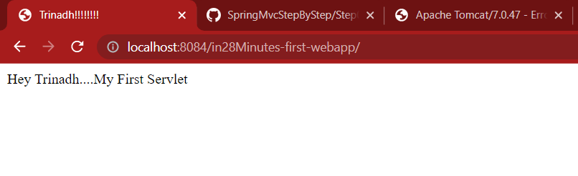

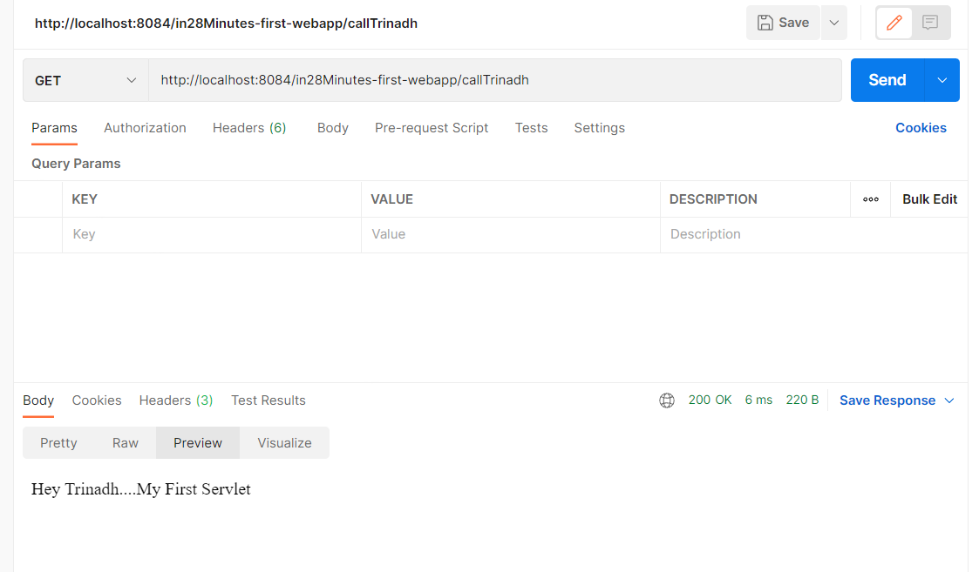

STEP 2

1. Home page having the following fields;

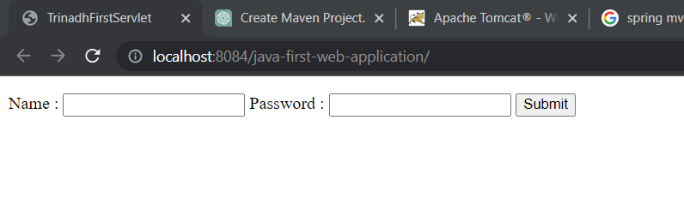

2)if invalid user

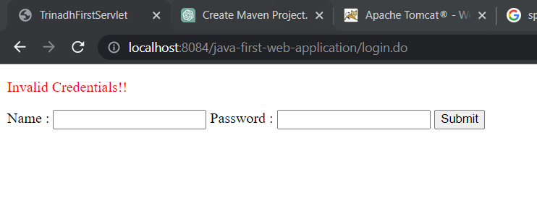

3)if user is valid

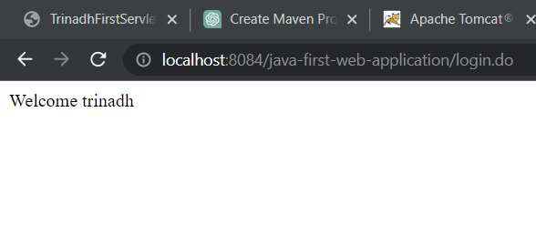

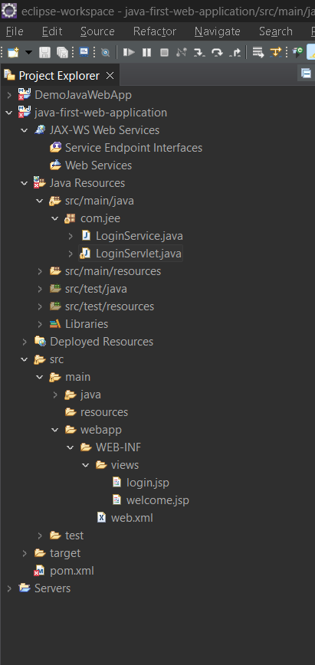

This clone/copy of this project saved in the following git location

<https://github.com/rayalatrinadh/JavaWebProject/blob/main/step2>