CS586
SSA
RAYYAN MAINDARGI
A20594926

2.MDA_EFSM : Vending Machine
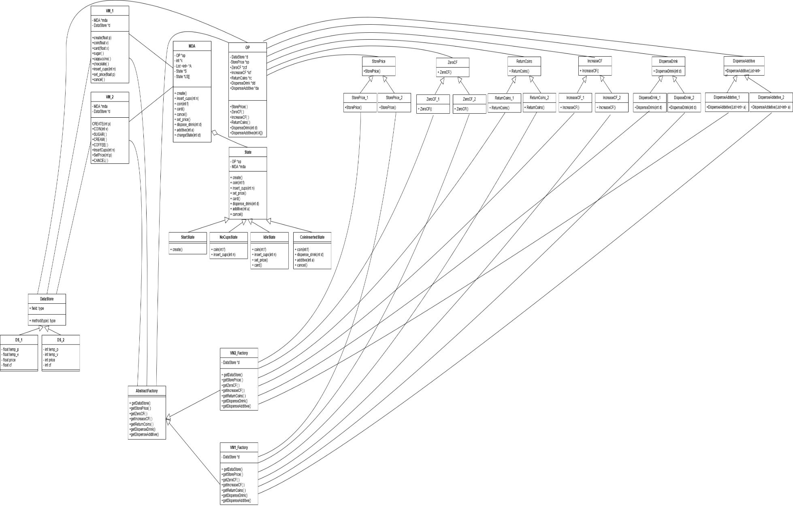
Note: If not readable view below images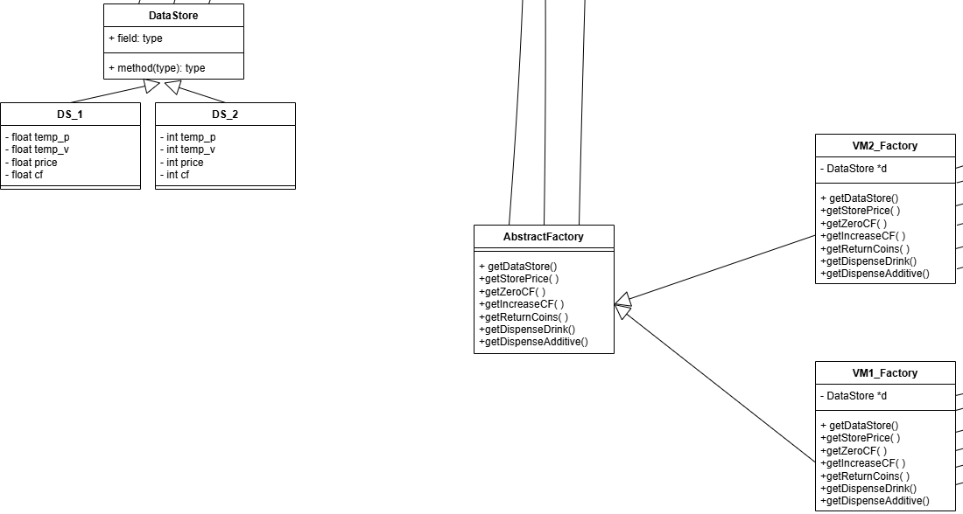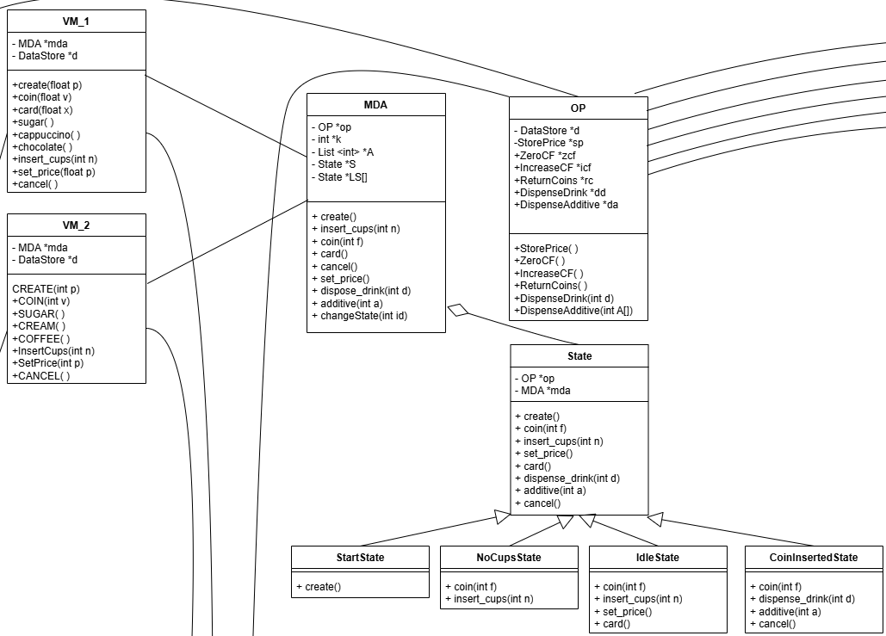

If still not readable refer the link : LINK
3. For each class in the class diagram(s), you should:
a. Describe the purpose of the class, i.e., responsibilities.
b. Describe the responsibility of each operation supported by each class.

- Class: MainVendingMachine.java
The MainVendingMachine.java file serves as the entry point for a vending machine simulation application that uses the Abstract Factory pattern to create and manage two different types of vending machines (VM-1 for cappuccino/chocolate and VM-2 for coffee) with their respective user interfaces and operations.
2) Class VM1
Purpose
This class represents VM-1 (Cappuccino/Chocolate Machine) and supports all operations provided by VM-1. It serves as part of the input processor in the vending machine system, implementing the client interface for VM-1 using the Abstract Factory pattern.
Attributes
- MDA m: Reference to the MDAEFSM (Meta-Design for Abstract Extended Finite State Machine) object that handles state transitions
- DataStore dataStore: Reference to the DataStore object that maintains all data values for the vending machine
Operations
Method | Description
create(float p) | Initializes VM-1 with price p for drinks by storing it in a temporary variable and triggering the create action in the state machine
coin(float v) | Processes coin insertion with value v, updates the balance, and determines if the amount is sufficient for a purchase
card(float x) | Handles card payment where x is the available limit on the card, checks if sufficient for purchase
sugar() | Disposes sugar additive into the drink (calls additive method with parameter 1)
cappuccino() | Dispenses a cup of cappuccino
Chocolate() | Dispenses a cup of chocolate
insert_cups(int n) | Adds n cups to the vending machine inventory
set_price(float p) | Updates the price of drinks to p
cancel() | Cancels the current transaction and returns any inserted coins
printOperations() | Displays current status of VM-1 including state, available cups, balance, and price

  - Class VM2
Purpose
This class represents VM-2 (Coffee Machine) and supports all operations provided by VM-2. It serves as part of the input processor in the vending machine system, implementing the client interface for VM-2 using the Abstract Factory pattern.
Attributes
- MDA m: Reference to the MDAEFSM (Meta-Design for Abstract Extended Finite State Machine) object that handles state transitions
- DataStore dataStore: Reference to the DataStore object that maintains all data values for the vending machine
Operations
Method | Description
CREATE(int p) | Initializes VM-2 with price p for drinks by storing it in a temporary variable and triggering the create action in the state machine
COIN(int v) | Processes coin insertion with value v, updates the balance, and determines if the amount is sufficient for a purchase
SUGAR() | Disposes sugar additive into the drink (calls additive method with parameter 1)
CREAM() | Adds cream to the drink (calls additive method with parameter 2)
COFFEE() | Dispenses a cup of coffee
insertCups(int n) | Adds n cups to the vending machine inventory
setPrice(int p) | Updates the price of drinks to p
CANCEL() | Cancels the current transaction and returns any inserted coins
printOperations() | Displays current status of VM-2 including state, available cups, balance, and price

  - Class: MDA
Purpose
The MDA class implements the finite state machine that controls the core logic of the vending machine system. It manages the current state of the machine, handles state transitions, and delegates operations to the appropriate state implementation.
Attributes
Attribute | Description
State s | Reference to the current state of the vending machine
State[] stateLIst | Array containing all possible states of the vending machine
OutputProcessor outputProcessor | Reference to the output processor that executes actions
int k | Number of cups available in the vending machine
List<Integer> ad | List to track selected additives (sugar, cream, etc.)
Operations
Method | Description
MDA() | Constructor that initializes all states and sets the initial state to StateStart
getOutputProcessor() | Returns the current output processor
setOutputProcessor(OutputProcessor) | Sets the output processor for executing actions
getK() | Returns the current number of cups available
setK(int k) | Updates the number of cups in the machine
create() | Initializes the vending machine with specified parameters
coin(int f) | Processes coin insertion (f=1 for sufficient funds, f=0 for insufficient)
insert_cups(int n) | Adds n cups to the vending machine
set_price() | Updates the price for drinks
card() | Processes card payment
dispose_drink(int d) | Dispenses the selected drink type (1=cappuccino, 2=chocolate, 3=coffee)
additive(int a) | Adds selected additive to the drink (1=sugar, 2=cream)
cancel() | Cancels the current transaction
changeState(int id) | Transitions the machine to a new state based on state ID
getA() | Returns the list of selected additives
setA(List<Integer> a) | Updates the list of selected additives

  - Class: State
Purpose
The State abstract class forms the foundation of the State design pattern in the vending machine system. It defines the interface for all concrete state implementations and provides default error behavior for operations that are not supported in specific states.
Attributes
Attribute | Description
MDA m | Reference to the MDA (state machine) object that this state belongs to
Operations
Method | Description
State(MDA m) | Constructor that initializes the state with a reference to its controlling MDA
create() | Handles machine initialization in states that support it
coin(int f) | Processes coin insertion in states that support it
insert_cups(int n) | Adds cups to the machine in states that support it
set_price() | Updates the price for drinks in states that support it
card() | Processes card payment in states that support it
dispose_drink(int d) | Dispenses the selected drink in states that support it
additive(int a) | Adds additives to the drink in states that support it
cancel() | Cancels the current transaction in states that support it

  - Class: StateStart
Purpose
The StateStart class represents the initial state of the vending machine when it is first powered on or reset. It handles the machine initialization process when the create() operation is invoked.
Inheritance
Extends the abstract State class, inheriting the default error behavior for operations that are not valid in this state.
Attributes
Inherits the MDA m reference from the parent State class.
Operations
Method | Description
StateStart(MDA m) | Constructor that initializes this state with a reference to its controlling MDA
create() | Overrides the default implementation to handle machine initialization

  - StateNoCups

Purpose
The StateNoCups class represents the state of the vending machine when it has been initialized but has no cups available to dispense drinks. It handles coin insertions and cup loading operations.
Inheritance
Extends the abstract State class, inheriting the default error behavior for operations that are not valid in this state.
Attributes
Inherits the MDA m reference from the parent State class.
Operations
Method | Description
StateNoCups(MDA m) | Constructor that initializes this state with a reference to its controlling MDA
coin(int f) | Handles coin insertion when the machine has no cups by returning the coins
insert_cups(int n) | Loads n cups into the machine if n > 0 and transitions to the Idle state

  - StateIdle
Purpose
The StateIdle class represents the ready state of the vending machine when it has cups available but is waiting for user interaction. This state handles coin insertion, card payment, cup addition, and price setting operations.
Inheritance
Extends the abstract State class, inheriting the default error behavior for operations that are not valid in this state.
Attributes
Inherits the MDA m reference from the parent State class.
Operations
Method | Description
StateIdle(MDA m) | Constructor that initializes this state with a reference to its controlling MDA
coin(int f) | Processes coin insertion based on sufficiency flag and transitions to CoinInserted state when sufficient
insert_cups(int n) | Adds n additional cups to the machine's existing inventory
set_price() | Updates the price for drinks in the machine
card() | Handles card payment and transitions to CoinInserted state

  - Class : StateCoinInserted.java
Purpose
The StateCoinInserted class represents the state of the vending machine after payment has been received (via coins or card). This state handles drink dispensing, additive selection, and transaction cancellation operations.
Inheritance
Extends the abstract State class, inheriting the default error behavior for operations that are not valid in this state.
Attributes
Inherits the MDA m reference from the parent State class.
Operations
Method | Description
StateCoinInserted(MDA m) | Constructor that initializes this state with a reference to its controlling MDA
coin(int f) | Returns additional coins as they are not accepted in this state
dispose_drink(int d) | Dispenses the selected drink with chosen additives if cups are available
additive(int id) | Toggles selection of specified additive (sugar, cream) for the current drink
cancel() | Cancels the current transaction, returns inserted coins, and returns to Idle state
  - Class : OutputProcessor
Purpose
The OutputProcessor class serves as a facade for the execution of actions in the vending machine system. It encapsulates the strategy implementations for various operations and provides a simplified interface for the state machine to execute concrete actions.
Attributes
Attribute | Description
DataStore dataStore | Reference to the data store that maintains the system's data values
StorePrice storePrice | Strategy for storing/updating drink prices
ZeroCF zeroCF | Strategy for resetting the current funds to zero
IncreaseCF increaseCF | Strategy for increasing the current funds when coins are inserted
ReturnCoins returnCoins | Strategy for returning inserted coins to the user
DispenseDrink dispenseDrink | Strategy for dispensing the selected drink
DispenseAdditive dispenseAdditive | Strategy for dispensing selected additives
Operations
Method | Description
OutputProcessor(AbstractFactory af) | Constructor that initializes all strategy implementations using the provided factory
getDataStore() | Returns the reference to the data store
storePrice() | Executes the price storage strategy
zeroCF() | Executes the strategy to reset current funds to zero
increaseCF() | Executes the strategy to increase current funds
returnCoins() | Executes the strategy to return inserted coins
dispenseDrink(int id) | Executes the strategy to dispense the selected drink type
dispenseAdditive(List<Integer> a) | Executes the strategy to dispense selected additives

  - Abstract Class: StorePrice
Purpose
The StorePrice class defines the interface for storing or updating the price of drinks in the vending machine. It is part of the Strategy design pattern implementation that allows different vending machine types to handle price storage differently.
Inheritance
This is an abstract class that must be extended by concrete implementations for specific vending machine types.
Attributes
Attribute | Description
DataStore dataStore | Reference to the data store that maintains the system's data values, including prices
Operations
Method | Description
StorePrice(DataStore dataStore) | Constructor that initializes the strategy with a reference to the data store
storePrice() | Abstract method that must be implemented by concrete subclasses to perform the actual price storage operation

  - Class: StorePrice1
Purpose
The StorePrice1 class is a concrete implementation of the StorePrice strategy for the VM-1 vending machine (Cappuccino/Chocolate Machine). It provides the specific logic to store floating-point price values for VM-1.
Inheritance
Extends the abstract StorePrice class, implementing the required storePrice() method.
Attributes
Inherits the DataStore dataStore reference from the parent StorePrice class.
Operations
Method | Description
StorePrice1(DataStore dataStore) | Constructor that initializes the strategy with a reference to the data store
storePrice() | Implements the price storage operation specifically for VM-1 with float values

  - Class: StorePrice2
Purpose
The StorePrice2 class is a concrete implementation of the StorePrice strategy for the VM-2 vending machine (Coffee Machine). It provides the specific logic to store integer price values for VM-2.
Inheritance
Extends the abstract StorePrice class, implementing the required storePrice() method.
Attributes
Attribute | Description
DataStore2 dataStore2 | Type-cast reference to the DataStore2 implementation to access VM-2 specific methods
Operations
Method | Description
StorePrice2(DataStore dataStore) | Constructor that initializes the strategy with references to the data store
storePrice() | Implements the price storage operation specifically for VM-2 with integer values
.
  - Abstract Class : ReturnCoins
Purpose
The ReturnCoins abstract class defines the interface for returning inserted coins to the user when a transaction is cancelled or cannot be completed. It is part of the Strategy design pattern implementation that allows different vending machine types to handle coin return operations differently.
Inheritance
This is an abstract class that must be extended by concrete implementations for specific vending machine types.
Attributes
Attribute | Description
DataStore dataStore | Reference to the data store that maintains the system's data values, including current funds
Operations
Method | Description
ReturnCoins(DataStore dataStore) | Constructor that initializes the strategy with a reference to the data store
returnCoins() | Abstract method that must be implemented by concrete subclasses to perform the actual coin return operation

  - Class: ReturnCoins1
Purpose
The ReturnCoins1 class is a concrete implementation of the ReturnCoins strategy for the VM-1 vending machine (Cappuccino/Chocolate Machine). It provides the specific logic to return float-valued coins to users of VM-1 when transactions are cancelled or cannot be completed.
Inheritance
Extends the abstract ReturnCoins class, implementing the required returnCoins() method.
Attributes
Inherits the DataStore dataStore reference from the parent ReturnCoins class.
Operations
Method | Description
ReturnCoins1(DataStore dataStore) | Constructor that initializes the strategy with a reference to the data store
returnCoins() | Implements the coin return operation specifically for VM-1 with float values

  - Class : ReturnCoins2
Purpose
The ReturnCoins2 class is a concrete implementation of the ReturnCoins strategy for the VM-2 vending machine (Coffee Machine). It provides the specific logic to return integer-valued coins to users of VM-2 when transactions are cancelled or cannot be completed.
Inheritance
Extends the abstract ReturnCoins class, implementing the required returnCoins() method.
Attributes
Inherits the DataStore dataStore reference from the parent ReturnCoins class.
Operations
Method | Description
ReturnCoins2(DataStore dataStore) | Constructor that initializes the strategy with a reference to the data store
returnCoins() | Implements the coin return operation specifically for VM-2 with integer values

  - Abstract Class: ZeroCF
Purpose
The ZeroCF abstract class defines the interface for resetting the current funds (CF) in the vending machine to zero. It is part of the Strategy design pattern implementation that allows different vending machine types to handle fund reset operations differently.
Inheritance
This is an abstract class that must be extended by concrete implementations for specific vending machine types.
Attributes
Attribute | Description
DataStore dataStore | Reference to the data store that maintains the system's data values, including current funds
Operations
Method | Description
ZeroCF(DataStore dataStore) | Constructor that initializes the strategy with a reference to the data store
zeroCF() | Abstract method that must be implemented by concrete subclasses to perform the actual fund reset operation

  - Class: ZeroCF1
Purpose
The ZeroCF1 class is a concrete implementation of the ZeroCF strategy for the VM-1 vending machine (Cappuccino/Chocolate Machine). It provides the specific logic to reset the current funds (cash flow) to zero for VM-1.
Inheritance
Extends the abstract ZeroCF class, implementing the required zeroCF() method.
Attributes
Inherits the DataStore dataStore reference from the parent ZeroCF class.
Operations
Method | Description
ZeroCF1(DataStore dataStore) | Constructor that initializes the strategy with a reference to the data store
zeroCF() | Implements the fund reset operation specifically for VM-1

  - Class: ZeroCF2
Purpose
The ZeroCF2 class is a concrete implementation of the ZeroCF strategy for the VM-2 vending machine (Coffee Machine). It provides the specific logic to reset the current funds (cash flow) to zero for VM-2.
Inheritance
Extends the abstract ZeroCF class, implementing the required zeroCF() method.
Attributes
Inherits the DataStore dataStore reference from the parent ZeroCF class.
Operations
Method | Description
ZeroCF2(DataStore dataStore) | Constructor that initializes the strategy with a reference to the data store
zeroCF() | Implements the fund reset operation specifically for VM-2

  - Abstract Class : IncreaseCF
Purpose
The IncreaseCF abstract class defines the interface for increasing the current funds (CF) in the vending machine when coins are inserted. It is part of the Strategy design pattern implementation that allows different vending machine types to handle fund increment operations differently.
Inheritance
This is an abstract class that must be extended by concrete implementations for specific vending machine types.
Attributes
Attribute | Description
DataStore dataStore | Reference to the data store that maintains the system's data values, including current funds
Operations
Method | Description
IncreaseCF(DataStore dataStore) | Constructor that initializes the strategy with a reference to the data store
increaseCF() | Abstract method that must be implemented by concrete subclasses to perform the actual fund increment operation

  - Class : IncreaseCF1

Purpose
The IncreaseCF1 class is a concrete implementation of the IncreaseCF strategy for the VM-1 vending machine (Cappuccino/Chocolate Machine). It provides the specific logic to increase the current funds (cash flow) when coins are inserted into VM-1.
Inheritance
Extends the abstract IncreaseCF class, implementing the required increaseCF() method.
Attributes
Inherits the DataStore dataStore reference from the parent IncreaseCF class.
Operations
Method | Description
IncreaseCF1(DataStore dataStore) | Constructor that initializes the strategy with a reference to the data store
increaseCF() | Implements the fund increment operation specifically for VM-1 with float values

  - Class: IncreaseCF2
Purpose
The IncreaseCF2 class is a concrete implementation of the IncreaseCF strategy for the VM-2 vending machine (Coffee Machine). It provides the specific logic to increase the current funds (cash flow) when coins are inserted into VM-2.
Inheritance
Extends the abstract IncreaseCF class, implementing the required increaseCF() method.
Attributes
Attribute | Description
DataStore2 dataStore2 | Type-cast reference to the DataStore2 implementation to access VM-2 specific methods
Operations
Method | Description
IncreaseCF2(DataStore dataStore) | Constructor that initializes the strategy with references to the data store
increaseCF() | Implements the fund increment operation specifically for VM-2 with integer values

  - Abstract Class : DispenseDrink
Purpose
The DispenseDrink abstract class defines the interface for dispensing drinks in the vending machine. It is part of the Strategy design pattern implementation that allows different vending machine types to handle drink dispensing operations differently based on the type of drink.
Inheritance
This is an abstract class that must be extended by concrete implementations for specific vending machine types.
Attributes
This class does not define any attributes, maintaining a clean interface focused solely on the drink dispensing operation.
Operations
Method | Description
DispenseDrink() | Default constructor for the strategy
dispenseDrink(int id) | Abstract method that must be implemented by concrete subclasses to perform the actual drink dispensing operation, where id specifies the type of drink

  - Class: DispenseDrink1
Purpose
The DispenseDrink1 class is a concrete implementation of the DispenseDrink strategy for the VM-1 vending machine (Cappuccino/Chocolate Machine). It provides the specific logic to dispense different types of drinks available in VM-1.
Inheritance
Extends the abstract DispenseDrink class, implementing the required dispenseDrink(int id) method.
Attributes
This class does not define any additional attributes beyond what it inherits from the parent class.
Operations
Method | Description
dispenseDrink(int id) | Implements the drink dispensing operation specifically for VM-1, where id specifies the type of drink

  - DispenseDrink2
Purpose
The DispenseDrink2 class is a concrete implementation of the DispenseDrink strategy for the VM-2 vending machine (Coffee Machine). It provides the specific logic to dispense coffee drinks available in VM-2.
Inheritance
Extends the abstract DispenseDrink class, implementing the required dispenseDrink(int id) method.
Attributes
This class does not define any additional attributes beyond what it inherits from the parent class.
Operations
Method | Description
dispenseDrink(int id) | Implements the drink dispensing operation specifically for VM-2

  - Abstract Class : DispenseAddetive
Purpose
The DispenseAdditive abstract class defines the interface for dispensing additives (such as sugar, cream) in the vending machine. It is part of the Strategy design pattern implementation that allows different vending machine types to handle additive dispensing operations based on user selections.
Inheritance
This is an abstract class that must be extended by concrete implementations for specific vending machine types.
Attributes
This class does not define any attributes, maintaining a clean interface focused solely on the additive dispensing operation.
Operations
Method | Description
DispenseAdditive() | Default constructor for the strategy
dispenseAdditive(List<Integer> a) | Abstract method that must be implemented by concrete subclasses to dispense selected additives, where the List parameter contains flags indicating which additives to dispense

  - Class : DispenseAddetive1
Purpose
The DispenseAdditive1 class is a concrete implementation of the DispenseAdditive strategy for the VM-1 vending machine (Cappuccino/Chocolate Machine). It provides the specific logic to dispense selected additives along with drinks in VM-1.
Inheritance
Extends the abstract DispenseAdditive class, implementing the required dispenseAdditive(List<Integer> a) method.
Attributes
This class does not define any additional attributes beyond what it inherits from the parent class.
Operations
Method | Description
dispenseAdditive(List<Integer> a) | Implements the additive dispensing operation specifically for VM-1 based on the provided selections list

  - Class : DispenseAddetive2
DispenseAdditive2 Class Documentation
Purpose
The DispenseAdditive2 class is a concrete implementation of the DispenseAdditive strategy for the VM-2 vending machine (Coffee Machine). It provides the specific logic to dispense selected additives along with coffee drinks in VM-2.
Inheritance
Extends the abstract DispenseAdditive class, implementing the required dispenseAdditive(List<Integer> a) method.
Attributes
This class does not define any additional attributes beyond what it inherits from the parent class.
Operations
Method | Description
dispenseAdditive(List<Integer> a) | Implements the additive dispensing operation specifically for VM-2 based on the provided selections list

  - Abstract Class : AbstractFactory
Purpose
The AbstractFactory abstract class defines the interface for creating families of related objects without specifying their concrete classes. It is the cornerstone of the Abstract Factory pattern in the vending machine system, providing a way to create different types of strategy implementations based on the vending machine type.
Inheritance
This is an abstract class that must be extended by concrete factory implementations for specific vending machine types.
Attributes
This class does not define any attributes, focusing solely on defining the factory method interface.
Operations
Method | Description
getDataStore() | Abstract method to create and return the appropriate DataStore implementation
getStorePrice() | Abstract method to create and return the appropriate StorePrice strategy
getZeroCF() | Abstract method to create and return the appropriate ZeroCF strategy
getIncreaseCF() | Abstract method to create and return the appropriate IncreaseCF strategy
getReturnCoins() | Abstract method to create and return the appropriate ReturnCoins strategy
getDispenseDrink() | Abstract method to create and return the appropriate DispenseDrink strategy
getDispenseAdditive() | Abstract method to create and return the appropriate DispenseAdditive strategy

  - Class: ClientFactory1
Purpose
The ClientFactory1 class is a concrete implementation of the AbstractFactory for the VM-1 vending machine (Cappuccino/Chocolate Machine). It creates and provides the specific strategy implementations required for VM-1's operations, ensuring all components are compatible.
Inheritance
Extends the abstract AbstractFactory class, implementing all required factory methods.
Attributes
Attribute | Description
DataStore dataStore | Reference to the VM-1-specific data store that maintains the system's data values
Operations
Method | Description
ClientFactory1() | Constructor that initializes a new DataStore1 instance for VM-1
getDataStore() | Returns the DataStore1 instance for VM-1
getStorePrice() | Creates and returns a StorePrice1 strategy instance for VM-1
getZeroCF() | Creates and returns a ZeroCF1 strategy instance for VM-1
getIncreaseCF() | Creates and returns an IncreaseCF1 strategy instance for VM-1
getReturnCoins() | Creates and returns a ReturnCoins1 strategy instance for VM-1
getDispenseDrink() | Creates and returns a DispenseDrink1 strategy instance for VM-1
getDispenseAdditive() | Creates and returns a DispenseAdditive1 strategy instance for VM-1

  - Class: ClientFactory2
Purpose
The ClientFactory2 class is a concrete implementation of the AbstractFactory for the VM-2 vending machine (Coffee Machine). It creates and provides the specific strategy implementations required for VM-2's operations, ensuring all components are compatible.
Inheritance
Extends the abstract AbstractFactory class, implementing all required factory methods.
Attributes
Attribute | Description
DataStore dataStore | Reference to the VM-2-specific data store that maintains the system's data values
Operations
Method | Description
ClientFactory2() | Constructor that initializes a new DataStore2 instance for VM-2
getDataStore() | Returns the DataStore2 instance for VM-2
getStorePrice() | Creates and returns a StorePrice2 strategy instance for VM-2
getZeroCF() | Creates and returns a ZeroCF2 strategy instance for VM-2
getIncreaseCF() | Creates and returns an IncreaseCF2 strategy instance for VM-2
getReturnCoins() | Creates and returns a ReturnCoins2 strategy instance for VM-2
getDispenseDrink() | Creates and returns a DispenseDrink2 strategy instance for VM-2
getDispenseAdditive() | Creates and returns a DispenseAdditive2 strategy instance for VM-2

  - Abstract Class : DataStore
Purpose
The DataStore abstract class defines the interface for managing and storing data for the vending machine system. It provides a unified interface for accessing and modifying data values while allowing for different implementations based on the vending machine type.
Inheritance
This is an abstract class that must be extended by concrete implementations for specific vending machine types.
Attributes
This class does not directly define attributes but instead provides abstract methods to access and modify the data values.
Operations
Float-based Methods for VM-1
Method | Description
getTemp_p1() | Returns the temporary price value for VM-1 (float)
setTemp_p1(float p) | Sets the temporary price value for VM-1
getCf1() | Returns the current funds value for VM-1 (float)
setCf1(float c) | Sets the current funds value for VM-1
getPrice1() | Returns the set price value for VM-1 (float)
setPrice1(float p) | Sets the price value for VM-1
getTemp_v1() | Returns the temporary coin value for VM-1 (float)
setTemp_v1(float v) | Sets the temporary coin value for VM-1
Integer-based Methods for VM-2
Method | Description
getTemp_p2() | Returns the temporary price value for VM-2 (int)
setTemp_p2(int p) | Sets the temporary price value for VM-2
getCf2() | Returns the current funds value for VM-2 (int)
setCf2(int c) | Sets the current funds value for VM-2
getPrice2() | Returns the set price value for VM-2 (int)
setPrice2(int p) | Sets the price value for VM-2
getTemp_v2() | Returns the temporary coin value for VM-2 (int)
setTemp_v2(int v) | Sets the temporary coin value for VM-2

  - Class: DataStore1
Purpose
The DataStore1 class is a concrete implementation of the DataStore abstract class specifically for the VM-1 vending machine (Cappuccino/Chocolate Machine). It provides storage and management for VM-1's float-based data values.
Inheritance
Extends the abstract DataStore class, implementing all required methods with a focus on float-based operations.
Attributes
Attribute | Description
float temp_v | Temporary variable to store the most recently inserted coin value
float price | The current price setting for drinks in VM-1
float cf | The current accumulated funds (cash flow) in VM-1
float temp_p | Temporary variable to store a price value before it's officially set
Operations
Implemented Float Methods for VM-1
Method | Description
getTemp_p1() | Returns the temporary price value
setTemp_p1(float p) | Sets the temporary price value
getCf1() | Returns the current funds value
setCf1(float c) | Sets the current funds value
getPrice1() | Returns the current price setting
setPrice1(float p) | Sets the price for drinks
getTemp_v1() | Returns the temporary coin value
setTemp_v1(float v) | Sets the temporary coin value

  - Class: DataSore2
Purpose
The DataStore2 class is a concrete implementation of the DataStore abstract class specifically for the VM-2 vending machine (Coffee Machine). It provides storage and management for VM-2's integer-based data values.
Inheritance
Extends the abstract DataStore class, implementing all required methods with a focus on integer-based operations.
Attributes
Attribute | Description
int temp_p | Temporary variable to store the price value before it's officially set
int cf | The current accumulated funds (cash flow) in VM-2
int price | The current price setting for drinks in VM-2
int temp_v | Temporary variable to store the most recently inserted coin value
Operations
Implemented Integer Methods for VM-2
Method | Description
getTemp_p2() | Returns the temporary price value
setTemp_p2(int p) | Sets the temporary price value
getCf2() | Returns the current funds value
setCf2(int c) | Sets the current funds value
getPrice2() | Returns the current price setting
setPrice2(int p) | Sets the price for drinks
getTemp_v2() | Returns the temporary coin value
setTemp_v2(int v) | Sets the temporary coin value

4) Dynamics Provide two sequence diagrams for two Scenarios
#1 create(2.5), insert_cups(20), card(7.2), sugar(), cappuccino()
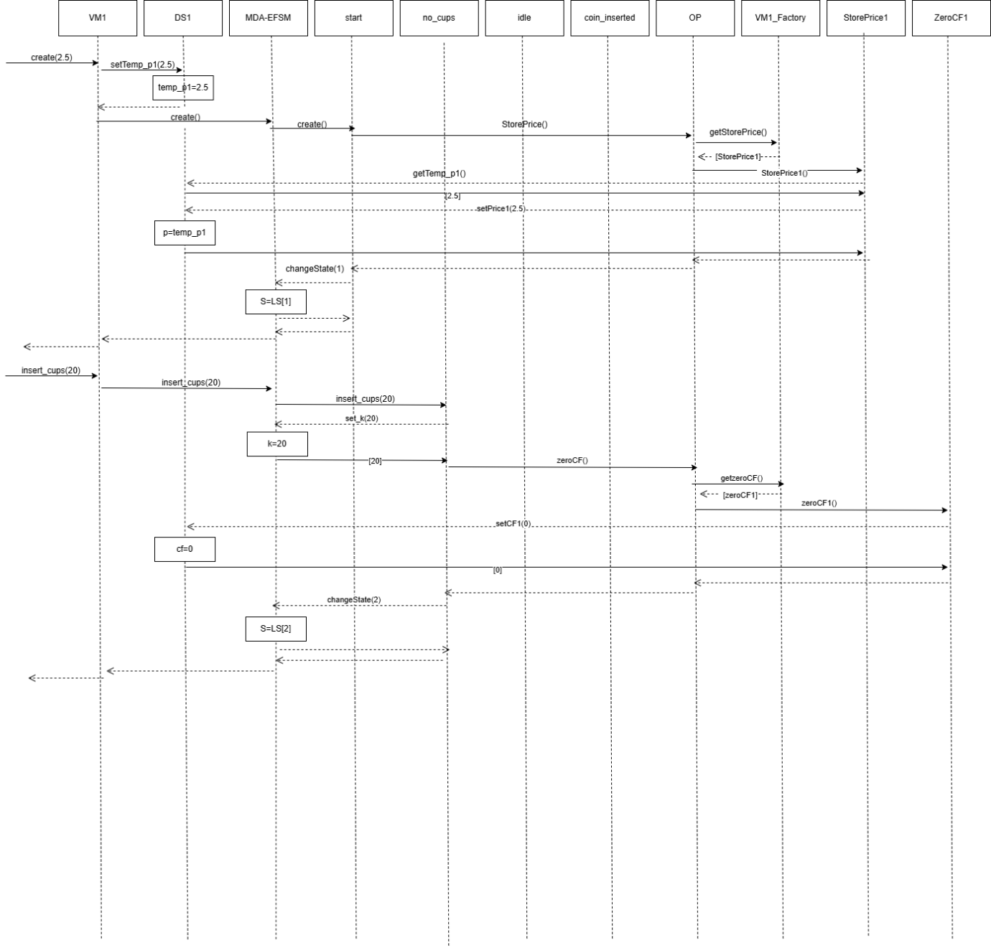
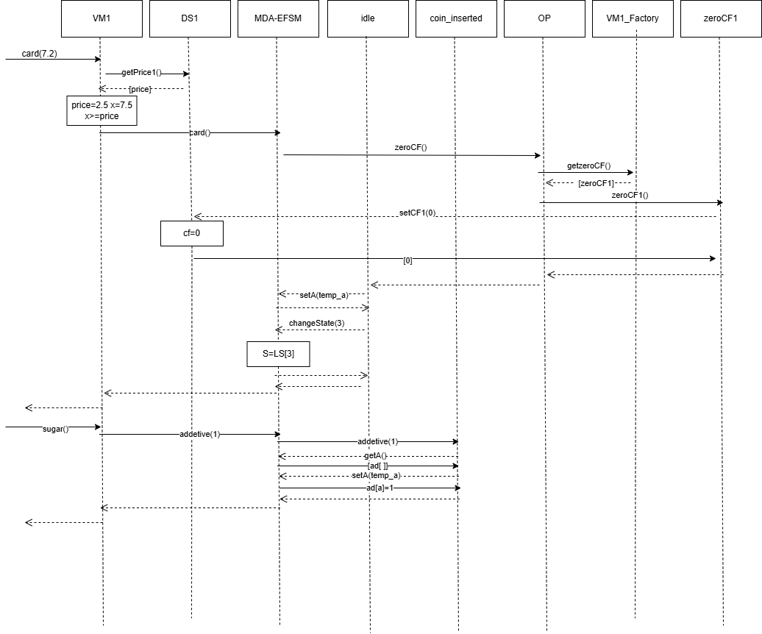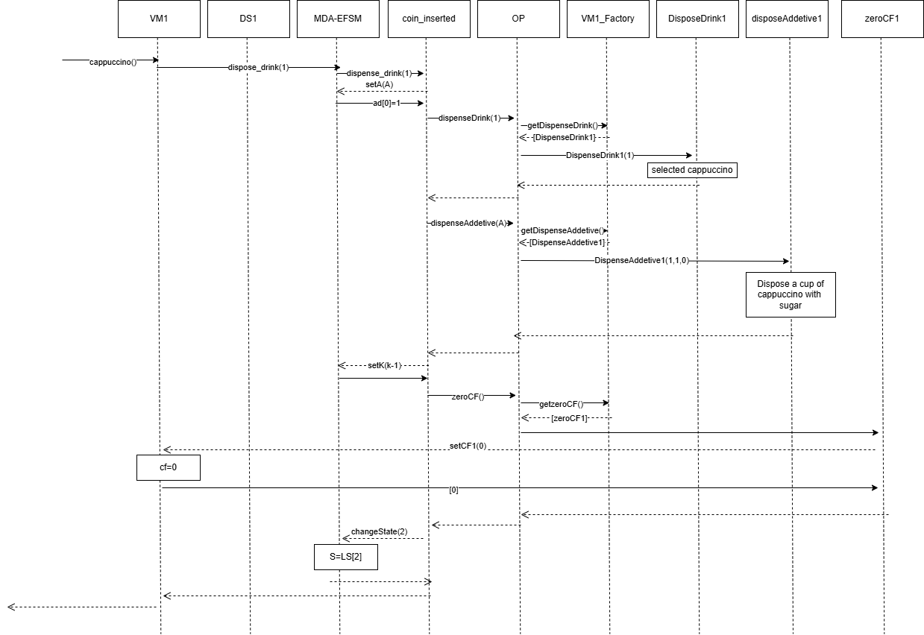#2 CREATE(2), InsertCups(1), COIN(1), COIN(1), C REAM(), COFFEE()
