Al-Yamamah University
College of Engineering and Architecture
Department of Software Engineering

GPA MANAGER PROJECT
(Group Project)

Prepared by:
Rayan Aboushark (202410467)
Abdullah Oyon alsoud (202510706)
CIS 201 Fundamentals of Web Design
Instructor: Sara Alsabeg
May 2026

Table of Contents
1. Introduction……………………………………3
2. Pages Layout & Color Scheme………………………………………3
3. Page Hierarchy……………………………………….3
4. Index Page (Home Page)……………………………………..3
5. GPA Counter Page (Product)……………………………4
6. About Us Page………………………………..4
7. Contact Page…………………………………….5
8. External Links…………………………………..5

1. Introduction
This project is a collaborative "GPA Manager" web application developed by Rayan Aboushark and Abdullah Oyon alsoud. The application provides an interactive platform for students to calculate and simulate their academic Grade Point Average (GPA) using modern web technologies.

2. Pages Layout & Color Scheme
The website follows Al-Yamamah University visual identity guidelines:
Color | Hex Value | Usage
Dark Blue | #0d3141 | Font & Header
Teal | #017f8d | Links & Buttons
Yellow | #f2c230 | Hover Effects
Red | #f21a05 | Dividers & Warnings
White | #ffffff | Background

3. Page Hierarchy
Navigation Flow: Index.html -> [About.html, Product.html, Contact.html]

4. Index Page (Home Page)
Welcome screen and project introduction.
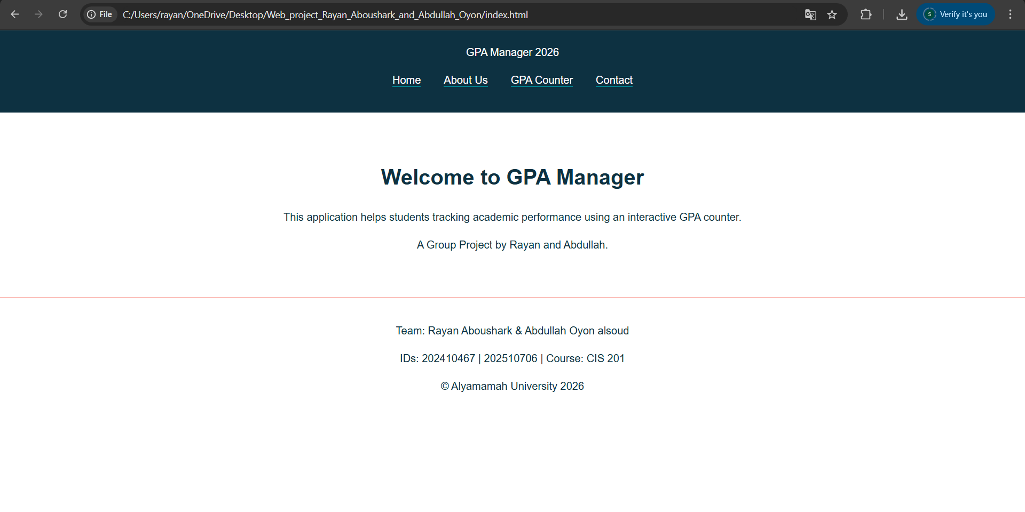

5. GPA Counter Page (Product)
JavaScript counter logic for GPA simulation (0.00 - 4.00).
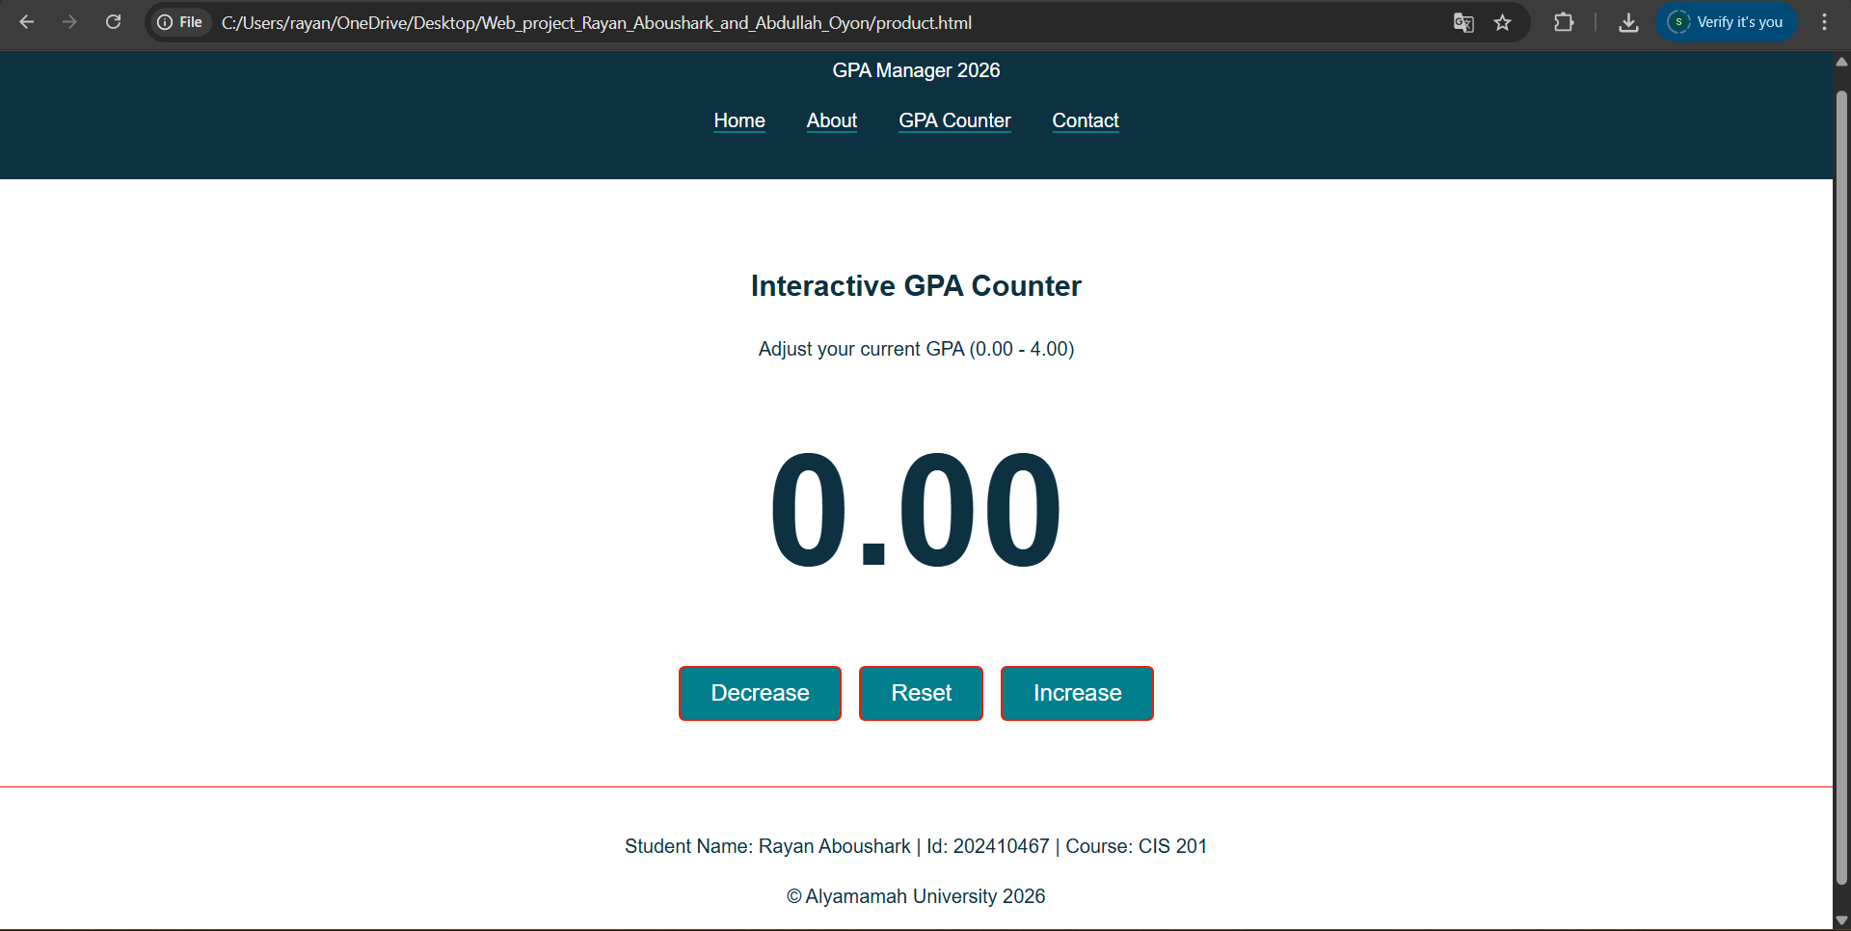

6. About Us Page
Student profiles and academic course table for the group members.
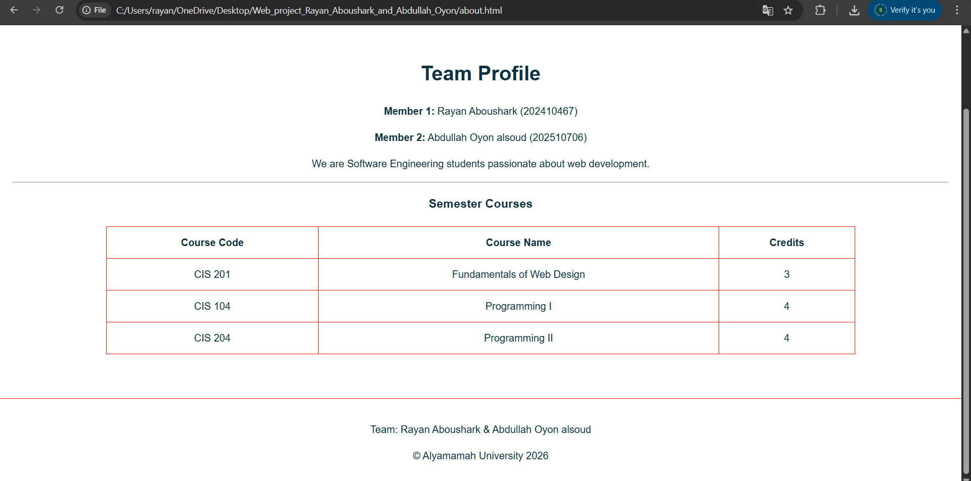

7. Contact Page
Feedback form for user communication.
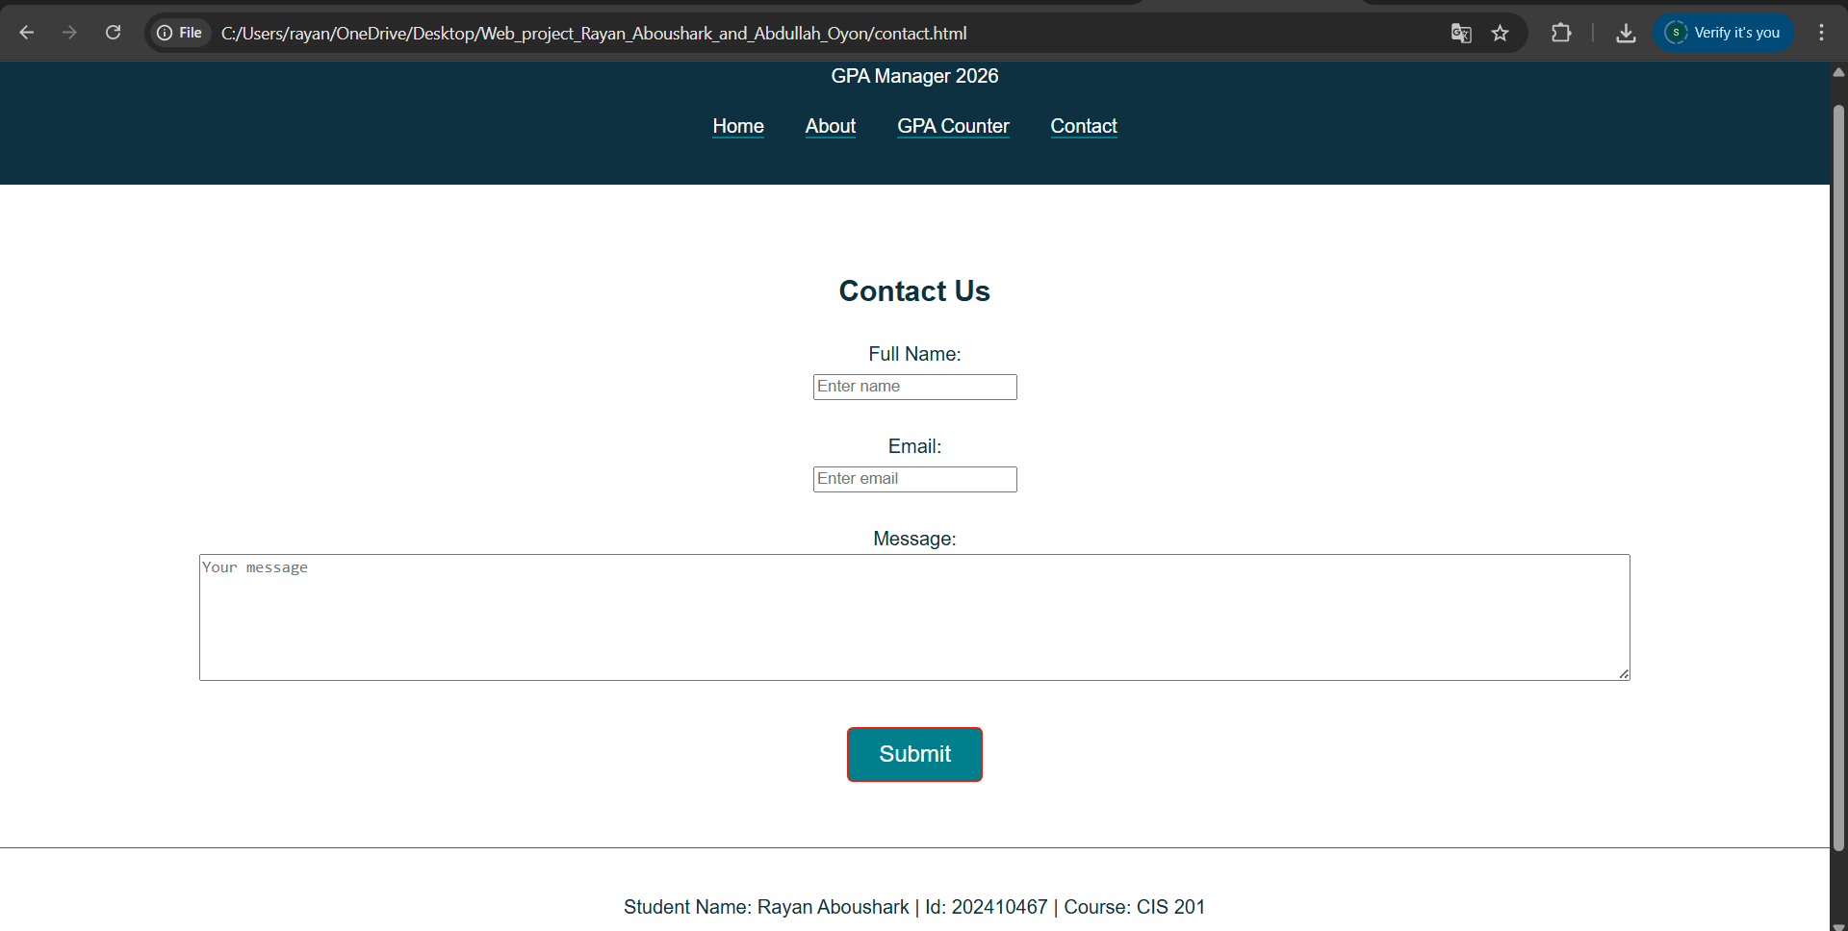

8. External Links
CSS: <link rel="stylesheet" href="MyStyle.css">
JS: <script src="Myjs.js"></script>

