INTRODUCTION

In today's rapidly evolving agricultural landscape, technology integration has become indispensable for optimizing farming practices, increasing productivity, and ensuring sustainable food production. With the global population projected to surpass 9 billion by 2050, the agricultural sector faces unprecedented challenges in meeting the growing demand for food while mitigating environmental impact and resource constraints.

In response to these challenges, the concept of precision agriculture has gained traction, leveraging advancements in smart management, access to information, data analytics, Internet of Things (IoT) devices, and efficient communication to revolutionize traditional farming methods. Among the technological innovations, smart farming applications have emerged as promising solutions to empower farmers with real-time insights, smart decision-making abilities, and automation capabilities.

This proposal report outlines the development and implementation of a "Smart Farmer Assistant Application," designed to serve as a comprehensive digital tool set for modern agriculturalists. By harnessing the power of cutting-edge technologies, this application aims to streamline farming operations, optimize resource utilization, and enhance overall efficiency, thereby enabling farmers to make informed decisions and maximize yields while minimizing costs and environmental impact.

Throughout this report, we will delve into background studies and previous work to gain better insights. Additionally, we will present an ER diagram of the Smart Farmer Assistant Application, highlighting its key features and functionalities that will revolutionize the way farmers interact with their land, crops, and livestock. Moreover, we will provide an estimated timetable for planning, developing, and deploying such a solution.

Ultimately, the Smart Farmer Assistant Application represents not only a technological innovation but also a transformative force poised to empower farmers, drive sustainable agricultural practices, foster economic growth, and ensure food security for generations to come.

BACKGROUND STUDIES

Dr. Nisha Auti et al. **[1]** conducted a literature survey focusing on the evolution and functionalities of farmer assistance applications, highlighting their significance in addressing the unique challenges faced by farmers. Key areas of focus included:

1. **Pest and Disease Management:** Farmer assistance applications provide crucial support in identifying and managing pests and diseases through extensive databases, image recognition, and machine learning algorithms. Real-time alerts and interventions empower farmers to minimize losses.
2. **Market Information Dissemination:** These applications offer timely updates on market prices, enabling informed decision-making regarding crop selection and pricing strategies. Some apps facilitate direct communication and transactions with buyers, reducing reliance on intermediaries, which is particularly beneficial for smallholder farmers.
3. **Crop Planning:** Farmer assistance applications analyze soil type, climate conditions, and historical yield data to recommend suitable crops for cultivation, maximizing yield potential and promoting sustainable agricultural practices.
4. **Labor Hiring:** Facilitating labor hiring is a crucial aspect of these applications, connecting farmers with available laborers for various agricultural tasks. By providing a platform for communication and negotiation, these apps streamline the process of securing temporary or seasonal labor, addressing a significant pain point in the agricultural sector.

Vimal B. Patel et al. **[2]** explore the utilization of Android technology to provide horticulture information to farmers. They highlight the increasing popularity of Android smartphones due to their affordability and the availability of free applications. The proposed "Farmer Helping Service" aims to offer detailed information on fruits, vegetables, and flowers in audio format to farmers, particularly targeting the Gujarati-speaking population in India.

The system intends to provide information without requiring internet access, making it accessible to farmers even in remote areas. The study emphasizes the importance of providing agricultural information in local languages to cater to the needs of illiterate farmers. The system's primary objective is to offer voice-based information on agricultural practices, soil types, fertilizers, etc., in Gujarati, facilitating easy access for farmers.

This study serves as a foundational piece for understanding the integration of mobile technology, particularly Android applications, in agricultural information dissemination. It underscores the potential of such applications to address the specific needs of farmers, especially those in regions with limited internet connectivity and literacy rates.

Kunal Bawankule et al. **[3]** delve into the realm of agricultural development facilitated by mobile technology. They highlight the transformative potential of mobile applications in agriculture, empowering farmers with unprecedented tools and resources for crop management, weather forecasting, and market access.

In their study, they underscore the significance of mobile applications in addressing the challenges faced by farmers, particularly in accessing critical information such as weather forecasts and market opportunities. They emphasize the need for advanced mobile solutions tailored specifically for the farming community, aligning with initiatives like digital India and smart agriculture.

This foundational piece serves as a crucial understanding of the integration of mobile technology in agriculture. It highlights the potential of mobile applications to cater to the specific needs of farmers, especially those in regions with limited internet connectivity and literacy rates, contributing to a more sustainable and efficient agricultural ecosystem.

Karan Gophane, et al. **[4]** introduce the Farmers Assistant Web Application, a digital solution aimed at enhancing profitability, digitizing farming practices, and bridging the gap between farmers and suppliers. This initiative seeks to streamline communication, eliminate intermediaries, and provide personalized interfaces for farmers, suppliers, and administrators, thereby revolutionizing the agricultural landscape.

In their exploration of agricultural technology, the authors highlight the increasing adoption of Management Information Systems in developed countries to assist in various agricultural tasks. The proposal focuses on providing vital agricultural information, such as details on fertilizers like Urea, Ammonium Chloride, and Calcium Nitrate, aiming to ensure fair compensation for farmers' efforts.

The Farmers Assistant Web Application addresses the prevailing challenges in the agricultural sector, including the lack of transparency in pricing and quality of farm products. By facilitating direct communication between farmers and consumers, offering features for booking farm vehicles like tractors, and establishing systems for resolving farmer's problems, this application aims to modernize and optimize agricultural practices.

ShitalChaudhari et al. **[5]** introduce a pioneering approach utilizing Android technology to revolutionize farming practices. The document sheds light on the omnipresence of mobile devices, particularly smartphones, in both urban and rural settings. It underscores the pivotal role played by mobile technology in modern agriculture, offering a pathway towards enhanced crop management and improved yields.

The proposed "Smart Farm Application" endeavors to bridge the gap between traditional farming methods and contemporary technological advancements. By harnessing the power of mobile computing and cloud technologies, the application aims to provide farmers with real-time access to crucial information such as weather updates, market prices, and expert advice. It recognizes the significance of catering to the diverse linguistic landscape of India, offering multilingual support to accommodate farmers from various regions.

The system architecture encompasses features like registration, weather forecasting, supplier-retailer relationships, crops information, notices, voice commands, and market trading. Through a combination of Android, PHP, XML, JSON, and Java technologies, the application promises to deliver a comprehensive solution tailored to the needs of Indian farmers.

TENTATIVE FEATURES

The proposed features of this system will be:

**User accounts**: Farmers can create user accounts.

**Track crops:** The app allows farmers to track information about their crops, such as the name, variety, planting date, and harvest date.

**Manage equipment:** By this app farmers can track their equipment, including the type, purchase date, and location.

**Manage tasks:** Farmers can create and manage tasks associated with their crops.

**Weather data:** The app might collect weather data such as temperature, humidity, rainfall, and wind speed using API.

**Sensor data:** Manage sensor inventory.

DATABASE DESIGN

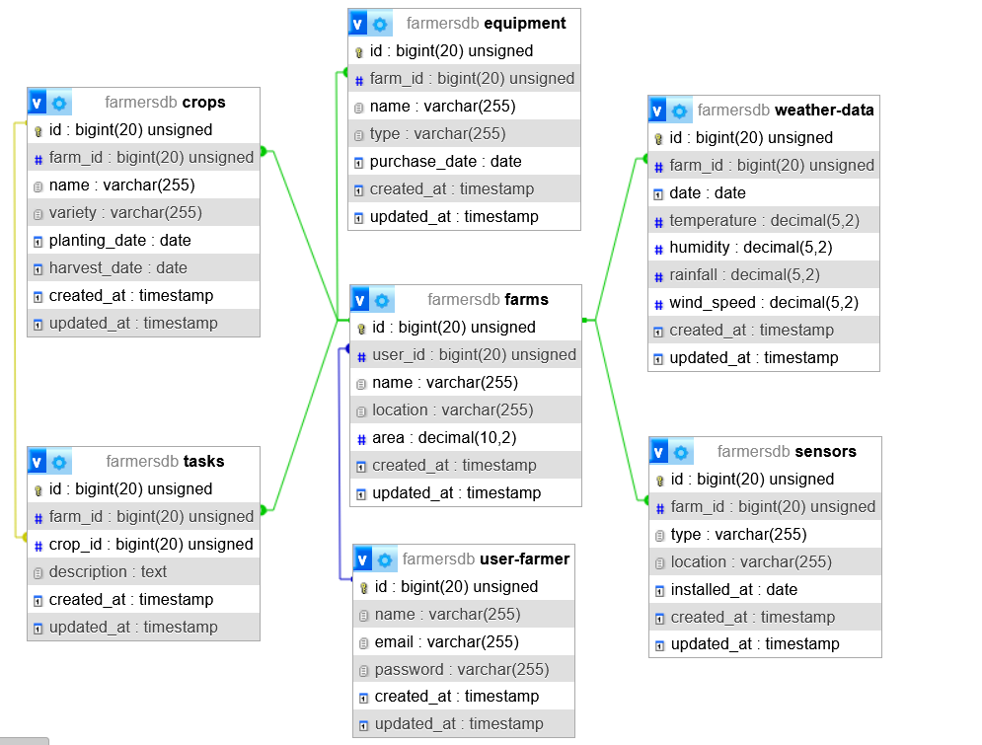

TIMELINE

|  |  |  |  |  |  |
| --- | --- | --- | --- | --- | --- |
| Stage | Planning | Designing | Developing | Testing | Deployment |
| Time | 3 Days | 3 Days | 15-17 Days | 7-9 Days | 2-3 Days |

CONCLUSION

In conclusion, the Smart Farmer Assistant Application represents a pivotal advancement in modern agriculture, addressing the complex challenges faced by farmers in today's dynamic landscape. By integrating cutting-edge technologies and innovative solutions, this application offers a comprehensive digital toolkit to empower farmers with real-time insights, smart decision-making capabilities, and automation functionalities. Through streamlined operations, optimized resource utilization, and enhanced efficiency, the application enables farmers to maximize yields while minimizing costs and environmental impact. With its potential to revolutionize the way farmers interact with their land, crops, and livestock, this application stands as a beacon of progress in the pursuit of a more resilient and prosperous agricultural sector.

As we move forward with the development we remain committed to realizing its full potential and making a good impact on the global agricultural community. Together, we can harness the power of technology to shape a more sustainable and prosperous future for farmers worldwide.

REFERENCE

**[1]** Dr. Nisha Auti, Kunal Lagad, Aditee Khedekar, Balaji Raut, Darshan Jain (2023), “Farmer’s Assistant App-Agrozenith”, International Journal for Research in Applied Science & Engineering Technology (IJRA) ISSN: 2321-9653; IC Value: 45.98; SJ Impact Factor: 7.538 Volume 11 Issue XI Nov 2023, pp. 1136-1139.

**[2]** Vimal B. Patel, Rahul G. Thakkar, Bankim L.Radadiya (2014), “An Android Application for Farmers to Disseminate Horticulture Information”, International Journal of Computer Applications (0975 – 8887) Volume 88 – No.4, February 2014, pp. 1-4.

**[3]** Kunal Bawankule, Charudutta Tekade, Shubham Bark, Pankaj Vishwakarma (2021), “Agricultural Development Using Mobile App for Farmers”, International Research Journal on Advanced Science Hub (IRJASH) Volume 03 Issue 05S May 2021, pp. 83-88.

**[4]** Karan Gophane, Jay Dhumal, Sahil Pawar, R.S. Pawar (2024), “FARMERS ASSISTANT WEB APPLICATION”, International Research Journal of Modernization in Engineering Technology and Science e-ISSN: 2582-5208 Volume:06/Issue:03/March-2024, pp-3364-3368.

**[5]** Shital Chaudhari, Vaishnavi Mhatre, Pooja Patil, Sandeep Chavan (2018), “Smart Farm Application: A Modern Farming Technique Using Android Application”, International Research Journal of Engineering and Technology (IRJET) e-ISSN: 2395-0056 p-ISSN: 2395-0072 Volume: 05 Issue: 02 | Feb-2018, pp. 318-320.