Build Approach
Phasing, sequencing & de-risking

Companion to the People Rise Product Scope & Go-to-Market Plan
Working document

1. The Recommendation
Build Phase 1 end to end — design it, build it, ship it to El-Delta — before designing any later phase in detail. Think about all phases at the architectural level (largely already done), but design and implement only Phase 1. Do not produce low-level design, mockups, or implementation detail for Phases 2–4 up front.
Phase 1 is the Job & Reward Design trio: Job Evaluation → Grading Structure → Salary Structure, consulting-led, into El-Delta as the first reference customer.

2. Why Phase 1 First, Not Design-Everything-First
Detailed design has a short shelf life. Low-level design, mockups, and implementation detail are perishable — they rot the moment reality touches them. Specify Phases 2–4 in detail now and the first weeks of real El-Delta use will invalidate the assumptions they rest on (questionnaire wording, grade thresholds, workflow steps), turning that work into rework. The further out the phase, the more speculative the detail, the more of it gets discarded.
The methodology is the biggest risk, and Phase 1 is the experiment that retires it. Until a real customer runs real jobs through the evaluation engine and the resulting grades survive scrutiny, the core point-factor methodology is unproven. Designing Phases 2–4 in detail before that is building upper floors before confirming the foundation bears weight. Finish the experiment first.
A small team must reach a paying reference customer fast. Designing the whole suite is months of work that ships nothing and earns nothing. The consulting-led model needs a live engagement and a reference account to survive and to prove itself. Every week on speculative design for Analytics is a week not spent getting El-Delta live.
The engagement itself teaches you Phases 2–4. A consulting deployment is a learning instrument: it reveals which adjacent products El-Delta and the SOE accounts actually pull you toward, in what order, with what real requirements. The build order may shift — government accounts might want Payroll before Performance. Designing it all now assumes you already know; shipping Phase 1 lets the market tell you.

3. Detailed Design vs. Architectural Decisions
The one trap in “phase-by-phase” is conflating two different things. You can design detail per-phase, but architectural decisions must account for all phases now, because they are expensive or impossible to reverse later.
Architectural (decide now, all-phases-aware) — largely already done:
- DB-per-tenant, with a shared control-plane DB and a separate benchmark store.
- The event backbone (task.completed and similar) and the “compute shared signals once” rule.
- The shared spines (org structure, competencies) and the modular product boundaries.
- PostgreSQL, deployment-agnostic packaging for SaaS and on-prem.
Detailed (design per-phase, only when you build it):
- Low-level design, data-model detail for that phase's entities, screen mockups, implementation.
Keep a lightweight “Phase 2+ considerations” list — not designs, just flags (“Performance will read evaluation scores via an event,” “Payroll will consume salary bands”) — so each Phase 1 implementation choice can be sanity-checked against known future needs. That list is cheap insurance; full LLD for those phases is expensive waste.

4. How to Sequence Phase 1
The sequence is HLD → LLD → ERD → mockups → implementation, with two adjustments. First, it is not a strict waterfall — expect to loop, especially mockups ↔ LLD, because screens surface data-model gaps worth fixing before you build.
Second, and most important: run the calibration back-test early — before building the full UI. The moment the evaluation engine can score jobs (even through a rough internal screen or seeded data), put 6–10 real El-Delta jobs of agreed relative seniority through it and confirm the rankings hold. If the CFO's role doesn't out-score a department manager, the weights need tuning — publish a v2 and re-test. Find this out before polished screens are built on top of the methodology, not after.
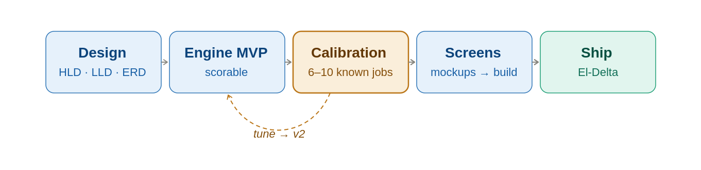
Calibration sits early — validate the engine, then build the experience around it.
This is the concrete expression of “the methodology is the differentiator”: in a consulting-led model, a system that produces grades people can't defend burns trust fast, so proving the model is the first real milestone — ahead of UI polish.

5. Phase 2+ Considerations (Flags, Not Designs)
A starting list of forward-looking flags to hold while building Phase 1 — to be expanded as the El-Delta engagement teaches you more. These are reminders, not specifications.
- Performance will read evaluation scores and competency data via events/the shared spine — don't lock the evaluation output format somewhere only the UI can reach it.
- Payroll will consume salary structures and bands — keep bands queryable and currency-aware from the start.
- Project & Task Management emits task.completed; Performance, Goals, and Financial Impact subscribe — the event contract matters more later, but don't preclude it now.
- Analytics / Insights computes burnout, utilization, and health signals once and displays them in many places — don't bury those computations inside a single product.
- Market benchmark (long-term moat) needs cross-tenant aggregation — the separate benchmark store and consent/anonymization terms are the enabling groundwork.
- Build order is provisional. Let the engagement — especially the government/SOE accounts — confirm whether Payroll, Performance, or Analytics comes next.

6. Phase 1 Milestone Checklist
Concrete steps from design kickoff to El-Delta live. The order encodes the build approach above — most importantly, M3 (calibration) is a go/no-go gate that comes before any UI polish. Treat M0–M2 as setup, M3 as the decision point, M4–M7 as delivery.

M0 — Design kickoff
☐ Confirm Phase 1 scope: Job Evaluation → Grading → Salary; El-Delta as pilot.
☐ Farouk begins point-factor upskilling from standard references.
☐ Agree the 6–10 reference jobs for the calibration back-test.
☐ Stand up repo, solution skeleton, control-plane DB + one tenant DB.

M1 — Methodology drafted (Farouk)
☐ Factor definitions, level scales, and point values (draft v1).
☐ Job-content questionnaire: questions + answer→point rules.
☐ Grade thresholds (score → grade mapping).
☐ Map El-Delta's five levels; define the initial job families.

M2 — Engine MVP (scorable)
☐ Phase 1 schema implemented; migrations run per tenant.
☐ Configurable, versioned evaluation engine (methodology = data).
☐ Score a job end to end via seeded data or a rough internal screen.

M3 — Calibration back-test [GO / NO-GO]
☐ Run the 6–10 known jobs through the engine.
☐ Confirm the rankings match agreed relative seniority.
☐ Tune weights → publish v2 and re-test if needed.
☐ Gate: methodology validated and defensible before any UI polish.

M4 — Grading & salary build
☐ Place evaluated jobs into the level × family grid; assign grades.
☐ Import market-data snapshot (geography / industry / size / recency tagged).
☐ Set band positioning per family; generate bands (67% spread, 25% overlap).
☐ Integrated: import El-Delta salary snapshot; compute compa-ratio + equity.

M5 — Screens & UX
☐ Questionnaire screen, generated dynamically from the methodology.
☐ Evaluation review + answer→score audit-trail view.
☐ Grade / band design and structure views.
☐ Compa-ratio / internal-equity views (permission-gated).

M6 — Hardening & deployment
☐ DB-per-tenant provisioning; backup / restore per tenant.
☐ Roles & permissions — who sees what, especially pay and sensitive views.
☐ Deployment package: SaaS default, on-prem-ready.
☐ Salary-data handling: consent, retention, PDPL-aware terms.

M7 — El-Delta live (pilot)
☐ Load El-Delta org, levels, families, and jobs.
☐ Run real evaluations; deliver the grade + salary structure.
☐ Reference-customer sign-off.
☐ Capture learnings to sequence Phase 2 — what El-Delta pulls toward next.

