Phase 1 — Detailed Design
Job & Reward Design: workflows, concepts, data model

Companion to the Product Scope and the Build Approach
Working document — confidential

Contents
1. Scope — what's in and out of Phase 1 3
2. Core concepts 3
3. The pipeline 4
4. Job Evaluation — workflow 4
5. Grading Structure — workflow 6
6. Salary Builder — workflow 7
7. Data model 8
8. Calibration back-test (the gate) 9
9. El-Delta defaults & open items 9

1. Scope — What's In and Out of Phase 1
Phase 1 is the Job & Reward Design trio: Job Evaluation → Grading Structure → Salary Builder. It is consulting-led and design-time: its core deliverable — a defensible grade and salary structure — needs no employee data. That is what lets it sell as a consulting engagement without a Payroll product underneath it.
In scope:
- Configurable, versioned job-evaluation engine (point-factor preset) with an audit trail.
- Grading structure: grades, the level × family grid, and where career-path / promotion-progression rules attach.
- Salary structure: market-data import, positioning per family, bands at 67% spread, 25% overlap.
- Standalone design output, plus an integrated analysis layer (compa-ratio, internal equity) when real salaries are imported.
Out of scope (later phases), but the foundation is laid now:
- Promotion workflow — Phase 2/3. It needs performance ratings (Performance product) and operational personnel data. Phase 1 only builds the grades, establishment, and bands it will later run on.
- Live payroll integration — Phase 1 uses a point-in-time salary snapshot via CSV, not a live feed.
- Performance, Goals, Analytics — downstream consumers; not built now, but not precluded (events and shared spines are planned for).

2. Core Concepts
The load-bearing ideas the workflows and data model rest on. Get these right and the rest follows.

Job vs. Position vs. Employee
Three separate things, never merged: a Job is a role definition (“Senior Accountant”) — the thing you evaluate; a Position is a specific seat (“…Cairo Finance, slot 3”) — the thing the establishment counts; an Employee is a person — the one you pay. You evaluate jobs, count positions, pay employees. Position-control (the open-box promotion gate) only works if these stay distinct.

Methodology as data, and versioning
The evaluation methodology — factors, the questionnaire, answer points, score-to-grade thresholds — is configuration data, not code. “Point-factor” is a seeded set of these rows; one engine runs them. The methodology is versioned: every evaluation pins the exact version it used, so re-tuning the weights publishes a v2 and leaves already-evaluated jobs pointing safely at v1. Nothing is silently re-graded.

The audit trail
Every answer chosen in an evaluation is stored as an immutable row carrying the points it was worth. Corrections happen by creating a new evaluation, never by editing history. Those rows are the audit trail: a grade traces back to the exact answers a named evaluator picked under a specific methodology version — the defensibility that is the actual product in a consulting engagement.

Standalone vs. integrated
Each product has honest standalone value and gets richer when siblings are present. Job Evaluation alone proposes generic grades; with Grading Structure it maps onto El-Delta's real grades. Salary Builder alone designs bands; with real salaries imported it computes compa-ratio and equity. The rule: own your data, pull from siblings if present, fall back gracefully if not.

Families are nullable, added in the design phase
A job needs only a level to be evaluated and scored; its family is optional and assigned later when families are defined. So El-Delta can start with its five levels and no families, run evaluations, and place jobs on the horizontal axis once families exist. Family is nullable and editable everywhere — no feature may assume it is set.

End-to-end traceability
The chain runs both ways: a salary band → its grade → the score → the specific questionnaire answers → the evaluator and methodology version. “Here is exactly why this job sits in this band” is the through-line of all three products, and the antidote to favoritism concerns in the market.

3. The Pipeline
The trio is one continuous flow: a job comes in, a defensible salary band comes out. Each product hands its output to the next.

Score → grades → bands. One pipeline, three sellable products.

4. Job Evaluation — Workflow
Job Evaluation is first because everything downstream needs the score. It turns a job into a defensible grade recommendation.
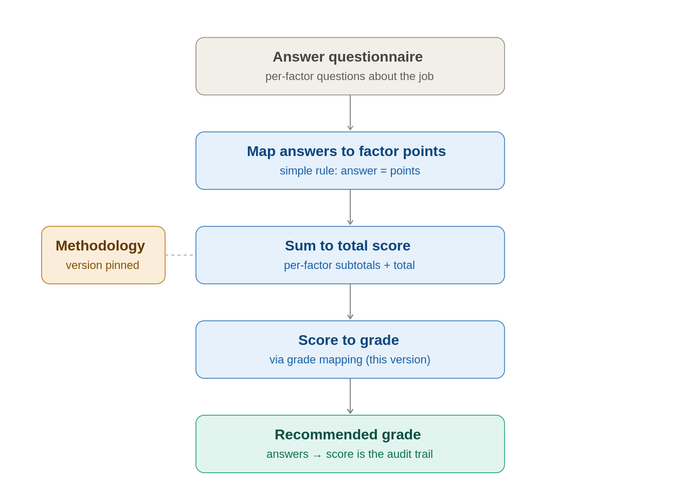
Answers → points → total → grade, every step traceable, under a pinned version.

Setting up the methodology (design-time)
Before any job is scored, the methodology is configured: its factors (Know-How, Problem Solving, Accountability…), a questionnaire of questions per factor, each answer option carrying fixed points, and a grade-mapping table (score ranges → grades). This is the methodology work in milestone M1.

Who authors the questionnaire
Two senses of “generate.” Farouk authors the content — the questions, answers, and points are HR methodology, set once per methodology version (and a real differentiator). The system generates the screen: because the questionnaire is stored as data, the Angular front-end renders the form dynamically from the current version. The consultant then answers it per job. Author once, render many. Any AI assistance stays a suggestion Farouk approves, never an autonomous author.

Scoring
Answers map to points by simple rule (answer X = Y points — the locked decision), the engine sums per-factor subtotals and a total server-side (never trust the browser to compute a grade), and the total falls into a grade range. Scope is four levels (Blue Collar, IC, Supervisory, Managerial); C-level is excluded — executive pay is market/board-benchmarked above the evaluated structure.

Job titles are aliases; content is identity
Job titles are unreliable across companies and even within one — El-Delta's “Senior Tech Lead” and another firm's “Senior Specialist Team Lead” may be the same work under different names, or not; the title alone tells you nothing. This is why evaluation scores content, not names: the point total is a content-based identity that makes two differently-named jobs comparable (the same score means equivalent measured work). Reconciling differently-named jobs across companies to shared reference jobs is the backbone of the future cross-company benchmark, but it is deferred — Phase 1 is single-tenant and needs no reference-job layer. The seam is left open: company titles are aliases over content-defined jobs, the evaluation score is the match key, and a reference-job link is an additive column when the benchmark phase arrives.

5. Grading Structure — Workflow
Grading Structure takes scored jobs and builds the skeleton: grades, the grid, and the rules that hang off it.
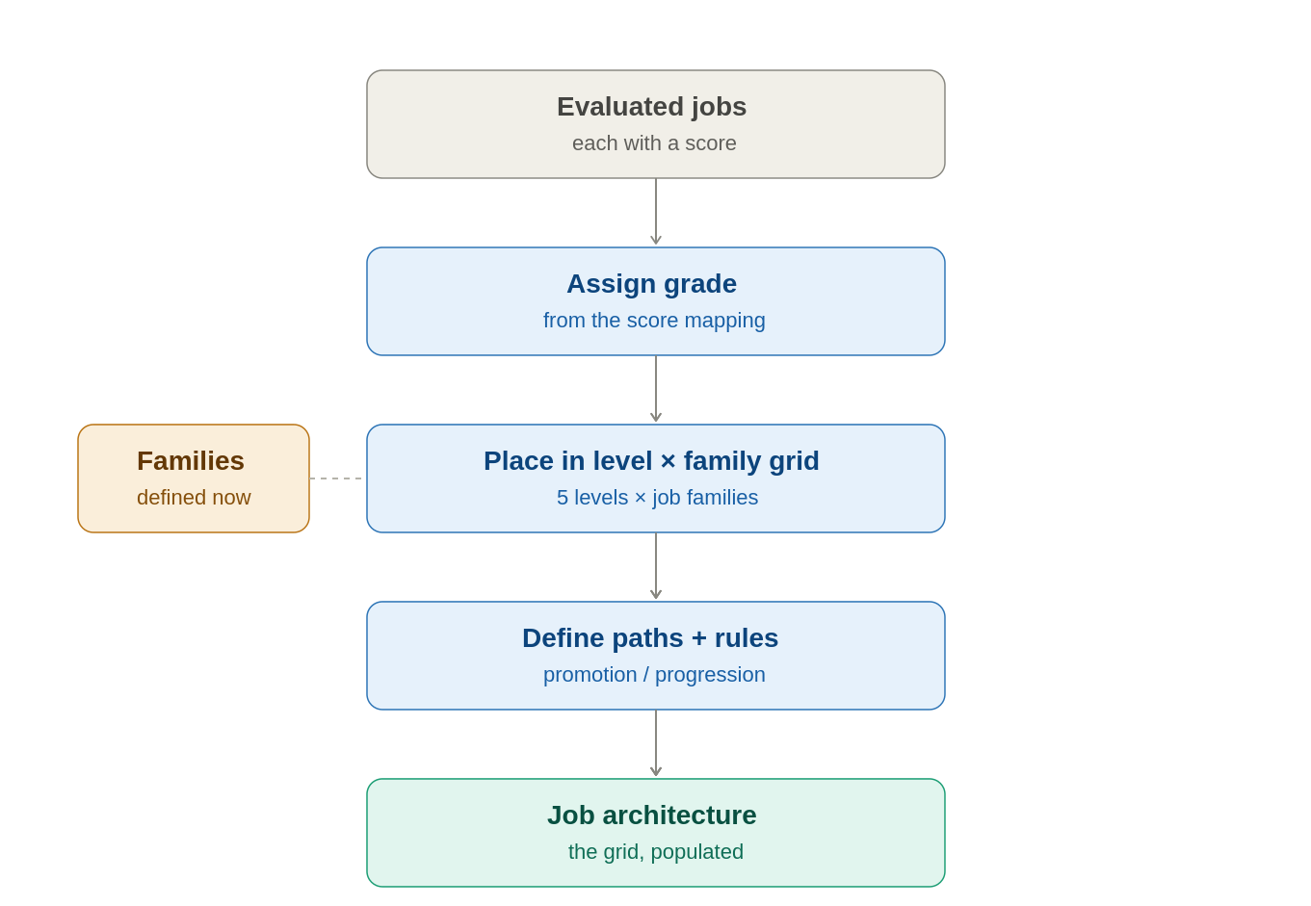
Jobs become a populated grid — level × family — with paths and rules attached.

Grid, paths, and rules
A grade comes from the score (via the mapping the methodology owns — Grading reads it, doesn't redefine it). The job is placed in the grid: its level (one of the five) crossed with its family. Career paths are routes through a family's levels, and the promotion vs. progression rules attach here.

Promotion vs. progression (definitions)
- Progression — movement within a grade (same job, more pay), performance-based annual increase inside the band. A quiet comp event.
- Promotion — movement between grades. Gated by three independent conditions: ≥ 2 years in grade, a rating of Excellent/Very good, and an open box (vacant approved position) in the target grade. Triggers a cascade (new grade → new band → pay adjustment → new competency profile). This is Phase 2/3; Phase 1 only lays its foundation.

Position-control / establishment
El-Delta runs a position-controlled model: a fixed number of approved seats per grade per unit. The structure needs an establishment view (approved positions, vacant or filled) so a future promotion can check for an open box. This shape maps recognizably onto government/SOE grade ladders.

6. Salary Builder — Workflow
Salary Builder prices the grades into bands. Everything down to the band is pure design; employee data only enters for the integrated analysis layer.
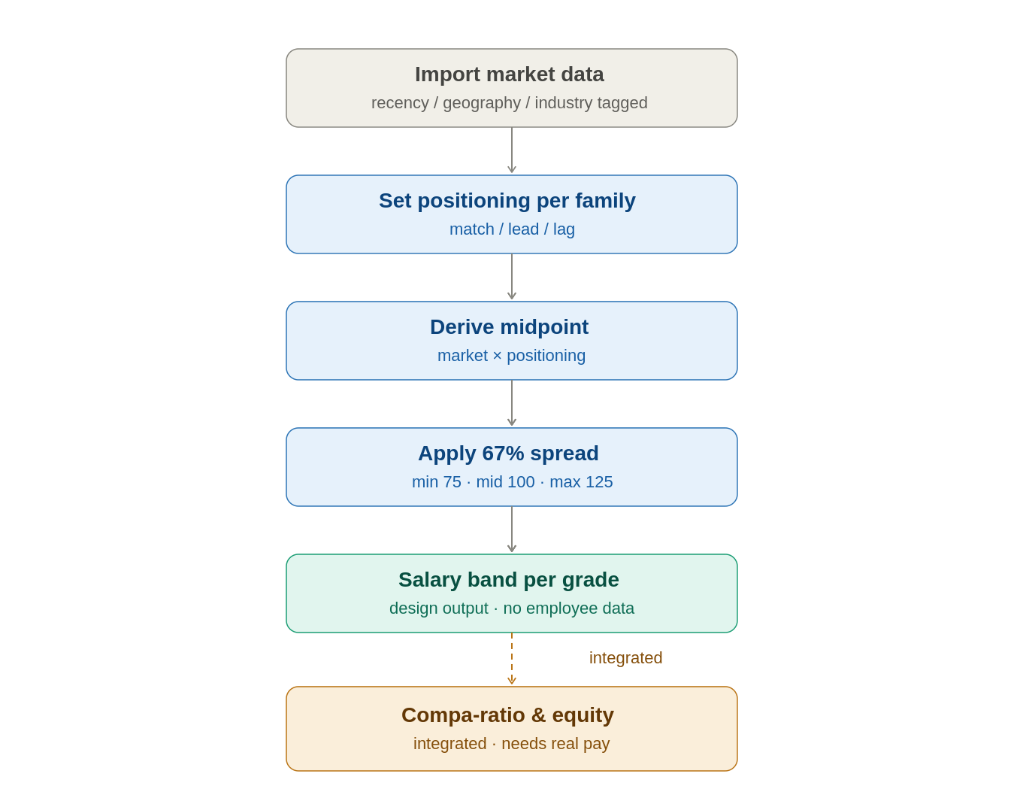
Market data → positioning → midpoint → 67% band (min 75 / max 125). Integrated mode adds compa-ratio and equity.

Market data
A point-in-time snapshot is imported (the locked sourcing model: customer-import v1 → own benchmark later), tagged with the attributes that make it meaningful — geography, industry, company size, and recency (recency especially, given currency and inflation volatility). Each survey row reports the salary distribution as percentiles — P25, P50 (the median, the typical market rate), P75, and P90 — because pay data is skewed and the median plus quartiles describe it more honestly than an average. The positioning posture is then a choice of which percentile anchors the band: match ≈ target P50, lead ≈ nearer P75, lag ≈ nearer P25.
Market data binds to the job — the unit the market actually prices (“senior accountant” is both a job and a survey line). Family and level are the job's coordinates and serve as a fallback grain when a survey is coarser than your job list (e.g. “finance roles, IC level” that several jobs share); grade is another fallback. A position never carries a market price — it inherits its band through job → grade → band — and only the employee has an actual salary, compared to the band for compa-ratio.

Bands
Positioning is set per family (match-the-market for El-Delta, varying by family). Each grade's midpoint derives from market × positioning, then the 67% spread (max ÷ min = 1.67) gives min 75%, midpoint 100%, max 125% of midpoint; consecutive midpoints step up by the 25% overlap (progression). Adjacent grades overlap by design, so a senior person in a lower grade can out-earn a junior in a higher one. Money is stored as exact decimal with an explicit currency — never float.

Grade overlap & auto-building the structure
Two controls, defined by Farouk's formulas. Spread = (max / min) − 1 — the band's width as the ratio of its top to its bottom. Overlap = (midpoint of current grade / midpoint of previous grade) − 1 — strictly the midpoint progression between consecutive grades. A naming note: what is labelled “overlap” here is the midpoint progression; whether two bands physically share range depends on it relative to the spread — with arithmetic-mean midpoints, adjacent bands overlap only when progression < spread (equal = they touch; greater = a gap).
One disambiguation the formula fixes: the band we sketched (min 75%, max 125% of midpoint) is a 67% spread under this definition (1.25 / 0.75 − 1), not 25%. El-Delta's confirmed defaults are a 67% spread and 25% overlap (progression) — a common, defensible “healthy structure” starting point. Because the progression (25%) sits well below the spread (67%), adjacent bands overlap substantially, which is the intended effect. In practice spreads often widen toward senior grades; the uniform default is an editable starting point the consultant can tune per grade.
To accelerate setup — exactly what a consultant wants for a new organization — the system can auto-build the grade structure from a grade count. The user says “we have N grades,” supplies a range to span (a lowest and highest anchor, or a starting midpoint plus a progression rate), and the system scaffolds N grades with evenly spaced midpoints, each with its spread and overlap applied per the formulas above. Two design notes: the output is an editable starting point (real structures are never perfectly even, so the user can nudge midpoints and widen individual bands), and it needs the range to be meaningful — which usually comes from the market data or the lowest/highest roles, so auto-build typically runs after some market reference exists. Both controls are additive to the schema (salary_band already carries spread_pct and overlap_pct).

Compa-ratio & internal equity (integrated only)
Once real salaries are imported, compa-ratio (actual pay ÷ band midpoint; below 75% = below scale) and internal-equity dispersion light up. Internal-equity findings can be legally sensitive (protected classes), so the methodology is defined with HR + legal. This layer needs consented, carefully handled data (PDPL-aware).

7. Data Model
The Phase 1 schema is 23 tables across three areas (full DDL in people_rise_phase1_schema.sql). It assumes DB-per-tenant — there is no tenant_id column; the database boundary is the tenant boundary. UUID keys, exact decimal money, versioned methodology, and an immutable evaluation-answer table are the load-bearing choices.
- Structure: org_unit, level, job_family, grade, job, job_position, employee, employee_assignment.
- Evaluation: methodology, methodology_version, factor, question, answer_option, grade_mapping, evaluation, evaluation_answer (immutable), evaluation_factor_score.
- Salary: market_data_snapshot, market_data_point, band_positioning_policy, salary_band, salary_import_batch, employee_compensation.
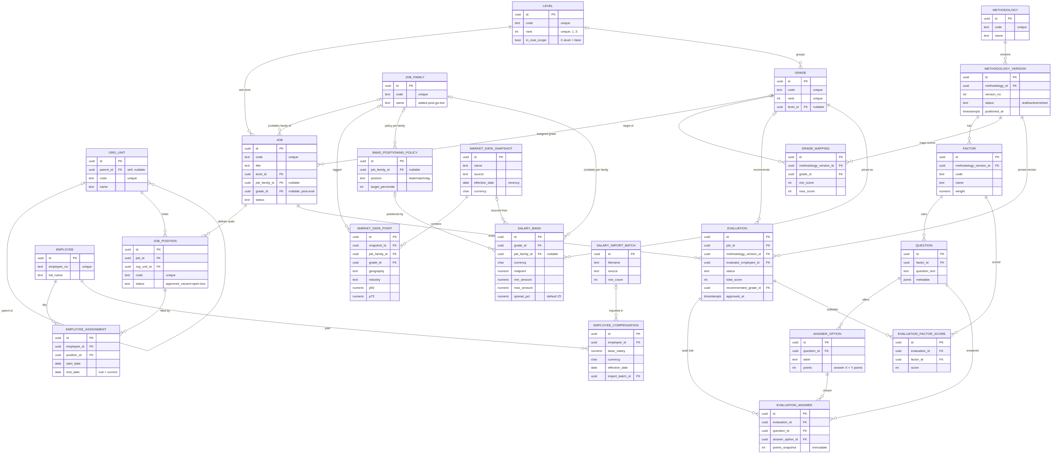
Phase 1 ERD — structure (left), evaluation (right), reward (centre). Full DDL in the .sql file.

8. Calibration Back-test (the Gate)
Before any UI is built, the methodology must be proven. Once the engine can score jobs (seeded data or a rough screen), run 6–10 real El-Delta jobs of agreed relative seniority through it and confirm the rankings match expectations. If the CFO's role doesn't out-score a department manager, tune the weights, publish a v2, and re-test. This is a go/no-go gate: in a consulting-led model, a system that produces grades people can't defend burns trust fast, so proving the model is the first real milestone — ahead of UI polish.

9. El-Delta Defaults & Open Items
Phase-1-relevant defaults, confirmed with Farouk (full list in the Product Scope, Section 2):
- Point-factor methodology; simple-rule questionnaire, HR-owned; four-level scope, C-level excluded.
- Five levels (Blue Collar → IC → Supervisory → Managerial → C-level); one role per level; no existing families or competency framework (built from scratch, uniform 1–5).
- Bands 67% spread + 25% overlap (progression), match-the-market varying by family; compa-ratio at midpoint = 100%, below 75% = below scale.
- Position-control / establishment model; market data via point-in-time snapshot.
Open for the design phase: Farouk's factor definitions and point values plus the calibration back-test; defining the job families and placing roles into the grid; confirming one questionnaire per methodology (recommended for comparability).

