People Rise
Product Scope & Go-to-Market Plan

A modular Human Capital Management suite
Owners: [Developer] — technical / product • Farouk — HR methodology
First partner / pilot: El-Delta
Working document — updated as the scope evolves

Contents
1. The platform concept 3
2. Decisions locked (El-Delta defaults) 3
3. The dependency model 5
4. System architecture & integration 7
5. The sellable products 8
6. Deployment & business model 9
7. Recommended starting point & roadmap 9
8. Task completion → value chain 11
9. Questions for Farouk 15
10. Decisions for the technical / business side 16
11. Cross-cutting principles 16

1. The Platform Concept
People Rise is a modular Human Capital Management suite. Organizations can buy the whole suite or individual products à la carte. Every product must:
- Stand alone as a sellable unit with real standalone value.
- Expose integration points so it gets richer when a customer owns sibling products.
The core design discipline that makes modularity work
Every product defines three things:
- What data it owns (its source of truth)
- What it pulls from sibling products if present
- A manual fallback for that data if those products are absent
This lets us honestly sell each piece à la carte without lying about what it does alone. Example: Salary Builder bought alone = you type in your grades. Bought with Job Architecture = it pulls them automatically.

2. Decisions Locked (El-Delta Defaults)
A snapshot of choices confirmed with Farouk. These are the El-Delta defaults the build assumes; the detailed methodology backlog and the few genuinely open items live in Section 8.

Company & go-to-market
- Org size: 150–250 employees — a small number of large accounts, not a long tail of small ones.
- HR owns payroll compliance (Egyptian tax, social insurance, labour law).
- Go-to-market: consulting-led for the design-tool products (Job Eval, Grading, Salary).
- Operating model: start Model A → evolve to Model B. Initially People Rise is Farouk's internal consulting tool — consultants use it to produce job-evaluation, grading, and salary structures for client organizations and hand over the deliverable. Over time it opens up: the client organization becomes a self-serve tenant whose own staff log in (land-with-services, expand-with-software). Architect for B from day one; the same software serves both. Model-A engagements across many clients are also how the anonymized benchmark accumulates.
- Pricing: deliberately deferred until after the El-Delta launch.

Architecture
- DB-per-tenant. Strongest isolation, clean per-customer backup, and the cleanest path to on-prem (one tenant DB + the app = the on-prem artifact). Fits the small number of large accounts. Add a shared control-plane DB (tenant registry, billing) and a separate benchmark-aggregation store the future anonymized extracts flow into — which is also better for consent and anonymization.
- PostgreSQL (Npgsql + EF Core on .NET). Free and open-source, so DB-per-tenant and on-prem carry no per-tenant or per-customer licensing — decisive for the SaaS-plus-on-prem, government/SOE model, and frictionless to deploy in a ministry data centre. Native JSONB and exact numeric money types suit the configurable methodology and comp data. Keep EF Core queries provider-agnostic where practical, as cheap insurance against a future contractual SQL Server mandate in a government RFP.
- One configurable evaluation engine. Point-factor / Hay-style are presets, not separate code paths; the questionnaire is configurable per methodology.
- Event-driven. Emit task.completed; Performance, Goals, and Financial Impact subscribe.
- Salary-data ingestion: a CSV/template import path, serving both consulting snapshots and the standalone fallback — built once.

Job & reward design
- Methodology: point-factor. Farouk upskills from standard references and owns the factor definitions, point values, and grade thresholds.
- Calibration validation. Back-test the draft model against 6–10 real El-Delta jobs of agreed relative seniority; tune weights until the rankings match expectations before going live. This turns “we learned the method” into “we proved the model is defensible.”
- Questionnaire: HR-owned. Answers map to factor points by simple rules (answer X = Y points); the answer→score trail is the audit trail.
- Scope: four levels (Blue Collar, IC, Supervisory, Managerial). C-level is excluded — executive pay is set by market/board benchmarking, above the evaluated structure (the standard approach).
- Hay IP: offer configurable point-factor; verify branding before using the “Hay” name.

Compensation
- Bands: 67% spread, 25% overlap (progression). Spread = (max / min) − 1 → min = 75% of midpoint, max = 125%; overlap = midpoint progression between consecutive grades. Because overlap (25%) sits below spread (67%), adjacent grades overlap by design — a senior person in a lower grade can out-earn a junior in a higher one.
- Positioning: match-the-market, varying by job family.
- Compa-ratio: actual pay ÷ band midpoint; below 75% = below scale. Integrated-mode (needs real salaries).
- Market data: customer-import point-in-time snapshot (v1) → own anonymized benchmark (long-term moat).
- Internal equity analysis: integrated-mode; methodology defined with HR + legal given protected-class sensitivity.

Performance & people signals
- Burnout risk and Performance Health Indicator: one computed signal each, visible to department heads up through CEO, never shown to the employee — enforced in permissions, not convention.
- Task evidence informs the objectives pillar; a human sets the rating (evidence, not auto-score).
- ROI rolls up to project/team only, never individual.

Structural inputs (El-Delta org)
- Five levels: Blue Collar → Individual Contributors → Supervisory → Managerial → C-level (Executive).
- One role per level — no multi-level roles, which keeps each role mapped to a single grade with no resolution logic.
- No existing job families (define in the design phase as the horizontal cut across levels) and no existing competency framework (build from scratch, uniform 1–5 scale with per-level descriptions).
- Position-control / establishment model. Promotion is gated by three independent conditions: an approved open box (vacancy) in the target grade, ≥ 2 years in the current grade, and an Excellent/Very good performance rating. The system needs an establishment table (approved headcount per grade per unit) the promotion workflow checks. Progression is a performance-based annual increase within the band. This position-control shape maps recognizably onto government/SOE grade ladders.
- Certifications: none mandatory today; build compliance-tracking and cert-to-competency mapping as dormant features, with the data-model fields (issuing body, issue/expiry, mapped competencies, mandatory-for-role flag) present from day one.
- Ramadan: reduce standard hours for the period so capacity isn't overstated and staff aren't mislabeled under-loaded.

3. The Dependency Model
Data flows up. The higher a product sits, the less it does standalone, because its value comes from synthesizing what is below it.

Layer 0 — Platform Core (mandatory base, never sold separately)
- Employee master record
- Org structure (departments, reporting lines, positions)
- Identity / auth / permissions
- The integration layer itself

Shared spines (foundational reference data, cross-cutting)
- Skills & Competencies library — competency framework + level scale, required profiles (per job/grade), held profiles (per person) + certifications, and Gap = Required − Held, computed once and consumed everywhere (LMS, Career Paths, Succession, ATS, Performance).

Layer 1 — Structure & Design Tools
- Job Evaluation — methodologies (point-factor / “Hay-style”, custom), factor library, job-content questionnaire, outputs (score → level → grade → salary-band recommendation)
- Grading Structure / Job Architecture — job families, levels, grades, career-path structure, promotion rules, progression rules
- Salary Structure Builder — market survey import, market positioning, salary structure design (+ integrated mode: internal equity, gap analysis, compensation planning)

Layer 2 — Operational Products (generate day-to-day data)
- Personnel / Core Admin — attendance, leaves, emergency contacts, documents
- Payroll — consumes salary structure + attendance/leaves + grades; legally constrained (Egyptian tax, social insurance, labor law)
- Goals — org → departmental → individual cascade
- Project & Task Management — projects, task management, workload, capacity model, allocation, time tracking. Task and delivery data (completion, on-time rate, project contribution) feeds Performance; load vs. capacity feeds utilization, the Team Heatmap, and burnout signals. This is the data-generation engine beneath Performance and Insights.
- LMS — learning; consumes competency gaps to recommend training
- ATS / Recruitment — req management, pipeline, interviews

Layer 3 — Performance
- Performance Management — KPI/objective cascade (linked to strategy), competency bank, Appraisal engine (plans, cadences, self-eval → manager-approval workflow → HR routing; three pillars: objectives / competencies / behaviors), Continuous Performance (feedback / follow-ups), and performance signals out (Health Indicator + clean scores consumed by other products)

Layer 4 — Analytics & Synthesis
- Insights — two personas:
  - Operational views (manager): Team Heatmap (overloaded / underutilized / high-performer / burnout-risk), team health
  - Strategic views (executive): CEO Dashboard, ROI, Financial Impact, Profitability
  - Computed signals it owns: burnout risk, blended health indicator, utilization rollups (computed once, displayed in many places)

Talent Cluster (consuming layers)
- Talent Intelligence Platform — ATS + candidate assessment + intelligence layer (pay recommendation, candidate scoring, probability of added value)
- Talent Management — Succession planning, Talent Risk, career-path qualification (fed by Skills spine + Job Architecture)

Future Data Moat
- Market Salary Benchmark — anonymized, aggregated compensation data built from the payroll customer base. Potentially the strongest differentiator (a live Egypt/MENA benchmark the big consultancies cannot easily replicate), but requires scale + consent + rigorous anonymization. Vision item, not v1.

4. System Architecture & Integration
How the suite is bounded internally and how it connects to the outside world. These are architectural decisions — made now, with all phases in view — even though Phase 1 ships only the Job & Reward trio.

Modular architecture
Each product is an independent module with three things of its own: its own data (its tables, its source of truth), its own API (a stable contract others call), and a clear boundary — it never reaches into another product's tables directly. Products don't share a database with each other; they share contracts. Underneath sits the platform core and shared spines (org structure, identity, competencies, the event bus), which every product reads from but none owns alone.
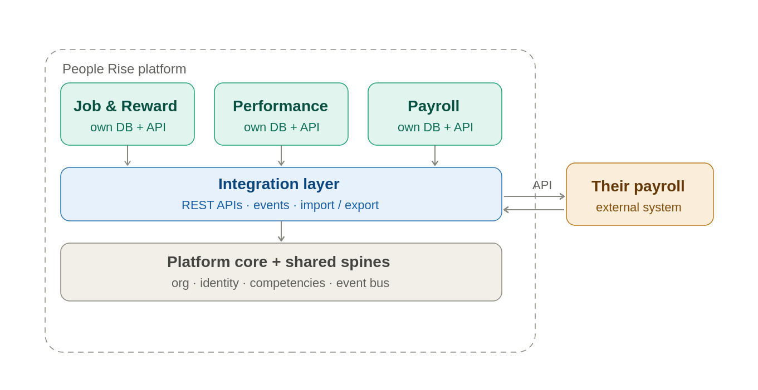
Products isolated by data, connected by contracts; one controlled door to the outside.
This is what lets the suite sell à la carte: a customer can buy Job & Reward alone and it works, because it depends only on the core — not on Performance or Payroll existing. The locked rule makes it concrete: every product owns its data, pulls from siblings if present, and has a manual fallback if not.

Integrating an external system (e.g. their existing payroll)
You don't replace a client's payroll — you exchange data with it across the integration layer, three ways depending on how modern it is: an API connector (cleanest); file import/export (the universal fallback, the same CSV path built for the consulting snapshot — always works, even with an old on-prem system); or events/webhooks (richest, for systems that support it). An adapter sits at your boundary translating their format to yours, so their schema never leaks into your products.

Phase 1 case: hand them the structures you designed; consume the actual salaries they run.

How your own products interact
Three mechanisms, in order of preference:
- Events (default). Project Management publishes task.completed; Performance, Goals, and Financial Impact each subscribe and react, none knowing the others exist. “Compute once, consume many.”
- API contracts (when needed now). Salary Builder asks Job Architecture for a grade via its API — a direct, synchronous call against a stable contract.
- Shared spines (foundational data). Every product reads org structure and competencies from the core.
The property tying it together is graceful degradation: because products talk through contracts and events rather than reaching into each other, a product that isn't installed simply has no subscriber and no caller — the event goes unconsumed, the API is never called, nothing breaks. That single property is what makes both the à-la-carte model and the on-prem story work.

Tenant model: consulting practice vs. client (Model A → B)
The tenant is always the client organization — the org whose structure is being evaluated — in both operating models. The difference is only who holds the login. In Model A, consultants are granted cross-tenant access through the control-plane DB, so one consultant operates across many client tenants. In Model B, the client's own staff are granted access to their tenant. The A→B transition is therefore an access grant, not a data migration — same tenant database, same schema, no re-platforming. The control plane tracks engagement status (active vs. archived) so backups and migrations target only live tenants, even when many short Model-A engagements create many databases.

5. The Sellable Products (Final Packaging)
# | Product | Layer | Standalone value | Business model
1 | Job & Reward Design (Job Eval + Grading + Salary Design) | 1 | High | Consulting-led + software
2 | Core HR & Personnel | 0–2 | High (system of record) | SaaS
3 | Payroll | 2 | High | SaaS (compliance-heavy)
4 | Performance & Goals | 3 | Medium (richer integrated) | SaaS
5 | Project & Task Management | 2 | High (crowded market — win on integration) | SaaS
6 | Talent Acquisition (ATS + Assessment + Intelligence) | 2 | High | SaaS + premium AI
7 | Learning (LMS) | 2 | High (near-standalone) | SaaS
8 | Talent Management (Succession + Talent Risk) | 3–4 | Low standalone | SaaS (integrated)
9 | Insights (Heatmap + CEO Dashboard + Financial/ROI) | 4 | Low standalone | SaaS (integrated)
10 | Market Benchmark (future) | data | — | Premium data product

6. Deployment & Business Model
Recommendation: SaaS-first as the business model and default, but architect for both.
- The à-la-carte, recurring-revenue, easy-upsell motion is SaaS-native; on-prem one-time licensing fights the modular vision.
- The government / state-owned-enterprise channel changes the weighting: public-sector buyers in Egypt frequently require local hosting or on-prem for sensitive HR/salary data, and must navigate data-protection rules (PDPL).
- Keep architecture deployment-agnostic (containerized, API-separated products) so a single-tenant / private-cloud / on-prem option can be offered as a premium enterprise tier.
- Consider regional/local cloud hosting to neutralize residency objections without abandoning SaaS.
- Payroll is the riskiest thing to host (most sensitive data) — extra caution.

7. Recommended Starting Point & Roadmap

Why start with Job & Reward Design (Job Eval → Grading → Salary)
- Lowest dependency / fastest to build — needs no payroll, attendance, or heavy integrations. A job exists independently of who fills it, so the engine needs almost no operational data. Buildable by a small team.
- Methodology-led = showcases Farouk — the evaluation factors, the job-content questionnaire, and the grading logic are the product's intelligence. Hard for pure-software competitors to copy; this is the moat.
- Consulting-compatible — these are design tools, not daily-ops tools. Sell the outcome as a service (land with consulting), then sell the software to maintain/evolve it (expand with subscription). Ideal for relationship-driven sales.
- Direct fit for the government / SOE channel — state-owned enterprises modernizing or rationalizing bloated, inconsistent grading structures is exactly the work this trio does. Classic public-sector reform, and El-Delta's board relations open that door warmly.
- Lower data-sensitivity than payroll — you are designing structures, not holding everyone's live salary, so the on-prem/residency objection is softer for a first release.
- A coherent, sequential pipeline — Job Evaluation (score jobs) → Grading Structure (organize into families/levels/grades) → Salary Structure Builder (price the grades). Each multiplies the next; together they are the strongest natural bundle.

Phased Roadmap
Phase 1 — Land: Job & Reward Design
Job Evaluation + Grading Structure + Salary Structure (design mode) + the Skills & Competencies spine. Sell consulting-led through El-Delta's board relationships into state-owned enterprises. Use El-Delta itself as the reference implementation.
Phase 2 — Operationalize: Core HR + Personnel + Payroll
Once a client's grading and salary structures are designed, the natural next sale is “now run it.” Payroll and Personnel consume those structures. This is where recurring SaaS revenue deepens. Higher build cost (compliance), but now you have customers and their structures already in the system.
Phase 3 — Differentiate: Performance & Goals + Project/Task Management + Insights
The high-value intelligence layer (appraisals, continuous feedback, KPIs, Team Heatmap, Health Indicator, CEO Dashboard), built on top of an installed base that already has org, grades, and people loaded. Project & Task Management ships alongside Performance here because task and delivery data is what makes performance scoring, utilization, and burnout signals real rather than manually entered. Position it as “PM that feeds your people data,” not as a generic Asana/Jira competitor — the integration is the moat, not the feature count.
Phase 4 — Expand & moat: Talent Intelligence, LMS, Talent Management, Market Benchmark
Recruitment intelligence, learning, succession — and eventually the anonymized market-salary benchmark riding on the payroll installed base.

Reference: Salary Builder — Standalone vs Integrated
Feature | Standalone (no Payroll) | Integrated (w/ Payroll)
Market Positioning | ✓ | ✓
Salary Structure Design | ✓ | ✓
Internal Equity Analysis | ✗ needs real salaries | ✓
Salary Gap Analysis | ✗ (or manual entry) | ✓ auto
Compensation Planning | partial (dummy data) | ✓ real budgets + performance

8. Task Completion → Value Chain
A single completed task is the smallest unit of work in the suite, and also the seed of every higher-order number an executive cares about. One task-completion event fans out to update goal progress, inform a performance evidence panel, feed team-level utilization and burnout signals, and register a real cost. This fan-out — compute once, consume many — is what makes the integrated suite worth more than the sum of standalone tools, and it is the concrete expression of the founding thesis: human capital as an investment with a measurable return.

The fan-out
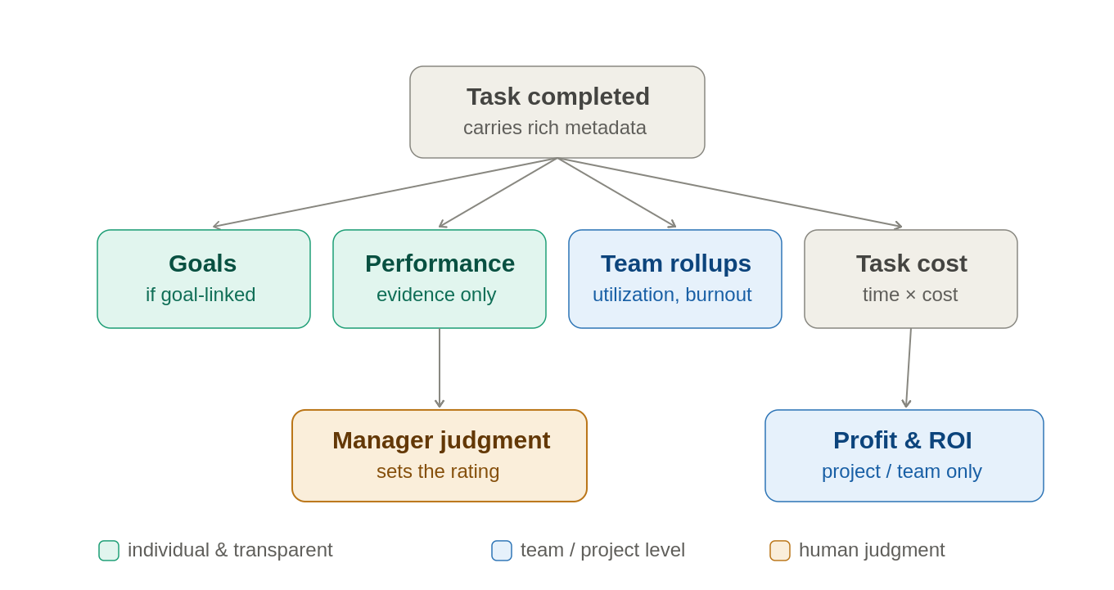
One task-completion event, four independent consumers. A product that isn't owned simply has no subscriber.
The links are not equally automatic, and that is deliberate. Goals update only for tasks linked to an objective; unmapped operational work advances nothing strategic and shouldn't pretend to. Performance receives evidence — throughput, rework rate, on-time delivery, complexity mix — not a score; a human manager weighs it and sets the rating, and the system records the evidence basis as an audit trail. Team signals (utilization, burnout) roll up at team level, where the gaming incentive is weaker. Cost is computed from time × loaded labour cost — always real, always honest.

Output vs. outcome
The distinction the whole model rests on: output is what was produced; outcome is what changed because of it. Closing 47 tasks is output; the bug rate dropping 30% is outcome. Output is individual and countable, so it lives in the evidence panel. Outcome is shared, slower, and tied to a goal, so it lives at the goal level — and that is what evaluation anchors on. A system that rewards output teaches people to maximise motion; one that anchors on outcome teaches them to ask whether the work mattered.

The revenue side: the Value Attribution Ladder
Cost is always real. Value is honest only at the level and tier the work supports. Rather than invent revenue for every task, each project or cost-center declares which value model applies, and ROI is computed only where the data supports it — and never at the individual level.
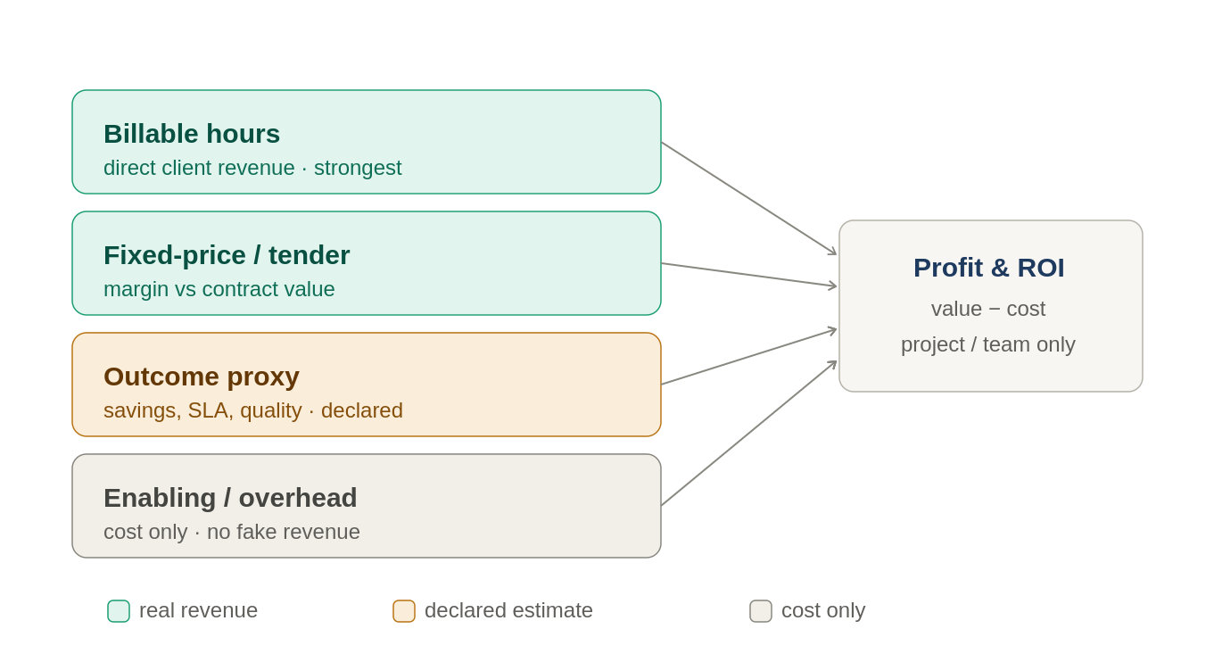
Four tiers of revenue honesty. A project picks the one tier that matches what it actually produces.
- Tier 1 — Billable hours → direct revenue. Professional services, IT outsourcing/offshoring, agencies, engineering firms — a large, growing sector in Egypt, often billing in USD/EUR. Revenue attributes to the project and even the task; ROI = billed revenue − loaded cost. Here utilization becomes a financial KPI, wiring the Heatmap straight to the P&L. Strongest, most defensible.
- Tier 2 — Fixed-price / tender → project margin. The dominant model for the SOE/government channel El-Delta opens. Win a tender worth X EGP, deliver a project; revenue attributes at contract/project level (not individual task). ROI = contract value − project cost. Also covers sales-driven revenue: a closed deal attributes to the deal and team.
- Tier 3 — Outcome proxy → value in native units. Internal work with no invoice: cost savings, SLA adherence, quality/defect improvement, risk reduction. The system does not fabricate revenue — it measures the outcome in its own unit; any monetary figure is stored and shown as the company's declared assumption, flagged as an estimate.
- Tier 4 — Enabling / overhead → cost only. Admin, support, long-horizon R&D. No revenue attribution. Reported honestly as investment/cost whose return shows up indirectly through the functions it enables.

Egyptian-market notes
- Inflation & currency. With high EGP inflation, nominal ROI across months misleads — cost today vs revenue recognised later isn't comparable. Margin must be date-aware with a real-vs-nominal view, and Tier-1 export work needs multi-currency contracts (bill USD/EUR, cost EGP). Recency discipline, same as the salary benchmark.
- Government tenders are the primary Tier-2 pattern — design contract/project-margin reporting around fixed-price delivery.
- SOE cost-accounting maturity. Public-sector loaded-cost definitions vary; let the customer configure what's included (base, allowances, social insurance, overhead).

The billing module
The billing module is the bridge that turns the top two ladder tiers into actual money. It sits between Project & Task Management, which owns the work, and Financial Impact, which wants the return. PM knows what was done; billing turns that into money owed and collected; Financial Impact subtracts cost and gets margin.
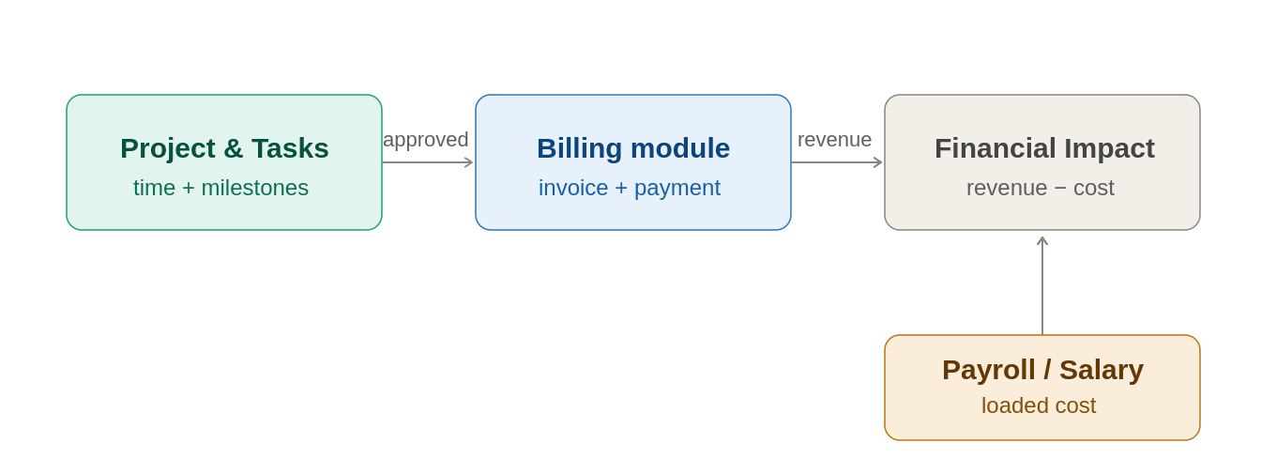
One-directional boundary. PM works fine without billing; the billable flag just goes unused.
The single most important design idea: margin = billing rate − loaded cost, both already in the suite. Cost comes from Salary Builder / Payroll; the billing rate is the revenue. The module is simply where those two meet on the same project and produce a number — which is why it belongs next to PM and feeds Financial Impact rather than being a standalone accounting tool.
Core objects (the whole spine). Five things talking to each other: a rate card (what an hour/role/project is worth, and in which currency), a billing setup on each project (model, contract value, client), timesheets (time against tasks, each flagged billable or not), invoices (drafted from approved billable time or reached milestones), and payments (what's actually collected). Everything else is refinement on top.
Billing models — mapped straight to the ladder. Keep it to three: time & materials (billable hours × rate) is Tier 1, the export-services model; fixed-price / milestone (a contract worth X, invoiced as milestones complete) is Tier 2, the government-tender model; retainer (a flat recurring fee) covers ongoing support. Each project picks one model at setup — the same moment the value-attribution tier is declared, so the two decisions collapse into one.
The PM boundary. PM owns projects, tasks, time, capacity, milestones. Billing reads from PM (approved billable time, milestone-completion events) and writes back almost nothing except a “billed” status so time isn't invoiced twice. Time passes through an approval step before it becomes billable — the same manager-approval discipline used elsewhere — and the boundary stays one-directional so PM never depends on billing existing.
Invoice lifecycle, kept simple. Draft → issued → paid, with partial and overdue states. The system drafts invoices automatically from billable time or milestones; a human reviews and issues them (never auto-issue to a client). Payment tracking marks paid/partial/overdue with aging buckets (30/60/90 days) — the AR/aging view surfaces the gap between billed and collected, which matters in a market where government clients pay slowly.
Egyptian must-haves (table stakes, not refinements).
- ETA e-invoicing. Egypt's Tax Authority runs a mandatory electronic invoicing system; real invoices must be submitted in a defined format. A first-class compliance integration and a credibility point with serious buyers — verify current ETA requirements and thresholds before building, as they've phased in over time.
- VAT & withholding. Egyptian VAT on the invoice, plus withholding tax that government and large clients apply at source.
- Multi-currency & FX. Tier-1 export work bills in USD/EUR while cost sits in EGP. Capture a rate per invoice and a clear rule for which FX rate/date is recognised — a margin at last quarter's rate is fiction.
- Retention & slow payment. Government fixed-price contracts often hold a retention percentage until completion and pay on long cycles. A retention field plus the aging view handle the months-long gap between “delivered” and “paid.”
MVP vs. later. First cut: rate cards, billable time from PM with approval, the three billing models, draft-invoice generation, mark-paid, and project margin out to Financial Impact — that alone makes Tiers 1 and 2 real. Defer: ETA e-invoicing integration, full multi-currency FX recognition, revenue-recognition rules, dunning/reminders, retainer automation. The MVP proves the margin story; the later pieces make it compliant and complete.

Architecture consequence
Build this event-driven: emit one task.completed event carrying its metadata, and let Performance, Goals, and Financial Impact each subscribe and react — don't have each product poll or recompute. The task data model must be richer than a completion boolean: linked goal, billable flag, complexity/effort, estimate-vs-actual time, rework/reopen flags. And the value side needs a revenue input — the billing module described above — which is a new integration boundary (and eventually an ETA e-invoicing and ERP/accounting connection) worth planning for now.

The guardrail
Individual-level ROI and profitability are explicitly out of scope. ROI rolls up to project and team level only. This is both statistical honesty (individual revenue attribution is noisy and ignores collaboration and enabling work) and an ethical/legal necessity — in the Egyptian and SOE context especially, a dashboard reducing a person to a profit figure is dynamite. The return is real at the team/project level, defensible to a CFO, and never pretends to price a human being.

9. Questions for Farouk (HR Methodology Parking Lot)
The high-level decisions are now locked in Section 2. What remains below is the design-phase methodology backlog Farouk owns — the detailed work behind those decisions. Three items are genuinely still open and strategic: (1) Farouk's point-factor upskilling and the calibration back-test against 6–10 known El-Delta jobs; (2) defining the job families and placing existing roles into the level-by-family grid; (3) the pricing model, deferred until after launch.

Job & Reward Design (Phase 1 — most urgent)
- Job Evaluation methodology: which methodologies out of the box, and the exact factor definitions + level scales for each (load-bearing — drives grading and salary).
- The job-content questionnaire: the actual questions, and how each answer maps to factor scores. Core differentiator.
- Whether answers map to factors via simple rules or weighted combinations.
- Promotion Rules vs. Progression Rules: precise criteria for each, and what a promotion triggers downstream (grade change → salary band change → comp event).
- Does El-Delta have existing job families/levels/competency framework, or are we designing from zero?

Skills & Competencies Spine
- Competency level scale: uniform across all competencies (simpler, integrates cleaner) or per-competency custom?
- Certification → competency mapping rules; which certs are compliance-mandatory for which roles.

Compensation
- Band positioning policy: lead, match, or lag the market? Compa-ratio methodology.
- Internal Equity Analysis methodology — especially if it touches protected classes; findings can be legally sensitive. Define with HR + legal; do not build without input.
- Compensation Planning: how do performance scores map to merit % (the merit matrix)?

Performance
- The three pillars (objectives/competencies/behaviors): weighting, and whether it varies by role/grade.
- Who sees the Performance Health Indicator, and does the employee see their own?
- Burnout signals: what should and should not feed it (compute once, display in Heatmap + Health Indicator).
- Should attendance feed into performance at all, and how?

Payroll / Compliance
- Egyptian tax, social insurance, labor law specifics (he or a finance person owns this).

Task → Value Chain
- How heavily does task evidence weight the objectives pillar, and should it touch individual ratings at all, or stay at team level?
- For each department/project, which value-attribution tier applies (billable, tender, outcome proxy, or cost-only)?
- For Tier 3 outcome proxies: which outcomes count, and who is allowed to attach a monetary estimate to them?

10. Decisions for the Technical / Business Side
- Pricing model: per-employee-per-month? per-product? tiered? (shapes architecture — need usage metering)
- Multi-tenancy approach: shared DB with tenant isolation vs. DB-per-tenant (foundational, painful to change later; also determines how easy on-prem is)
- Market-data sourcing model: customer-import (v1) → own anonymized benchmark (long-term moat). Benchmark needs scale + consent + anonymization thresholds first.
- Self-evaluation immutability in the data model (two parallel records — employee self-eval + manager assessment — not one editable record).
- Capacity model (where “100% utilized” is defined) — lives in Project Management, consumed by Heatmap; leave-adjusted via Personnel.
- Graceful degradation spec for cross-product views (e.g., Heatmap shows only the performance axis without Project Management, with an upsell hook to connect it).
- Hay Method IP: verify what can be branded/replicated vs. offered as configurable point-factor before shipping. Do not ship “Hay” by name without checking.
- Build one configurable evaluation engine; Hay/Point-Factor are presets, not separate code paths. Same for the questionnaire (configurable per methodology).
- Event-driven backbone: emit a task.completed event; Performance, Goals, and Financial Impact subscribe (compute once, consume many). A product that isn't owned simply has no subscriber.
- Task metadata model: linked goal, billable flag, complexity/effort, estimate-vs-actual time, rework/reopen — richer than a completion boolean, or none of the value chain means anything.
- Revenue input: a lightweight billing/contracts module in Project & Task Management, or an ERP/accounting import — a new integration boundary the suite doesn't have yet.
- Inflation / currency handling: date-aware margin, real-vs-nominal views, multi-currency contracts for export billing.

11. Cross-Cutting Principles to Hold Onto
- Data flows up. Operational products produce signals; analytics products synthesize them. Never rebuild Layer 4 analytics inside a Layer 3 product.
- If a metric needs financial data to compute, it is Insights — not Performance.
- Compute shared signals once (burnout, gap, health indicator, utilization), display in many places.
- Some products are operational SaaS (Payroll, Personnel, Performance); some are design tools that pair with consulting (Job Eval, Grading, Salary design). Different pricing, sales motion, and delivery — a richer business, not a problem.
- Cost is always real; value is honest only at the tier the work supports. Never fabricate individual revenue.
- ROI rolls up to project and team, never individual — for statistical honesty and ethical/legal safety.
- Output is evidence; outcome is what you evaluate. Equip human judgment with data; never replace it.

