RAYAN-8
A Custom 8-Bit Processor with a C++ Assembler
Experiential Learning Report
Course: Computer Organisation and Architecture
Student: Rayan Ahmad | Roll No: 25BTRCN166 | B.Tech CSE
Toolchain: Verilog HDL (Icarus Verilog), C++17, GTKWave, WSL
Version: Architecture Specification v1.0

Contents
1. Introduction and Objectives
2. Problem Statement
3. Architecture and Block Diagram
4. Instruction Set Architecture
5. Hardware Implementation
6. Assembler Implementation
7. Testing Methodology
8. Experimental Results
9. Screenshots and Waveforms
10. Conclusion and Future Scope
11. References

1. Introduction and Objectives
RAYAN-8 is a custom 8-bit processor designed in Verilog HDL, together with a C++17 assembler that translates assembly language into the machine code the processor executes. The project was built from an empty repository to a tested, working CPU that runs real programs, following a phased plan.
The objectives were:
- Design a working 8-bit CPU with a defined instruction set.
- Implement the datapath: ALU, register file, memory, and program counter.
- Build a multi-cycle control unit as a finite-state machine.
- Write a two-pass assembler that encodes assembly into machine code.
- Simulate and test every module and the whole processor.
- Run non-trivial programs (multiplication, Fibonacci, array maximum) and record the clock cycles.
Version 1.0 deliberately excludes pipelining, cache, and interrupts. Those are future extensions, not part of the first working processor.

2. Problem Statement
Design a processor from scratch: define its architecture and instruction set, implement the hardware, build the software toolchain, and prove the whole system works. The main challenge was not coding but removing ambiguity from the design first, so that later debugging targets code rather than undecided architecture. Every design choice, from the instruction format to the loop mechanism, was fixed and documented before hardware code was written.

3. Architecture and Block Diagram
The processor is 8-bit with a 16-bit fixed-length instruction word and an 8-bit address space.
Parameter | Value
Data width | 8 bits
Instruction width | 16 bits
Address width | 8 bits
General-purpose registers | 4 (R0-R3), 8-bit each
Instruction memory | 256 x 16 bits
Data memory | 256 x 8 bits
ALU | 8-bit
Status flags | Zero (Z), Carry (C)
Execution model | Multi-cycle FSM
Hardware description | Verilog HDL
Assembler | C++17
The datapath contains the program counter, an incrementer, a next-PC selection multiplexer, instruction memory, the instruction register, the control unit, the register file, an ALU operand-B multiplexer, the ALU, the flag register, a write-back multiplexer, and data memory. Figure 1 shows the complete block diagram.
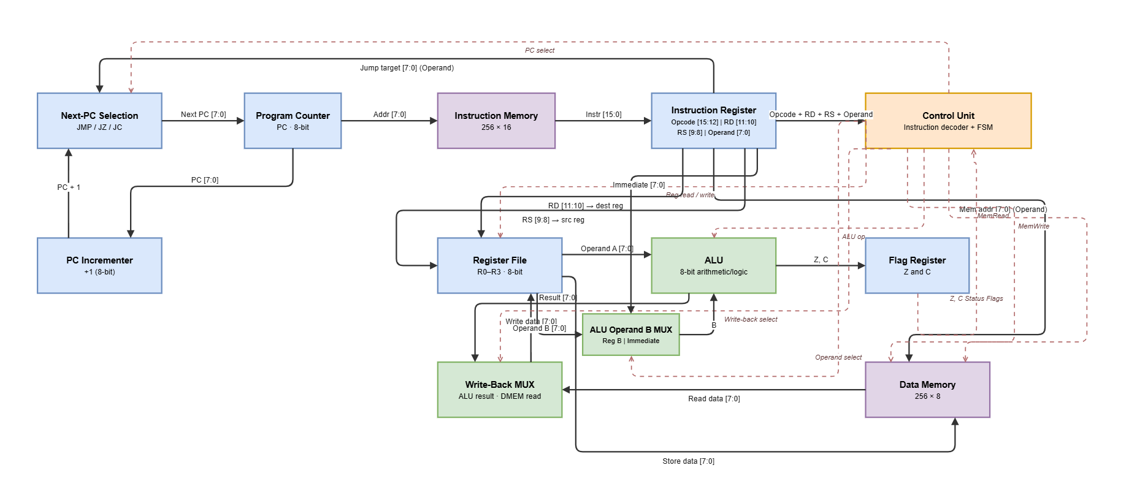
Figure 1. RAYAN-8 CPU datapath.

4. Instruction Set Architecture

4.1 Instruction format
Field | Bits | Width
Opcode | 15-12 | 4
RD | 11-10 | 2
RS | 9-8 | 2
Operand | 7-0 | 8
Registers are encoded R0=00, R1=01, R2=10, R3=11. The meaning of RD, RS, and Operand depends on the opcode. Unused fields are set to zero.

4.2 Opcode map
Opcode | Mnemonic | Type | Fields used | Flags
0000 | LDI | Immediate | RD, Operand | Z
0001 | ADD | ALU reg,reg | RD, RS | Z, C
0010 | SUB | ALU reg,reg | RD, RS | Z, C
0011 | AND | ALU reg,reg | RD, RS | Z
0100 | OR | ALU reg,reg | RD, RS | Z
0101 | XOR | ALU reg,reg | RD, RS | Z
0110 | NOT | ALU unary | RD, RS | Z
0111 | MOV | Data transfer | RD, RS | Z
1000 | LOAD | Memory read | RD, Operand | Z
1001 | STORE | Memory write | RD, Operand | none
1010 | JMP | Branch | Operand | none
1011 | JZ | Branch | Operand | none
1100 | JC | Branch | Operand | none
1101 | HALT | Control | none | none
1110 | reserved | - | - | -
1111 | reserved | - | - | -

4.3 Example encodings
Assembly | Binary | Hex
LDI R0, 15 | 0000 00 00 00001111 | 000F
ADD R0, R1 | 0001 00 01 00000000 | 1100
STORE R0, 20 | 1001 00 00 00010100 | 9014
LOAD R2, 20 | 1000 10 00 00010100 | 8814
JZ 8 | 1011 00 00 00001000 | B008

5. Hardware Implementation

5.1 Modules
File | Module | Role
rtl/alu.v | alu | 8-bit arithmetic/logic, Z and C flags
rtl/regfile.v | regfile | 4 registers, two read ports, clocked write
rtl/imem.v | imem | 256x16 instruction ROM, combinational read
rtl/dmem.v | dmem | 256x8 data RAM, clocked write
rtl/pc.v | pc | 8-bit program counter
rtl/pc_inc.v | pc_inc | PC + 1 incrementer
rtl/ir.v | ir | 16-bit instruction register
rtl/status_flags.v | status_flags | Z and C flag register
rtl/control_unit.v | control_unit | FSM and opcode decoder
rtl/cpu.v | cpu | top-level datapath integration

5.2 Control unit FSM
The control unit is a six-state Moore machine: FETCH, DECODE, EXEC, MEM, WB, and HALT. Each instruction takes a fixed number of clock cycles.
Instruction | State path | Cycles
ADD, SUB, AND, OR, XOR, NOT, LDI, MOV | FETCH DECODE EXEC WB | 4
LOAD | FETCH DECODE EXEC MEM WB | 5
STORE | FETCH DECODE EXEC MEM | 4
JMP, JZ, JC | FETCH DECODE EXEC WB | 4
HALT | FETCH DECODE HALT | 3

5.3 Key design decisions
- A PASS operation was added to the ALU so that LDI and MOV route their value through the ALU, keeping the write-back mux two-input.
- The ISA has no jump-if-not-zero. Loops count down with SUB and exit on the Carry (borrow) flag via JC.
- Memory uses direct addressing only, so the address is an immediate in the instruction. There is no register-indirect mode, which limits indexed loops.
- The register file has a synchronous reset so the CPU starts with all registers at zero.
- Control signals that feed a value used in a later state (alu_op, bsel) are driven by the opcode, not gated by the state, so write-back reads the correct value.

6. Assembler Implementation
The assembler (asm/assembler.cpp) is written in C++17 and runs in two passes. Pass one collects labels and assigns each instruction an address. Pass two encodes every instruction into a 16-bit word, resolving label references to their addresses. It supports decimal and hexadecimal immediates, register operands R0-R3, and labels for branch targets.
It reports clear errors for: unknown mnemonic, invalid register, operand out of the 0-255 range, undefined label, and wrong operand count. Its output is a hex file with one 16-bit word per line, which loads directly into the instruction memory. The assembler output was checked to be byte-for-byte identical to the hand-encoded machine code used by the hardware testbenches.

7. Testing Methodology
Testing was done at three levels, each with a Verilog testbench run by Icarus Verilog. A Makefile target compiles and runs every testbench separately, because a single $finish would otherwise stop the whole simulation.
- Unit level: each module (ALU, register file, memory, PC, IR, flags, control unit) has a dedicated testbench.
- ISA level: a regression runs small programs through the full CPU covering every opcode, including taken and not-taken branches.
- Experiment level: multiplication, Fibonacci, and array maximum run as real assembled programs, with the clock-cycle count recorded.
The interactive debugger (tools/rayan8-debugger.html) reimplements the same ISA and FSM in JavaScript. It was verified to produce identical final states to the Verilog for all four sample programs, so it can be trusted as a visual model of the hardware.

8. Experimental Results

8.1 Verification summary
Fourteen testbenches run with 166 assertions, all passing.
Testbench | Checks | Result
alu_tb | 13 | PASS
control_unit_tb | 63 | PASS
regfile_tb | 9 | PASS
imem_tb | 6 | PASS
dmem_tb | 5 | PASS
pc_tb | 5 | PASS
ir_tb | 5 | PASS
status_flags_tb | 5 | PASS
cpu_tb | 6 | PASS
cpu_isa_tb | 24 | PASS
cpu_integration_tb | 6 | PASS
cpu_mult_tb | 5 | PASS
cpu_fib_tb | 6 | PASS
cpu_arraymax_tb | 7 | PASS

8.2 Program results
Program | Inputs | Result | Cycles
Integration | a=10, b=20 | R0=30, RAM[100]=30, branch taken | 37
Multiplication | 7 x 5 | R2 = 35 | 108
Fibonacci | fib(10) | R0 = 55, R1 = 89 | 306
Array maximum | [3,42,17,8,25] | R0 = 42 | 133
Cycle counts are measured from reset release to halt. The JavaScript debugger reports the same programs within one cycle, a difference in how the final halt cycle is counted, not a behavioral difference.

9. Screenshots and Waveforms
Figure 1 (section 3) shows the CPU datapath diagram. Two further captures belong here and should be added from your own machine:
- GTKWave waveform of the multiplication or Fibonacci run, opened from build/cpu_mult.vcd or build/cpu_fib.vcd, showing PC, opcode, registers, and flags changing per cycle.
- A screenshot of the interactive debugger (open tools/rayan8-debugger.html in a browser), showing the datapath highlight, disassembly, registers, and RAM.
These are left as placeholders rather than fabricated images. The .vcd files are generated by the testbenches and are ready to open in GTKWave.

10. Conclusion and Future Scope
RAYAN-8 v1.0 is complete and verified. A custom 8-bit processor, its instruction set, a multi-cycle control unit, and a working assembler were built and tested end to end, and the system runs real programs correctly with recorded cycle counts.
Future extensions, in rough order of value:
- Register-indirect addressing so arrays can be scanned in a loop rather than unrolled.
- More registers by widening the RD and RS fields, or a larger address space.
- A signed overflow flag to support signed comparisons.
- Pipelining and cache studies as the advanced (Phase 9) extensions.
- Interrupts and an I/O model.

11. References
- S. Harris and D. Harris, Digital Design and Computer Architecture, 2nd ed., Morgan Kaufmann, 2012.
- D. Patterson and J. Hennessy, Computer Organization and Design, 5th ed., Morgan Kaufmann, 2014.
- Icarus Verilog simulator documentation, https://steveicarus.github.io/iverilog/.
- GTKWave waveform viewer documentation, https://gtkwave.sourceforge.io/.
- ISO/IEC 14882:2017, Programming Language C++.
- A. Waterman et al., The RISC-V Instruction Set Manual, Vol. I, UC Berkeley.

