Make sure PCB passes DRC
Make Gerbers
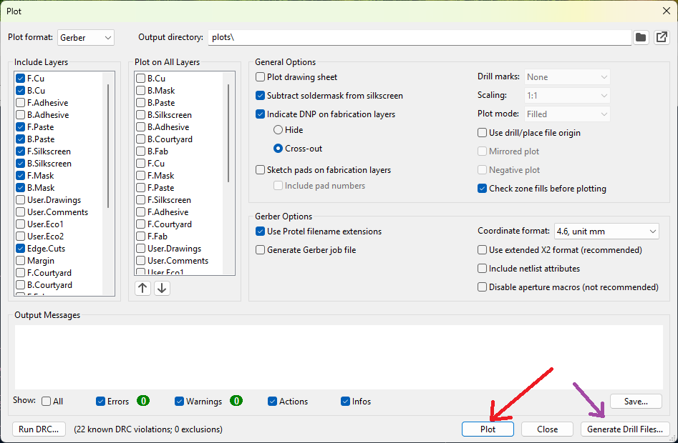
Make Drill Files
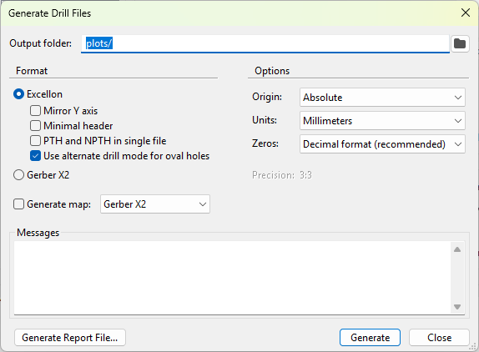

Compress all files in Plots folder to ZIP and rename zip file
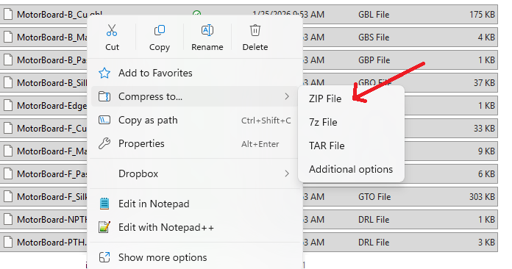
Create/double check BOM.xlsx of the parts JLCPCB will mount; looks like this
Comment | Designator | Footprint | LCSC
4.7uF | C1,C2,C10,C11 | 0805 | C1779
22uF | C5,C6,C7 | 0805 | C45783
0.1uF | C3,C4 | 0603 | C1590
680uF | C8 | SMD,D10xL10.5mm | C2980172
330uF | C9 | SMD,D10xL10.5mm | C5155335
120 | R4 | 0603 | C22787
1.5k | R2,R5 | 0603 | C22843
3.3k | R1 | 0603 | C22978
10k | R3 | 0603 | C25804
33k | R6,R7 | 0603 | C4216
TCAN1057AVDRQ1 | U6 | SOIC-8 | C3235000
LM2596S-5.0/NOPB | U1 | TO-263-5 | C116713
LED | D1, D2 | SMD,1.6x0.8mm | C5879214
BAT60AE6327 | D3,D4 | SOD-323 | C513277
DRV8871DDAR | U7,U8 | SO-PowerPad-8 | C75864
SMDRI127-330MT | L1 | SMD,12.3x12.3mm | C9400
B530C-13-F | D5 | SMC(DO-214AB) | C110488
LaunchPad | J3_J1, J2_J4 | SMD,P=2.54mm | C3294468
LM2937IMP-3.3/NOPB | U2,U4 | SOT-223 | C140265

Generate Placement file
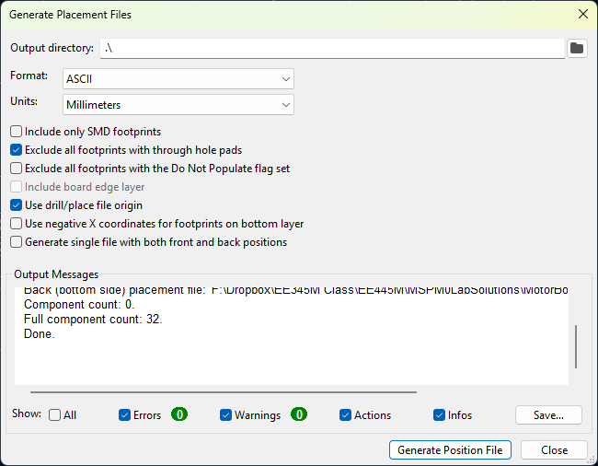
Edit pos file to this format, yellow are entries needing editing
Designator | Mid X | Mid Y | Layer | Rotation
C1 | 100.4570mm | -73.5660mm | top | 270
C2 | 100.3300mm | -78.3920mm | top | 90
C3 | 66.8020mm | -53.0860mm | top | 180
C4 | 71.3870mm | -45.7200mm | top | 0
C5 | 121.9200mm | -53.7870mm | top | 270
C6 | 112.3950mm | -98.2320mm | top | 90
C7 | 141.2240mm | -74.4830mm | top | 90
C8 | 57.2770mm | -67.8270mm | top | 90
C9 | 82.4230mm | -67.9360mm | top | 90
C10 | 139.7610mm | -48.7680mm | top | 0
C11 | 139.7610mm | -44.1960mm | top | 0
D1 | 66.6750mm | -107.4420mm | top | 180
D2 | 132.4610mm | -109.9820mm | top | 180
D3 | 77.3430mm | -115.6970mm | top | 0
D4 | 77.3430mm | -110.4900mm | top | 0
D5 | 58.0390mm | -81.6320mm | top | 90
J2_J4 | 92.7100mm | -54.5950mm | top | 0
J3_J1 | 92.7100mm | -97.7750mm | top | 0
L1 | 70.3880mm | -85.5980mm | top | 0
R1 | 63.1190mm | -107.4420mm | top | 0
R2 | 128.5250mm | -109.9820mm | top | 0
R3 | 127.7620mm | -40.8310mm | top | 90
R4 | 74.8670mm | -43.0530mm | top | 0
R5 | 111.9510mm | -113.2840mm | top | 0
R6 | 121.9200mm | -57.7210mm | top | 90
R7 | 112.3950mm | -94.2970mm | top | 270
U1 | 70.3580mm | -71.424mm | top | 270
U2 | 109.7030mm | -76.1860mm | top | 180
U4 | 133.2480mm | -46.4960mm | top | 0
U6 | 66.5480mm | -48.0500mm | top | 0
U7 | 117.0940mm | -55.5810mm | top | 0
U8 | 117.0940mm | -96.4380mm | top | 180

Upload .zip “Add gerber file” Standard PCB/PCBA
FR-4
Qty
Industrial
Single PCB
1.6mm
Green color
White silkscreen
FR4
Leadfree
Others default
Select PCB assembly
Economic
Top side only
Default options
Add BOM file (BOM file)
Add CPL file (position file)
BOM and pos files to JLCPCB
Double check position and rotation, fix position file and reupload as needed

