# Finances

This module is the one that will gather all the payments and activity and will assign them to the corresponding merchants.

There are several kinds of activities:

* Regular Payments: These are the payments we receive through Credit Card transactions.
* Processor Adjustments: These are payments we apply in the system in cases when the system does not capture a regular payment that was made by the merchant.
* Cash/Check/Transference Payments: These are payments the merchant makes, either because they have a Payment Agreement or they want to pay the loan in cash to end the contract sooner.
* Refund: This is money we give the merchant in cases when our system takes more money than it should at the end of the loan (because the Processor company didn’t mark the loan as paid in full or whatever reason).
* Renewal Repurchase: Since we can renew a contract as soon as it has paid 60% of the total owed amount, most of the times the previous contract has a pending amount once we renew it, so we use part of the new MCA to pay off the pending amount of the previous contract. This is a repurchase.
* Credit Transference: This is transference of a certain amount that has been paid in one merchant to another merchant. For example if Merchant A paid $100 of his contract, we can transfer that credit to Merchant B.
* Cash Processing: There are certain merchant that have special agreements with us and don’t make regular payments through Credit Card transactions. Instead, they pay us in cash the same amount we expected to receive through Credit Cards. This is not the same as a regular Cash Payment, because the Cash Processing is done within the parameters of the offer. The way this should work is, at the time that we add the Processor Company affiliate numbers to the merchants, we should have an option to mark the merchant as Cash Processing, even if we still add the affiliate number. For example, let’s say Merchant A has an affiliate number for VisaNet and one for CardNet, and we have both in the system. If we have a special agreement with the client we can mark the client as Cash processing and the system will stop expecting payments from Credit Cards and will start expecting Cash payments. If at any time we want to stop receiving cash and start receiving Credit Card transactions, we would just need to mark the affiliate numbers as active.

There should be a finances screen that will let us add these activities (except for the Regular payments, which can only come from Credit Card transactions). In this screen, we would click a button called Add Activity, that will ask us what kind of activity we want to add and will show us a drop list of the available options. We need to specify the ID of the merchant, the amount, and the date of the activity. In the case of Processor Adjustments, we need to specify the affiliate number that processed that specific payment.

Once an activity has been added, the system needs to automatically save a note to the merchant with the type of activity, the amount and the date of the activity.

This is the screen where we add the activities:



In addition to this, in this module we should be able to see a list of all the activities, by doing a search with specific parameters of the payments we want to see. This list should be exportable to Excel.

This is how the activities screen looks now:

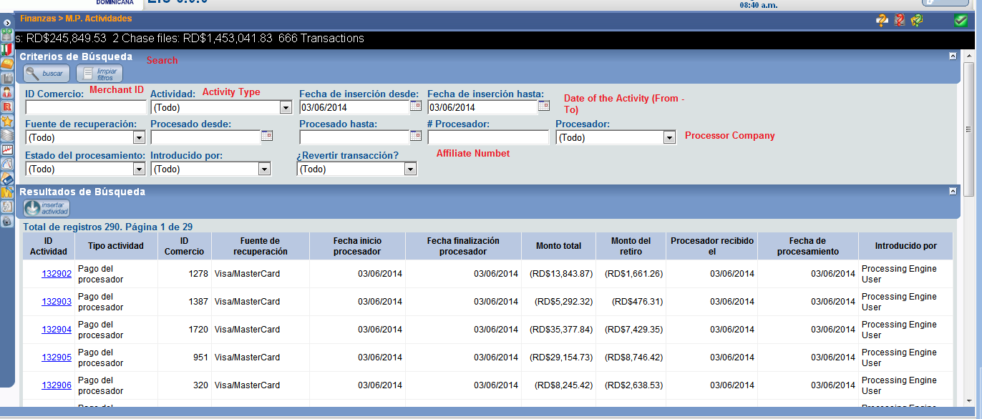

These are the parameters we need to see in the list:

* Activity ID
* Activity type
* Merchant ID
* Processor Company
* Date of the activity
* Total Amount
* Price Amount
* Capital Amount
* Processing date
* Added by (User)

So, in the end, this screen should look much like the Activity tab in the Merchant screen:



Except that we the first three columns should be the Activity ID, Type of activity and Merchant ID.

## Transfer Files

Much like the request and answer of the Credit Card volumes, we request and receive the transactions for the funded affiliate numbers. Every day our system sends a WSF files with all the active Merchants, the retention percentage and the pending amount to the Processor Companies, who will, in turn, answer with a PAF files with the transactions for every Merchant. Is from this PAF file that our system pulls the Credit Card transactions.