AvanzaMe – Merchant Cash Advance

Solution Outline

Version 1.0 – 6/28/2014



# Document Status and Revision History

|  |  |  |  |
| --- | --- | --- | --- |
| Version | Author | Issue date | Revisions |
|  |  |  |  |
|  |  |  |  |
|  |  |  |  |

**Document Authorizations**

|  |  |  |
| --- | --- | --- |
| Name | Position | Email |
|  |  |  |
|  |  |  |

# Document Purpose

This document is intended to provide high level requirements of *AvanzeMe.com*. This document contains outline of high level design of the solution. For the technical design document to be completed following should be completed and signed off with client manager:

1. Business requirements
2. Functional requirements
3. Relevant Enterprise standards

Each section of the document contains notes/suggestions these suggestions.

### Table of Contents

Document Purpose 3

Table of Contents 4

1. Project Summary 6

2. Application Design 7

2.1. Interfaces 7

2.1.1 Sales Representatives 7

2.1.2 New System Users 7

2.1.2.1 Prequal Work flow 7

*Note: 8

2.1.2.1.1 List of Merchants Pending for Review 8

2.1.2.1.2 Document Scanning 9

2.1.2.1.3 Data Entry 10

2.1.2.1.4 - Credit Card Volumes 13

2.1.2.1.5 - Scoring Job, Merchant Evaluation 14

2.1.2.1.6 - Offer Creation 14

2.1.2.1.7 - Offers Pending for Acceptance 16

Additional Information 17

2.1.2.2 Contract Work flow 17

2.1.2.2.2 Verification Call 19

2.1.2.2.3 Data Entry 20

2.1.2.2.4 Verification Tasks 22

2.1.2.2.4.1 Bank Information Verification 22

2.1.2.2.4.2 Corporate Documents Verification 23

2.1.2.2.4.3 Commercial Name Verification 23

2.1.2.2.4.4 Landlord Call 24

2.1.2.2.5 Review Task 24

2.1.2.2.6 Contract Task 25

2.1.2.2.7 Funding Task 25

2.1.2.2.8 Final Validation 26

Notes on SalesForce 26

Final Notes 26

2.1.2.3 Renewals Work flow 26

2.1.2.3.1 List of Merchants that Qualify for Renewal 26

2.1.2.3.2 Merchant Evaluation 27

2.1.2.3.3 Document Verification 27

2.1.2.3.4 Offer Creation and Acceptance 28

2.1.2.3.5 Renewal Review 28

2.1.2.3.6 Contract 29

2.1.2.3.7 Funding 29

2.1.2.3.8 Final Validation 29

2.1.2.3.9 Notes on Credit Card Volumes 30

2.1.2.3.10 Notes on SalesForce 30

2.1.2.3.11 Final Notes 30

2.1.2.4 Merchant Screen 30

2.1.2.4.1 Business Tab 30

2.1.2.4.2 Landlord Tab 32

2.1.2.4.3 Contacts Tab 33

2.1.2.4.4 Owners Tab 33

2.1.2.4.5 Profiles 34

2.1.2.4.6 Documents Tab 35

2.1.2.4.7 Activity Tab 35

2.1.2.4.8 Statements Tab 35

2.1.2.4.9 History Tab 37

2.1.2.4.10 Risk Evaluation Tab 37

2.1.2.4.11 Contract Tab 37

This new pop up should contain these tabs: 38

2.1.2.4.11.1 General Tab 38

2.1.2.4.12 Contract Activity tab 38

2.1.2.4.13 Sales Representative Tab 38

2.1.2.4.14 History Tab 38

2.1.2.4.15 Collections Tab 40

2.1.2.4.16 Final Notes 40

2.1.2.5 Permissions controls: 40

2.1.2.5.1 Permissions and Roles 40

2.1.2.5.2 User Profiles 41

2.1.2.6 The Collections Work flow 42

2.1.2.6.1 The Collections Screen 43

2.1.2.6.2 Datacrédito 43

2.1.2.6.3 Affiliations 43

2.1.2.6.4 Documents 44

2.1.2.6.5 Landlord 44

2.1.2.6.6 Payment Agreement 44

2.1.2.6.7 Legal 45

2.1.2.6.8 Generate Letter 46

2.1.2.6.9 Activity 46

2.2. User Management 46

2.3. Data Output 47

2.4. Data Management 47

2.5. Coding Requirements 47

# 1. Project Summary

The new system will automate existing manual work done during loan application processing. A series of tasks are performed by Organization Employees for giving loan to a merchant/customer. Currently, these tasks are assigned manually. Files are moved to next officer once a task is completed by one officer.

These tasks are assigned based on their roles. The new system will automate process of task assignments. The Completed tasks will be moved in queues of next person to review application. Credit check of the merchant will be automated by using credit reports. Also, collection of Credit Card Sales will be automated using VisaNet and CardNet processors APIs. However there will be provision to manually enter statements.

New system will also be integrated with SalesForce.com. SalesForce and New System will be synced on regular basis to provide updated status to sales reps. Sales reps will be able to track status of merchants/contracts in sales force.

New system will send out notifications in form of emails. Email notifications will be sent out to predefined email groups. System will also have provision to add new persons to email sender lists.

# 2. Application Design

The new system is intended to manage tasks for loan officers. New system should fetch new leads from the SalesForce.com.

## 2.1. Interfaces

The New System will provide interfaces for 2 types of users:

## 2.1.1 Sales Representatives

Sales representatives will not be interacting directly with New System. However, Inputs done by sales rep in SalesForce.com will be treated as initial input for new system. Data from SalesForce will be imported into new system. Status of imported merchants and their contracts will be

## 2.1.2 New System Users

New system will have different roles viz. Underwriters, contract administrators etc. These users interact with system directly. System users will work on tasks assigned to them by Job scheduler. Multiple tasks can be queued for a user.

Each user will have access to a number of screens depending on their role and permissions. There are two main sections of application:

## 2.1.2.1 Prequal Work flow

Prequal work flow screens lists tasks for merchant creation. The new merchants are fed into system from sales force. For each merchant a series of tasks need to be completed as a pre-requisite. This includes verification of merchant information like Gross Yearly Sales. Below diagram shows the list of steps and their relation:

**1. List of3. merchants pending for** review

**2. Document Scanning**

**3. Data Entry**

**4. Send and Receive VisaNet and CardNet Request**

**5. Merchant Evaluation**

**6. Offer Creation**

**7. Offers Pending for Acceptance**

**8. Offer Acceptance**

### *Note:

Actions: There will be four buttons in each screen:

* 1. Complete - Complete the current step.
  2. Save - Save data but current step is not completed.
  3. Kick Back - Go to a previous step in work flow. All the information should be filled in with the old information, but if the user edits it, it will use the new information. Usually to the person that completed the work flow tasks, but it should also let us choose among the available users when we choose to kickback.
  4. Decline - Decline contract.
  5. Skip step - Skip current step. Only for authorized user. To overrule the need to complete a certain step. We would just ignore the skipped step, but this cannot be used by every user, only admin or specific users that have this button can use it, also there should be a log of all the skipped tasks.

1. Work flow application will create a task for each step. These task will be assigned to users.
   1. Tasks will have following status:
      1. Completed
      2. Pending
      3. Pending CC Volumes
   2. All tasks should be completed to assign the next one, the only tasks that appear together are the 4 verification tasks in the contract work f low and the need to be completed before the review task is assigned.
   3. the assignment will be done like the original assignment. Randomly among all the users that have permission to work the task.
2. Roles cannot be changed unless all tasks are completed or reassigned to another user.
3. User with permission we could let a certain Role see the tasks for another Role and assign viewing or editing rights for these tasks

### 2.1.2.1.1 List of Merchants Pending for Review

Sales reps enter information about leads into SalesForce.com. Sales Reps convert lead into a potential merchant after he signs form in SalesForce.com. Only leads converted into potential merchant will be evaluated in new system

The first step will be to check for merchants pending for review. The way it should work is once a Sales Representative creates a merchant in SalesForce (clients that fill our form, not leads) and the feeding from SalesForce to the new system occurs, we should see a list of the created Merchants that have not been reviewed. Then we select one of those Merchants and start the review process. Once this process starts, the system should assign an ID number to the new merchant. For example, the first merchant will be ID 1, the second ID 2, and so on, unless the Merchant is being recreated for reevaluation purposes, in which case it will keep the ID that was assigned to it the first time it was created.

Here are few important checks for merchant creation:

1. Before adding a new merchant in system user need to check if merchant already exists in system.
2. Existing record search can be done by RNC, Merchant Name, Processor Affiliate Number, Owner Id Number or Owner last name. If no record were found a pop-up could come up that asks "would you like to create a new merchant" when yes, the required information to add this merchant to the queue would be Merchant Name and Sales Rep. Then all the other information will be filled manually in the Data Entry.
3. We also need the option to do this step manually. That is by manually adding a Merchant to the list, and every field that requires information from SalesForce will be filled manually. Check for existing record will still be performed on merchant details being entered manually.
4. The merchant will be linked to same SalesRep who converted lead to Merchant in SalesForce.Sales Rep can be changed during the data entry process, but it could be change after the merchant is created. Sales Rep of a merchant cannot be changed after funding. Anyone can change it if they have these privileges.
5. There should be privilege to add two sales reps to a merchant. Both the sales reps should be able to work on same merchant/contract. Sales Reps can be divided as “Primary” and “Secondary”. Categorization of sales re will affect splitting their commissions.
6. Sales Rep will not affect merchant scoring or funding process.
7. Once merchant is created system will assign an ID to merchant. If merchant already exists his ID will be used for reference. The new or existing Merchant ID will be updated in SalesForce.com.

**\*Note:** All users can add notes for merchant in new system.

### 2.1.2.1.2 Document Scanning

The second step is the Document Scanning, here we should be able to scan any document we have, but the only required document will be the Application Form, which we should be able to upload in PDF or any image format (it should allow us to scan PDFs, docs, xlsx, and any image file):

Our current Doc Scan screen looks like this (my notes in red):

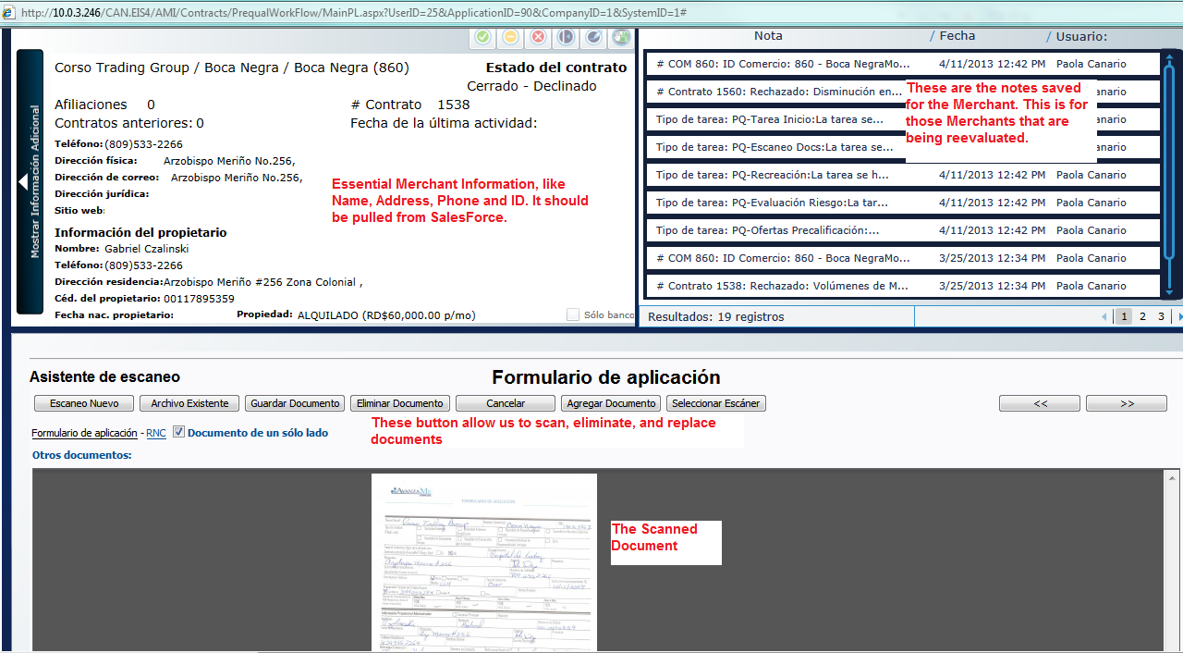

Uploaded documents will be linked to Merchants or contract depending upon type of document. Application form will be linked to a merchant. Users should be able to view documents in Merchants Profile screen.

**\*Note:** 1. Application Form is mandatory to upload.

2. The note should have a field above it that adds the default email address and lets us add any address we want.

### 2.1.2.1.3 Data Entry

The third step is the data entry. All this information should be filled from SalesForce, but we should be able to modify anything, in case we have to. The information we should have here is:

* Name of the Company
* Name of the Business
* RNC: This is the ID the government assigns to every company. It should have a maximum of 11 numbers.
* Address
* City
* Province: This should be a drop down list with the following options:
* Azua
* Bahoruco
* Barahona
* Dajabón
* Duarte
* Elías Piña
* El Seibo
* Espaillat
* Hato Mayor
* Independencia
* La Altagracia
* La Romana
* La Vega
* María Trinidad Sánchez
* Monseñor Nouel
* Montecristi
* Monte Plata
* Pedernales
* Peravia
* Puerto Plata
* Hermanas Mirabal
* Samaná
* Sánchez Ramírez
* San Cristóbal
* San José de Ocoa
* San Juan
* San Pedro de Macorís
* Santiago
* Santiago Rodríguez
* Santo Domingo
* Valverde
* Distrito Nacional
* Telephone Number: Dominican telephone numbers have 10 digits in the format: (xxx) xxx-xxxx.
* Email
* Industry Type: We will annex all the options that will make up this drop list. This comes from the predetermined MCC codes.
* Type of Property: This should be a drop down list with two options, Owned and Rented.
* Rent Amount: This should be a currency field.
* Gross Yearly Sales: This should be a currency field.
* Processor Company: Either CardNet or VisaNet.
* Affiliate Number: The affiliate number for the business with either CardNet or VisaNet (or both). We should be able to add more than one affiliate number. This is the number the Processor company identifies the business with. It affects the Merchant because the Processor Company will send us CC sales for that number exclusively, and it is through that number(s) we would be taking payments. We could add more than one processor number for more than one processor.

Then we should have the Owner’s Information in the same screen:

* Name
* Last Name
* ID or Passport Number: A maximum of 11 characters, either numbers or letters.
* Phone Number
* Cell Phone Number: In the format (xxx) xxx-xxxx.
* Address
* Email

Users should be able to add multiple owners for a merchant.

Our current Data Entry Screen looks like this:

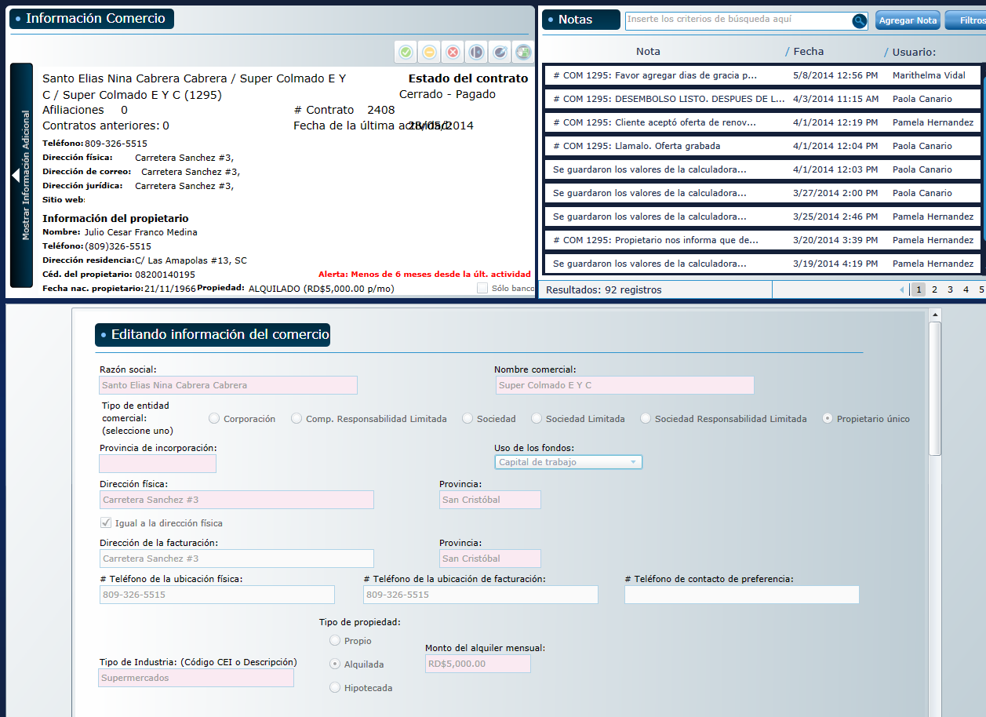

As you can see, the top part is very similar to the Doc Scan screen, and bellow is all the information I have indicated above.

The name of the company is the legal name of the company that owns the business and the name of the business is the name the business uses for its operations. For example, Company A could own Restaurant Food, but it could also own Store One, which would be created as a separate merchant. So we would have two merchants, Store One and Restaurant Food, owned by the same company. This is called affiliations, and affiliation is when a Legal Name has more than one business. this way we can search a merchant by affiliations to see all their related business and performance.

All the information in Data Entry page is required. However, All fields can be edited by authorized users should be able to edit information on Data Entry screen.

**\*Note:** 1. OwnerID is unique, It's the number the Government assigns to every citizen. 2. The system should check for Merchants with similar information in this fields and show us a list so we can manually decided. Also, we should have a search box where we can type a RNC, Owner ID, Affiliate number, etc, and it will show us a list of every Merchant that matches any of these fields, and then we will decide if it's a duplicate or no. 3. See No.2.

2. In our system, every Merchant is one Business. A company or an owner might have more than one Merchant and, thus, get more than one loan. 2. The person signing the contract will be determined by the legal documents the client provides.

### 2.1.2.1.4 - Credit Card Volumes

At this point the system should send a request to VisaNet and CardNet for the credit card volumes, then, once we receive the request, the work flow continues. There are times when we receive the volumes outside the normal process, through email or some other way, which is why we need to have the option, in our system, to manually type the credit card volumes, so that it can go on to the scoring job.

Once the Merchant is created, the system will automatically send a Request through an MRF file to the Credit Card Processor Company. This MRF file contains the Date of the Request, the ID of the Merchant in our System, the Merchant’s affiliate number with the Processor and the Company ID. System should request maximum available data from processors. Visanet usually sends no more than 12 months, but cardnet has sent more than 20 months of data

Also, at this point we would like the system to automatically send the physical Form we scanned earlier to CardNet (but not to VisaNet), perhaps through the same way we will send the Volumes request. (This is something we will work out in detail later)

Here is an example of an MRF file:

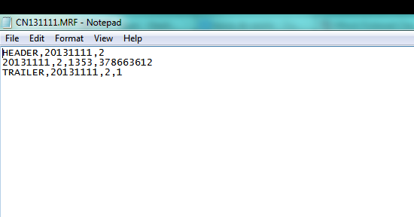

The Processor Company will respond with an SPF file containing the monthly credit card volumes of the merchant requested. Here is an example of an SPF file:

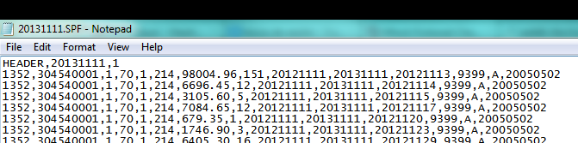

### 2.1.2.1.5 - Scoring Job, Merchant Evaluation

After we have received the Credit Card Volumes through the SPF file or manually introduced, the new task is going to be the Merchant Evaluation task. Here our officer will generate the score for the Merchant, take a look at the Datacrédito and the Credit Card volumes, and then decide whether to go to the Offer Creation task or decline the Pre-qualification.

Every Datacrédito report we pull should be saved as a Document in the Merchant. And we should have a list of every Datacrédito report we have ever pulled for the Merchant and be able to access them at any time.

### 2.1.2.1.6 - Offer Creation

Here we create the offers. One Merchant could have any number of offers saved. To create the offer we use a Calculator Application.

This is how the calculator currently looks:

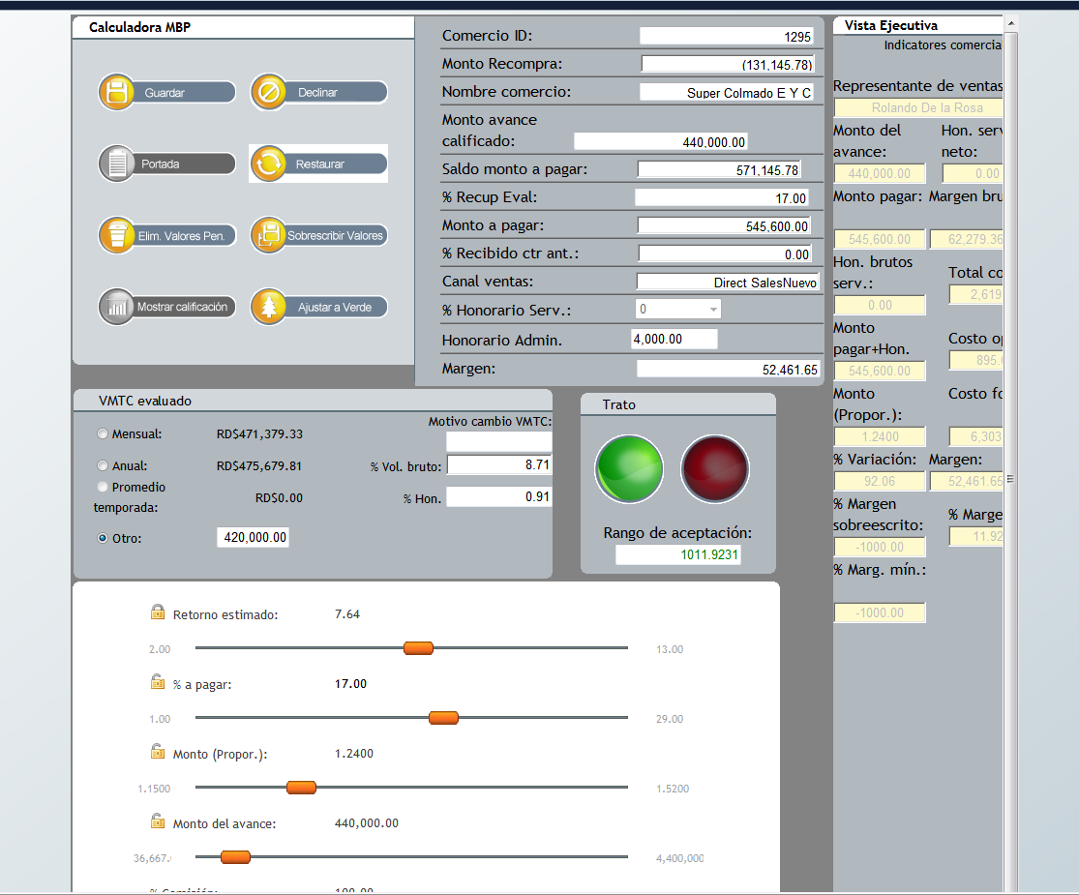

This is an idea of what it could look like (simplified):



*This should pull the Gross Yearly Sales automatically from the information entered in the Merchant Creations process, but it should let us change it manually in case we need to. The Average Monthly Credit Card Sales should be calculated from the volumes. It should also let us change in manually if we need to.*

*This is the Offer Calculator. The components of the offer are the Time in months the contract is expected to last, the loaned and owed amount, the proportion (This is the Owed Amount divided by the Loaned Amount, for example, if the loan is going to be 100, and the owed amount will be 150, then the proportion is 1.5) and the retention percentage, which is the fixed percentage we will be discounting from the credit card sales of the Merchant as payment. Every field should have sliders to move around the amounts until the officer is comfortable with the offer.*

*This button is to save the current offer, so that the officer can do more than one offer to present the client.*

*Here it should display all the saved offers and the details of the offers.*

*Once the officer has saved all the offers he needs to, he can hit complete or decline (as usual). If he hits complete, then the system should generate a PDF file with all the saved offers and the details. This is the file the officer is going to send the Sales Representatives so that they can present them to the client.*

At the same time, it should send an email to the Sales Rep in the following format:

ID # XXX: Merchant Name

Sales Representative Name: John Doe

Business Owner Name: Jack Doe

Offer Date: DD/MM/YY

Expiration Date: DD/MM/YY

Offers

Offer 1

MCA Amount: RD$104,000.00

Owen Amount: RD$127,920.00

Price: 1.2300

% Retention: 29.00%

Repayment Time (months): 5.03

Pending Requirements:

Additional Notes:

**\*Notes:**

1. This is where we will model the decline letter and will be sent to the email the customer provided as well as sent to the sales rep, sales manager, also any other email address could be included manually.
2. If Gross Yearly Sales is modified while Offer generation is should be updated in merchant details.
3. If Gross yearly Sales is modified after generating an offer: The system should calculate if that offer still applies for the new Gross Yearly Sales, and if it doesn't, it should let us know, maybe we should have a Offer Does Not Apply sign in the offer. Remember the retention % can never be more than 9% of the total gross sales, so if for example the gross sales are less once we analyze the merchant, then there would be a probability that we overpass that 9% threshold.
4. Good to have feature: Maintain log of change in Gross Yearly Sales changes while Offer generation.
5. If the last scoring is less than 60 days prior to when reevaluating, we can reactivate this merchant, if not it has to go through the complete PQ work flow once again.
6. On Offer expiration email notification should be sent to The Sales Rep, Sales Manager, General Manager and Risk Manager.
7. In the prequal offer everything could be changed thrue the calculator and if applies. We don't need Merchant's consent to change it. It would be good to keep track of the changes.

### 2.1.2.1.7 - Offers Pending for Acceptance

This should be another list where we have all the pending offers with the option to accept any offer and kick off the contract work flow. If the offer is declined, the Agent will choose any of the decline reasons and the Merchant will be marked as declined, with the possibility of reactivation within a 60 day window. If the contract has not been reactivated after 60 days, then the Merchant must be recreated in the usual way.

Every pending offer has an expiration time of 30 days. If after the 30 days have passed, the offer has not been neither declined nor accepted, it will be marked as expired and no longer valid.

We need to be able to edit any Offer parameter before accepting it and, once it’s been accepted, the system should automatically send an email with the accepted offer to the Sales Rep and Management people we will indicate at a later time.

**\*Note:**

1. On Offer acceptance/denial system should send notification to a specific group of emails such as the sales manager, underwriting manager, general manager and ops team, as well as any manually entered email.
2. Offers will be generated by Under Writers and admin users.

### Additional Information

Every step of the work flow should have the following buttons on the top:

* **Complete Button**: This is the button that we will click once we are ready to complete the task and move on to the next task.
* **Decline Button**: This is the button that we will click if we want to decline the Merchant at any point in the process. It will ask the user to specify the Decline reason, which will come from the following list:

**Declined By Avanzame**:

* Unacceptable Credit Score
* Merchant doesn’t fulfill Gross Yearly Sales requirement
* Merchant doesn’t have authorized Credit Card Processor
* Merchant doesn’t fulfill minimum CC transactions requirement
* CC sales have gone down
* Less than 5 months accepting CC payments
* CC volumes don’t fulfill requirements
* The person who signed the form is not an authorized person
* The Merchant has already been created by another Rep
* Merchant stopped processing.

**Declined By the Client:**

* The client doesn’t want a loan at this time
* The client declines because of the Administrative Expenses
* The client declines because of the price
* The client declines because of the Retention Percentage
* The client wants a bigger loan
* The client wants a higher repayment time
* The client is unreachable / refuses to return calls
* The client refuses to present required documents
* Merchant has different financing option

* **Kick Back Button**: This is the button that we will click if we want to kick back the Merchant from a task to a previous task of choosing.
* **Notes Button**: This button should open the Notes application that will let us save any note or comment to the Merchant.
* **Documents Button**: This button should open a pop-up that will let us display any document that has been scanned and saved to the Merchant. We need to have this because sometimes our Agent needs to verify some information with the physical form.

## 2.1.2.2 Contract Work flow

Contract work flow screens lists tasks for contract review. Contracts of the merchants are reviewed in contracts work flow. Additional documents for contract are uploaded and contract completed. Diagram on next page shows the list of steps and their relation:

**2.1.2.2.1 Document Scanning**

**Contract Approval**

**Review**

**3. Data Entry**

**Contract being Signed**

**4d. Commercial Name Verification**

**4c. Corp Documents Verification**

**4b. Landlord Call (if rented)**

**4a. Bank Information Verification**

**8. Final Validation**

**Gathering Documents**

**1. Document Scanning**

**2. Verification Call**

**Processing Documents**

**5. Review Task**

**6. Contract**

**7. Funding**

**Funded**

**Note: The red squares signify a change in status for the contract.**

The first step of the Contract process should be a search screen much like the first screen in the Merchant Creation workflow. In this screen the Officer will look for the Merchants that have accepted offers and then begin the process of working the contract, which will start with the Contract Document scan. At this point the status of the Contract should be Gathering Documents, both in the system and in SalesForce.

The Contract Doc Scan Task should be exactly the same as the Prequalification Document Scan task, except for the documents that are going to be required to complete. The required documents are:

* Legal Documents of the Company (PDF, JPG, GIF, PNG, DOC)
* Commercial Name Verification Screenshot (JPG, PDF, PNG, GIF)
* RNC Screenshot (JPG, PDF, PNG, GIF)
* ID or Passport (JPG, PDF, PNG, GIF)
* Lease Contract or Land Title (PDF, JPG, GIF, PNG, DOC)
* Null Check (JPG, PDF, PNG, GIF)
* Bank Statements (PDF, JPG, GIF, PNG, DOC, XLSX)

Although these documents are required, we should have a way of marking any of these documents as pending (Except for the Legal Documents of the Company) to be uploaded later in the workflow.

After this task is completed, the Status will be automatically changed to *Processing Documents* both in our system and in SalesForce.

**\*Note:**

1. Its the same Document Scanning task, just that in PQ only the Application Form will be required, in the contract it should already have the Form uploaded and then let us upload all the other documents specified in the Contract Work flow document.
2. Yes, we specified this in the document. The legal Corporate document can never be marked as pending. As for the others, we can't complete the commercial name verification task without the commercial name screen shot, the Bank Verification task without the uploaded Null Check, the Landlord Verification without the Lease Contract uploaded.

### 2.1.2.2.2 Verification Call

The Verification Call task is where the Officer is going to call the Merchant owner and ask to confirm some information. So, this screen should consist of the script of the call (which we will provide you), the fields for the Officer to modify accordingly and a box with a list of the documents that were marked as pending in the document scanning task so that we can ask the client for the documents.

In this screen the Officer will see all the questions and confirm the information we already have. All the fields should be filled automatically if we already got the information in previous stages; if not, then the box should be left blank for the officer to fill. In every case, we should be able to modify all the fields except the loan and owed amount. As usual, the officer can complete or decline.

### 2.1.2.2.3 Data Entry

This is very similar to the PQ Data Entry. The information we will require in this screen will be:

* Name of the Company
* Name of the Business
* RNC: This is the ID the government assigns to every company. It should have a maximum of 11 numbers.
* Address
* City
* Province: This should be a drop down list with the following options:
  + - Azua
    - Bahoruco
    - Barahona
    - Dajabón
    - Duarte
    - Elías Piña
    - El Seibo
    - Espaillat
    - Hato Mayor
    - Independencia
    - La Altagracia
    - La Romana
    - La Vega
    - María Trinidad Sánchez
    - Monseñor Nouel
    - Montecristi
    - Monte Plata
    - Pedernales
    - Peravia
    - Puerto Plata
    - Hermanas Mirabal
    - Samaná
    - Sánchez Ramírez
    - San Cristóbal
    - San José de Ocoa
    - San Juan
    - San Pedro de Macorís
    - Santiago
    - Santiago Rodríguez
    - Santo Domingo
    - Valverde
    - Distrito Nacional
* Telephone Number: Dominican telephone numbers have 10 digits in the format: (xxx) xxx-xxxx.
* Email
* Industry Type: We will annex all the options that will make up this drop list. This comes from the predetermined MCC codes.
* Type of Property: This should be a drop down list with two options, Owned and Rented.
  + - Rent Amount: This should be a currency field.
    - Gross Yearly Sales: This should be a currency field.
    - Processor Company: Either CardNet or VisaNet.
    - Affiliate Number: The affiliate number for the business with either CardNet or VisaNet (or both). We should be able to add more than one affiliate number.
* Use of the Advance: This will be a drop list with the following options:
* Debt Payment
* Remodeling
* Tax Payment
* Equipment
* Cash Flow

Then we should have the Owner’s Information in the same screen:

* Name
* Last Name
* ID or Passport Number: A maximum of 11 characters, either numbers or letters.
* Phone Number
* Cell Phone Number: In the format (xxx) xxx-xxxx.
* Address
* Email

Then we should have the Landlord Information (this only applies if the Type of Property is marked as Owned):

* Company: This is the name of the company that owns the building.
* Name: This is the name of the person that represents the company or owns the building.
* Last Name: This is the last name of the person that represents the company or owns the building.
* Telephone Number

Then we should have the Bank Information:

* Name of the Bank
* Bank Account Number
* Bank Code

Then we should have the Trade References:

* Name of the Reference
* Telephone Number

**Note:**

This should have some sort of way for us to add more than one reference in case we need to.

There should also be a Gross Yearly Sales Calculator that will work through two methods.

Method 1

We will manually put in the Credit Card percentage of the monthly sales and it will use that to calculate the total Gross Yearly Sales. For example, if the Merchant sells US$100,000 through credit cards every month (or whatever we receive from CardNet and VisaNet) and we set the Credit Card monthly sales percentage at 40%, then the system will take the Cash Sales as 60% and calculate the total Yearly Sales. If credit card sales are US$100,000, that represent a 40% of the total monthly sales, then the total monthly sales would be US$250,000 (US$100,000 / 40%), and the total yearly sales would be US$3,000,000 (US$250,000 * 12). This may seem confusing, please ask for further clarification if you need to. The goal here is to calculate the Gross Yearly Sales with the credit card volumes we already have and a percentage we will manually put in.

Method 2

*We will type in three months of Bank Statements and the system will use that and the credit card volumes to calculate the yearly sales. It will do so as in the previous method, except that the percentage will be determined with the Bank Statements amount. We will annex an excel sheet with the formulas we use to calculate the Gross Yearly Sales, please let us know if you don’t understand.*

After this task is complete, the system will simultaneously assign the following four verification tasks.

**\*Note:**

1. Information like the Trade References or the Landlord information will be entered here.
2. References are people the Merchant does business with, we need to have them in the system in case we want to check some information with them about the client.
3. Every field can be edited in DE screen.
4. Authorized owners will be the ones that sign the contracts and the system should let us know in the Contract Task who are the authorize owners so we know who we have to get to sign.
5. If the Merchant has affiliate numbers from both. You should pull data from ALL the affiliate numbers associated to the Merchant.
6. We will either manually type in the average percentage or we will put in three months of total monthly sales (we can get them from the bank statements) and you will divide the cc sales by the total sales and that should give you the cc percentage.\
7. Data entry step cannot be skipped by any user.

### 2.1.2.2.4 Verification Tasks

Note:

1. They all have to be completed and they are independent from each other. In the case of the Landlord Verification, this task will only show up if during the DE we select the type of property as Rented, otherwise the business does not have a landlord and we don't need to verify this.

#### 2.1.2.2.4.1 Bank Information Verification

In this task we will check the Bank Information in our system against the information on the Check we uploaded in the Documents Scanning task (if it was not uploaded and, instead, marked as pending, it should not let us complete this task without uploading the document). The screen could look something like this:



Note:

1. The Checks have written on them the bank account number and name, we upload a picture of the check and then write the information from that into our system.

#### 2.1.2.2.4.2 Corporate Documents Verification

This is task is similar to the previous task, except it should display the Legal Documents scanned in the Document Scanning task, and it should show two sets of fields, one for the Business and one for the Owners.

For the Business we will check the following:

* Name of the Company
* Address of the Company
* RNC

For the Owners we will check the following:

* Name
* Last Name
* ID or Passport number
* Telephone Number

For the owners, it should let us add as many owners as we need to, but we need a way to mark some of the owners as Authorized to Sign the Contract; maybe a check box.

#### 2.1.2.2.4.3 Commercial Name Verification

In this task the officer will make sure the information in the Commercial Name Verification Screenshot (which the officer will take from a webpage like yellow pages and upload it in the doc scan task) matches the information we have in the system. If the screenshot has not been uploaded because it was marked as pending, we should not be able to complete this task without uploading it. It should have the Business Name, Telephone Number, Address, City and Province.

It could look something like this:



#### 2.1.2.2.4.4 Landlord Call

In the Landlord Verification Call task, much like the regular Verification Call, the officer will follow a script (which we will provide) and then verify the required fields. The screen could look like this:



After these four tasks are completed, the system will change the status to *Review*.

**\*Note:**

1. This step will be skipped if the Type of Property was marked as owned during the Data Entry.

### 2.1.2.2.5 Review Task

This task will have all the previous tasks in different tabs in the same screen, so that another officer can review the first officer’s work. For example, it will have a document scan tab with all the documents the first officer uploaded, then a Verification Call tab with the fields the first officer filled, then a Data Entry tab with the data the first officer completed, and the rest of the tasks.

The goal in this task is for a different officer to review *everything* the first officer did from one screen. After this task is completed, the system should automatically change the status to *Contract Approval*, and push the change in status to SalesForce.

**Note:**

1. The review task should have all the tasks the officer completed organized in different tabs. For example, one tab for the documents, one tab for the data entry, one tab for the landlord info, etc. This will be done by a different officer than the one who completed the first part of the work flow. The goal here is for a different officer to review the first officer's work.
2. All previous tasks will be shows in each tab. Like we will have 5 Tabs, One for Document Scanning other 4 for all review tasks?

### 2.1.2.2.6 Contract Task

This task should be exactly the same as the Review Task (assigned to a different person) but with an extra tab that will let us print the Contract so that we can send it to the client. We will provide you with the format of the contract and all other documents we need to print in this tab.

It should also include another task called Administrative Expenses. In here we should see the Administrative Expenses we charge for each contract. They work in a scale, if the Loaned Amount is less than $500,000.00, we charge $4,000.00, if it’s from $500,000.00 to $999,999.99 we charge $8000, and anything greater we charge $12,000.00 (please note that this table could be updated at any moment). It should show the corresponding Expense by default, but it should let us manually change it, in case we want to override the scale.

After this task is completed, the status should be automatically changed to *Contracts being Signed* both in the system and in SalesForce.

Note:

1. If we have the credit card percentage we can calculate the cash percentage, and from there the total sales.

### 2.1.2.2.7 Funding Task

This is the task that the UW will complete once the money has been transferred to the client. It should have two checkbox, the first one “Contract Received and Reviewed”, to be marked once we receive the signed contracts from the client and the second one will be “Merchant Funded” to be marked once the merchant has the money. This task cannot be completed without both checkboxes marked and the system should keep a log of the user who marks the checkboxes.

This is the information the screen should display in this task:

* Bank Name
* Bank Account Number
* Bank Account Name
* Parameters of the Offer
  + MCA Amount
  + Administrative expenses
  + Total Funding Amount (MCA Amount – Administrative expenses)
* Owners that were marked as Authorized to Sign the Contracts back in the Corporate Documents task

After this task is completed, the status should be automatically changed to Funded both in the System and in Salesforce. One a contact is funded and status is updated this status could not be changed by anyone, only should change when the merchant has paid off the MCA.

**Note:**

1. Funding in the system will be just to mark the check boxes specified in the document. The actual funding will be done outside the system, and once done, we will go into the Funding task and mark the checkboxes.

### 2.1.2.2.8 Final Validation

In this task we will upload the signed contract and final legal documents, so it should have a documents uploading app similar to the Doc Scan task. After this task is completed, the workflow is done.

Note:

1. This is where we upload the signed documents. It needs to happen after funding because in our process we receive the final legal documents after the client has the money in the bank

### Notes on SalesForce

The exchange between the system and SalesForce does not need to happen in real time. Maybe we can set up three or four cut times where the system will gather all the status, offers and information and feed it back to SalesForce.

### Final Notes

All the tasks should have a timestamp of when they were assigned and when completed and by whom. This way we can track the complete time of any case or group of cases, even identify by status changes.

Every screen should have the following buttons:

* Complete
* Decline
* Notes
* Documents
* Skip Step: This button can only be used by a user with admin privileges and will be used to skip any step we deem unnecessary. This should *not* be used by regular users.

## 2.1.2.3 Renewals Work flow

Merchants who has paid off their loan up to 60% of their owned amount can ask for more loan. To process those merchants a complete work flow will be added to new system. This is called Renewals Work Flow. Below diagram shows steps of Renewals work flow:

### **2.1.2.3.1 List of Merchants that Qualify** for **Renewal**

**3. Document Verification**

**4. Offer Creation and Acceptance**

**5. Renewal Review**

**6. Contract**

**7. Funding**

**8. Final Validation**

**Review**

**Renewal Approval**

**Contracts being signed**

**Funded**

**Note: The red squares signify a change in status for the contract.**

**1. List of Merchants that qualify for Renewal**

**2. Renewal Evaluation**

**Applies for Renewal**

**Renewal Process**

This is the first step of the Renewal work flow. It should show a list of all the Merchants that qualify to be renewed. The requirement for an active contract to be renewed is that the contract has at least a 60% of the owed amount paid.

So, the list should show all the Merchants with 60% paid and it should give us the option to mark any of these Merchants as pending to be reevaluated at a later time. If we select this, it should ask us when (what exact date) we want it to start showing up in the list again or after what number of days or after a certain amount has been paid. For example, let’s say Merchant A has already paid 60% of his contract, so he shows up in the list. But when we see it in the list, we decide we don’t want to reevaluate Merchant A right now so we mark it as pending for reevaluation and the system shows us a pop up asking us if we want it to show up in the list after a certain date, number of days, or after the contract has a higher percentage paid.

If we want to evaluate it now, then we select the Merchant and kick off the process. At this point the status should be “Applies for Renewal”.

**\*Note:**

1. New contract will be created.
2. Status of new contracts will be "In Renewal Process".
3. **Merchant status**, it will be tied to the Active contract. If the active Contract is being paid well within the agreed time, it will be "Merchant paying below time". If the Contract is being paid around the time agreed then it will be "Merchant paying on time". If the Contract is being paid well above the time agreed then it will be "Merchant paying above time". If it has no active contract then the Merchant status will simply be "Inactive". So, in the Renewal process the Merchant status will be decided by the active contract. If the Merchant is in collection it will be inactive, but if the Merchant has not been paying for the last week then it should change the status to "Active Investigation".

### 2.1.2.3.2 Merchant Evaluation

Here our officer will generate the score for the Merchant, take a look at the Datacrédito and the Credit Card volumes, and then decide whether to go to the Offer Creation task or decline the Renewal.

Every Datacrédito report we pull should be saved as a Document in the Merchant. And we should have a list of every Datacrédito report we have ever pulled for the Merchant and be able to access them at any time.

If the renewal is not declined, it should change the status to “Renewal Process”.

**\*Note:**

* Evaluating officer will trigger credit report pull.
* New contract will be created before merchant evaluation starts.

### 2.1.2.3.3 Document Verification

This step will be like a regular Document Scanning screen, but it will be called Document Verification. It will work exactly like a doc scan screen, but with no required uploads. The officer will use this screen to verify that the required documents are all up to date so that he knows if he needs to ask the client for an updated document.

**\*Note:**

* Renewals officer will decide if existing documents can be used or new documents are required.

### 2.1.2.3.4 Offer Creation and Acceptance

This task will be the calculation of the new offer. The calculator will resemble the regular contract calculator; it will only change in that we need to show somewhere the information for the active contract, as in how much was the loaned amount, how much is owed, and all the other information. Since we need to pay off the remaining amount of the previous contract, it should show how much money the client will be actually getting. For example, let’s say Merchant A has $40,000.00 left to pay of his current contract, and we’re offering him a new loan of $100,000.00, we need to pay off first the $40,000.00 he owes us, so we would actually be giving him $60,000.00.

Since this task will be done with the client on the phone, we need to be able to accept in this task any of the saved offers. Once an offer is accepted, it will go to Renewal Verification.

If the offer is accepted, it should change the status to “Review”.

This screen could look like this:



**\*Note:**

1. The existing contract will remain untouched until the moment the new contract is funded and the previous contract is paid off with part of the amount of the new contract.
2. Status of contract after acceptance will be updated to "In Review".
3. Once the offer is created and saved in the offer creation task.

### 2.1.2.3.5 Renewal Review

This task will have the different tabs with the documents and all the information of the Merchant so that another officer checks the first officer’s work.

This is much like the Review task in the regular Contract Work flow. After it’s done, the status should be changed to “Renewal Approval”.

**Note:** Status of contract will be updated to "Renewal Waiting for Approval".

### 2.1.2.3.6 Contract

This task should be exactly the same as the Review Task (assigned to a different person) but with an extra tab that will let us print the Contract so that we can send it to the client. We will provide you with the format of the contract and all other documents we need to print in this tab.

It should also include another task called Administrative Expenses. In here we should see the Administrative Expenses we charge for each contract. They work in a scale, if the Loaned Amount is less than $500,000.00, we charge $4,000.00, if it’s from $500,000.00 to $999,999.99 we charge $8000, and anything greater we charge $12,000.00 (please note that this table could be updated at any moment). It should show the corresponding Expense by default, but it should let us manually change it, in case we want to override the scale.

After this task is completed, the status should be changed to “Contract being signed”.

**Note:** Status of contract will be update to "Contracts Being Signed".

### 2.1.2.3.7 Funding

This is the task that the UW will complete once the money has been transferred to the client. It should have two check box, the first one “Contract Received and Reviewed”, to be marked once we receive the signed contracts from the client and the second one will be “Merchant Funded” to be marked once the merchant has the money. This task cannot be completed without both check boxes marked and the system should keep a log of the user who marks the check boxes.

This is the information the screen should display in this task:

* Bank Name
* Bank Account Number
* Bank Account Name
* Parameters of the Offer
  + MCA Amount
  + Administrative expenses
  + Total Funding Amount (MCA Amount – Administrative expenses – Owed amount from previous contract)
* Owners that are marked as Authorized to Sign the Contracts

After this task is completed, the status should be automatically changed to “Funded” both in the System and in Salesforce. One a contact is funded and status is updated this status could not be changed by anyone, only should change when the merchant has paid off the MCA.

*Note:

1. Status of new contract will be "Funded".
2. Status of existing contract will change to “Closed”.

### 2.1.2.3.8 Final Validation

In this task we will upload the signed contract and final legal documents, so it should have a documents uploading app similar to the Doc Scan task. After this task is completed, the work flow is done.

### 2.1.2.3.9 Notes on Credit Card Volumes

In this work flow the system should work with the Credit Card Volumes as calculated with our system and should not request new volumes from the Processor Companies unless the previous contract ended more than 3 months before the time of the renewal.

If the contract is active or ended less than 3 months before the renewal, it should be easy for the system to calculate the volumes. If an active contract has a retention percentage of 10% and is paying us 10,000 every month, then his credit card sales for the month must be 100,000.00 (which is 10,000 / 10%).

### 2.1.2.3.10 Notes on SalesForce

The exchange between the system and SalesForce does not need to happen in real time. Maybe we can set up three or four cut times where the system will gather all the status, offers and information and feed it back to SalesForce.

### 2.1.2.3.11 Final Notes

All the tasks should have a time stamp of when they were assigned and when completed and by whom. This way we can track the complete time of any case or group of cases, even identify by status changes.

Every screen should have the following buttons:

* Complete
* Decline
* Notes
* Documents
* Skip Step: This button can only be used by a user with admin privileges and will be used to skip any step we deem unnecessary. This should not be used by regular users.

## 2.1.2.4 Merchant Screen

This is the screen where we’ll go when we want to check or modify any information from an already created Merchant. This screen will be divided in many different tabs, which we will access depending on the information we want to see. To access this screen, we should be able to search the Merchant we want to see through ID number, company name, business name, owner name, or affiliate number.

**\*Note:**

1. Status of merchant should be shown in screen.
2. Status contract should be shown to the user in screen.
3. Merchant screen will be accessible to all users.
4. All users cannot edit information in merchant screen.

### 2.1.2.4.1 Business Tab

This is the main tab, and it will contain the following information:

* Name of the company
* Name of the business
* Business Status
* RNC
* Type of entity
* Address
* City
* Province
* Telephone Number
* Email
* Date the business started
* Date the business began accepting CC (This information should be pulled from the SPF file the Processor Companies send)
* Type of industry
* Processor Company and Affiliate Number (As many as the Merchant has)
* Legal Address, City and Telephone Number

Our current Merchant Screen looks like this:

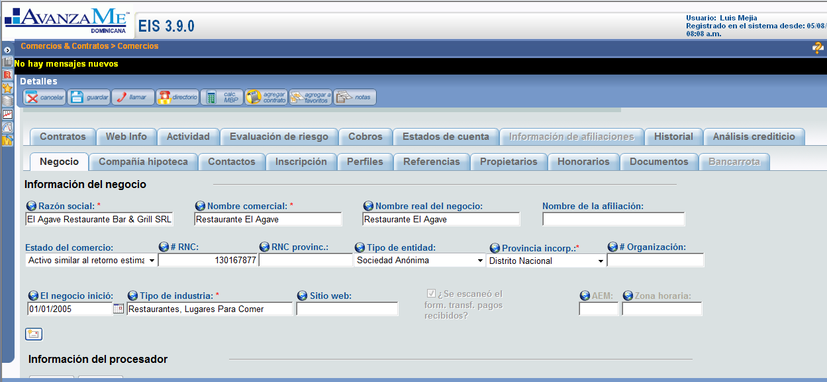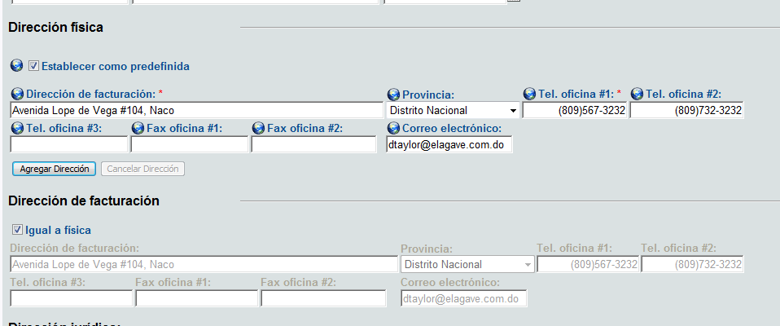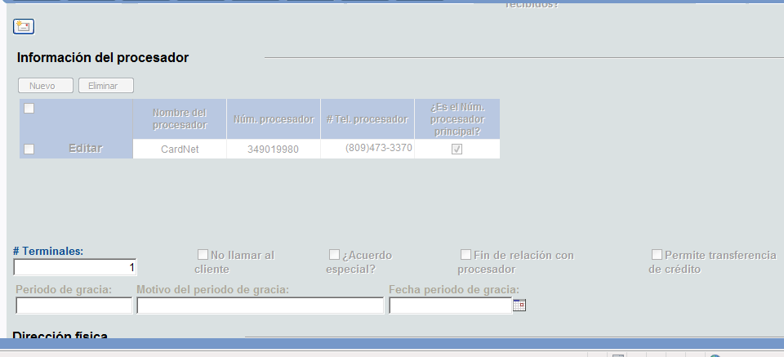

### 2.1.2.4.2 Landlord Tab

This is the tab that contains the information of the landlord, if it applies. If the business owns the local, then this tab should be empty.

It contains these fields:

* Type of property
* Landlord Company Name
* Landlord Name
* Telephone Number
* Cell Phone Number
* Email
* Address  
  City
* Monthly Rent Amount

Below this should be a copy of the script from the Landlord verification task and all the answers that were filled in (if the contract work flow has been completed).

Our current Landlord tab looks like this:

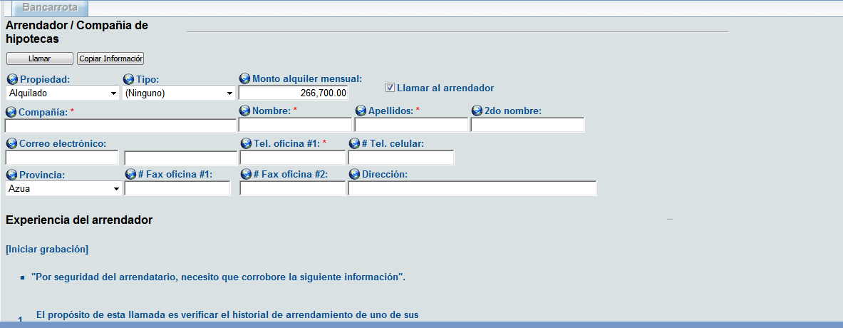

### 2.1.2.4.3 Contacts Tab

This is where we store all the information regarding contacts of a Merchant. A contact is any person within the business of the Merchant that we can call for information. It could be an owner or not.

It contains these fields:

* Name
* Last Name
* ID
* Date of Birth
* Position
* Address
* City
* Province
* Email
* Telephone Number
* Cell Phone Number

In this screen we should be able to add and delete Contacts.

Our current Contacts tab looks like this:

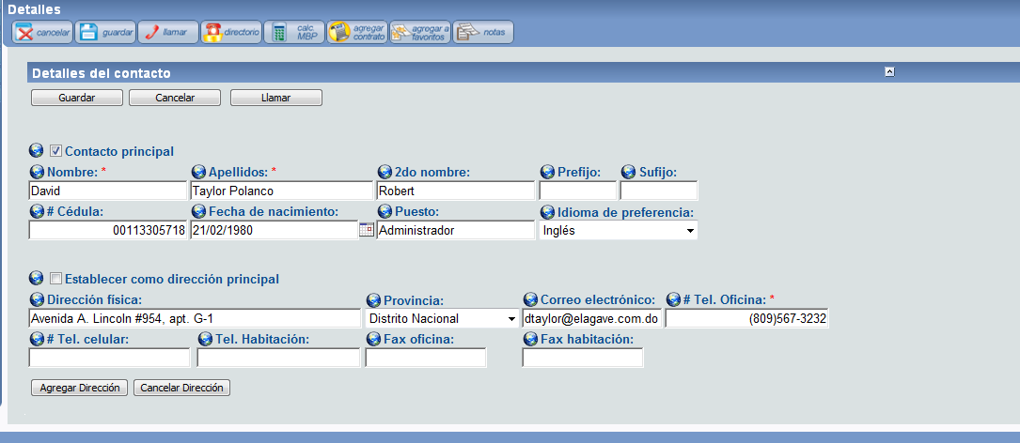

**\*Note:**

1. A contact is a person from the business of the merchant whom we can talk to if we need to. For example, let's say there's the Accountant of the business, if we talk to him, we create him as a contact (because he's not an owner) and then next time we need to talk to him we will have his information on the system.
2. Only authorized users should be able to add/edit contacts.
3. All fields are mandatory to create a contract.
4. History of deleted contacts should be logged.
5. A merchant can have multiple contacts.

### 2.1.2.4.4 Owners Tab

This tab is exactly like the Contacts tab except it needs to add a couple of fields:

* Name
* Last Name
* ID
* Date of Birth
* Position
* Address
* City
* Province
* Email
* Telephone Number
* Cell Phone Number
* Date became Owner
* Authorized to sign the contract (checkbox)

In the same way, we should be able to add and remove owners here.

### 2.1.2.4.5 Profiles

This is the tab that contains information about the credit card affiliates and volumes.

It should have the following fields:

* Gross Yearly Sales
* Average monthly transactions (number of tickets per month)
* Average Monthly Credit Card sales: If the Merchant has an active contract this field will be calculated with the payments. For example, if a merchant is paying 10,000 every month and the retention percentage of his contract is 10%, then his monthly sales must be 100,000 (10,000/10%).
* Average used in the Calculator: This is the average credit card sales that were used in the calculator when the offer was made (if the Merchant has a contract).
* Monthly credit card sales as calculated by our system (if the merchant has an active contract) detailed month by month.
* Monthly credit card sales received from the Processor companies detailed month by month.

In this screen it would be convenient to have a drop list in the top that would let us choose between VisaNet and CardNet or both, and then show just the information concerning the selected option. For example, if we choose VisaNet, the fields will be filled only with VisaNet information, if I select CardNet only with CardNet information and if I select both, with all the information we have.

Our current Profiles tab looks like this:

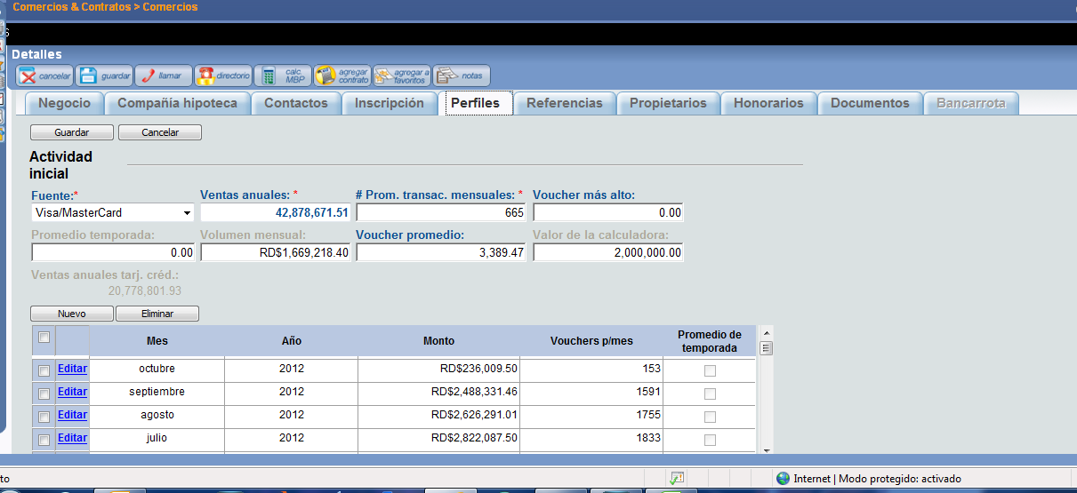

*Note:

1. If both is selected as processors the values shown on screen will be sum of value for both processors.
2. Information should be shown for recent contract.

### 2.1.2.4.6 Documents Tab

This is a list of all the documents uploaded in the work flows. It should let us upload and delete documents right in this screen and it should show the date and user that uploaded every document.

**\*Note:**

1. Documents for all contracts should be shown.
2. if it was uploaded before the workload, then it should be seen as already there in the work flow and we won't need to upload it again.
3. History of documents should be logged.

### 2.1.2.4.7 Activity Tab

This is the tab where we see all the payments the Merchant has done. You can organize this however you want, as long as we get to see in detail every financial activity in the Merchant, and organize it in a daily and monthly way.

Our Activity tab looks like this:



**\*Note:**

1. You will understand this once we go though the Finances Module, but there are different types of activity. Payments is the main one, but no the only one.

### 2.1.2.4.8 Statements Tab

This is the tab where we generate the statements for the client. We will provide you with the correct format, but the way it works is we select a range of dates and then we click one of two buttons. The first button will be “Generate Statements” which will bring up a pop up with a PDF file of the statements. The second button will be “Send Statements” which will automatically send the statements from the chosen range of dates to the Merchant’s email address along with a corresponding script that we will write.

Also in this tab is where we can generate the fiscal invoices, just the same method as the statements.

Apart from this manual generation, the system should automatically send the statements to the client on the first and 16th of every month. Also, the fiscal invoices (we will provide you with the correct format) will be sent along with the statements.

The statements look like this:

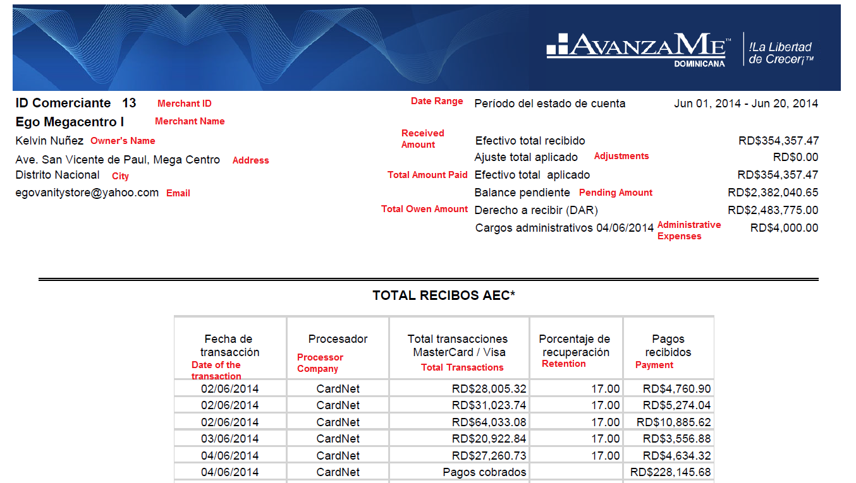

In red you’ll find the translation for every field. Some of these fields won’t make sense until we go through the Finances Module.

And this is how the Fiscal Invoices look:

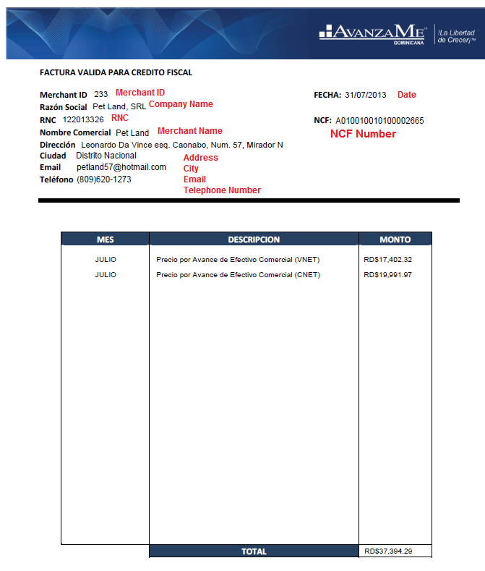

The NCF number is a sequential number, once the system is running we will tell you from what number to start and from then on the system assigns the numbers sequentially.

Again, it won’t make sense until we go through the Finances Module.

**\*Note:**

1. By default the system should send the statements every 1st and 16th of every month, but maybe it could be useful to be able to change these dates for every individual merchant.
2. We should use changed values. In any case, we won't be able to change the parameters of the contract after it is funded but we could change any information from the merchant screen.

### 2.1.2.4.9 History Tab

This tab should show a log of all the changes in every field or status of the Merchant.

### 2.1.2.4.10 Risk Evaluation Tab

This tab should let us access all the generated Datacréditos as well as keep a list of every score the system has ever given the Merchant. This tab has all scoring evaluations made to this merchant, how they differ is through the contract number. Also it should have a stored all the credit reports pulled.

### 2.1.2.4.11 Contract Tab

This tab contains information about every contract the Merchant has ever had. It should show us a list of all the contracts with the parameters and the date they were funded. If we click a contract, it should popup a different screen with different tabs.

The list of contracts could look like this:



I believe you’re familiar with every field, except for “Real Time” which is the projected time the merchant will pay the contract in. For example, the offer was agreed to be paid in 8 months, so if he has to pay 175,000 in 8 months, then he would have to pay 21,875 per month to pay the contract in full in 8 months. But if he’s been paying 23,150 per month, then he will be projected to pay in 7.56 month (175,000 / 23,150). This is how the Real Time of the contract should be calculated, except that the calculations should be done based on what he has to pay per day and what he’s been really paying every day.

### This new pop up should contain these tabs:

### 2.1.2.4.11.1 General Tab

In this tab is the general information of the contract.

The fields are:

* Contract Number
* MCA Amount
* Owed Amount
* Contract Status
* Funding Date
* Scanned contract and IOU (this button should show us a PDF of the contract and IOU)
* Retention Percentage (This field should be editable according to permissions and it should keep a log of changes)
* Administrative Expenses (This field should be editable according to permissions and it should keep a log of changes)

**\*Note:**

1. Status of contracts cannot be changed from contracts screen.
2. On the merchant no, of the contract nothing can be changed aside from the retrieval % (based on user permission).

### 2.1.2.4.12 Contract Activity tab

This is much like the previous activity tab, but for this specific contract.

### 2.1.2.4.13 Sales Representative Tab

Here we should be able to add and remove Sales Reps associated with the contract.

### 2.1.2.4.14 History Tab

This is a log of all the changes in every field.

Our Contract tab looks like this:

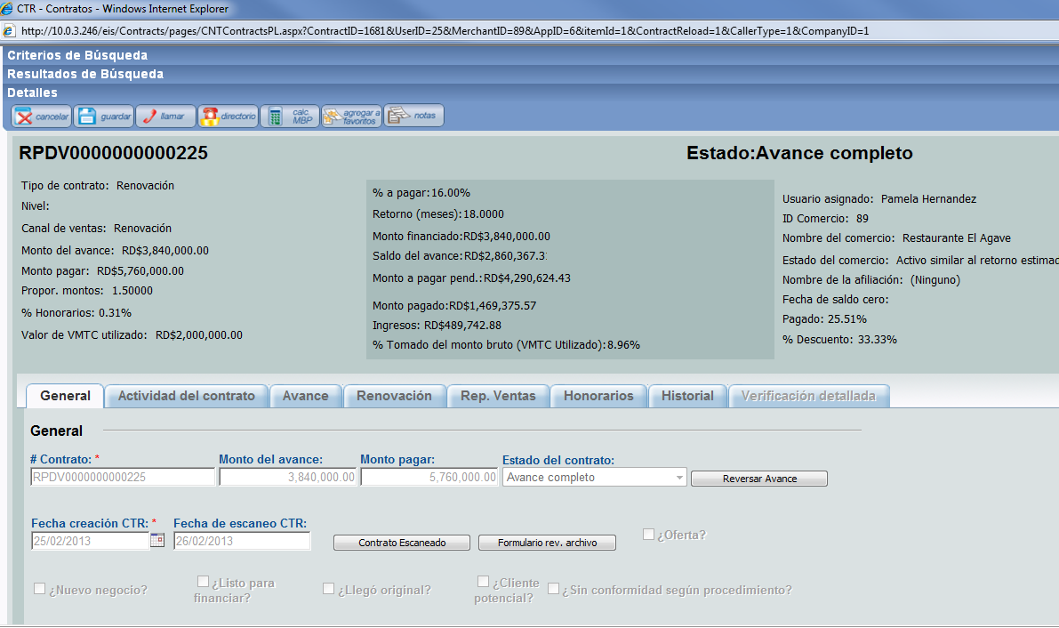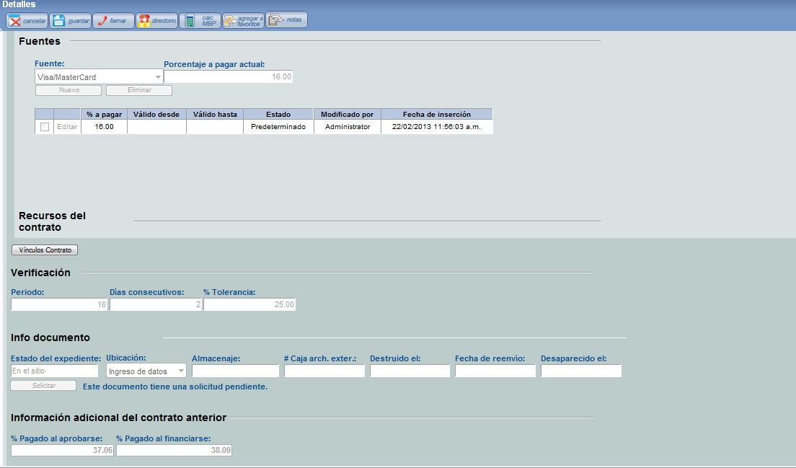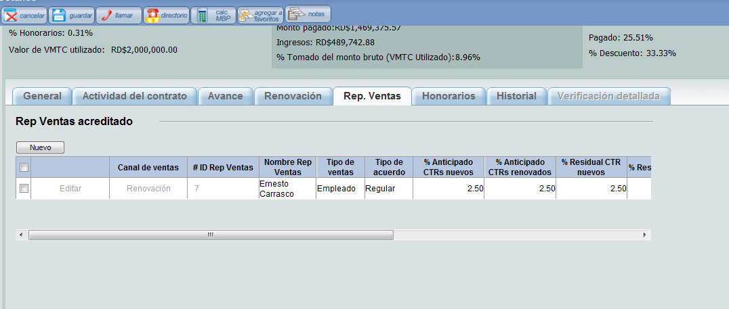

### 2.1.2.4.15 Collections Tab

In this tab we will see information if the Merchant has a contract (or has had a contract) in collections. It will show what amount entered collections, the status of the contract, the date it entered collection and other fields that we will go into detail when we complete the Collections workflow document.

### 2.1.2.4.16 Final Notes

The Merchant screen needs to have the following buttons:

* Save Button: To save any change made to any field.
* Cancel Button: To erase any change made.
* Call Button: With a list of all the stored telephone numbers in the Merchant, including owners, contacts, landlord and business numbers.
* Notes Button: A button to access the Notes application to write and read notes.

Once we enter a Merchant screen, the first seen we need to see on top is an information box on top with the essential information:

* Merchant ID
* Merchant Name
* Amount left to pay of the current contract
* Date of the last activity (this is the date of the last payment we received)
* Merchant Status

## 2.1.2.5 Permissions controls:

User permissions can be controlled by users with admin rights from user section. Details of pages is as below:

### 2.1.2.5.1 Permissions and Roles

The way we want this to work is, we create different user roles and assign permission to these roles to use different parts of the system, and then we assign the roles to the different users.

We need to have two types of permissions: Reading Rights and Modification Rights. Reading rights gives the user that has the role assigned to see and read the part of the system that has been assigned to the role with reading rights. For example, if the “Operations Officer” role has been assigned reading rights for the Finances Screen, any user with this role will be able to see the Finances Screen but won’t be able to make any modifications. Any user with a role that has Modification Rights for the Finances Screen will be able to both see and modify the information in the Finances Screen.

The only pre-created user role should be that of Administrator, that will have both Reading and Modifications rights to every part of the system. Any other role we want, we need to be able to create and then assign Reading, Modification, or No Rights to every module of the system individually (Workflows, Merchant Screen, Finances, Reports). Once we assign rights to a module, it should assign by default rights to everything IN the module, but we need to be able to select certain parts of the module with different rights. For example, in the Reports screen we want certain roles to have Reading Rights for some reports but No Rights for other reports.

It could be something like this:



To keep in mind that once every single component of the system is constructed it must be included in the permissions screen (calculator, scoring, etc).

### 2.1.2.5.2 User Profiles

The user profiles should contain information about the user such as Name, Last Name, and Date they joined the company, role, etc. We need to be able to assign any role to any user.

For those users that have roles with Rights to Workflows, we need a sort of timetable that will let us select the day and time we want workflows task to be assigned to that user. For example, let’s say User A and User B have rights to the Contract workflow, and in the time table in the User A’s profile we select Mondays, Wednesdays and Fridays from 8 AM to 5 PM for him to be able to work in the Contract Workflow, he will only be assigned tasks inside this time windows in those specific days, and User B will be assigned no tasks in these days unless we select the same days in the time table.

The time table could look like this:



Here we need to have an option to give leave permissions to some users. For example we can select a range of dates when the user won’t be in the office (like a vacation) and it will deactivate the user for that time without have to modify the time table.

**\*Note:**

1. Roles cannot be changed unless all tasks are completed or reassigned to another user.

## 2.1.2.6 The Collections Work flow

The Collections work flow will work in two branches. The first branch, which will be a sort of prevention work flow, will show us a list of all contracts that are paying 30% (or more) slower than expected and all contracts funded more than 30 days ago that are paying 20% (or more) slower than expected. This first branch will who us the information of the Merchant and the Contract and, if we click one of the Merchants, it will lead us to the Collections screen for that Merchant (a screen we will specify in the second branch).

It could be something like this:



The second branch, which will be the actual Collections workflow, will show a list of all the Merchants that have 4 or more days without registering any payment for their active contract by default, but there should be an option to select merchants that haven’t been paying for X amount of days. The merchants will be ordered by the amount of days without processing in descending order. In this list, if there’s a Merchant that has being showing for a monthly average of 2 times or more, it should be marked red as a warning. The monthly average will be calculated by dividing the number of times the merchant has showed up in the Collections workflow by the number of months the contract has been active for. For example, if Merchant A has an active contract that was funded 4 months ago and it has showed up in the Collections workflow 8 times, then it shows up an average of 2 times a month, and it should be marked red.

In this list we should also see the clients that have missed payments from a Payment Agreement.

It could look like this:



Once we click a merchant, it will take us to the Merchant’s Collection screen.

### 2.1.2.6.1 The Collections Screen

In this screen we will look at the information and decide what to do with the Merchant. This screen should have all the information we need plus a series of buttons that will let us take action.

It could look like this:



### 2.1.2.6.2 Datacrédito

If we click this button the system should ask us if we want to pull the latest generated credit report or if we want to generate a new one, and then show us the credit report in a popup.

### 2.1.2.6.3 Affiliations

As we have specified before, a company or owner might own several different business which are created as separate Merchants in our system. But we still need a way to link them, so an affiliation is a link that exists between all the Merchants that have the same RNC number (this means they are owned by the same company) or the same Owner ID (which means they are owned by the same person).

This button will pull the Merchant’s affiliation screen, which could look something like this:



As you can see, there are two tabs. One tab is for the merchants with the same RNC and the other is for the Merchants with the same Owner.

There should be two boxes of information, one for all the merchants with the same RNC or Owner as the Merchant we are currently in that have Active Contracts and another box for all the affiliations that don’t have Active Contracts.

For the inactive contracts we need a button that will let us request the CC volumes for the merchants to the Processor Company. If we request the volumes, this list should show a Volumes Status that will be marked as pending until the Processor Company sends the requested volumes.

### 2.1.2.6.4 Documents

This button should bring up the regular documents screen and let us upload or see any document we need and then let us return to the collections workflow.

### 2.1.2.6.5 Landlord

This button should bring up the regular landlord screen so that we can see the information of the landlord and the script of the landlord call as was filled out during the contract work flow.

### 2.1.2.6.6 Payment Agreement

This section will be used when we agree with the client to a payment plan where the client will pay us a fixed amount every agreed period until the owed amount is met.



In this screen the user will upload the signed physical agreement document, which will be stored along with all the other documents from the merchant.

The date of the agreement will be the date the agreement was signed and the start date and end date are the dates of the first and last payment, respectively. The start date will be set by the user, but the end date will, by default, depend on the contract. If the contract has been active for two months at the moment of the start date, and the offer had an estimated turn of 8 months, then the end date will be set by default in a date that will allow the contract to be paid within the 8 months. In the case of the example it would be 6 months from the start date. Although this will be set like this by default, we should be able to modify it.

The interval is the amount of the days between each payment. For example, if we set the interval to 15, then the client will pays us every 15 days.

The amount of the payments will be decided by dividing the pending amount of the contract by the number of periods. In the case of the example, if we have 6 months between the start and date, and payments every 15 days, then we have 12 periods ((6 * 30) / 15). If this contract has a pending amount of $60,000, then the payments should be $5,000 each for 12 periods.

The date of the first payment will be the start date and the following dates will be the previous date plus the number of days of interval. For example, if the start date is January 1st and the interval is 15 days, then the first payment will be on January 1st, the second payment on January 16th, the third payment on February 1st and so on.

Every payment due should be detailed from start to finish, and every payment should have the status of the payment. This will make more sense once we go over the Finances module but if this contract receives the payment on the set date, it will be pulled out of the Collections workflow and return to normal. But if the merchant misses one payment, or does not pay the full amount of the period, it should go back into the Collections workflow.

If the client does not pay the full amount in a certain period, the remaining amount should be added up to the next period. For example, if a client has a payment of $5,000 due February 1st, but come the day he only pays $4,000, then the next payment, say it’s supposed to be on February 16th, should be $6,000, which is the corresponding $5,000 plus the remaining $1,000 from the previous period. The status should be “Paid”, “Incomplete” and “Missed Payment”.

Every payment should detail the date the payment was received. If the client has missed payments and pays on a later date, the system will take the money and apply it to the earliest missed payment and the date of the payment will be the date the client actually pays.

### 2.1.2.6.7 Legal

We will use this screen if we assign the client to an external legal firm. In this screen we should store the information of who has the case and what documents they have.

It could look like this:



It should have the information of the Lawyer, and below, we should see a list of all the documents uploaded for this particular merchant, with a checkbox mark beside the document that we will mark if the external legal firm is in possession of said document. For example, if we handed the Leasing Agreement, Corporative Documents and Contract for this merchant to an external legal firm, we would mark the corresponding checkbox of these documents in this screen.

The Lawyer will be selected through a drop list that will have all the lawyers created in the system.

There should be a Create New Lawyer button that will let use create and save new lawyers.

This button should bring up a screen like this:



As you can see it could show us a list of all the created lawyers and let us edit or delete them, as well as let us save new lawyers to the system.

### 2.1.2.6.8 Generate Letter

With this button we will access a letter that we will send to the Merchant as a physical letter or through email. We will give you a template of the letter and tell you what information the system should populate automatically.

### 2.1.2.6.9 Activity

Here the user will mark what he or she had done in the Collections screen and write a note. It should be a drop list for the user to choose with the following options:

* Contacted by telephone
* Contacted by email
* Investigative visit
* Letter
* Legal warning
* Contacted landlord
* Notify Payment
* Payment Agreement
* Other

In order for the system to be able to save an activity, some conditions have to be met. For all activities a note should be written and saved. In the case of “Notify Payment” the system should check if the Payment Receipt document has been uploaded before it lets us save this activity. For “Payment Agreement” it shouldn’t let us save unless a Payment Agreement has been activated through the Payment Agreement button and the Payment Agreement document has been uploaded.

## 2.2. User Management

New System provides a way to manage users. User management includes creating, editing and deleting users. There will be different roles in the system. User rights can change in system. Permissions of user roles can also change.

## 2.3. Data Output

New System will provide output depending upon screen and role of user. Here is a list of Output:

2.3.1 Prequal Work flow - System will list all the merchants assigned to user based on his role.

## 2.4. Data Management

## 2.5. Coding Requirements