GitHub Account Initialization and Repository Creation Instructions. See last page for advanced guide to install command line interface.

**Setting Up a GitHub Account**

1. Navigate to github.com
2. In the upper right-hand corner, select the “Sign Up” button. 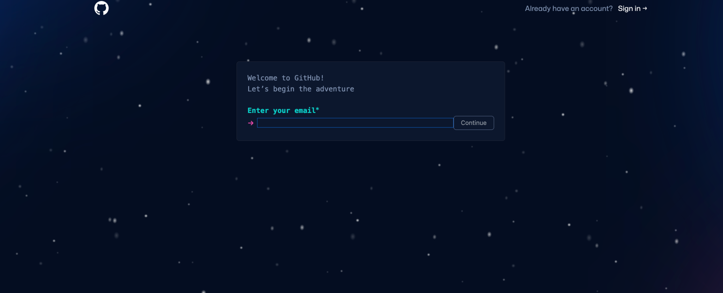
3. Enter your email
4. Initialize a password
5. Answer Marketing questions
6. Solve CAPTCHA
7. Create Account
8. Check email for account verification code
9. After verifying account from email, you should be redirected back to GitHub with this screen: 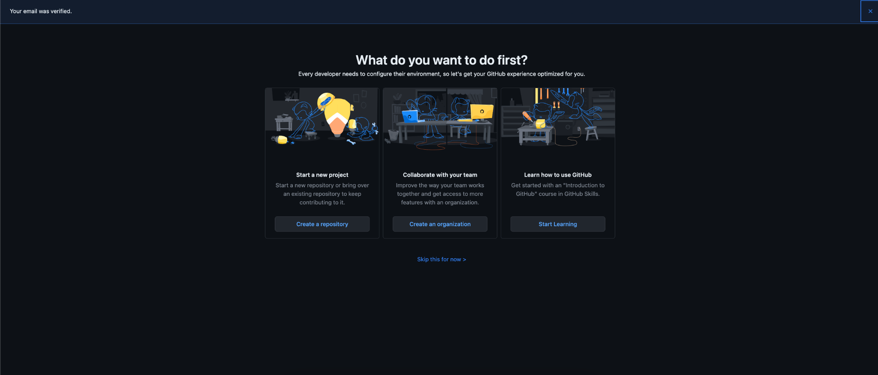
10. Click “Create a repository”
11. You will be redirected to a site to enter in repo details. You may think of a repo as a directory.

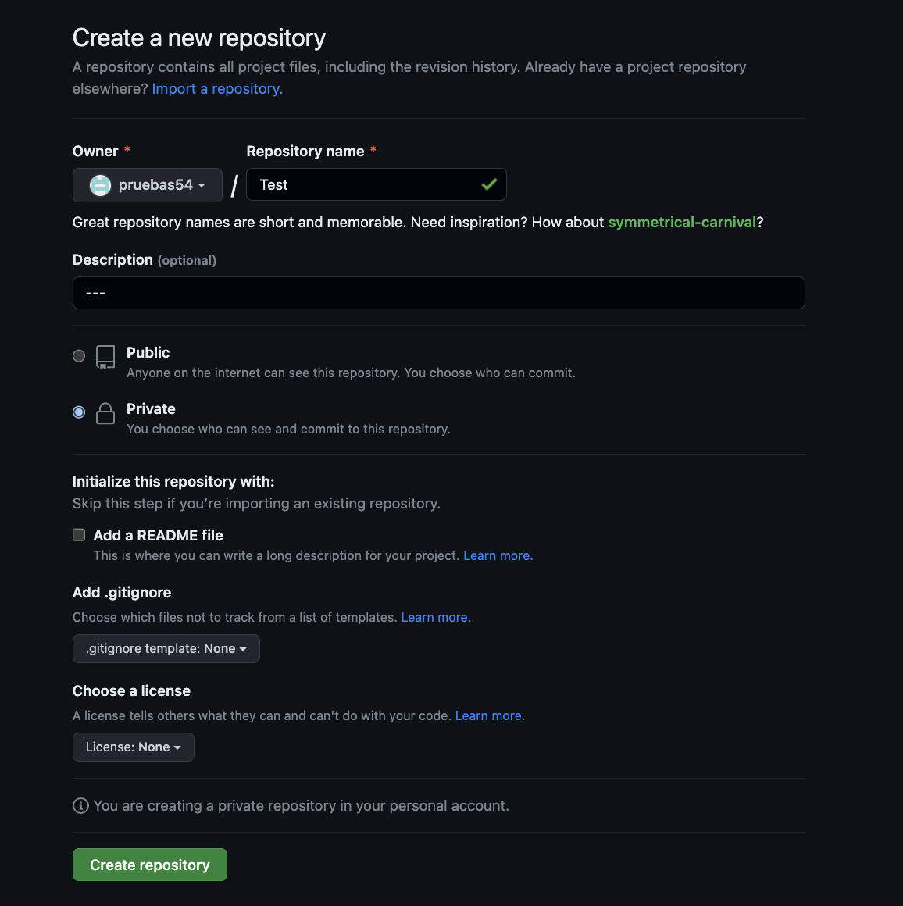

1. After entering in details, create the repo.
2. 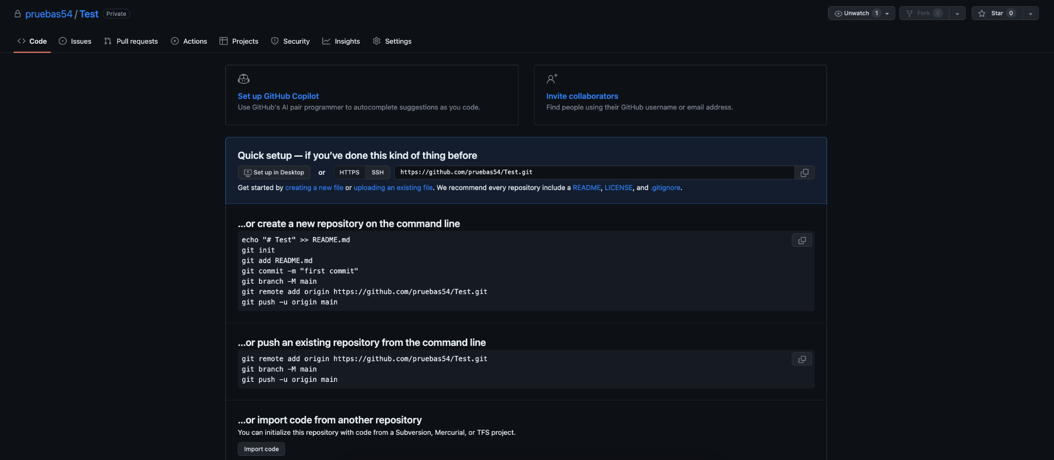
3. To upload your code, click “upload an existing file” underneath the “Quick setup” box.
4. 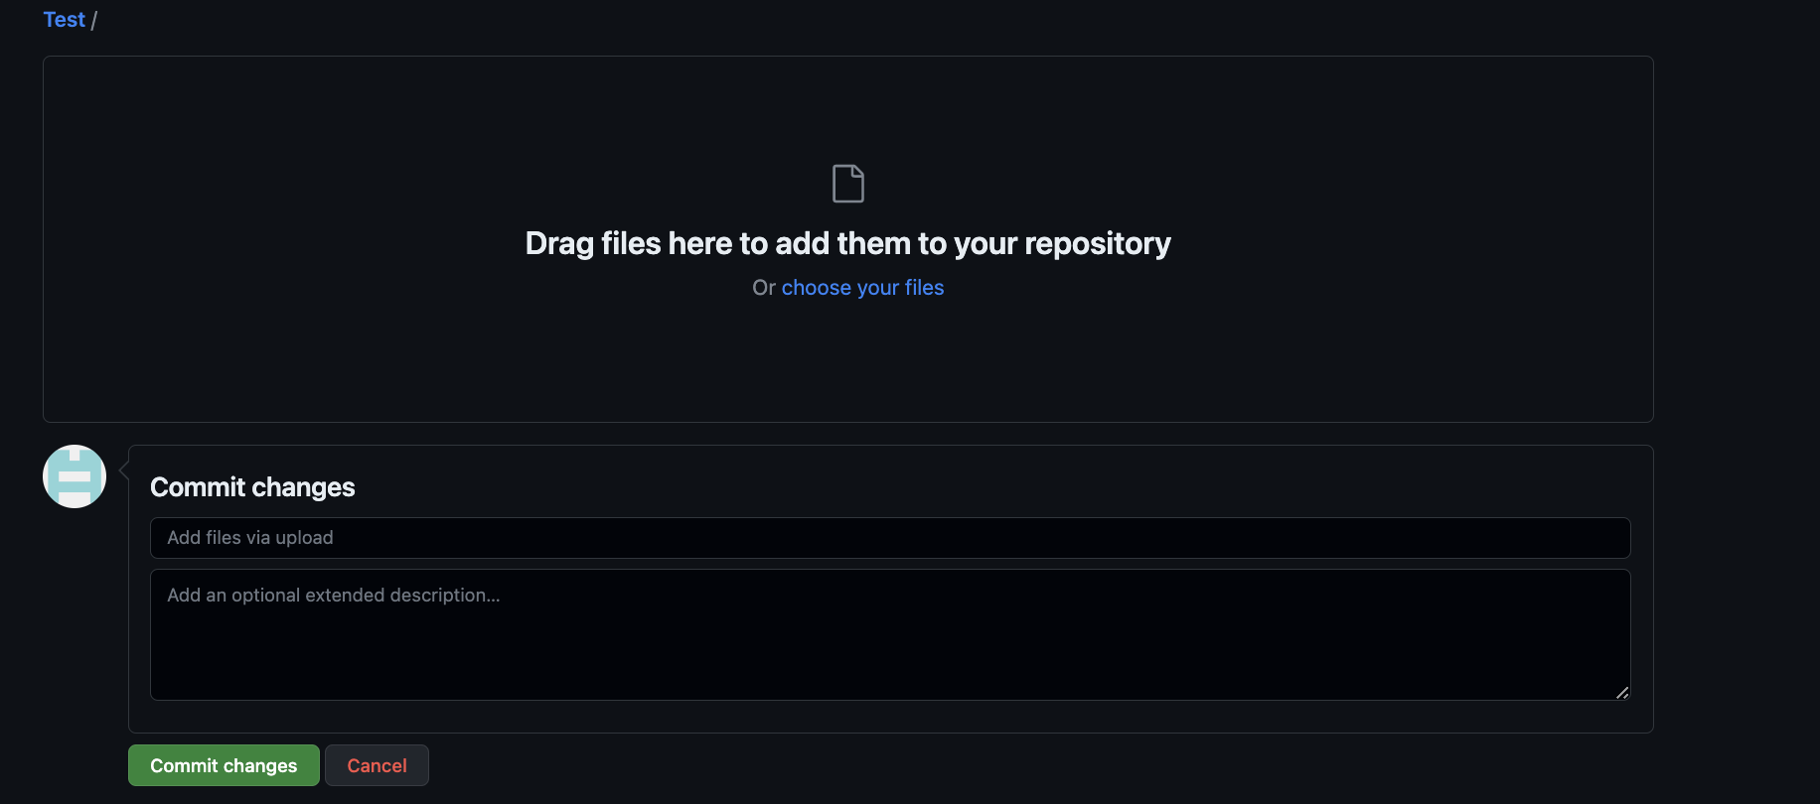
5. Once you have selected your files, click commit changes, this should add the files to your first repo! Congrats.
6. To edit code:
   1. Click file name in repository homepage.
   2. 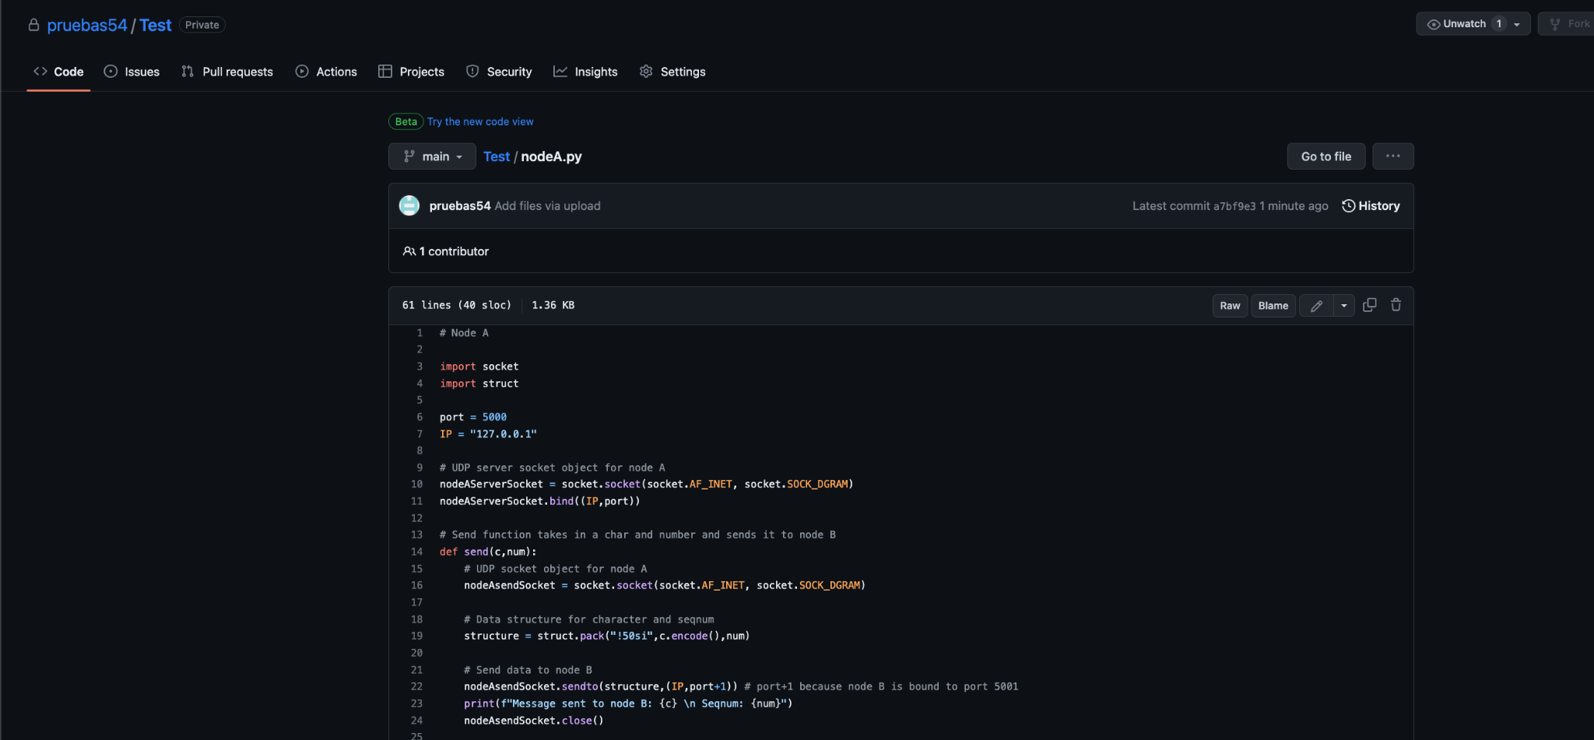
   3. Click the pencil next to the “Blame” button.
   4. Make the necessary changes in the file.
   5. In the bottom, you may commit directly to the main branch, but we will use a pull request. Click “Create a new branch”, name it whatever you want, the propose the changes. 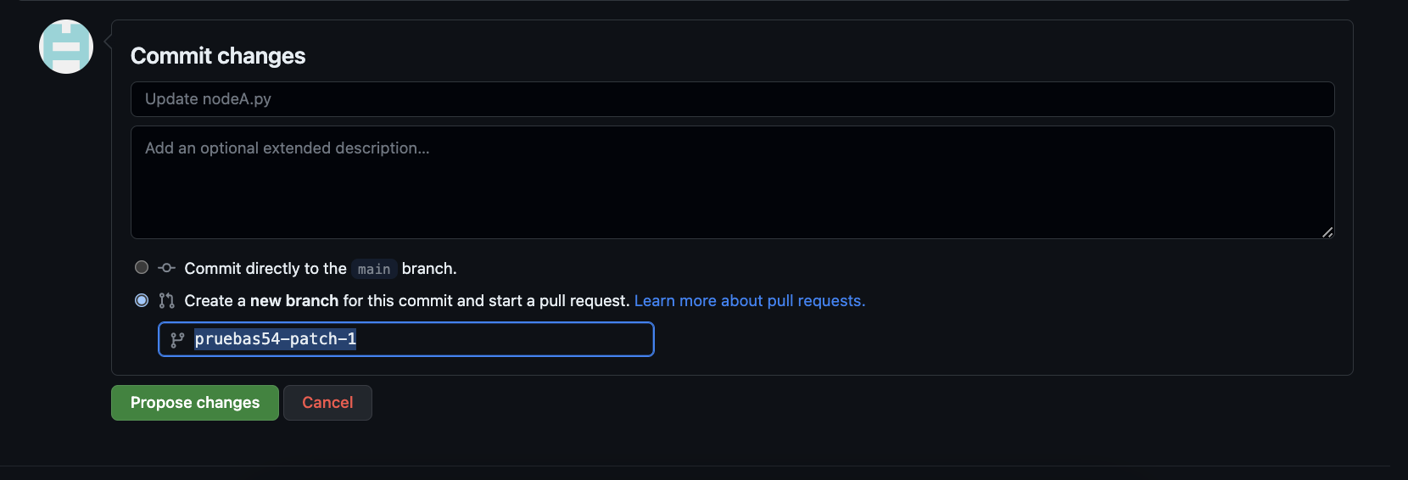
   6. 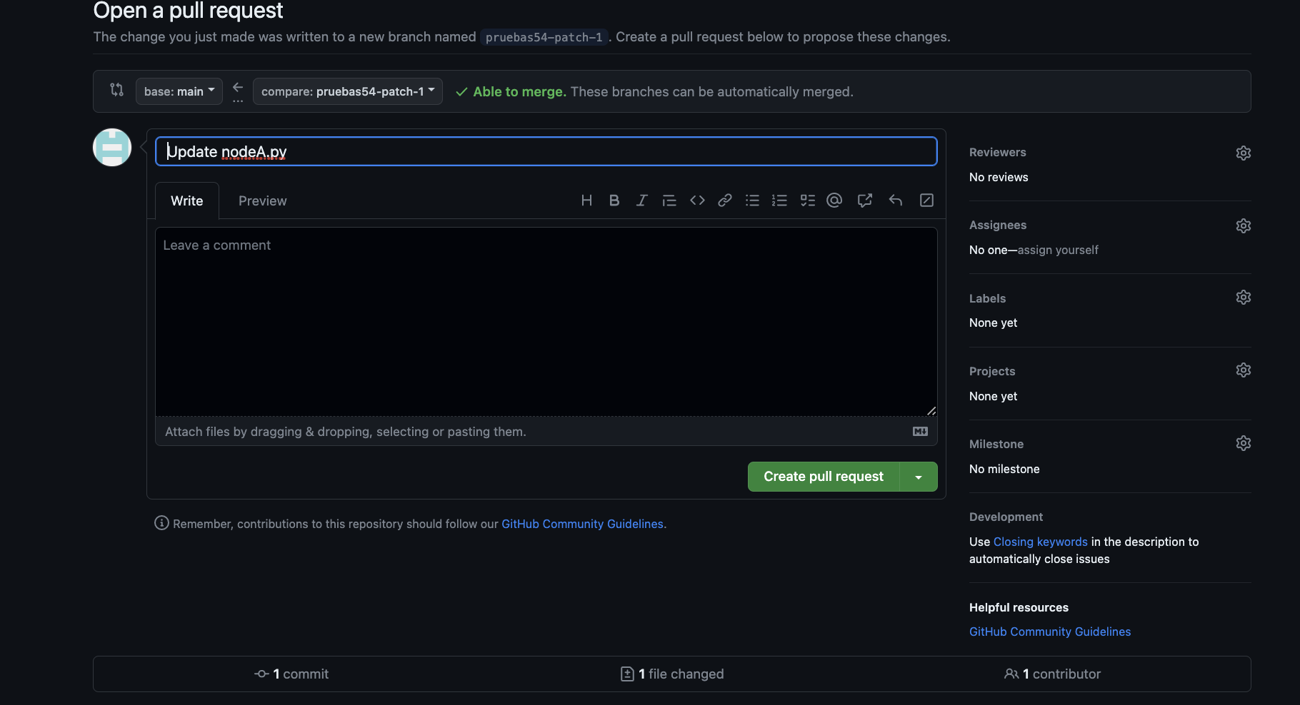
   7. You will be redirected to the pull request screen, from here you may inspect changes made to your target file. Once everything looks good, create the pull request!
   8. 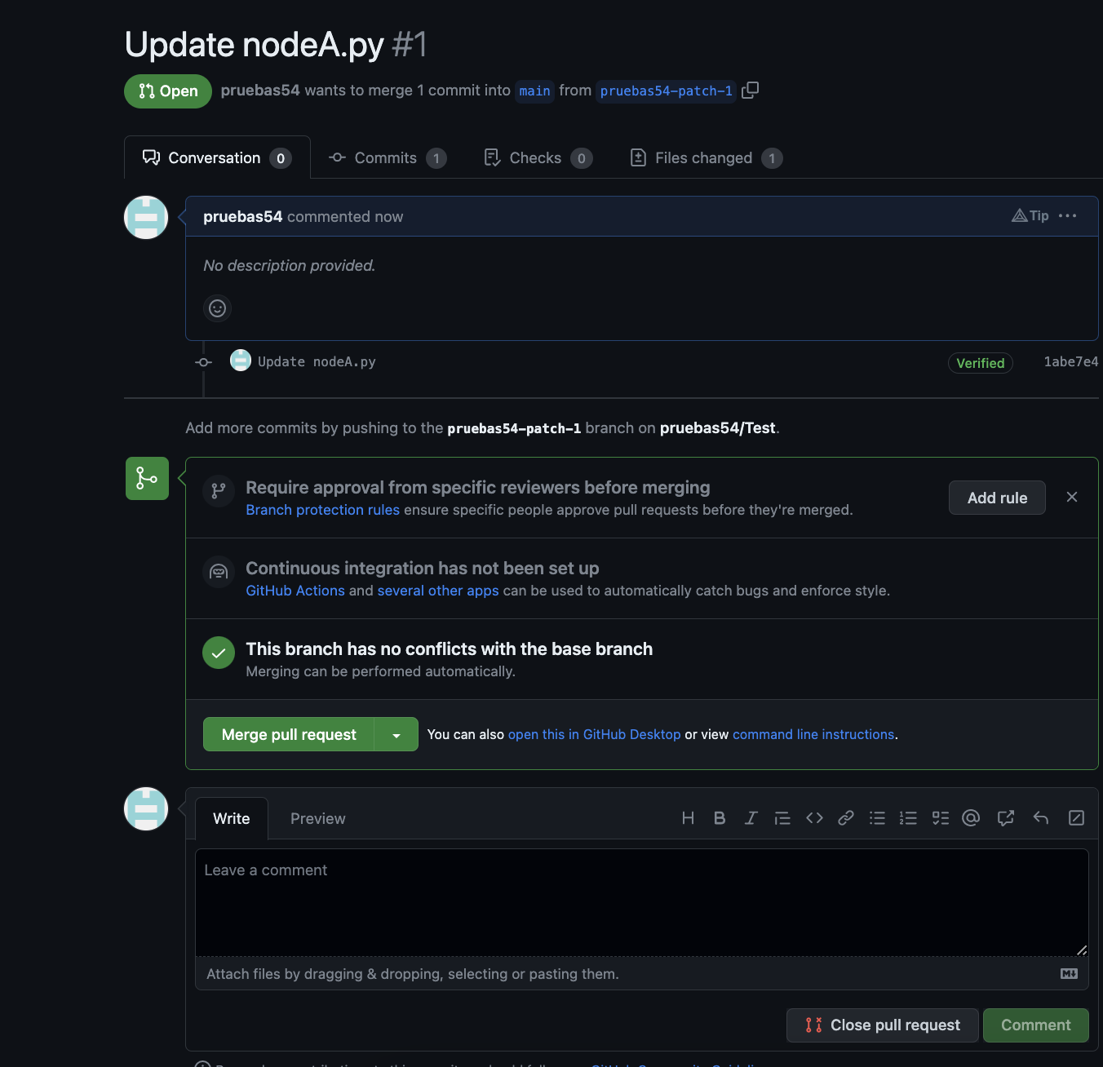
   9. Now your pull request is created and waiting for you to merge it into your master branch. Your new file with your desired edits is in a different branch that was created when you opened the request. Click “merge pull request” to replace your old file in the master branch with your new edited file in the alternate branch. You must confirm the merge.
   10. 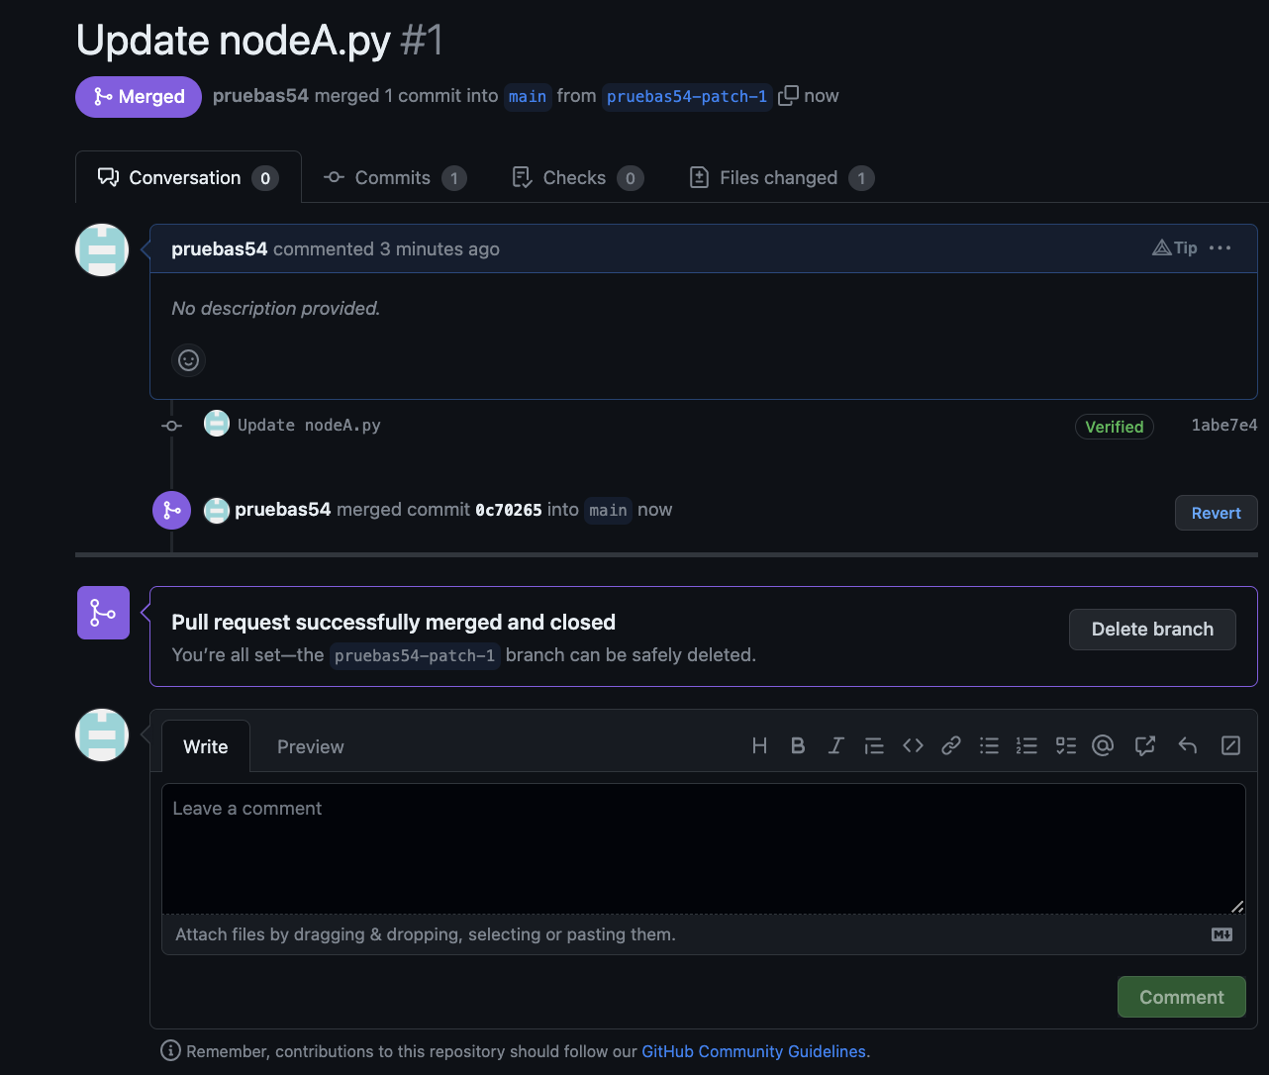
   11. After confirming the merge, you may delete the alternate branch as everything is now updated.

Inviting someone to a private repository

1. From the main page of a repo: 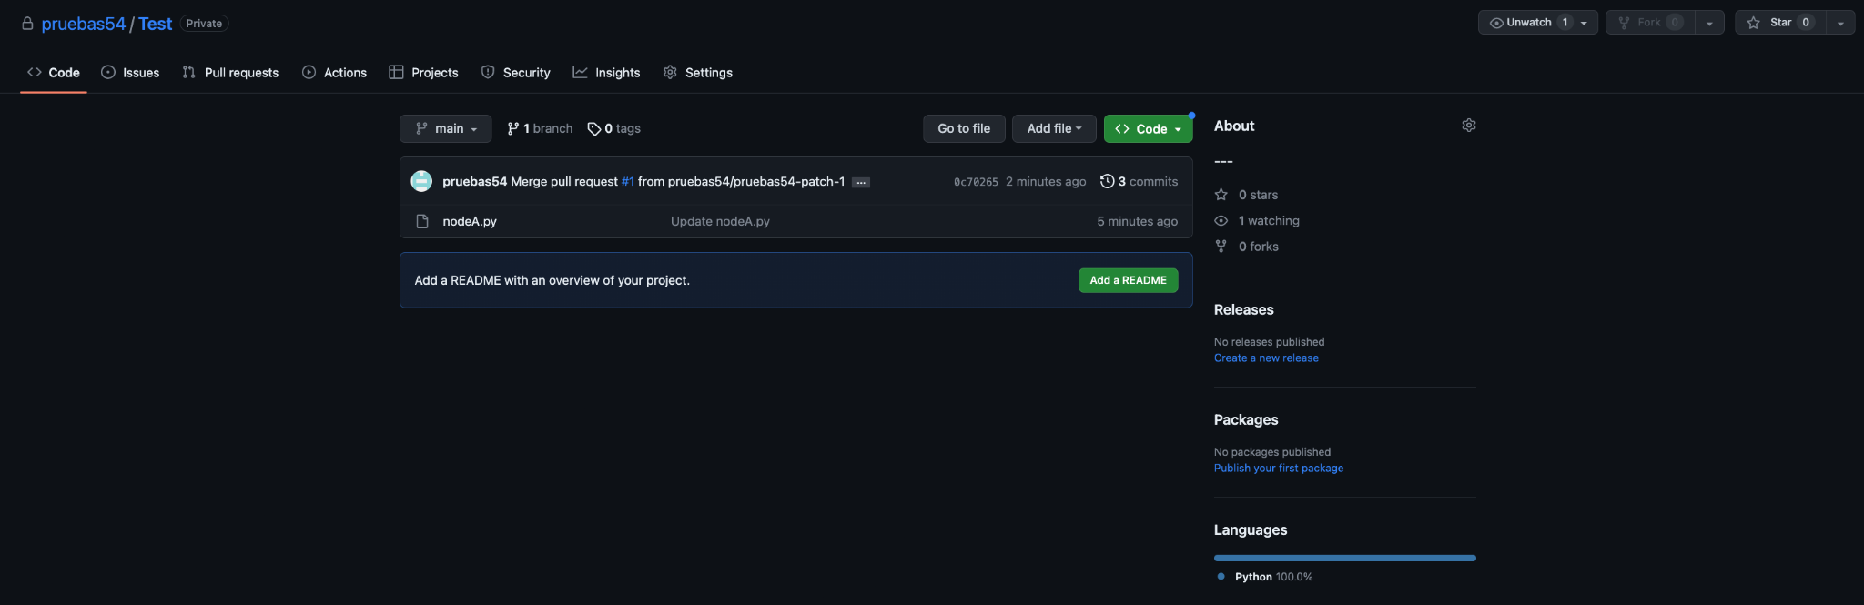

Click settings

1. 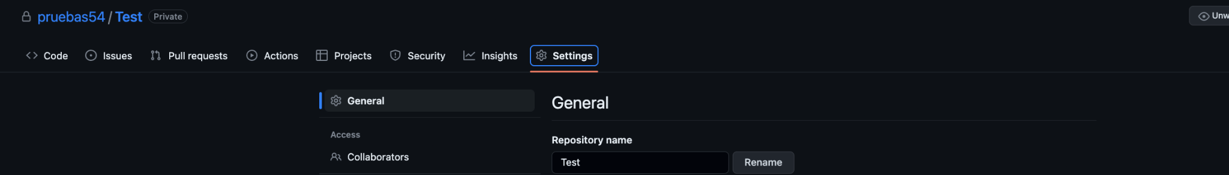

From here click “Collaborators” under Access in the left hand column of the settings options.

1. 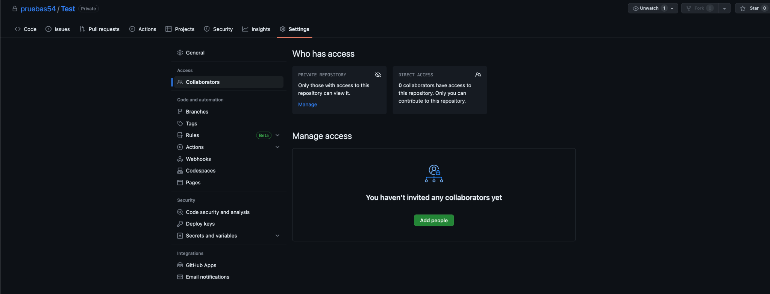

Select the “Add people” button, look up either their github username, or their email used to create their account, then add them to the repository. That’s it!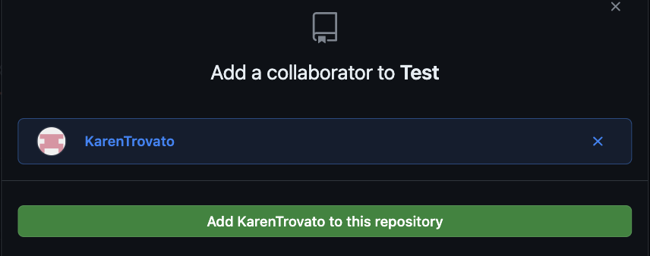

For those who desire a more advanced experience

1. Install the github command line interface (normally referred to as CLI) [here (scroll down for install instruction based on your OS)](https://github.com/cli/cli#installation)
2. Once that is installed, you can refer to the documentation [here](https://cli.github.com/manual/index) in order to access, create, edit, and delete entire repositories or single files **all from the command line**, whether in Terminal, Command Prompt, or Visual Studio Code’s integrated terminal.

Written by: Oscar Bruno, Spring 2023