

**Faculty of Science and Information Technology**

**Department of Computing & Information System**

**Semester Assignment: Fall 2023**

**Course Title: Operating Systems LAB;**

**Submitted By: MD. Rayan Ahmed**

**ID:221-16-641**

**CIS(A)**

**Submitted to:** **MS. Sonia Nasrin**

**INTRODUCTION**

Title: "Online Medicine Shopping Management System Shell Script"

Description: This shell script creates an online medicine shopping system. It presents a list of medicines with prices and allows users to select items, specifying the quantity. The script calculates the total cost and offers payment options: Cash on Delivery or Pay at the Counter. It collects user information and generates an order summary. Users can choose their preferred payment method and receive their order details accordingly.

This script lets you buy medicine online. It welcomes you to "Online Pharma" and shows you a list of medicines with names, strengths (in milligrams), and prices. You choose medicines by entering numbers 1 to 5, or exit. For each medicine, you say how many packets you want. The script calculates the cost and adds it up. It shows your order summary and asks how you want to pay:

1. Cash on Delivery: You provide your name, phone, email, and delivery location. Your order arrives in an hour.

2. Pay at the Counter: You give your name, phone, and email, and pay at the pharmacy.

Finally, it shows your order details and confirms your choice.

**MOTIVATION**

**Title: "Motivation Behind Online Medicine Shopping Script"**

Description: This script provides a user-friendly way to buy medicines online, making the process easy and efficient. It showcases the benefits of automation by simplifying everything from choosing medicines to making payments.

It demonstrates how technology can improve our lives by removing the need for physical trips to the pharmacy. Users can make informed decisions, track their choices, and pick their preferred payment method. This user-friendly design and functionality show how technology can enhance convenience in our daily lives.

**OBJECTIVE**

**Title: "Objectives of the Online Medicine Shopping Script"**

Description: creating a user-friendly online medicine shopping system with the following key objectives:

Simplified Ordering: The script provides a straightforward way for users to buy medicines online, making the process hassle-free.

User-Friendly Interface: It offers a welcoming and easy-to-use interface, ensuring users can navigate the system effortlessly.

Display Medicines: Users can view a list of available medicines, including names, strengths, and prices for informed choices.

Select Medicines: Users can choose medicines by entering corresponding numbers, creating their shopping cart.

Calculate Costs: The script computes the total cost based on the quantity of packets selected by the user.

Flexible Payments: Users can opt for either Cash on Delivery or Pay at the Counter, offering payment flexibility.

Gather User Details: For the selected payment method, the script collects essential user information, such as name, phone number, email, and delivery location.

Order Summary: It generates an order summary with selected medicines, individual costs, and the total order cost for user reference.

Order Status: The script provides clear confirmation or declination messages to inform users of their order's status.

**TOOLS**

**Title: "Tools Used in the Online Medicine Shopping Script"**

Description: This script utilizes several key tools and components to create an effective online medicine shopping system. Here are the simplified tools used:

Bash Shell: The script is written in the Bash scripting language.

Text Display: It uses the 'echo' command to show text on the screen, making the system user-friendly.

Arrays: The script employs arrays, specifically an associative array, to store medicine details and prices.

User Input: It captures user input through the 'read' command, allowing users to make choices and provide information.

Conditional Statements: The script uses 'if' and 'case' statements to make decisions based on user input and validate choices.

Variables: It utilizes variables to store and manage data, such as 'total_cost' and 'order_list,' to keep track of the order.

Loops: The script includes a 'while' loop, repeatedly guiding the user through medicine selection until they finish.

**METHODOLOGY**

**Title: "Methodology for Online Medicine Shopping Script"**

Description: This script's methodology for the online medicine shopping system can be summarized in a simplified format as follows:

1. Introduction:

1. Begin by setting up the script in Bash.
2. Greet users with a welcoming message.

2. Show Medicine List:

1. Display a list of available medicines with names, strengths, and prices.
2. Help users choose their medicines.

3. Select Medicines:

1. Users pick medicines by entering numbers or can choose to exit.
2. Keep track of selections and quantities in a virtual cart.

4. Calculate Costs:

1. For each medicine, calculate the cost by multiplying the quantity with the price.
2. Maintain the total cost throughout the process.

5. Choose Payment:

1. Offer two payment options: Cash on Delivery and Pay at the Counter.
2. Let users select the one they prefer.

6. Gather User Details:

1. Depending on the chosen payment, collect necessary user information like name, phone number, email, and delivery location.

7. Order Summary:

1.Generate a summary of the user's order, including chosen medicines, individual costs, and the total.

1. Allow users to review their order.

8. Confirm or Conclude:

1. If Cash on Delivery is chosen, confirm the order and provide delivery details.

2. For Pay at the Counter, acknowledge the choice and finish the process.

1. If input is invalid, inform the user for clarity.

**IMPLEMENTATION**

**CODE:🡪**

#!/bin/bash

clear

echo ">>>>>>>>>>>>>>>>>>>>>>>>>>>!!<<<<<<<<<<<<<<<<<<<<<<<<<<<<<<<<<"

echo ">>>>>>>>>>>>>>>!!>Welcome to Online pharma<!!<<<<<<<<<<<<<<<<<"

echo ">>>>>>>>>>>>>>>>>>>>>>>>>>>!!<<<<<<<<<<<<<<<<<<<<<<<<<<<<<<<<<"

echo -e "\n "

echo " Medicine Lists "

echo " "

echo "----------Medicine name----------MG----------Price----------"

echo "(1) Napa 120 15 TK "

echo "(2) Fexo 120 60 TK "

echo "(3) Zimax 500 100 TK "

echo "(4) Moxibac 500 180 TK "

echo "(5) Napa-Extra 500 25 TK "

declare -A medicines

medicines["Napa"]="15"

medicines["Fexo"]="60"

medicines["Zimax"]="100"

medicines["Moxibac"]="180"

medicines["Napa-Extra"]="25"

total_cost=0

order_list=""

while true; do

echo " "

echo "1->Napa 2->Fexo 3->Zimax 4->Moxibac 5->Napa-Extra "

echo " "

read -p "Please select an option (1-5, or 'exit' to finish): " choice

if [[ $choice == "exit" ]]; then

break

elif ((choice >= 1 && choice <= 5)); then

medicine_name=""

case $choice in

1) medicine_name="Napa";;

2) medicine_name="Fexo";;

3) medicine_name="Zimax";;

4) medicine_name="Moxibac";;

5) medicine_name="Napa-Extra";;

esac

read -p "Enter the number of packets you want: " packets

cost=$((packets * medicines[$medicine_name]))

total_cost=$((total_cost + cost))

order_list+="Added $packets packets of $medicine_name to your cart for $cost TK.\n"

else

echo "Invalid option. Please select a valid option."

fi

done

echo -e "\nYour order summary:"

for medicine_name in "Napa" "Fexo" "Zimax" "Moxibac" "Napa-Extra"; do

echo "$medicine_name - ${medicines[$medicine_name]} TK per packet"

done

echo "Total cost: $total_cost TK"

echo -e "\nSelect a payment option:"

echo "1. Cash on Delivery"

echo "2. Pay at the Counter"

read -p "Enter your choice (1/2): " payment_choice

case $payment_choice in

1)

echo "You've chosen Cash on Delivery. Please provide the following information:"

read -p "Name: " name

read -p "Phone: " phone

read -p "Email: " email

read -p "Location (CITY, AREA, ZIP, ROAD): " location

clear

echo ">>>>>>>>>>>>>>>>>>>>>>>>>>>!!<<<<<<<<<<<<<<<<<<<<<<<<<<<<<<<<<"

echo ">>>>>>>>>>>>>>>!!>Welcome to Online pharma<!!<<<<<<<<<<<<<<<<<"

echo ">>>>>>>>>>>>>>>>>>>>>>>>>>>!!<<<<<<<<<<<<<<<<<<<<<<<<<<<<<<<<<"

echo -e "Name: $name "

echo -e "Phone: $phone "

echo -e "Email: $email"

echo -e "Your order will be delivered at $location within 1 hour\n"

echo -e "Medicine List:\n$order_list"

echo "Total cost: $total_cost TK"

;;

2)

echo "You've chosen to Pay at the Counter. Please provide the following information:"

read -p "Name: " name

read -p "Phone: " phone

read -p "Email: " email

clear

echo -e "Name: $name "

echo -e "Phone: $phone "

echo -e "Email: $email"

echo -e "Payment at the Counter.\n"

echo -e "Medicine List:\n$order_list"

echo "Thank you for visiting us"

;;

*)

echo "Invalid payment option. Your order is not confirmed."

;;

Esac

**OUTPUT, SCREEN-SHOT🡪**

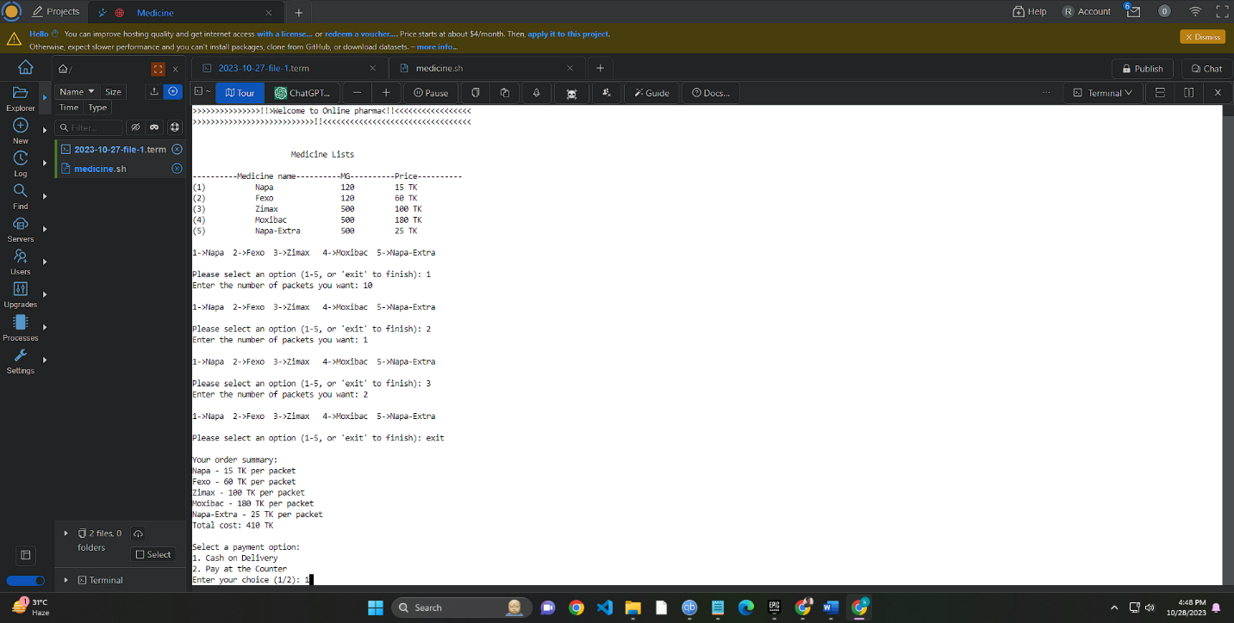

**After choosing cash on delivery option**

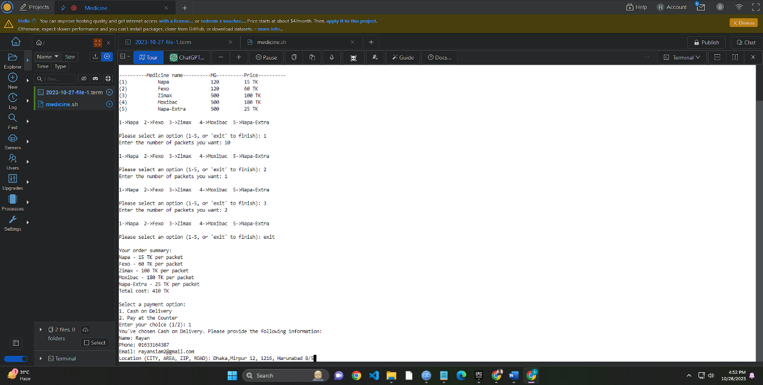

**After filling the required information**

**It will give a invoice and execute the programme**

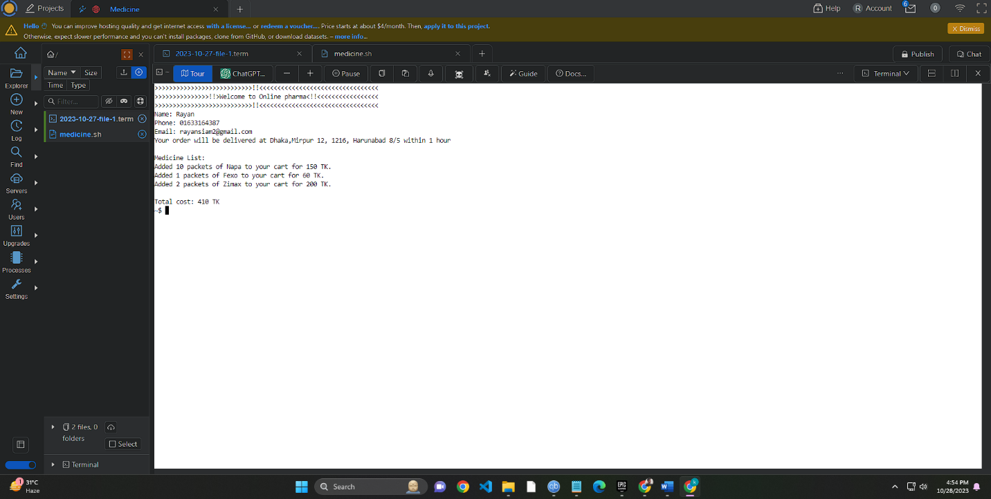

**IF the user chooses “PAY AT THE COUNTER”**

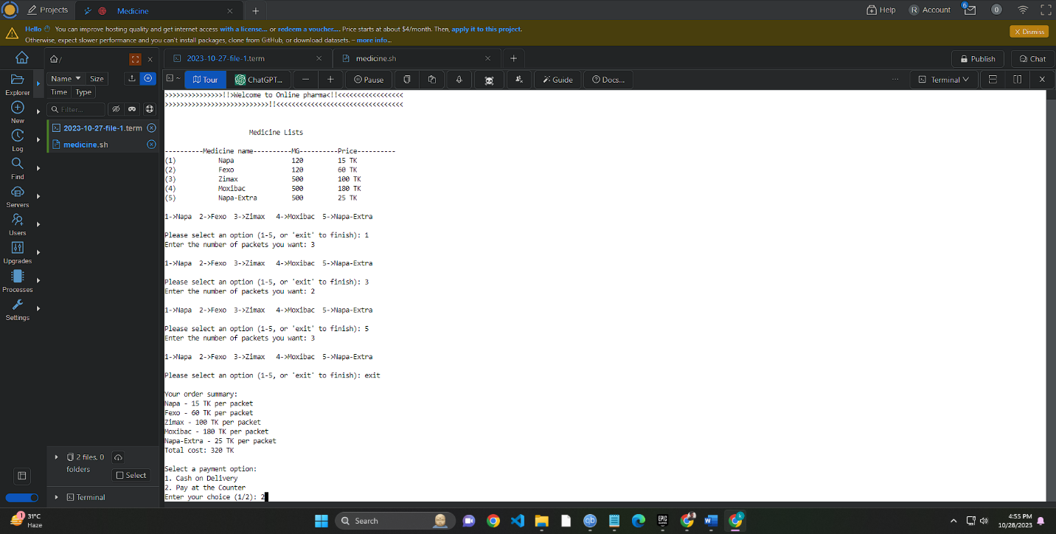

**The user has to fill the data the system asked**

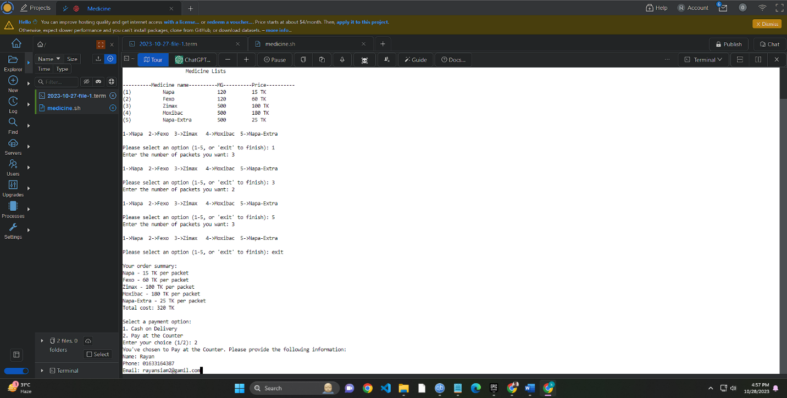

**After pressing enter it will give this Invoice**

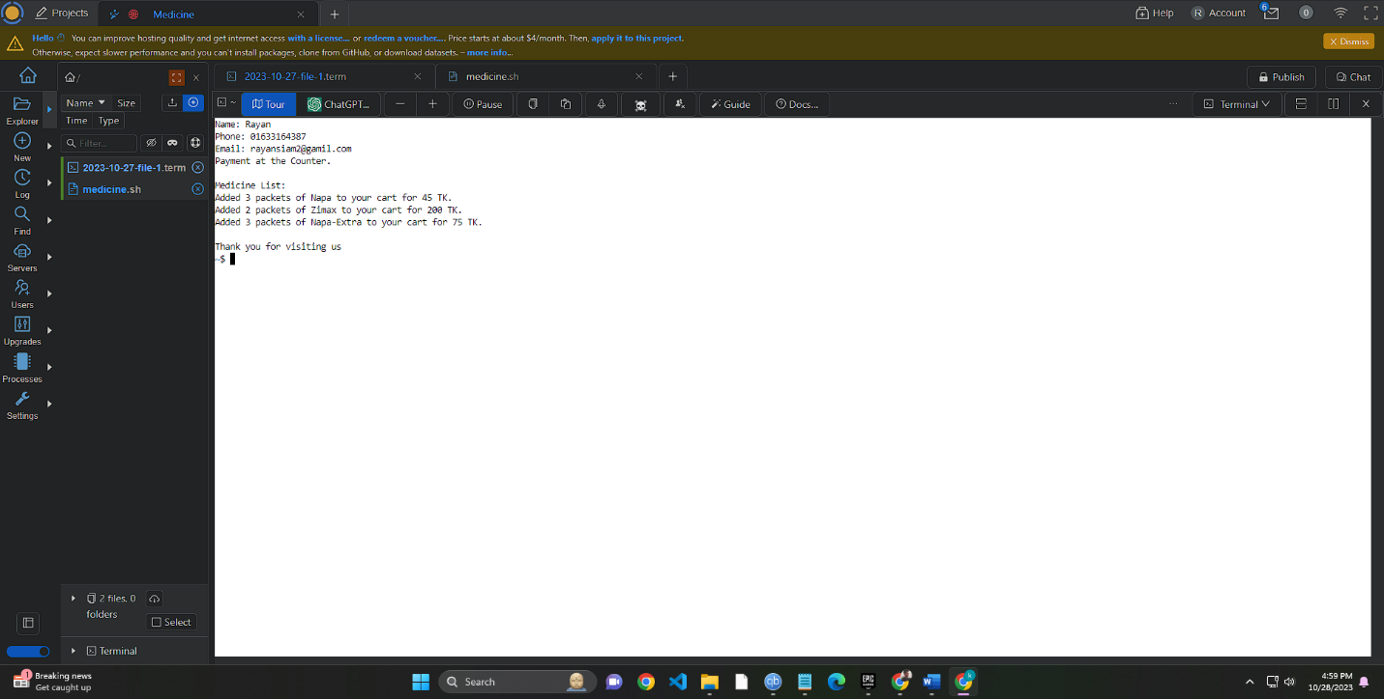

**CONCLUSION**

**Title: "Conclusion for Online Medicine Shopping Script"**

In Conclusion:

This script has effectively created an online platform for purchasing medicines, ensuring a user-friendly and streamlined process. Users are greeted with a welcoming introduction to "Online Pharma" and are provided with a clear list of available medicines, making it easy to select their choices. The script handles medicine selection, cost calculations, and flexible payment methods. Depending on the chosen payment option, it gathers user information for order processing. An order summary is presented for review, and the script confirms the order, emphasizing the convenience and simplicity of online medicine shopping. In summary, it showcases the advantages of automation in improving the accessibility and efficiency of essential product purchases.

**REFERANCE**

**Title: "References for Project Assistance"**

Reference:

Throughout the project, I faced several challenges. To overcome these hurdles, I sought help from various sources. I conducted online research

using Google and watched instructional videos on YouTube. Additionally, I utilized the ChatGPT platform to obtain guidance and insights. These resources played a significant role in understanding and resolving project-related issues, ensuring its successful development.