
Assignment on Semester Project

Submitted by:
Name: Rayan Ahmed
ID: 221-16-641
Dept. of CIS, DIU

Submitted to:
Name: Md. Nasimul Kader Sir
Dept. of CIS, DIU

Final project

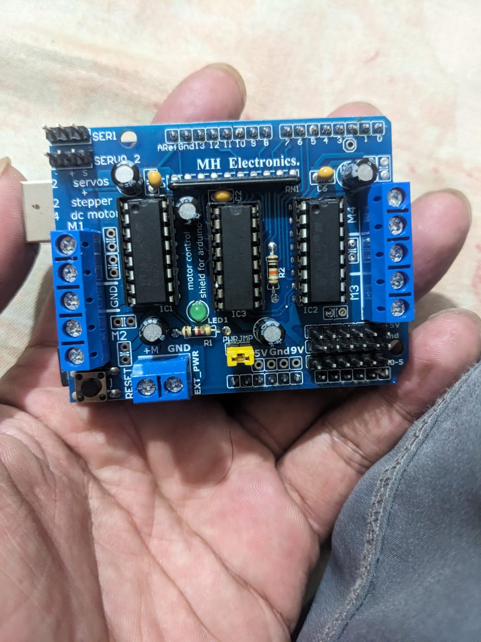
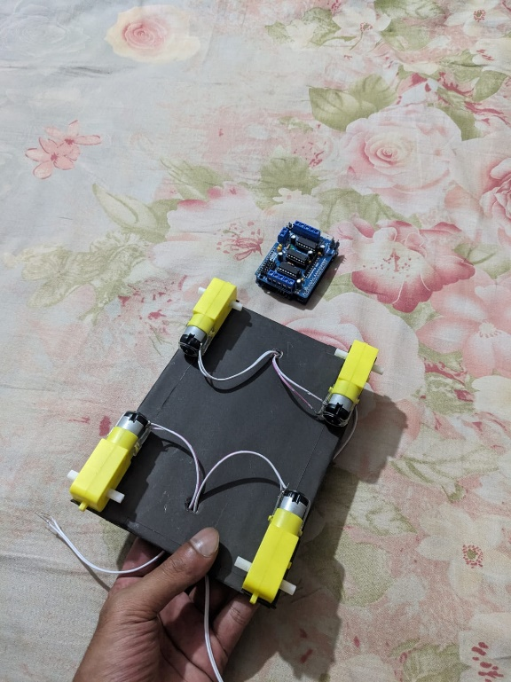

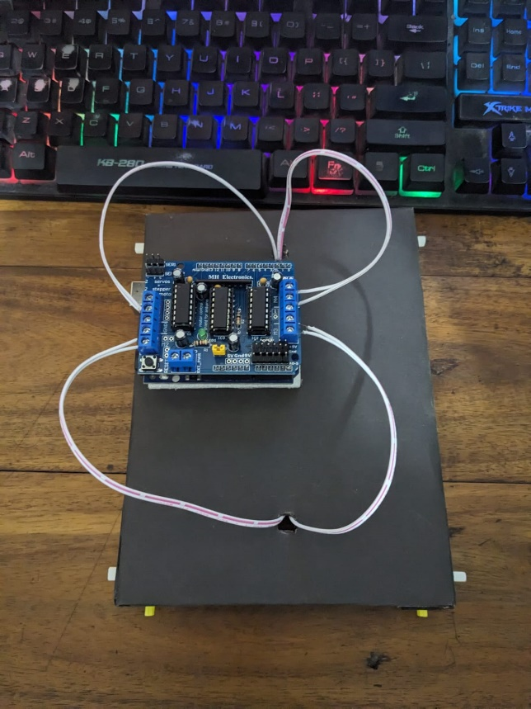

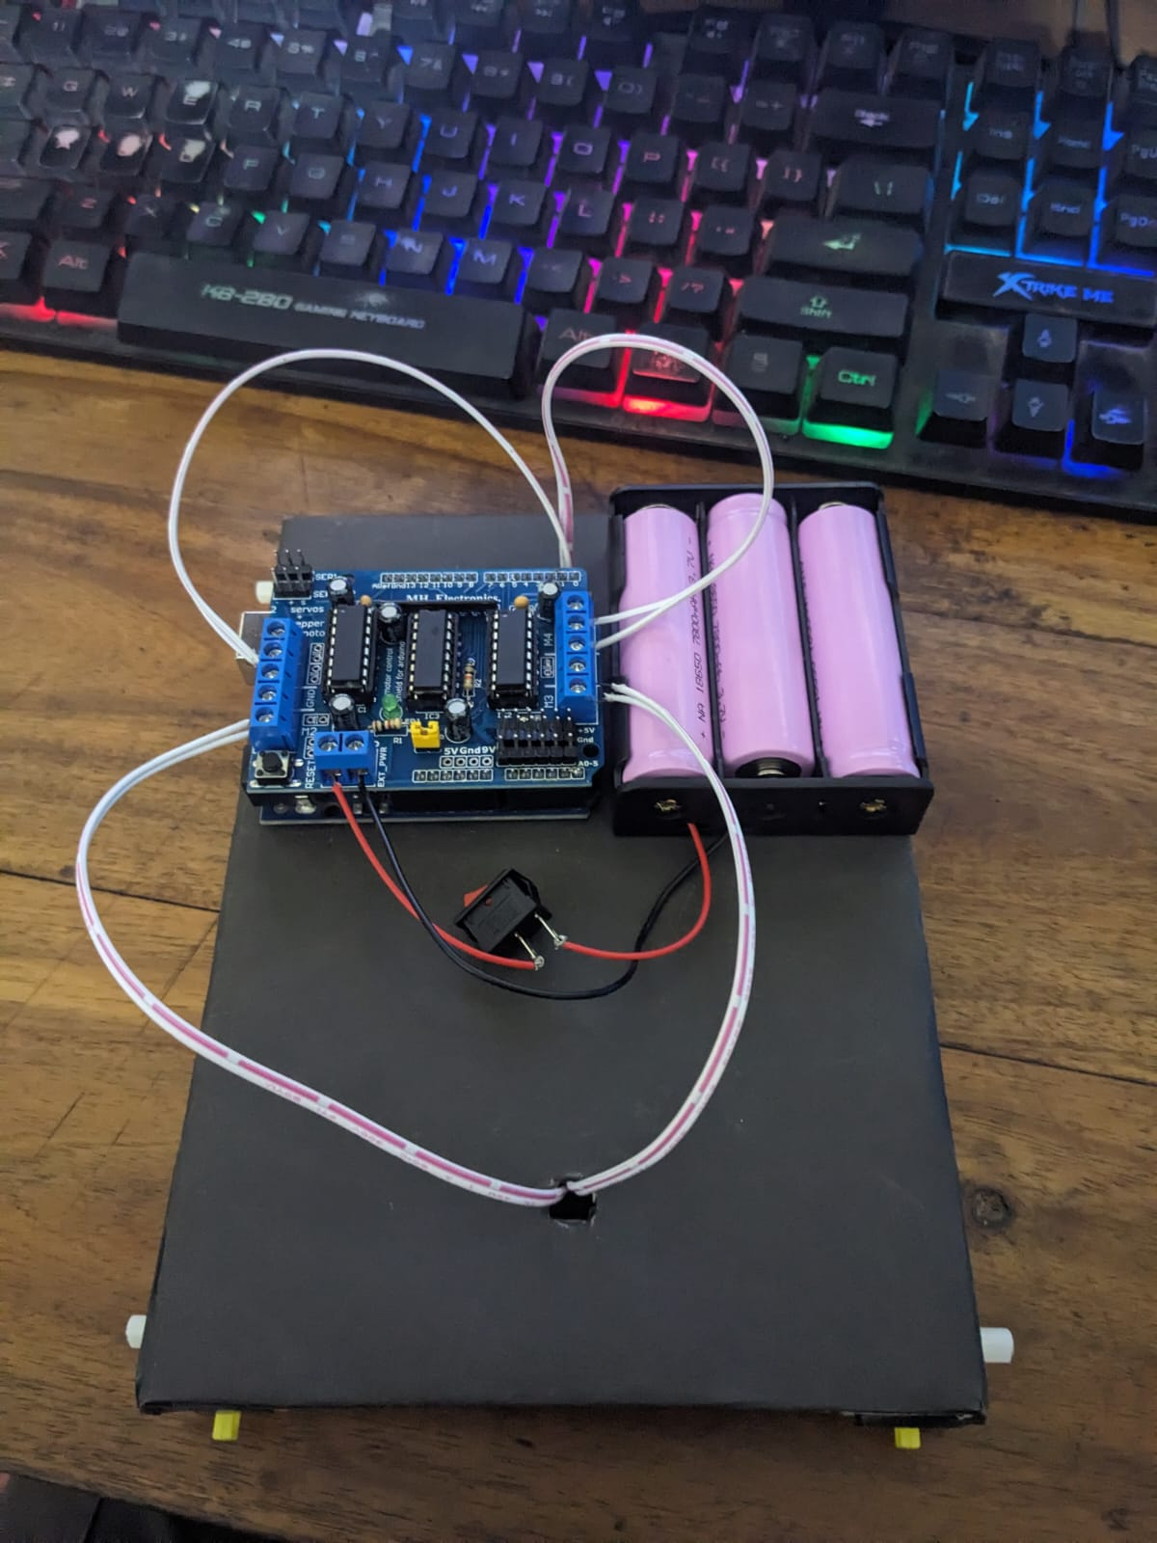
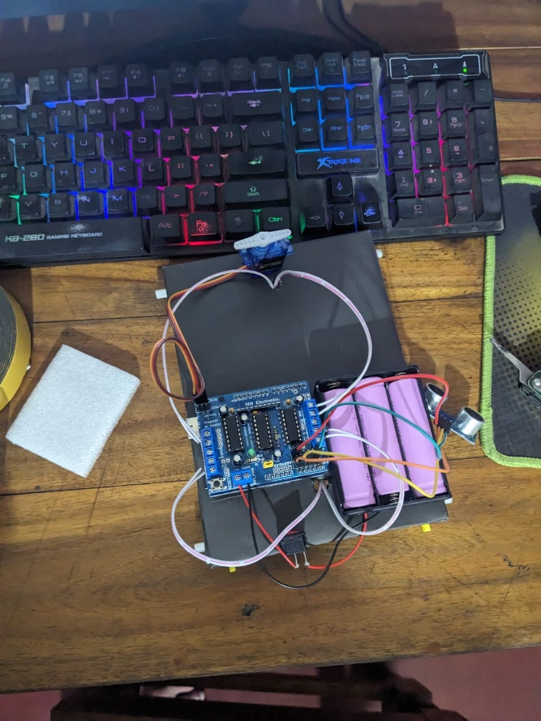
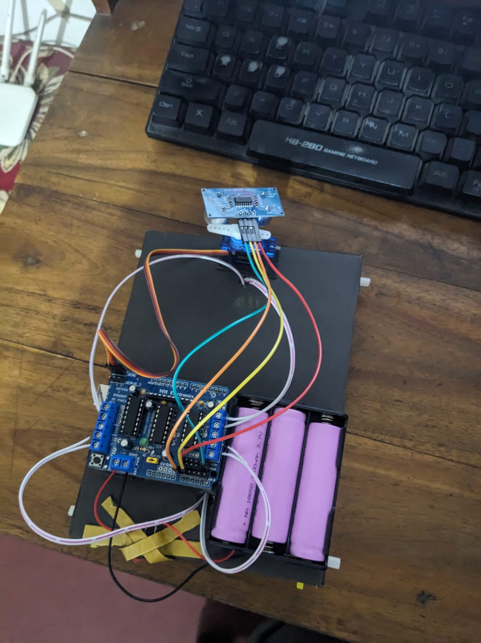

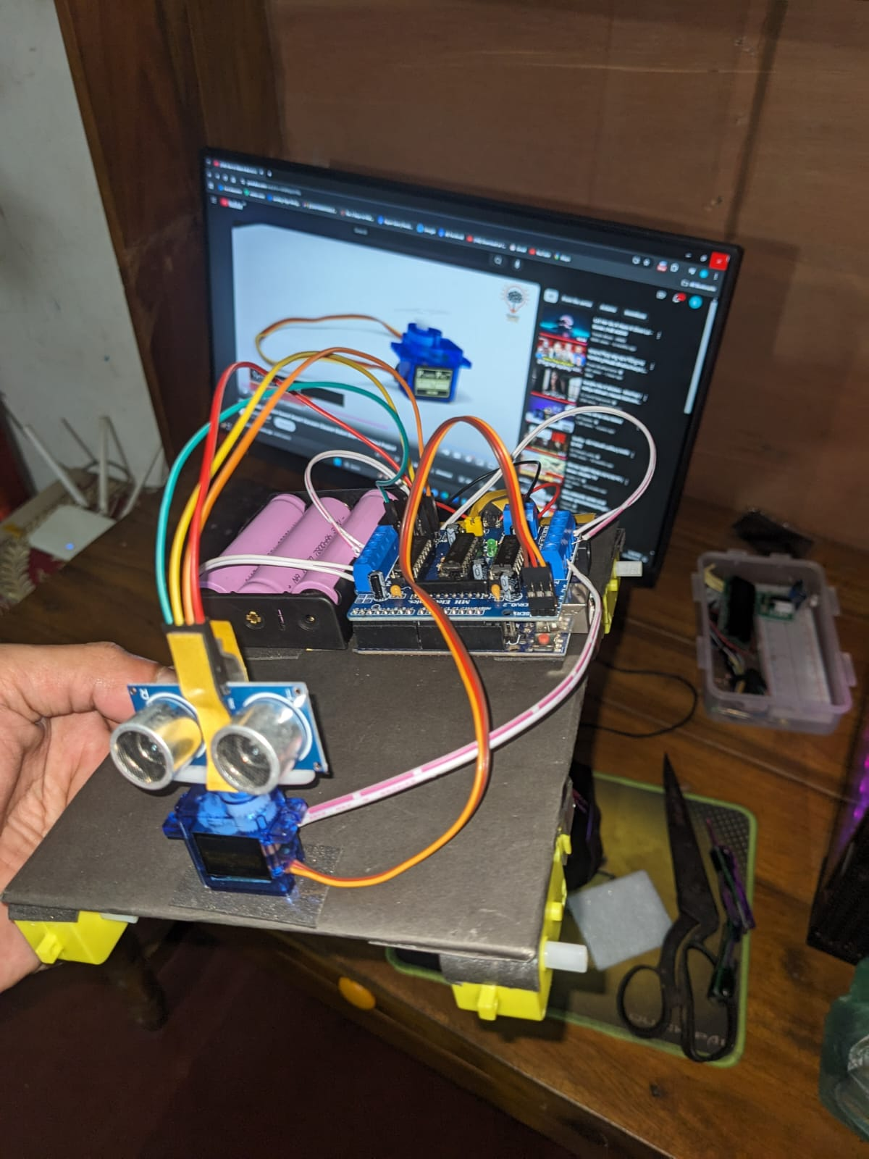
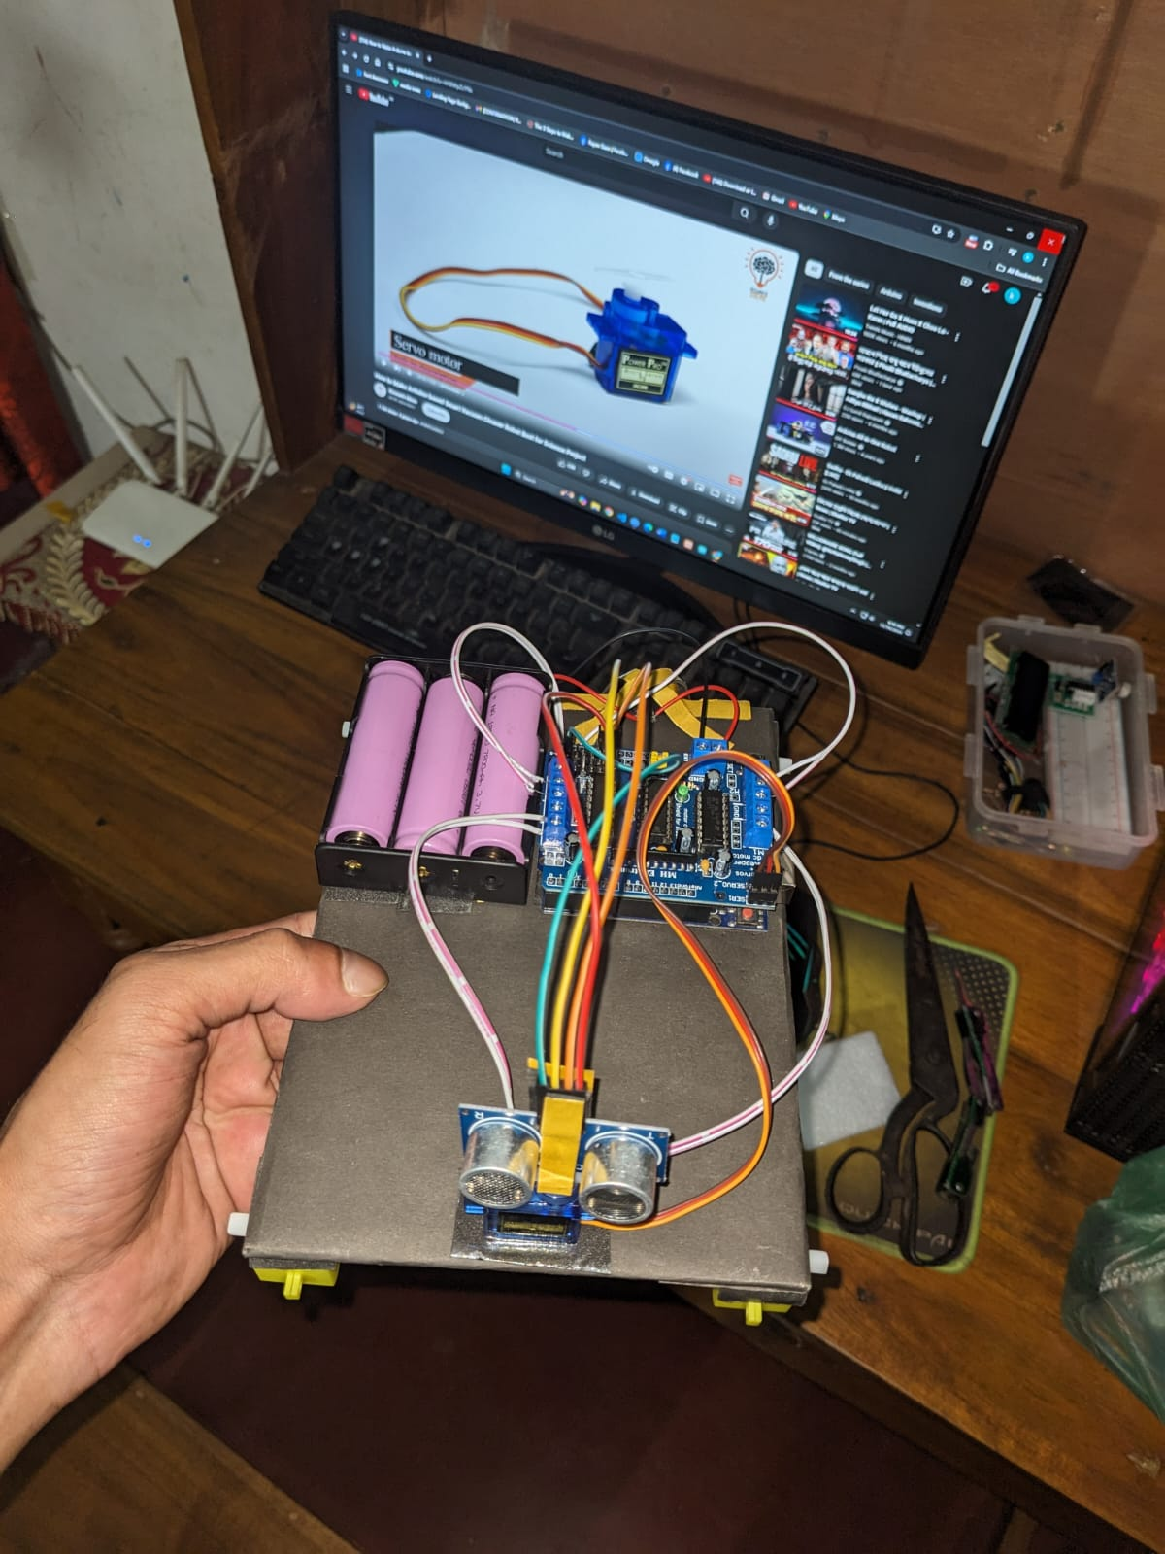

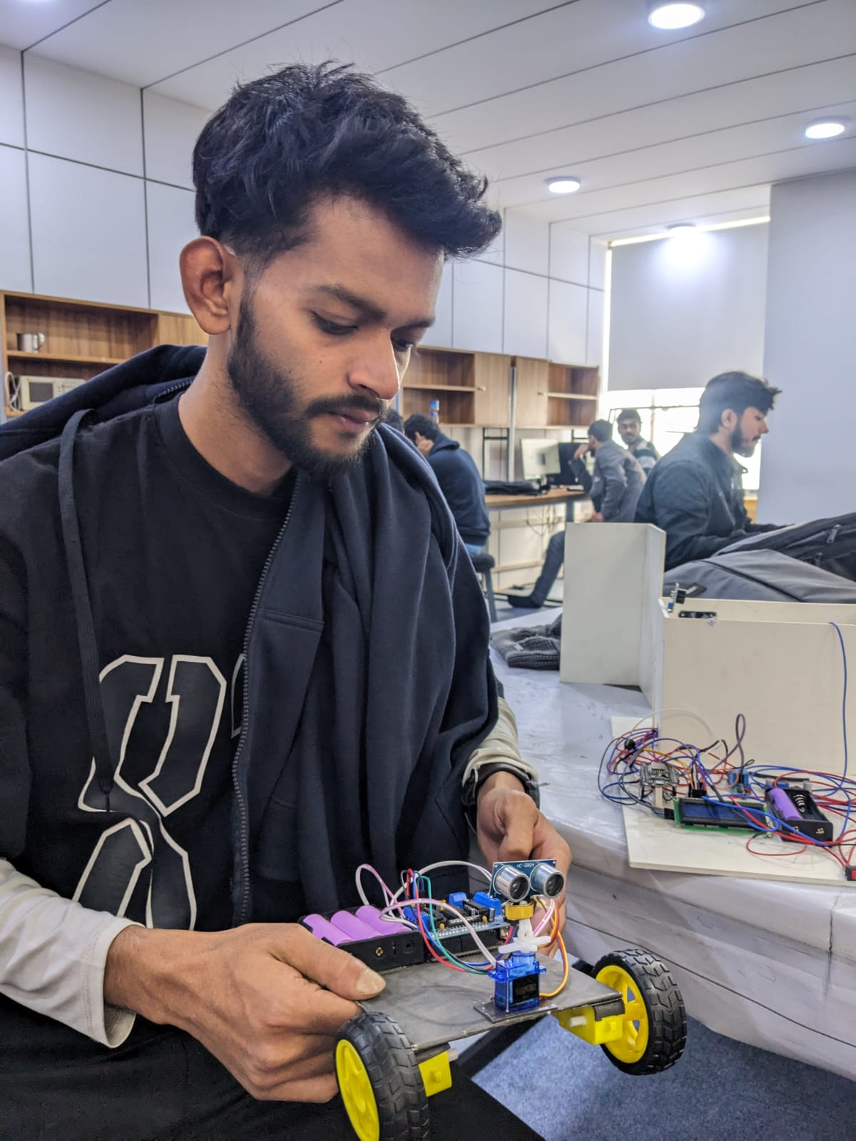
Code Implementation

#include <AFMotor.h>
#include <NewPing.h>
#include <Servo.h>

#define TRIG_PIN A0
#define ECHO_PIN A1
#define MAX_DISTANCE 200
#define MAX_SPEED 70 // sets speed of DC motors
#define MAX_SPEED_OFFSET 20

NewPing sonar(TRIG_PIN, ECHO_PIN, MAX_DISTANCE);

AF_DCMotor motor1(1, MOTOR12_1KHZ);
AF_DCMotor motor2(2, MOTOR12_1KHZ);
AF_DCMotor motor3(3, MOTOR34_1KHZ);
AF_DCMotor motor4(4, MOTOR34_1KHZ);
Servo myservo;

boolean goesForward=false;
int distance = 100;
int speedSet = 0;

void setup() {

myservo.attach(10);
myservo.write(115);
delay(2000);
distance = readPing();
delay(100);
distance = readPing();
delay(100);
distance = readPing();
delay(100);
distance = readPing();
delay(100);
}

void loop() {
int distanceR = 0;
int distanceL = 0;
delay(40);

if(distance<=15)
{
moveStop();
delay(100);
moveBackward();
delay(300);
moveStop();
delay(200);
distanceR = lookRight();
delay(200);
distanceL = lookLeft();
delay(200);

if(distanceR>=distanceL)
{
turnRight();
moveStop();
}else
{
turnLeft();
moveStop();
}
}else
{
moveForward();
}
distance = readPing();
}

int lookRight()
{
myservo.write(50);
delay(500);
int distance = readPing();
delay(100);
myservo.write(115);
return distance;
}

int lookLeft()
{
myservo.write(170);
delay(500);
int distance = readPing();
delay(100);
myservo.write(115);
return distance;
delay(100);
}

int readPing() {
delay(70);
int cm = sonar.ping_cm();
if(cm==0)
{
cm = 250;
}
return cm;
}

void moveStop() {
motor1.run(RELEASE);
motor2.run(RELEASE);
motor3.run(RELEASE);
motor4.run(RELEASE);
}

void moveForward() {

if(!goesForward)
{
goesForward=true;
motor1.run(FORWARD);
motor2.run(FORWARD);
motor3.run(FORWARD);
motor4.run(FORWARD);
for (speedSet = 0; speedSet < MAX_SPEED; speedSet +=2) // slowly bring the speed up to avoid loading down the batteries too quickly
{
motor1.setSpeed(speedSet);
motor2.setSpeed(speedSet);
motor3.setSpeed(speedSet);
motor4.setSpeed(speedSet);
delay(5);
}
}
}

void moveBackward() {
goesForward=false;
motor1.run(BACKWARD);
motor2.run(BACKWARD);
motor3.run(BACKWARD);
motor4.run(BACKWARD);
for (speedSet = 0; speedSet < MAX_SPEED; speedSet +=2) // slowly bring the speed up to avoid loading down the batteries too quickly
{
motor1.setSpeed(speedSet);
motor2.setSpeed(speedSet);
motor3.setSpeed(speedSet);
motor4.setSpeed(speedSet);
delay(5);
}
}

void turnRight() {
motor1.run(FORWARD);
motor2.run(FORWARD);
motor3.run(BACKWARD);
motor4.run(BACKWARD);
delay(500);
motor1.run(FORWARD);
motor2.run(FORWARD);
motor3.run(FORWARD);
motor4.run(FORWARD);
}

void turnLeft() {
motor1.run(BACKWARD);
motor2.run(BACKWARD);
motor3.run(FORWARD);
motor4.run(FORWARD);
delay(500);
motor1.run(FORWARD);
motor2.run(FORWARD);
motor3.run(FORWARD);
motor4.run(FORWARD);
}

