LocalShare

“A secure, peer-to-peer file sharing web app that works instantly between any two devices-without uploading files to any server”

Let users share files via link or QR, directly browser-to-browser using WebRTC, with a spring boot backend acting only as the signaling server (for peer discovery)

List of Abbreviations
Abbreviations | Full term
AES | Advanced Encryption Standard
API | Application Programming Interface
DB | Database
DTO | Data Transfer Object
DTLS | Datagram Transport Layer Security
HTTP | Hypertext Transfer Protocol
HTTPS | Hypertext Transfer Protocol Secure
ICE | Interactive Connectivity Establishment
NAT | Network Address Translation
P2P | Peer-to-Peer
PWA | Progressive Web Application
QR | Quick Response
REST | Representational State Transfer
SDP | Session Description Protocol
WSS | WebSocket Secure
WebRTC | Web Real-Time Communication

Functional requirements

- Create share session – Sender clicks “create session”- backend generates a unique session id
- Join session – Receiver enters the code or scans QR to connect to the sender
- Peer connection – Once both are in session, a WebRTC data channel is established via socket.IO signaling.
- File transfer – Sender selects file → gets streamed via WebRTC data channel to receiver
- File encryption – Before sending, file is AES-encrypted in the browser. Receiver decrypts it
- Progress UI – show upload an download progress for each file
- Device QR link – show QR code for easier connect on mobile
- Connection fallback – if peer to peer fails (e.g., behind NAT/ firewall) , use Springboot relay proxy.
- Local history – share previous share sessions in browser using indexedDB
- Auto cleanup – sessions expire after inactivity (server + client)

Non-Functional requirements

- Performance – Must handle 100 concurrent signaling sessions easily. File transfer is P2P. So server load stays low.
- Scalability – Redis for many signaling clients.
- Security – HTTPS/WSS for all signaling. WebRTC data is encrypted (DTLS).
- Cross-Platform – Works on desktop and mobile browsers
- Offline support – Service worker for PWA install and local cache of UI.

Tech Stack

Layer | Technology | Purpose
Frontend | React (Vite) + Tailwind css | UI + file picker + WebRTC client
Frontend | Socket.IO-client + WebRTC APIs | Peer descovery + file channel
Backend | Spring Boot (Java 17) | Rest APIs + signaling server
Backend | Netty-socketio | WebSocket/Socket.IO server implementation
DB (optional) | Redis | Store active session metadata
Build/deploy | Docker/Docker Compose | Containerize backend & frontend
Hosting | Railway

Architecture Diagram

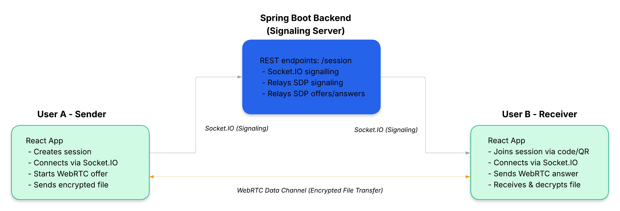

Redis – Stores active session metadata
Netty SocketIO – Handles the signaling between peer (exchanging WebRTC connection info)

bossThread = thread that accept new connections
workerThread = thread that handles data transfer

Model(Session.java)

- Internal representation – how data is stored
- contains redis- specific fields
- never exposed directly to API

DTO(SessionResponse.java)

- External representation – what API returns
- only contains fields client need

What is Redis template?

- Its like a toolbox for redis operations:
- set(key,value) – store data
- get(key) – retrieve data
- delete(key) – remove data
- expire(key,timeout) – auto delete after timeout

HTTP Status Codes

Code | Status | Use
200 OK | Success | Normal response
400 Bad Request | Client error | Invalid input, logic failure
404 Not Found | Resource missing | Session does not exist
500 Internal Server Error | Server error | Unexpected exceptions

WebRTC requires three types of messages

- OFFER – Sender proposes a connection parameter
- ANSWER – Receiver responds with their parameters
- ICE_CANDIDATE – Network route information from both sides

Signaling message parameters

Parameter | Description
Type | - Type of signaling message.  - Value: offer, answer, ice_candidate
SessionId | - Session ID this message belongs
Sdp | - SDP data  - Contains connection parameters (e.g., codecs, formats, etc.)  - Used for OFFER and ANSWER messages
Candidate | - ICE candidate data  - Contains network route information (IP,port,protocol)  - Used for ICE_CANDIDATE messages
From | - Senders socket ID (for routing)
To | - Receiver’s socket ID (for routing)
Message | - Additional metadata and error messages
Timestamp | - Timestamp when message was created

WebRTC Handshake Process
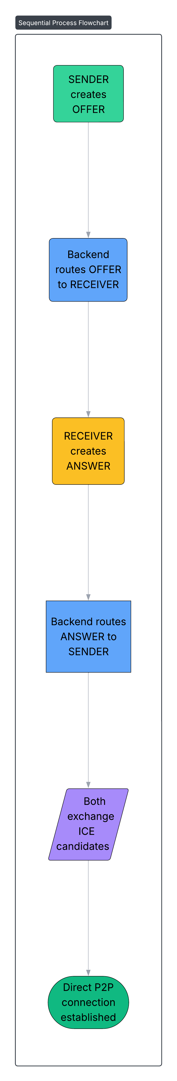

Architecture (Single Container)
