Table of Contents

[To update the table of contents, select the message below and press F9]

**No table of contents entries found.**

1. Pages
   1. Page Tree

wap  
 login  
 register  
 event list  
 product list  
 product page  
 select pruduct  
 cart page  
 check out page  
 all address  
 select address  
 address province  
 address city  
 select payment  
 check out finish  
 my accont pic  
 my accont txt  
 order details  
 in site message  
 message

* 1. wap
     1. User Interface

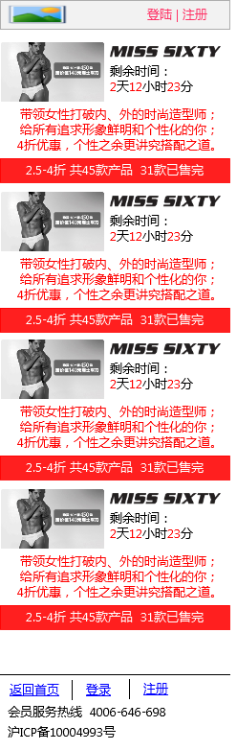

* 1. login
     1. User Interface

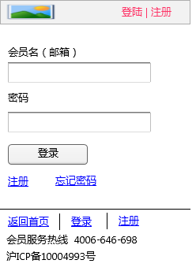

* 1. register
     1. User Interface

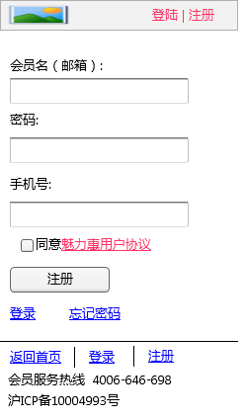

* 1. event list
     1. User Interface

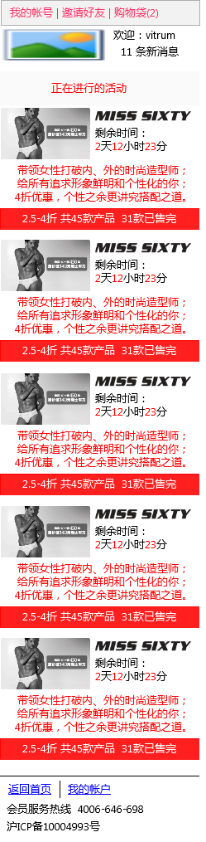

* 1. product list
     1. User Interface

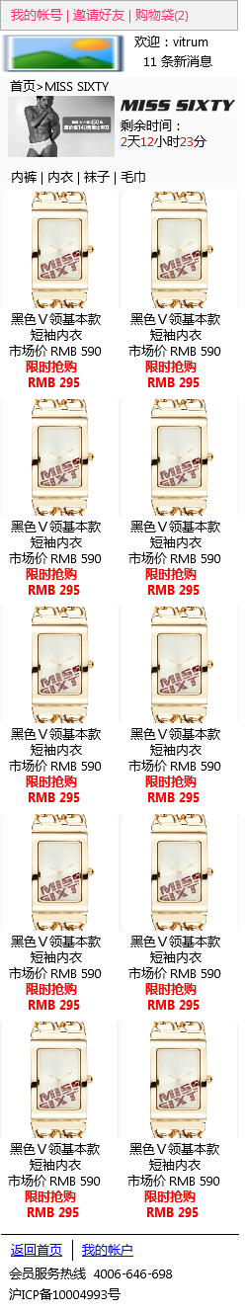

* 1. product page
     1. User Interface

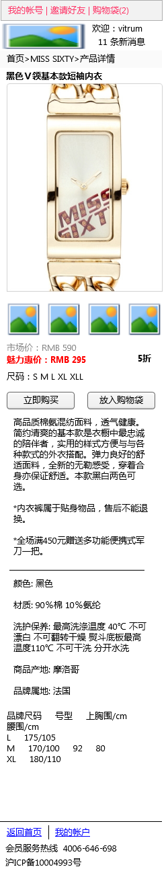

* 1. select pruduct
     1. User Interface

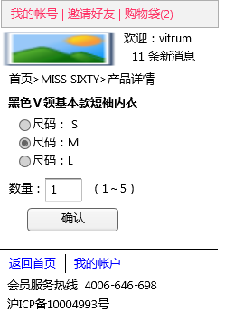

* 1. cart page
     1. User Interface

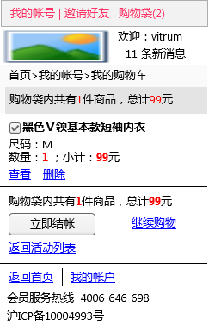

* 1. check out page
     1. User Interface

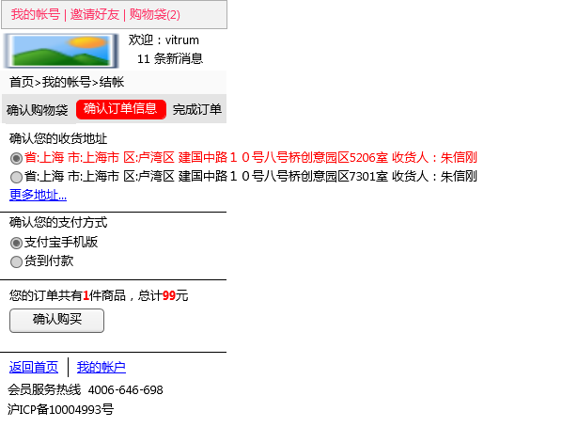

* 1. all address
     1. User Interface

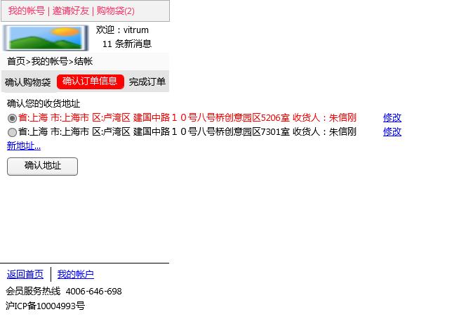

* 1. select address
     1. User Interface

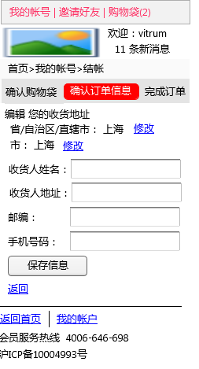

* 1. address province
     1. User Interface

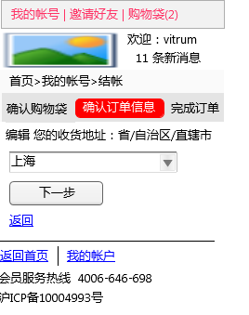

* 1. address city
     1. User Interface

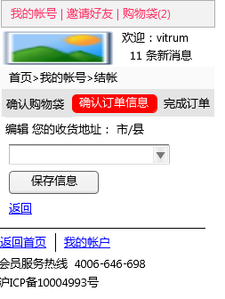

* 1. select payment
     1. User Interface

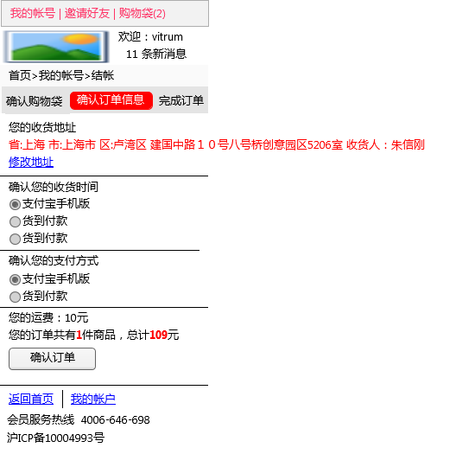

* 1. check out finish
     1. User Interface

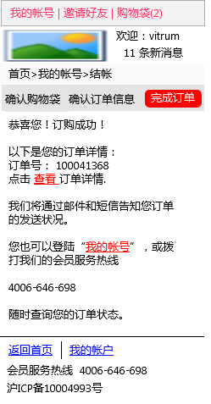

* 1. my accont pic
     1. User Interface

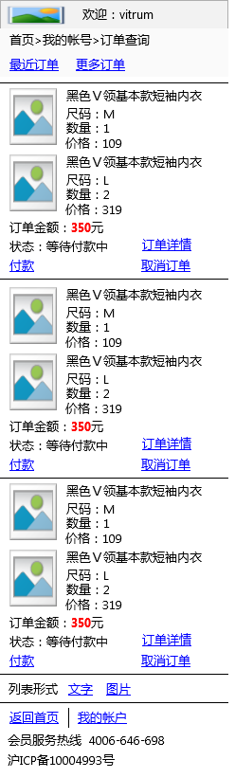

* 1. my accont txt
     1. User Interface

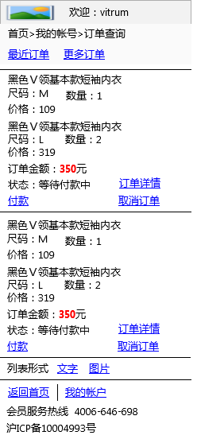

* 1. order details
     1. User Interface

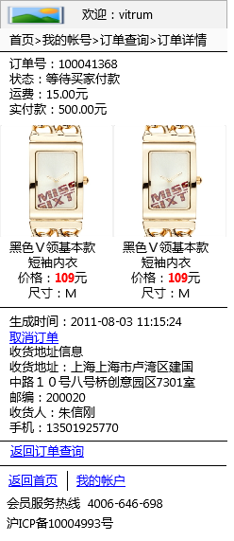

* 1. in site message
     1. User Interface

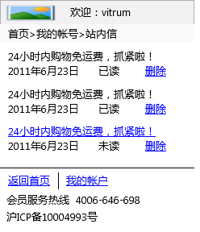

* 1. message
     1. User Interface

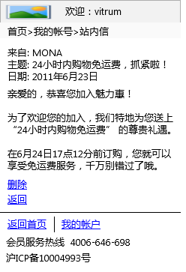

1. Masters
   1. Master List

wap  
 order list pic  
 order list txt  
 register  
 login  
 gls logo  
 gls logo vister  
 footer vister  
 footer member  
 top nav member  
 header member  
 header member mygls  
 header vister  
 event banner  
 product block  
 product block for order

* 1. order list pic
     1. User Interface

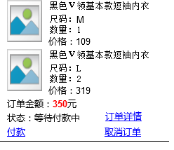

* 1. order list txt
     1. User Interface

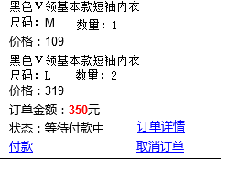

* 1. register
     1. User Interface

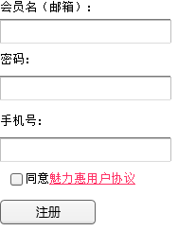

* 1. login
     1. User Interface

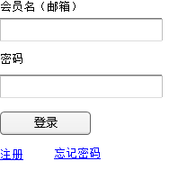

* 1. gls logo
     1. User Interface



* 1. gls logo vister
     1. User Interface



* 1. footer vister
     1. User Interface

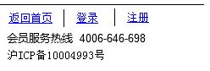

* 1. footer member
     1. User Interface

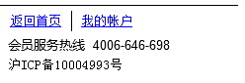

* 1. top nav member
     1. User Interface



* 1. header member
     1. User Interface

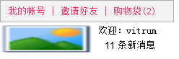

* 1. header member mygls
     1. User Interface



* 1. header vister
     1. User Interface



* 1. event banner

OnPageLoad (页面加载时):  
 Case 1:

* + 1. User Interface

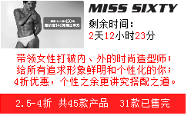

* 1. product block
     1. User Interface

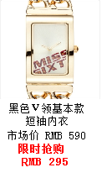

* 1. product block for order
     1. User Interface

