How to T-Shoot a large SQL Server Log File *(The most common SQL Server problem on the Internet)*

Symptom

A SQL Server transaction log file (.ldf)) is significantly larger that its database file (.mdf).

Recovery Models

To return free space held by SQL Server transactions logs to the OS, you first need to understand SQL Server database recovery models.

Database recovery models dictate how SQL Server database transaction logs are utilized (or not utilized).

There are 3 types of SQL database recovery models: **Simple**, **Full** and **Bulk Logged**. The Bulk-logged recovery model option is for use during specific bulk operations, i.e. BULK INSERT, CREATE INDEX SELECT INTO, etc.

|  |  |  |
| --- | --- | --- |
| **Recovery Model** | **Able to backup the Transaction Log?** | **Recovery to point in time?** |
| Simple | * **No** | No, only from last good backup |
| Full | * **Yes** | Yes, using the last full backup and the transaction log |

Transaction Logs

Every INSERT, UPDATE and DELETE activity are stored in transaction logs.

Check Disk Usage: GUI

1. SSMS 🡪 Database 🡪 Reports 🡪 Standard Reports 🡪 Disk Usage

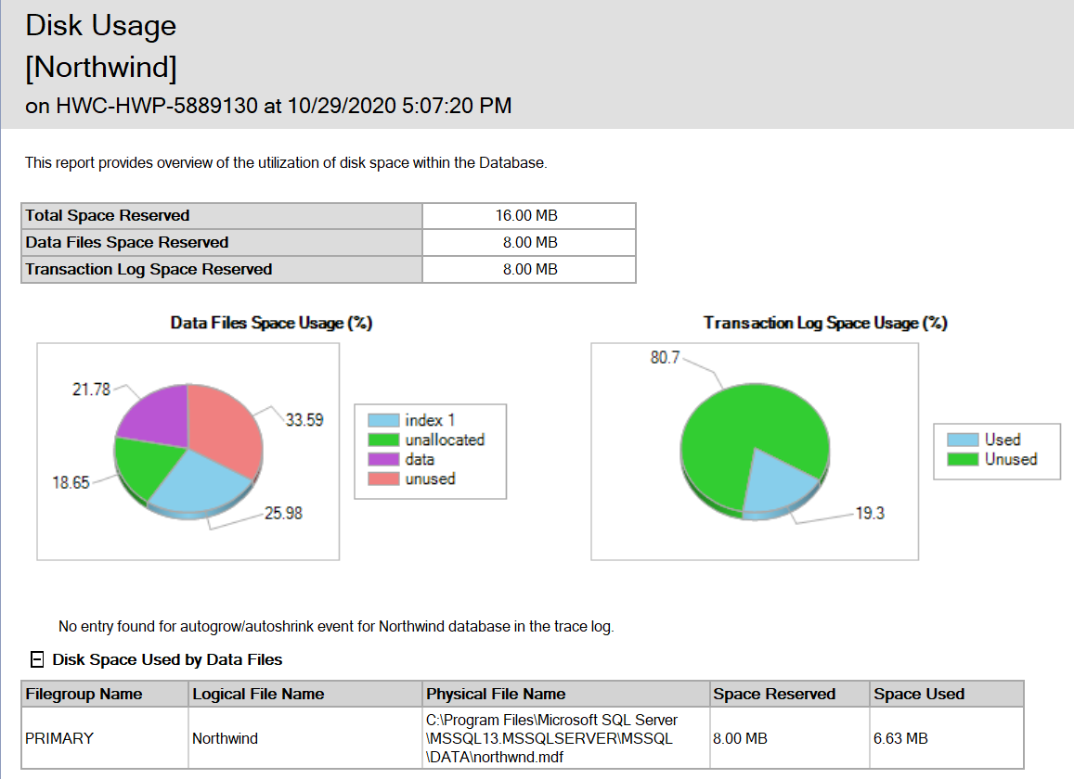

Check Disk Usage: T-SQL

-- Show space used for the current database

EXEC sp_spaceused

GO

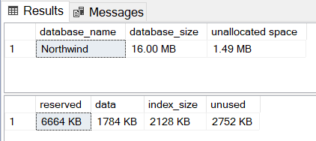

-- Show SQL Server Transaction Log File Size and % Space Used

DBCC sqlperf(logspace);

GO

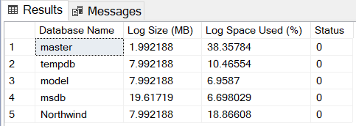

Get the Recovery Model: GUI

1. SSMS 🡪 Database 🡪 Properties 🡪 Options Tab

Get the Recovery Model: T-SQL

-- Get the Recovery Model for a Database

SELECT name, recovery_model_desc

FROM sys.databases

WHERE name = 'Northwind';

GO

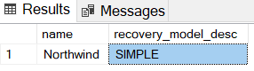

Tip:

Check if/when the transaction log was last backed up. If not recent, this could be the culprit.

Database 🡪 Properties 🡪 General Tab

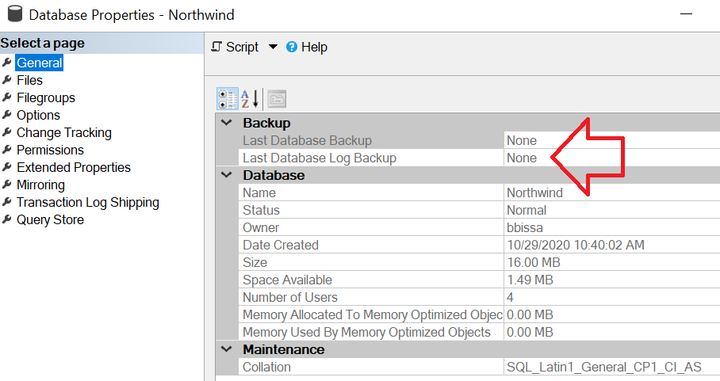

Shrink the Transaction Log (gracefully)

1. Backup the database
2. Backup the transaction log
3. **NOTE: While normally shrinking anything in a database is not recommended (i.e. due to fragmentation), in this case it is warranted**
4. SSMS 🡪 Tasks 🡪 Shrink 🡪 Files 🡪 File type: **Log**
5. Shrink action: **Reorganize pages before releasing unused space** (and enter a desired **Shrink file to** size) as shown below

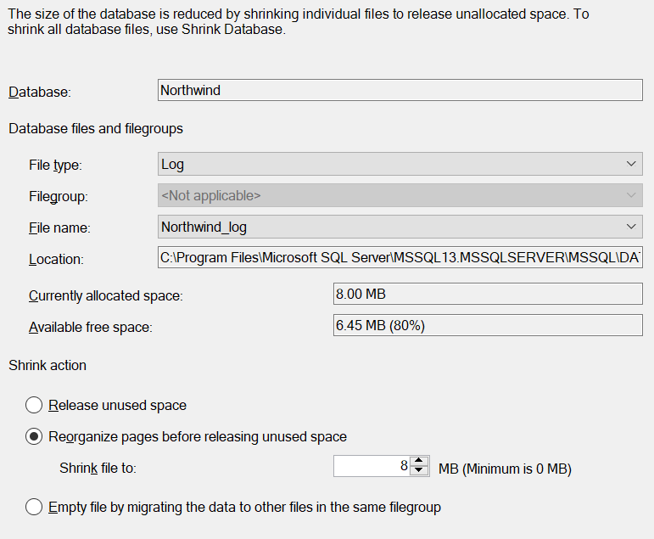

Shrink the Transaction Log (not so graceful): GUI

Use this option if the transaction log has filled the disk, and you are unable to expand the drive, and you do not have enough room to backup the log (and the recovery model is set to full)

1. Backup the database
2. SSMS 🡪 Database 🡪 Properties 🡪 Options Tab
3. Recovery model: **Simple** (this will immediately empty the transaction log)
4. SSMS 🡪 Tasks 🡪 Shrink 🡪 Files 🡪 File type: **Log**
5. Shrink action: **Reorganize pages before releasing unused space** (and enter a desired **Shrink file to** size) as shown in image above
6. After the space is returned to the OS, return the recovery model back to Full
   1. SSMS 🡪 Database 🡪 Properties 🡪 Options Tab
   2. Recovery model: **Full**

Shrink the Transaction Log (not so graceful): T-SQL

USE Northwind

GO

ALTER DATABASE Northwind

SET RECOVERY SIMPLE

GO

DBCC SHRINKFILE (northwind, 10) -- (logFileName, shrink file to size in MB)

GO

ALTER DATABASE Northwind

SET RECOVERY FULL

GO

References:

1. Get the sample databases for ADO.NET code samples: <https://docs.microsoft.com/en-us/dotnet/framework/data/adonet/sql/linq/downloading-sample-databases>
2. Recovery Models (SQL Server): <https://docs.microsoft.com/en-us/sql/relational-databases/backup-restore/recovery-models-sql-server?view=sql-server-ver15>