BitLocker-to-go Key Recovery

1. Recovery the key
2. Access the drive (it’s now read-only)
3. Format the drive
4. And Turn on BitLocker again

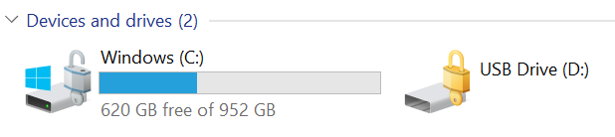

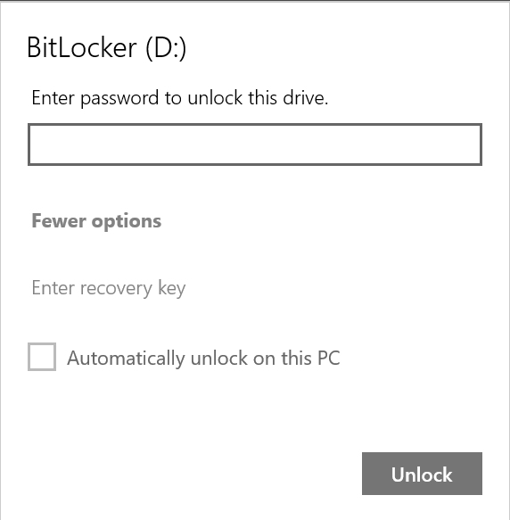

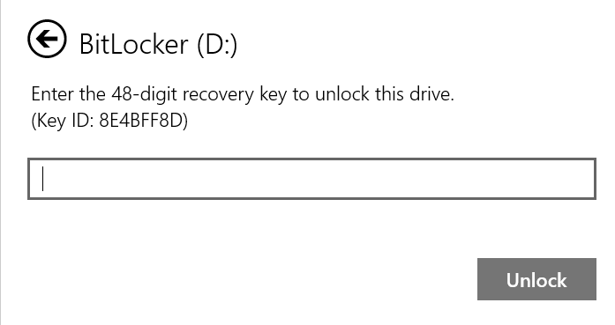

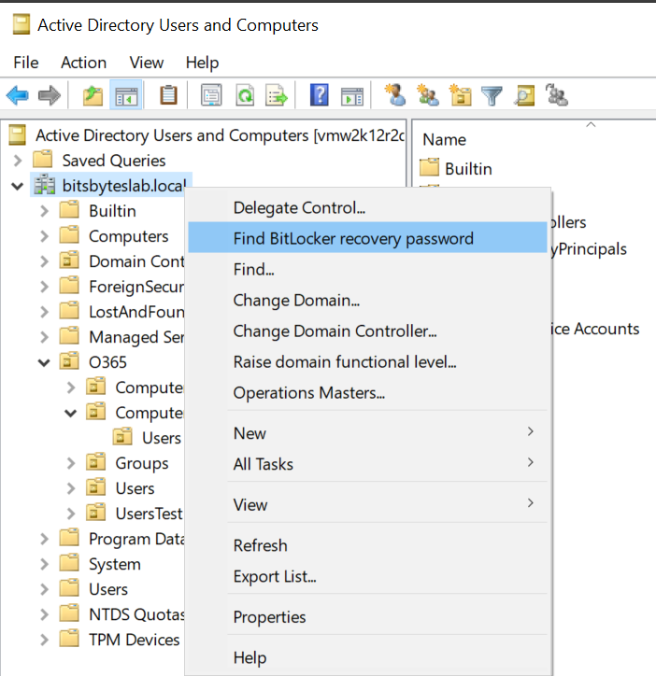

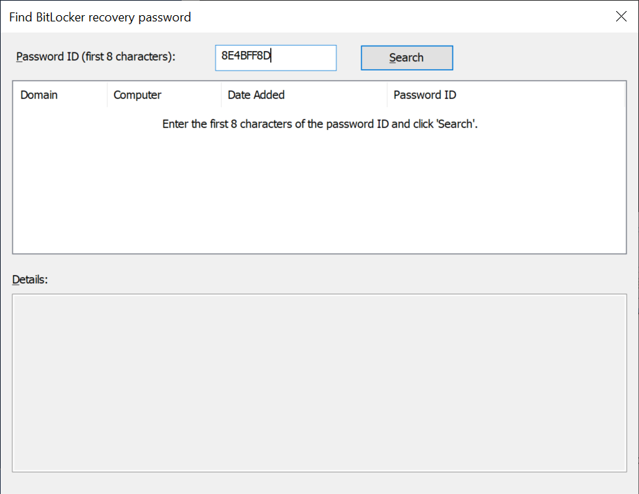

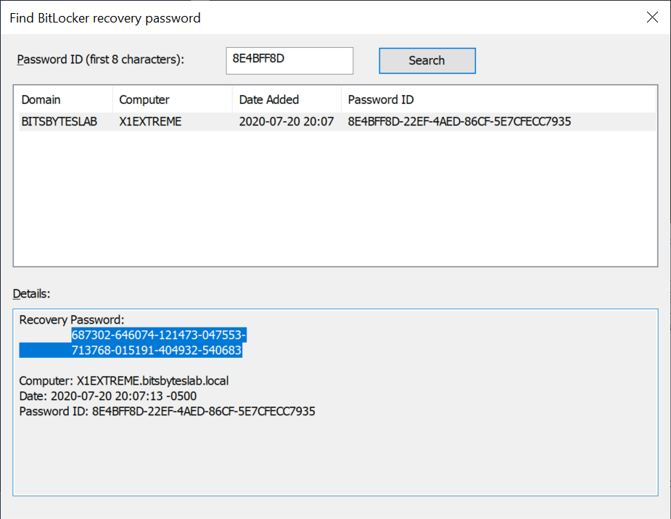

687302-646074-121473-047553-713768-015191-404932-540683

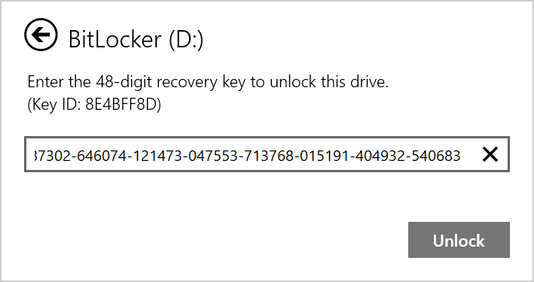

Now copy the required data from the (now read-only drive)

Format the drive and re-enable BitLocker-to-go

