BitLocker-to-go Key Recovery

Introduction

This guide provides one of two key recovery options that can be used to unlock BitLocker encrypted USB drives. The approach discussed here leverages Active Directory to store a copy of the decryption key.

Key Finding

1. After the key is retrieved from Active Directory and used to unlock the USB drive, you are forced to re-format and then re-enable BitLocker-to-go
2. Note however, after also implementing the second option that uses a DRA Certificate, unlocking the drive using the key stored in Active Directory no longer required the drive to be re-formated/re-encrypted

Overview

1. Recover the key
2. Access the USB drive (which is now read-only)
3. Copy required data from the USB drive
4. Format the drive
5. Re-enable BitLocker

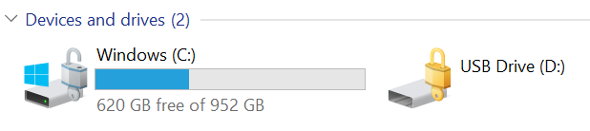

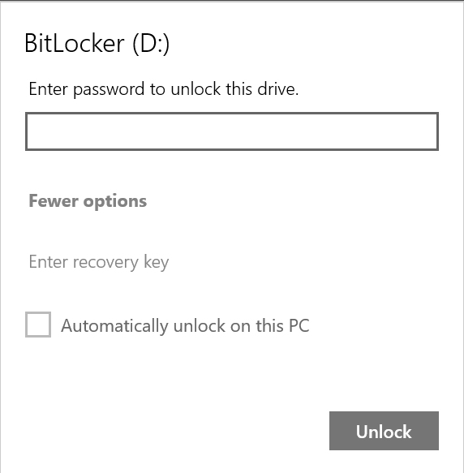

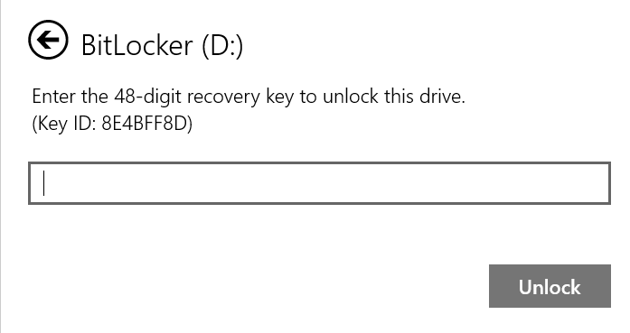

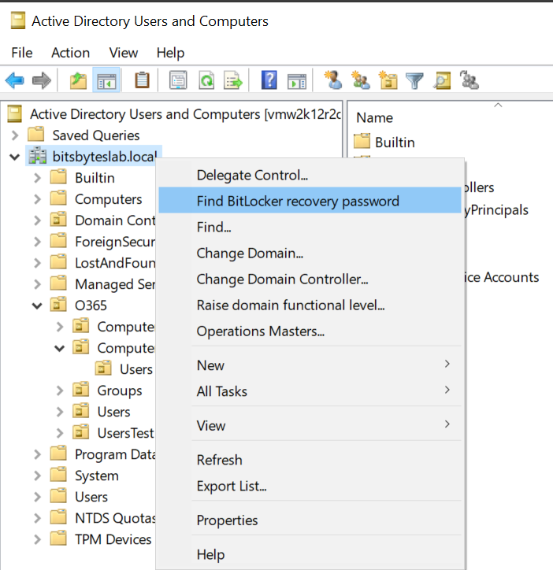

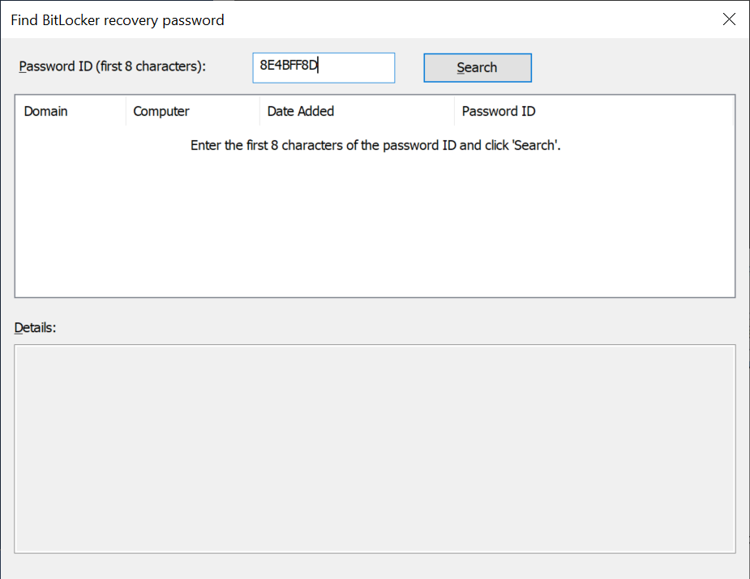

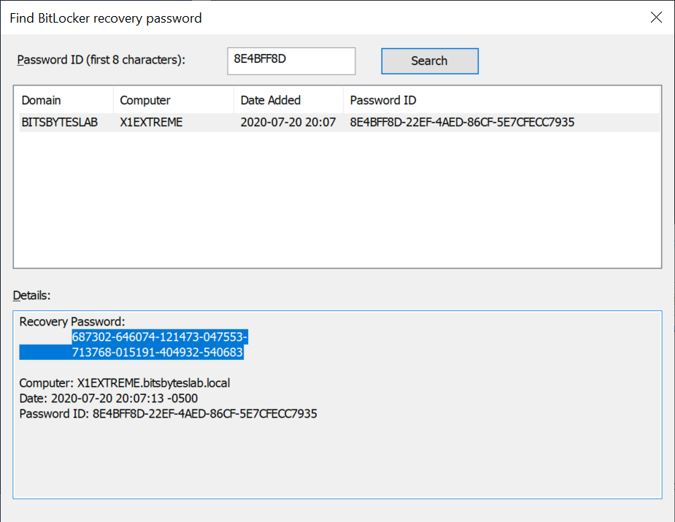

687302-646074-121473-047553-713768-015191-404932-540683

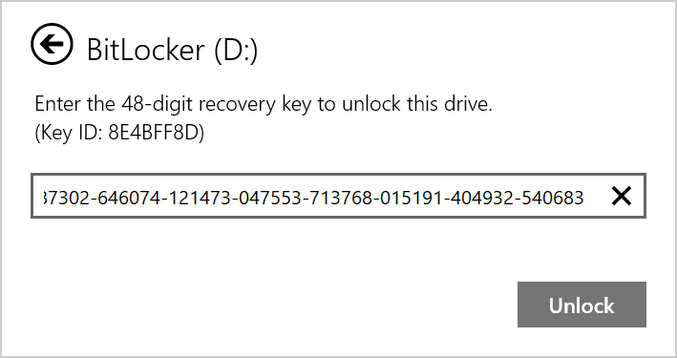

Now copy the required data from the (now read-only drive)

Format the drive and re-enable BitLocker-to-go

