BitLocker-to-go Management

Option 1 of 2: Install the BitLocker Drive Encryption Administration Utilities via Server Manager

1. Server Manager
2. Add Roles and Features
3. Role-based or feature-based installation
4. Select a server from the server pool
5. Next\Next
6. Select the two BitLocker Administration options shown below

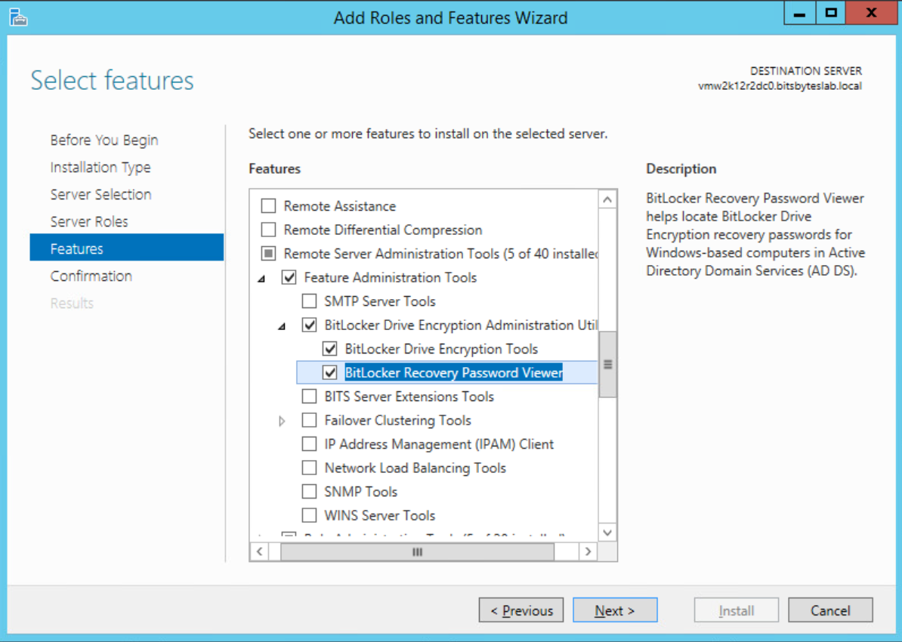

1. Next
2. Close

Option 2 of 2: Install the BitLocker Drive Encryption Administration Utilities via

Windows 10, Add a feature

* Note: A reboot is required on Windows 10

1. Search
2. Add or Remove Programs
3. Optional Features
4. Add a feature

