RSDC PoC

Only two Active Directory Group Policies are required

|  |  |  |  |
| --- | --- | --- | --- |
| Group Policy Name | Details: GPO Status | Setting | Delegation |
| RSDC_Deny_All | Computer configuration settings disabled | User Configuration\Policies\Administrative Templates\System\Removable Storage Access\   * All Removable Storage classes: Deny all access | 1. **Authenticated users**: Allow Read + **Allow** Apply 2. **RSDC_Read_Only**: Allow Read + **Deny** Apply 3. **RSDC_Deny_All_Exception**: Allow Read + **Deny** Apply |
| RSDC_Read_Only | Computer configuration settings disabled | User Configuration\Policies\Administrative Templates\System\Removable Storage Access\   * CD and DVD: Deny write access * Floppy Drives: Deny write access * Removable Disks: Deny write access * Tape Drives: Deny write access * WPD Devices: Deny write access | 1. **Authenticated users**: Allow Read 2. **RSDC_Read_Only**: Allow Read + **Allow** Apply |

Only two Active Directory Global Security Groups are required

|  |
| --- |
| Group Name |
| RSDC_Deny_All_Exception |
| RSDC_Read_Only |

RSDC_Deny_All

Details\GPO Status: Computer configuration settings disabled

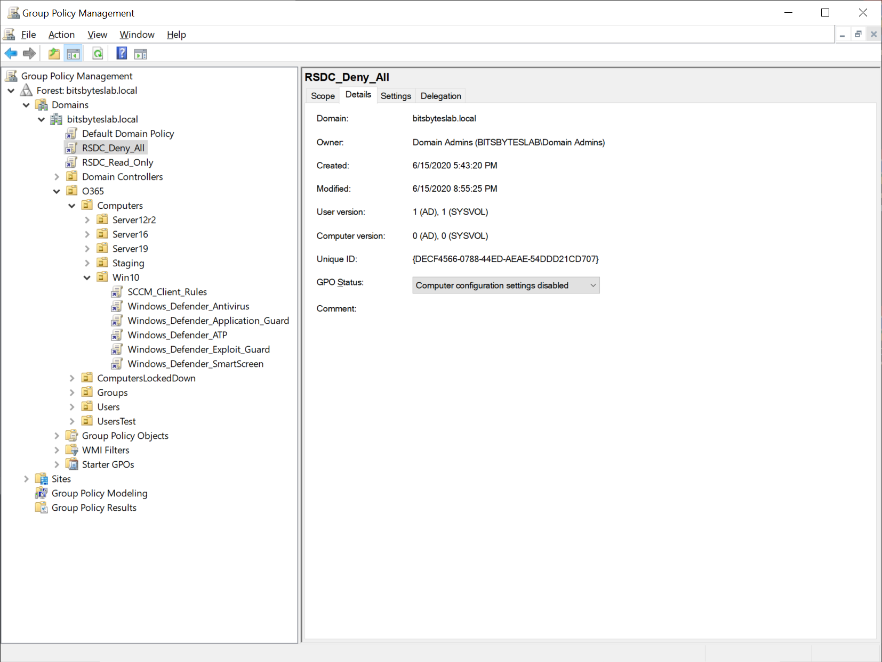

Settings

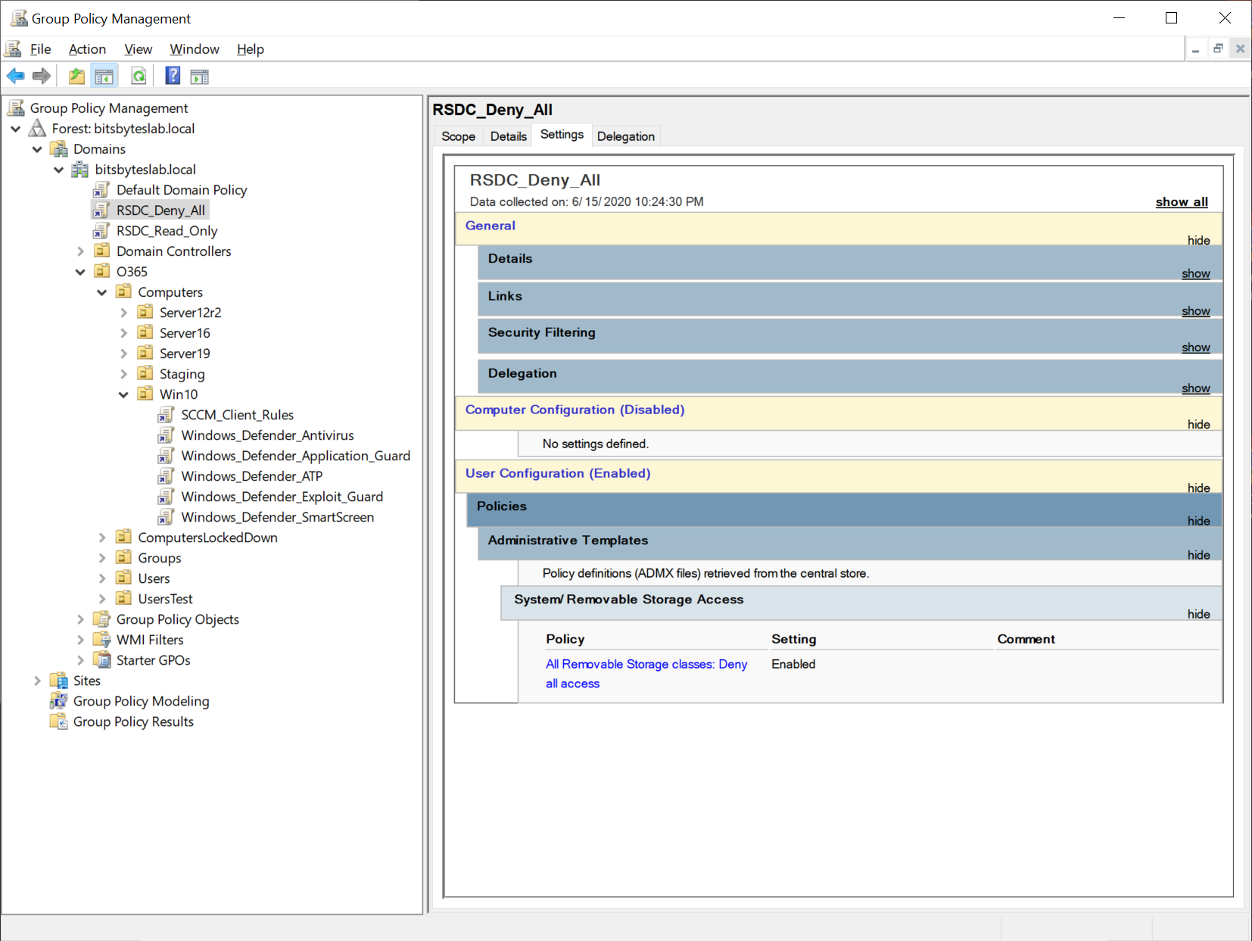

Permissions for Authenticated Users

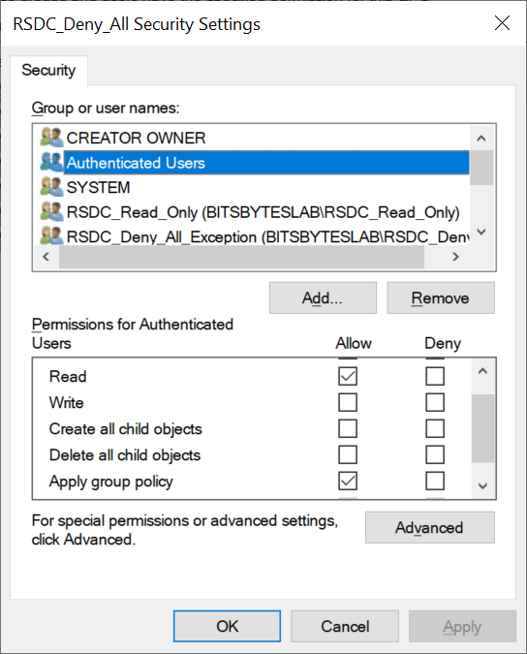

Permissions for the RSDC_Read_Only group

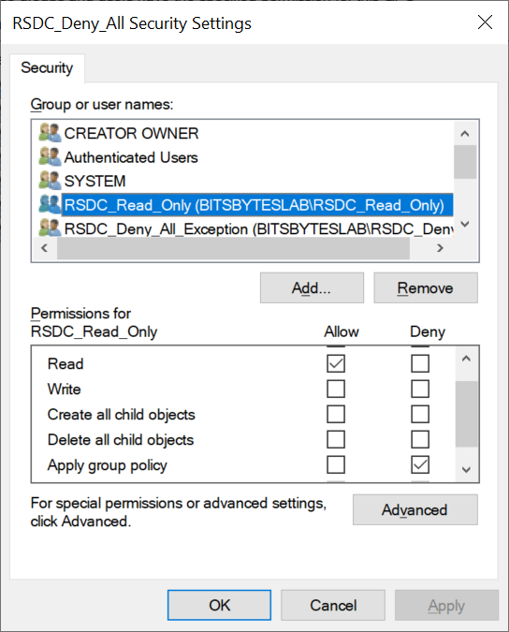

Permissions for RSDC_Deny_All_Exception group

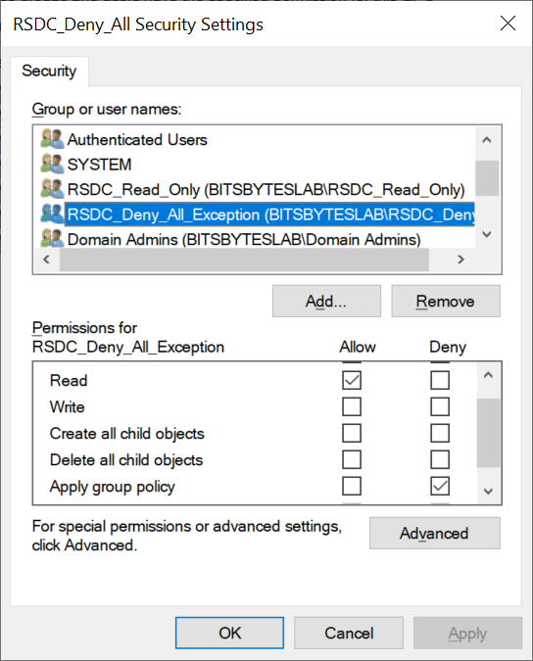

RSDC_Read_Only

Details\GPO Status: Computer configuration settings disabled

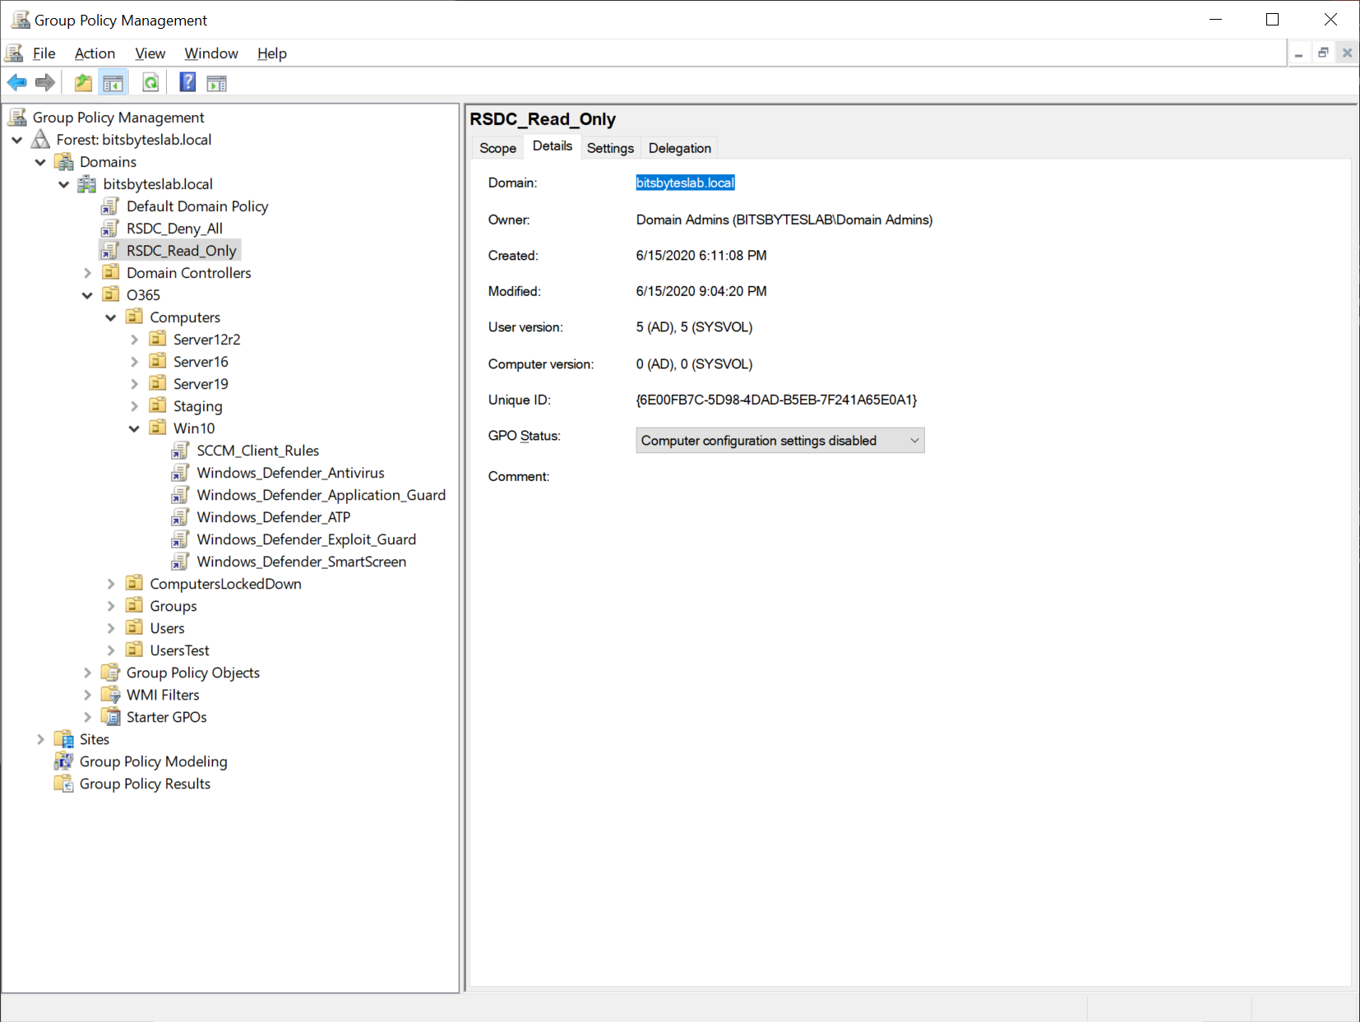

Settings

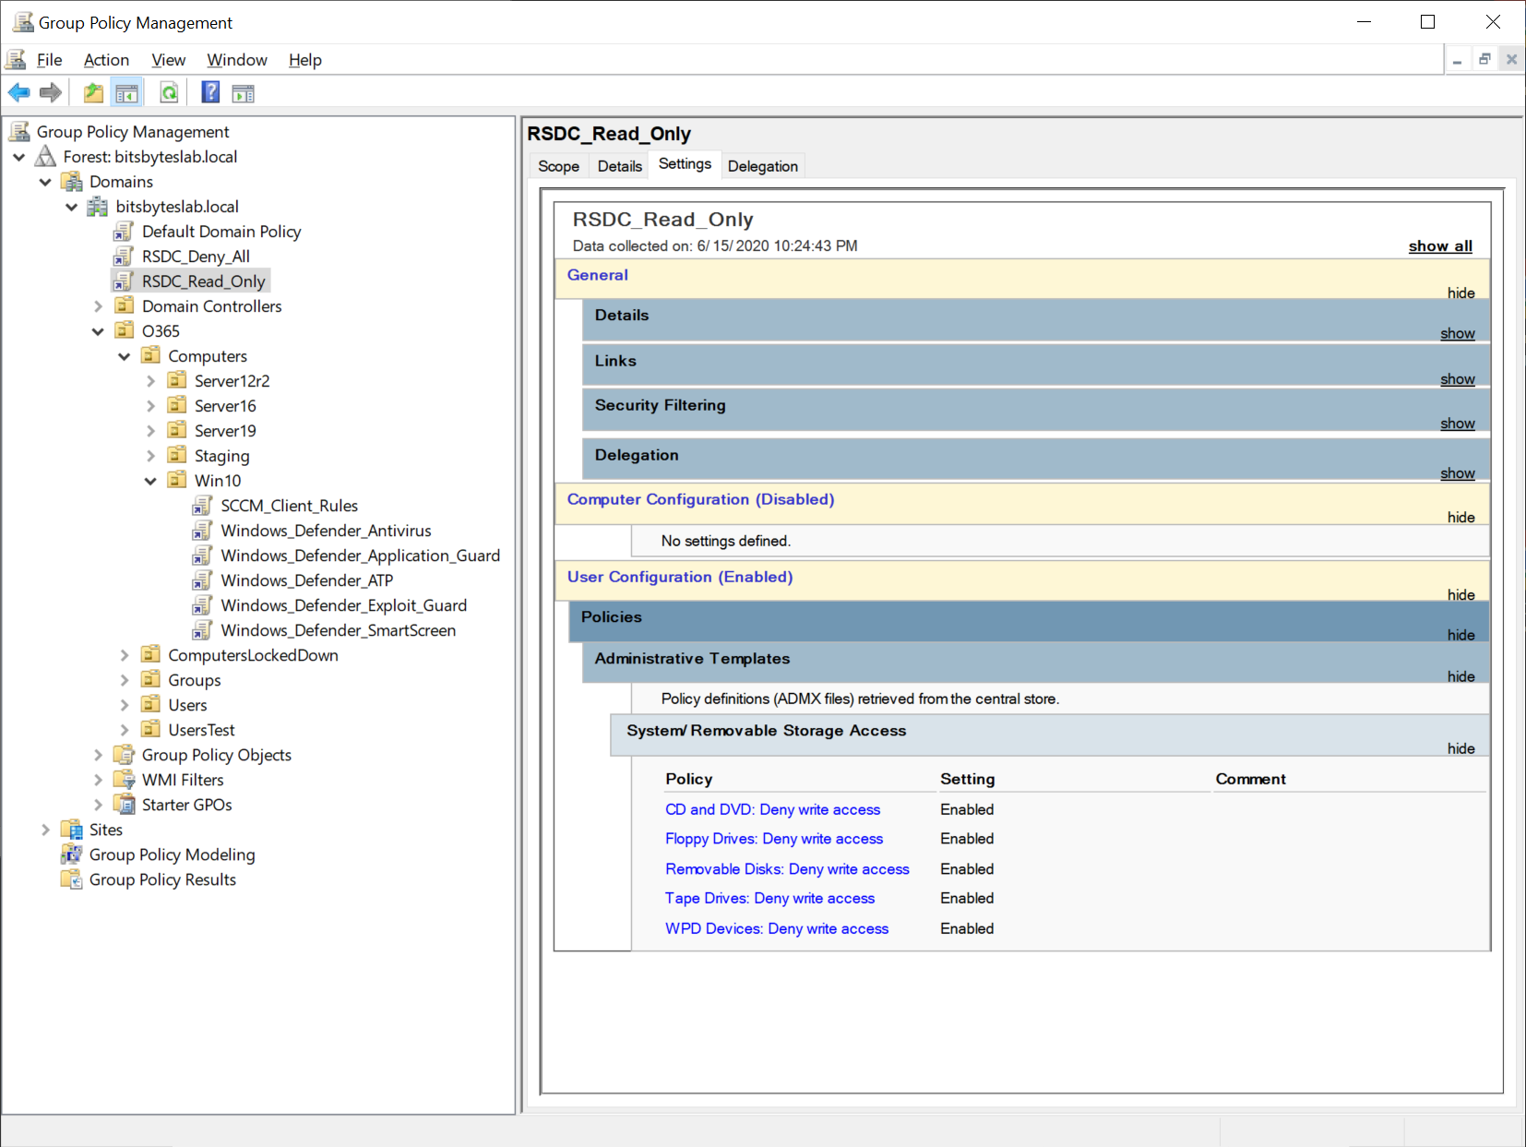

Permissions for Authenticated Users

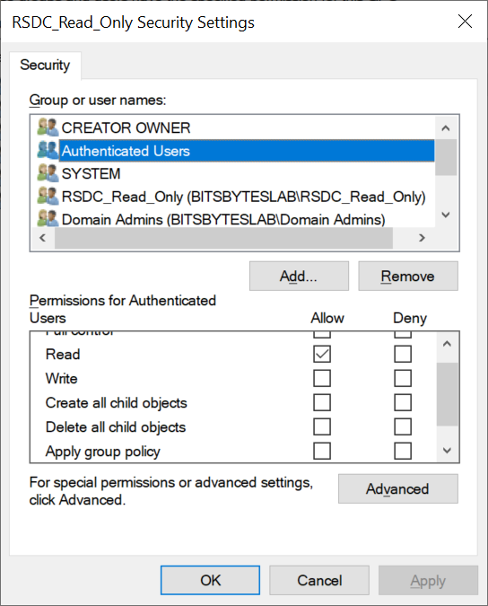

Permissions for the RSDC_Read_Only group

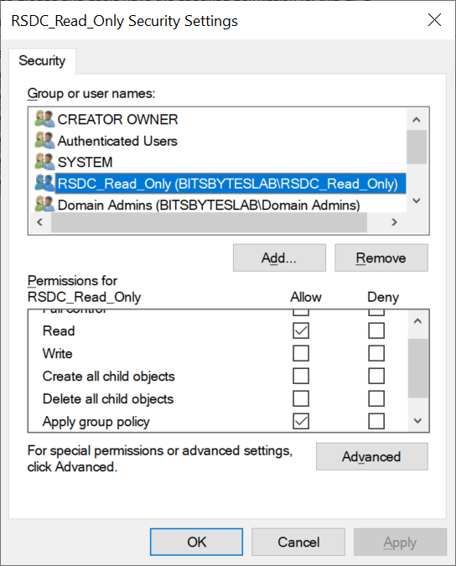

Tests

RSDC_Deny_All (the default)

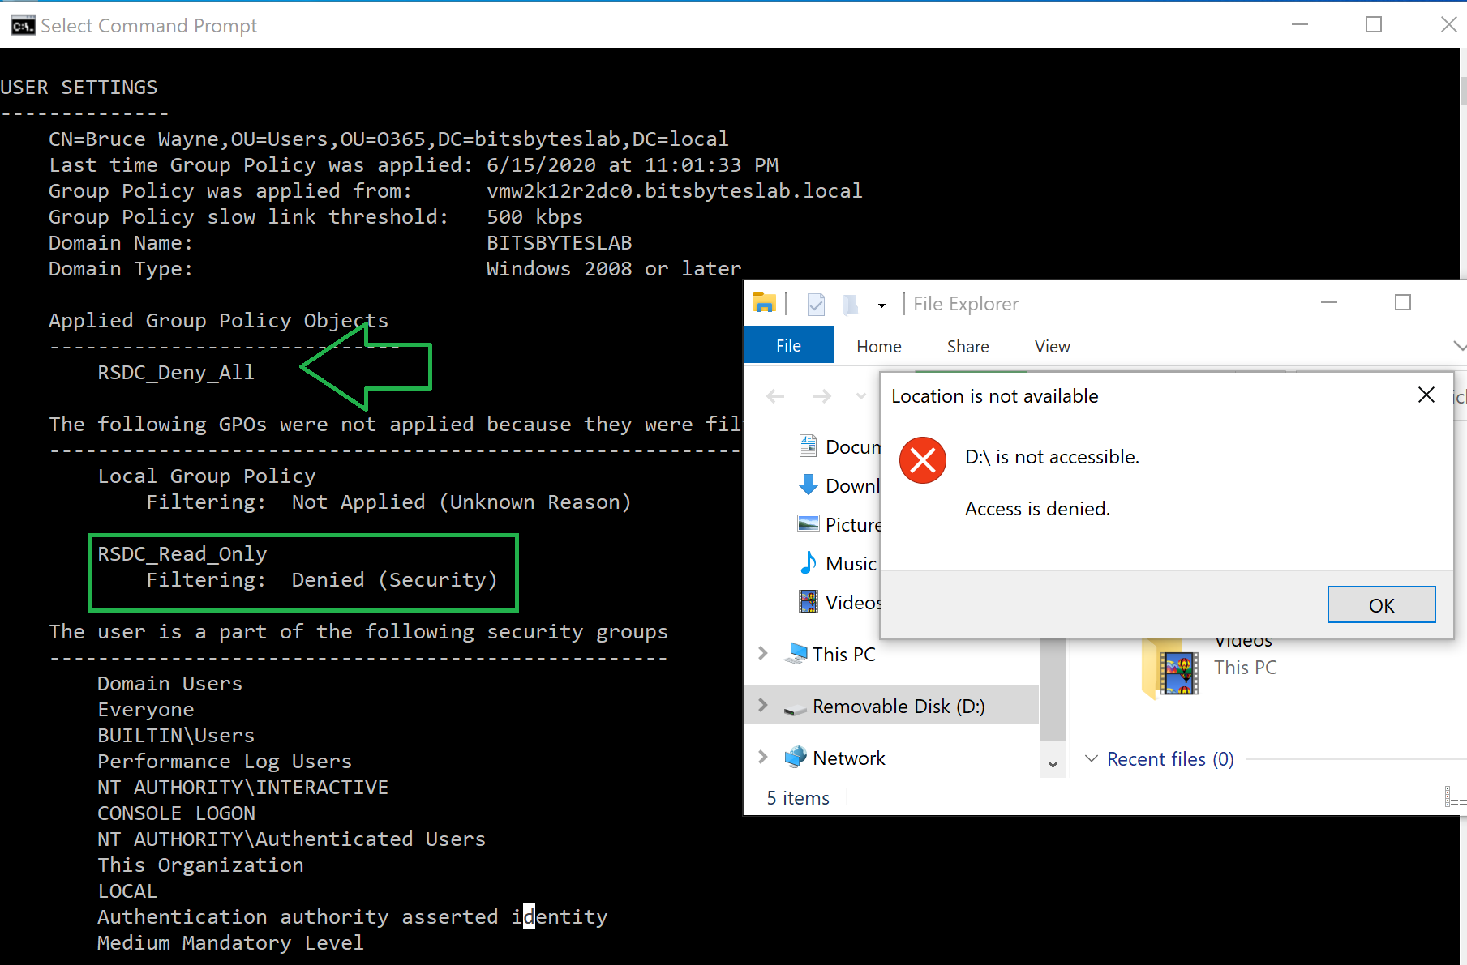

RSDC_Read_Only

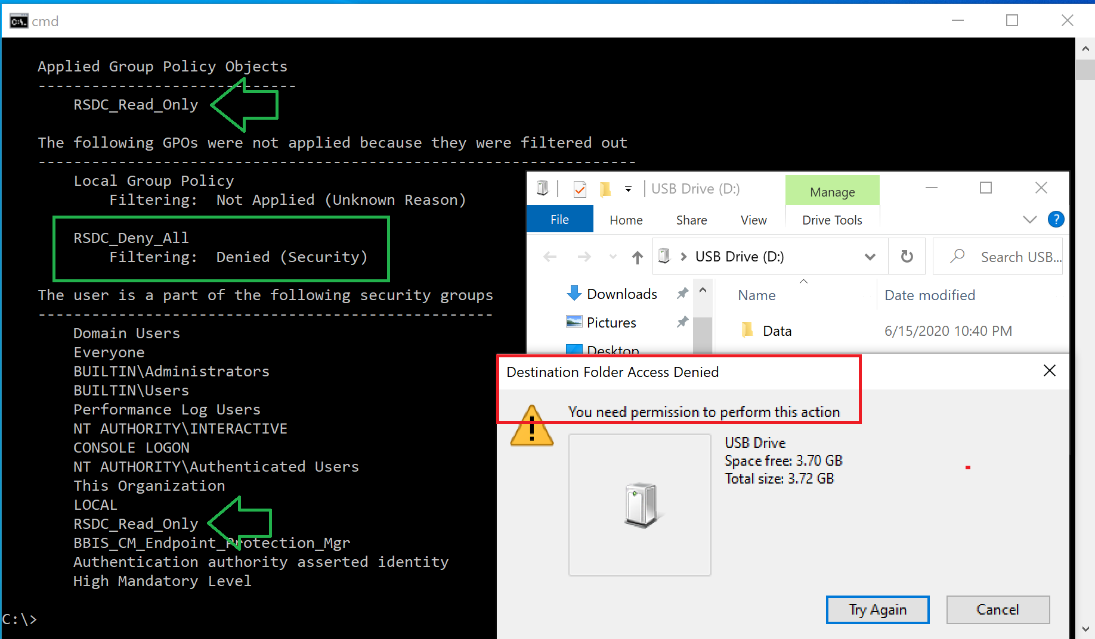

Allow R/W by simply denying the RSDC_Deny_All policy (via membership in the RSDC_Deny_All_Exception group)

