Intro to the Windows Assessment & the Windows Performance Toolkits

Overview

The Windows Performance Toolkit includes the Windows Performance Recorder (WPR.exe). WPR can be used to troubleshoot performance issues by profiling your computer in real-time. WPR generates output that can then be analyzed using the Windows Performance Analyze (WPA.exe), typically by Microsoft support. Note, WPR.exe is now included in Windows 10 under %Systemroot%\System32, however the toolkits provide a rich set of apps to collect and analyze your captures.

Dependencies

WPR requires local Administrative permissions.

Output

WPR will produce an Event Trace Log (.etl) file, as well as a folder containing many system Program Database Debug (.pdb) files. In addition to using WPA to analyze the output generated by WPR, you can use the Windows Event Viewer or TraceLog to read the .etl file. By default, TraceLog can be found under C:\Program Files (x86)\Windows Kits (see installation instructions below).

Basic usage of the Windows Performance Toolkit

WPR captures data based on a particular profile, i.e. CPU, Heap, DiskIO, and many more. For a complete list of available profiles, type: **wpr -profiles**

The sequence of events to perform a capture using WPR include:

1. Start a capture
2. Reproduce your issue
3. Let the capture run for at least 20 minutes
4. Stop the capture
5. Send the resultant logs to Microsoft for further analysis (or analyze the using WPA)

WPR Capture Example

After noticing that the Antimalware Service was consistently consuming +2GB of RAM, which may imply a memory leak in the MsMpEng.exe process, WPR was used to perform a capture on the Windows 10 computer. The logs were then sent to Microsoft for analysis.

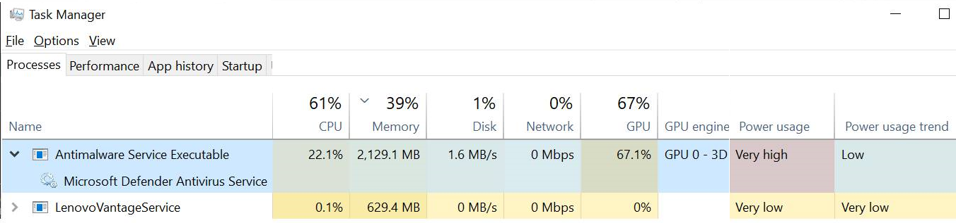

Below are two common scenarios for using WPR.

|  |  |
| --- | --- |
| **Symptom** | **Command** |
| Consistently high CPU utilization | wpr – start CPU |
| Consistently high memory usage | wpr – start heap |

Installing the Windows Assessment and the Windows Performance Toolkits

1. Download and install the Windows Assessment and Deployment Kit (Windows ADK) for Windows 10, version 1903 (and 1909) from <https://docs.microsoft.com/en-us/windows-hardware/get-started/adk-install>
2. Run adksetup.exe

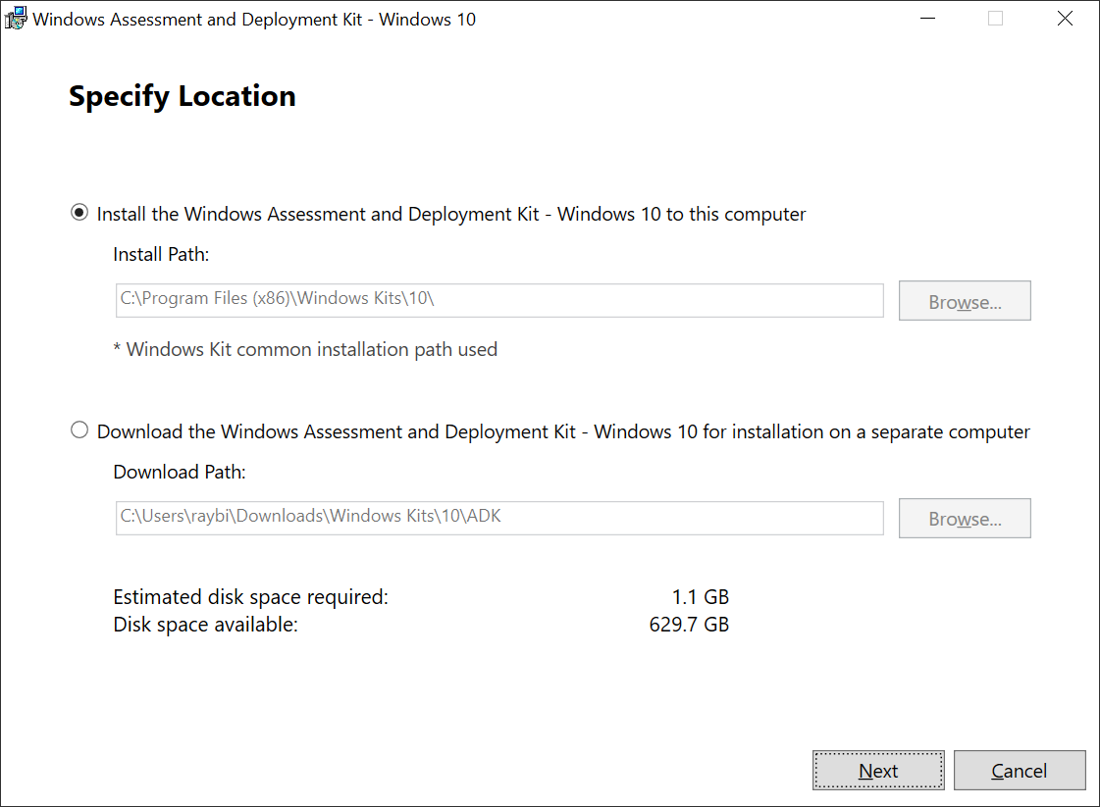

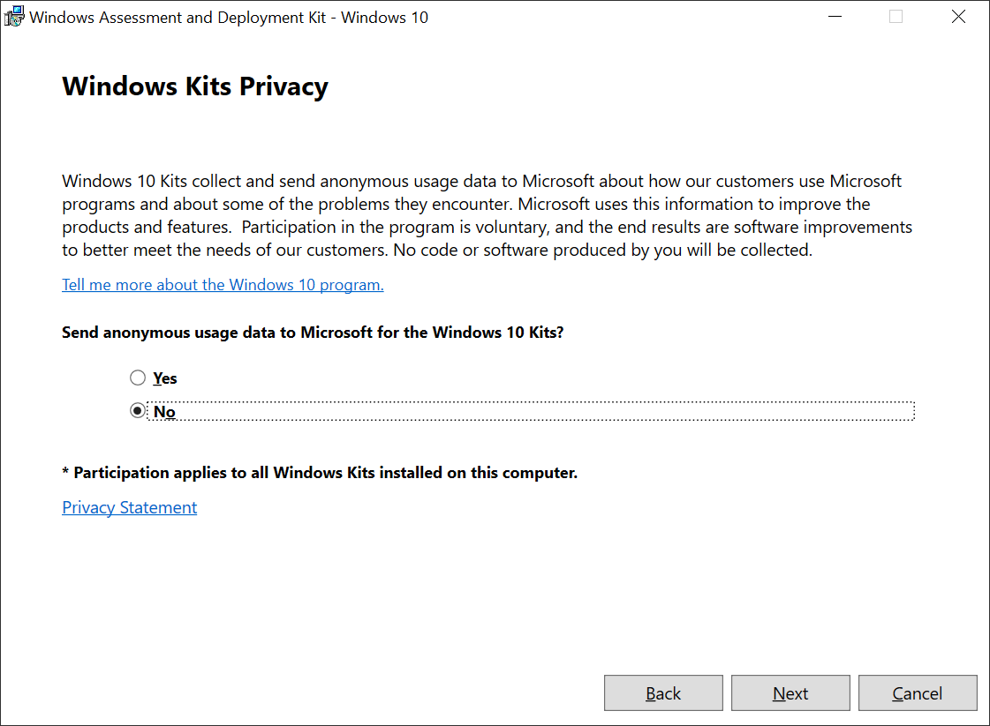

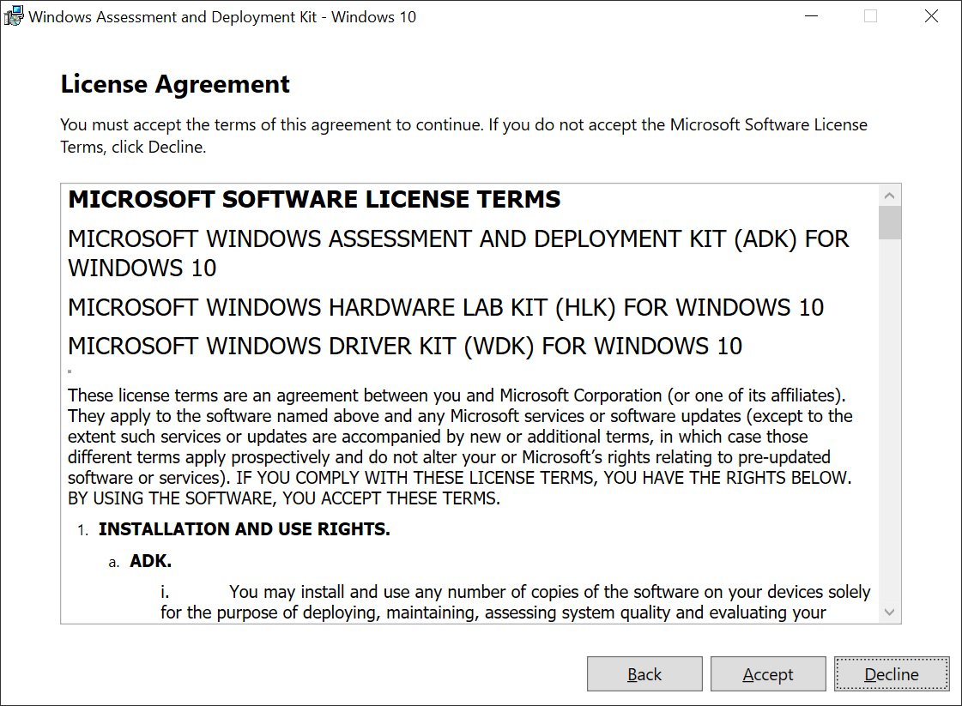

Select

* Windows Performance Toolkit (this includes WPR, WPA and Xperf)
* Windows Assessment Toolkit

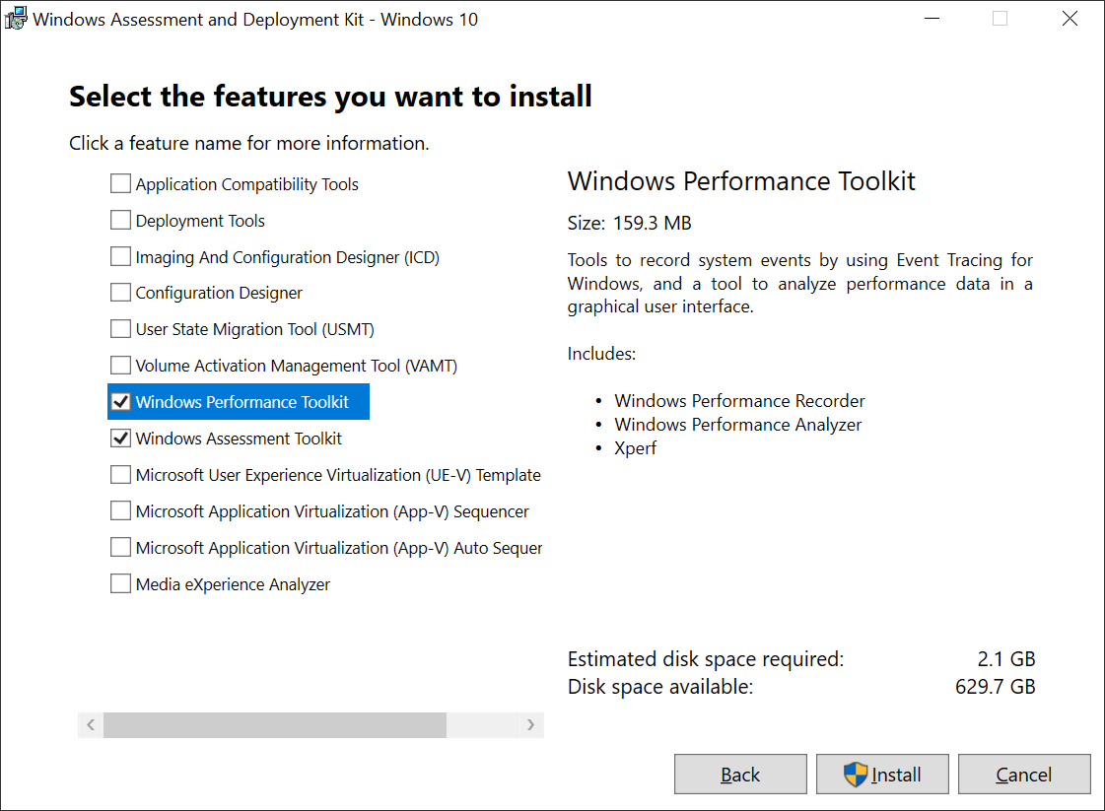

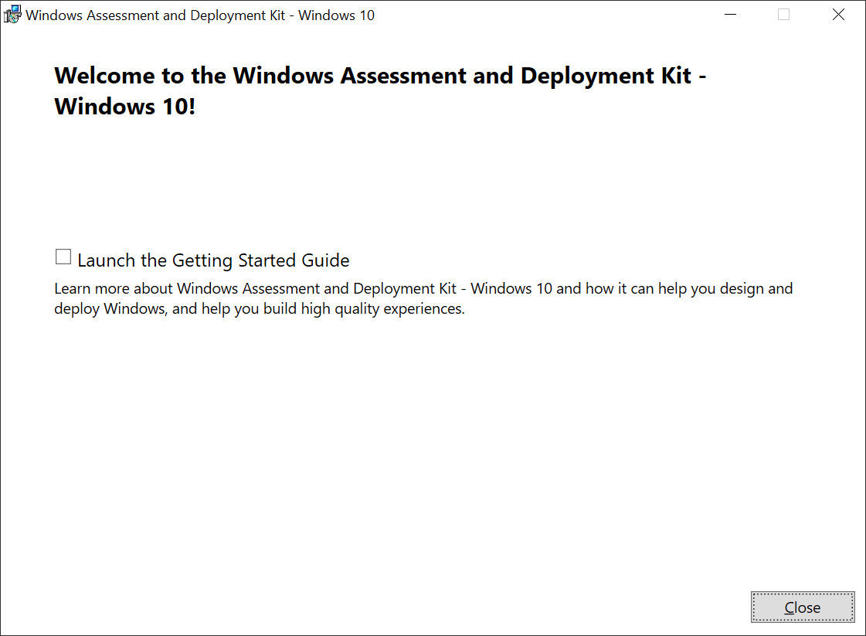

References

1. What’s new in ADK kits and tools

<https://docs.microsoft.com/en-us/windows-hardware/get-started/what-s-new-in-kits-and-tools?redirectedfrom=MSDN>