To run the program these steps must be performed beforehand
- Execute chinese.b5.CameraShy.exe
- Go View->Don’t show gif steg window and uncheck box
- Go Security -> Mask password and uncheck box
- Maximize window and leave to one side as seen in figure 2.

Using the program
Steps | Expected Results | Actual Results | Pass / Fail | Comments
- Execute CameraShyCracker.exe | GUI appears | GUI appears  See Fig 1 | pass
- The goal is to place X and Y coordinates for the mouse pointer to click on three spots and then press the Test button. | Mouse pointer appears on designated areas and clicks. | Mouse pointer appears on designated areas and clicks.  See Fig 2 and 3. | pass | This will take various attempts of testing
- The program simulates the same movements a user would make to break the password manually and each action has a delay by default of 500 ms.  We can change this delay with faster or slower computers so the program does not crash. | Change values of delay. | Changes values of delay. | pass | On our test computer we ran with a 100ms delay.
- Write in the filepath and filename of the wordlist in the textbox next to the label wordlist. | Write filepath and filename. | Write filepath and filename. | pass
- You need to preselect the file using the load button chinese.b5.CameraShy. This will enable the cracker to select the last one selected in camerashy. | File to crack is preselected. | File to crack is preselected. | pass | This needs to be done after mouse pointer locations testing.
- Press the crack button to execute the dictionary attack. If success then the hidden text appears in chinese.b5.CameraShy.exe and message box notification appears showing password and if not wordlists ends and message box appears saying password not found | Sequence of visible movement start simulating a human user.  If password found message box appears See Fig 4 | Sequence of visible movement start simulating a human user.  If password found message box appears See Fig 4 | pass | If delay is too short the program may crash in which case you can either press the Esc key to exit or stop button.
- Exit by pressing ESC key or Stop button. | Program exits | Program exits | pass

Fig 1 CameraShyCracker.exe GUI
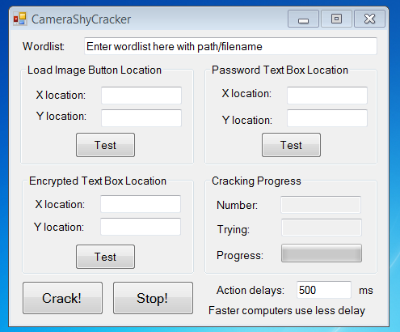

Fig 2. Areas where program must click with mouse pointer.
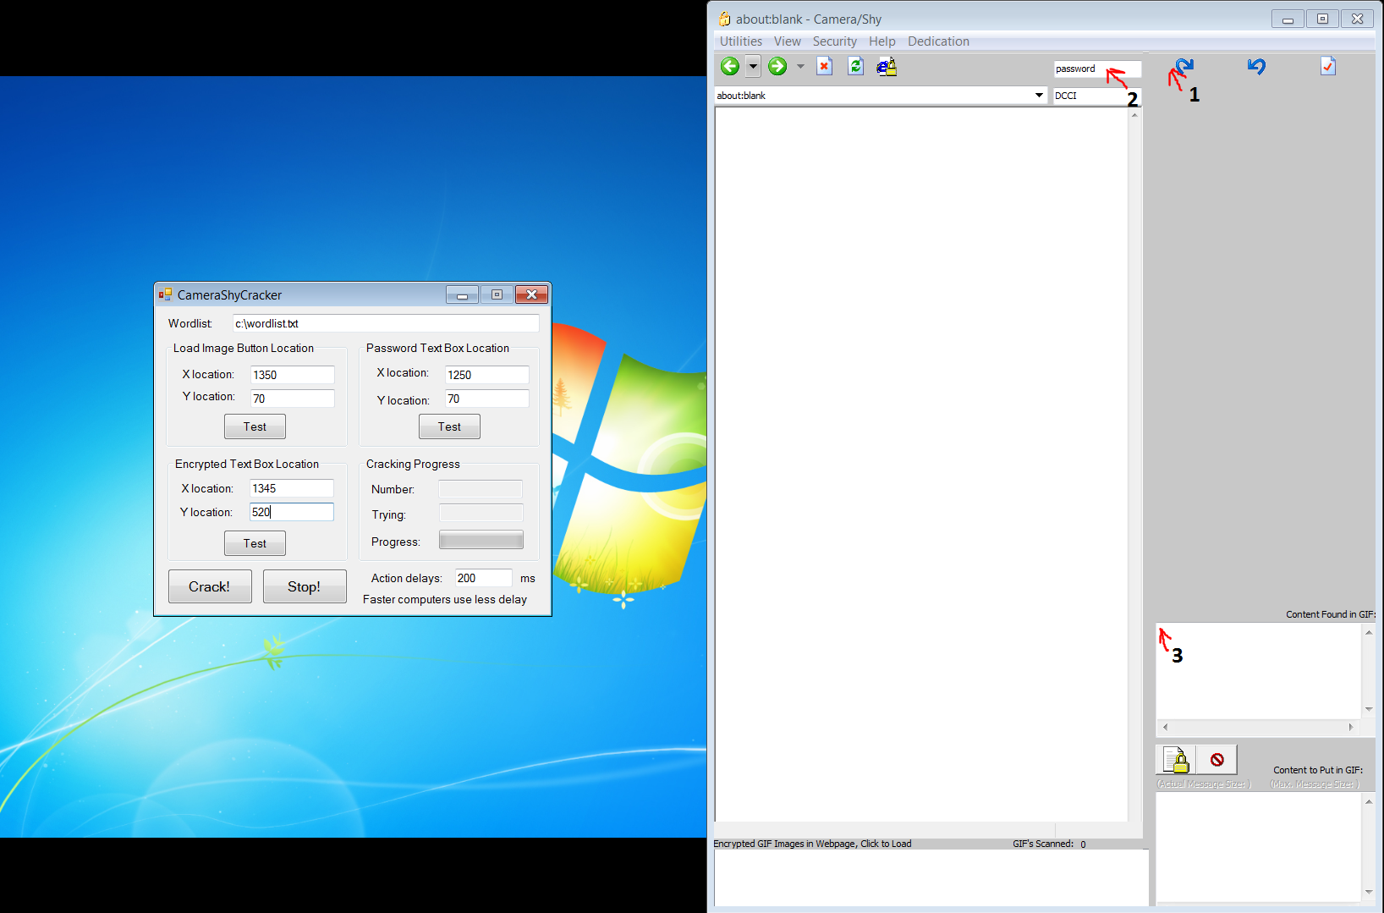

Fig 3. Corresponding click areas.

Figs 4. Password found
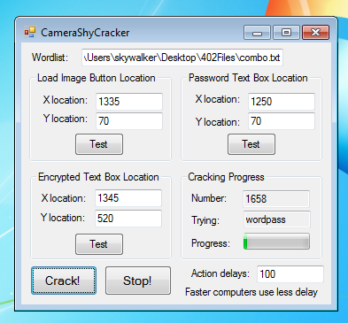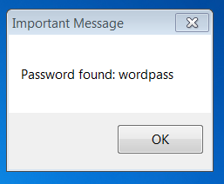

Fig 5. Password not found
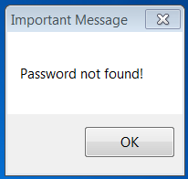

Fig 6. Password for File1 found
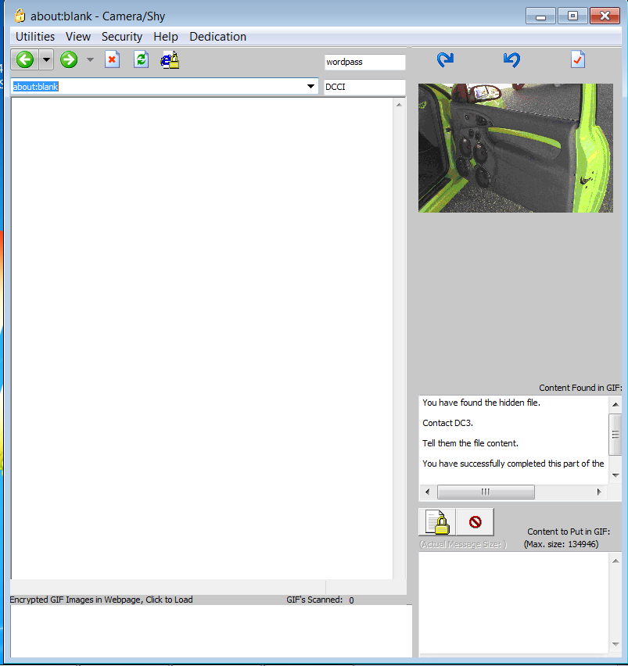

Fig 7. Signature manual attack by writing first letter we get an error message.
