User manual:

1. Interface:

The utility lists available physical and logical volumes
Steps | Expected Results |  | Actual Results | Pass / Fail | Comments
1 Press  List Volumes button |  | Below is an  example result | Below | Pass | Prints out some attributes on each drive

Figure 1
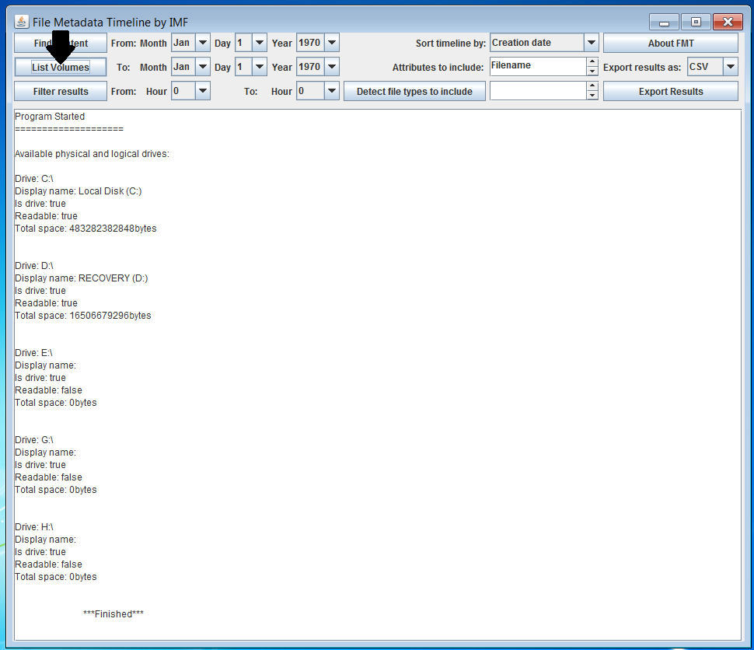

1.2 The interface provides the ability to choose a range of time
Steps | Expected Results |  | Actual Results | Pass / Fail | Comments
1 Press: Find Content Button | File chooser dialog | 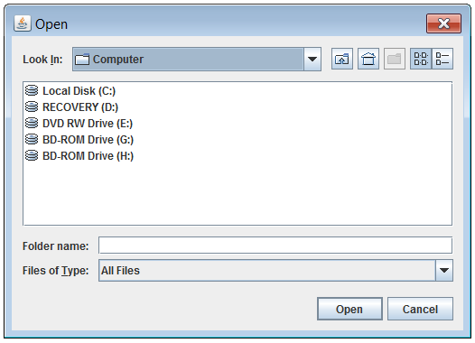 |  | Pass
2 Select drive or folder and press OK button | Closes dialog and finds all files and displays them to text area on GUI | See figure 2 |  | Pass | This can take a few minutes depending on the size of the volume or directory selected.
3 Select From Month, Day, Year and also To month day, year by using drop-down tabs |  | 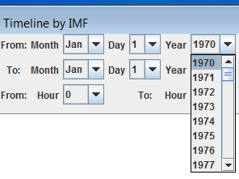 |  | Pass
4 Select time attribute to sort. This is done by selecting from the dropdown menu: Sort Timeline By |  | 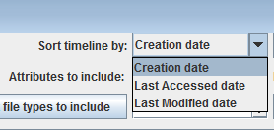 |  | Pass | Note: The program is not capable of using MFT last edited time.
5 Select attributes to include by clicking on items in the attributes to include list box and pressing Ctrl while selecting multiple attributes. |  | 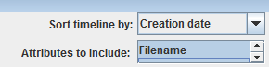 |  | Pass
6 Press the detect file types to include button | List box fills with items |  |  | Pass
7 Select file types to include by clicking on them while holding down Ctrl to select multiple items and scrolling down the list with scroll-bar or mouse wheel |  | 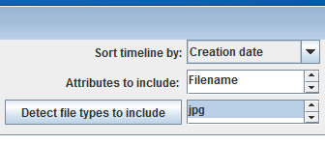 |  | Pass
8 Finally, press the filter button | Results appear | See figure 3 |  | Pass

Figure 2 Find content results
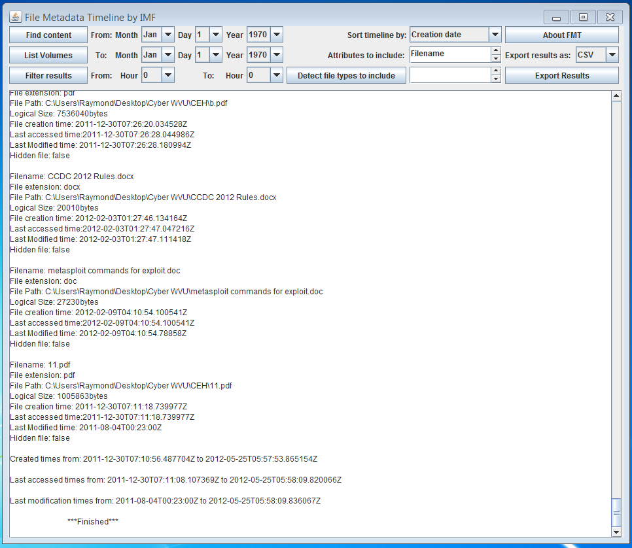

Figure 3 Results from pressing the filter button after selecting filter options 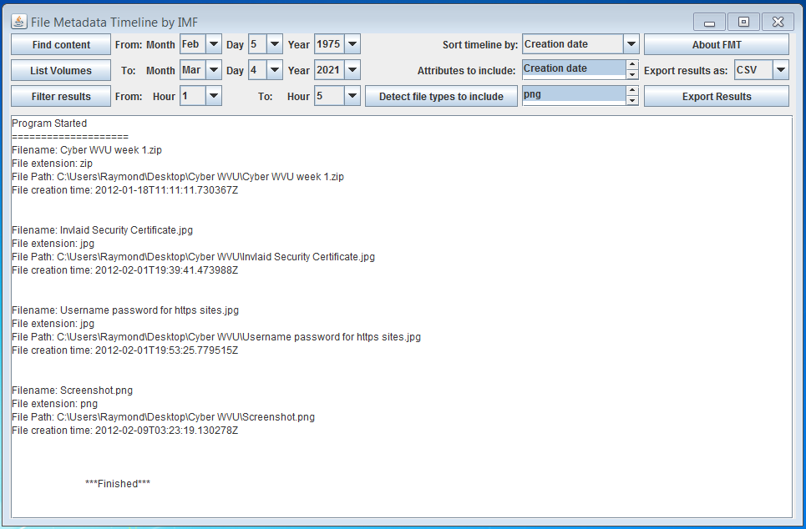

1.3 The interface provides the ability to select specific file types
Steps | Expected Results | Actual Results | Pass / Fail | Comments
1 As previously explained in section 1.2, Steps 6 and 7  Hit Detect file types button and then select file types to include from list box by pressing Ctrl + click on items | See figure 3 | See figure 3 | Pass | Must first Find Contents as explained in section 1.2

1.4 The interface provides the ability to include specific file attributes
Steps | Expected Results | Actual Results | Pass / Fail | Comments
1 As previously explained in section 1.2, step 5 | See figure 3 | See figure 3 | Pass | Must first Find Contents as explained in section 1.2

1.5 The interface provides the ability to select an output format
Steps | Expected Results | Actual Results | Pass / Fail |  | Comments
1 Select type from dropdown box | See figure 4 | See figure 4 | Pass | Must first Find Contents as explained in section 1.2
2 Press Export results button | See figure 5 | See figure 5 | Pass | Only need to enter filename

Figure 4 Exporting results
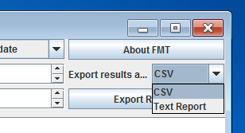

Figure 5 Exporting results
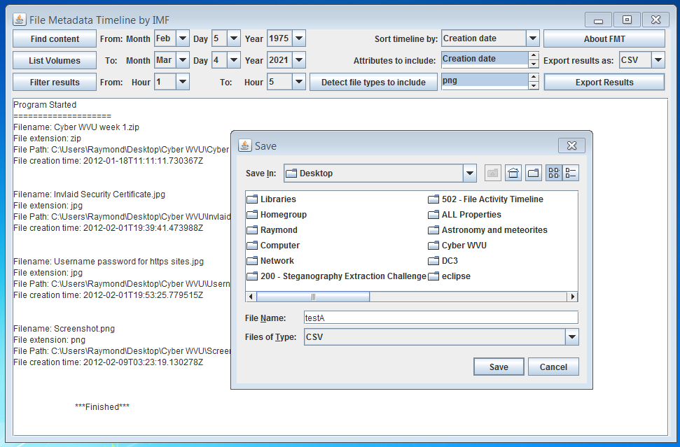
2. Functionality

The utility can mount a physical volume
Steps | Expected Results | Actual Results | Pass / Fail | Comments
1 Using the Find Content button, select volume and press ok. | Opens file chooser which displays all available physical volumes. | Opens file chooser which displays all available physical volumes. | Pass

The utility can mount a logical volume
Steps | Expected Results | Actual Results | Pass / Fail | Comments
1 Using the Find Content button, select volume and press ok. | Opens file chooser which displays all available logical volumes. | Opens file chooser which displays all available logical volumes. | Pass

Specific folders can be selected
Steps | Expected Results | Actual Results | Pass / Fail | Comments
1 Using the Find Content button. | Opens file chooser. | Opens file chooser. | Pass
2 Navigate to folder in dialog and press ok. | Searches and displays all available content and content attributes. | Searches and displays all available content and content attributes. | Pass

The utility can limit the output to a specific range of time
Steps | Expected Results | Actual Results | Pass / Fail | Comments
1 Select time range, file attributes to include and file types to include and time attribute to sort by. | n/a | n/a | Pass | Use after finding content as previously explained.
2 Press Filter Results button. | Displays sorted results. | Displays sorted results. | Pass

The utility can limit the output to specific file types
Steps | Expected Results | Actual Results | Pass / Fail | Comments
1 Select file types by clicking and holding down the Ctrl button. |  |  | Pass | Use after finding content as previously explained.
2 Select time attribute to sort by and attributes to include. |  |  | Pass
3 Press filter results button. | Displays results in text area. | Displays results in text area. | Pass

Specific file attributes can be included or excluded from the output
Steps | Expected Results |  | Actual Results | Pass / Fail | Comments
1 Select file attributes by clicking and holding down the Ctrl button. |  |  |  | Pass | Use after finding content as previously explained.
2 Select time attribute to sort by and file types to include. |  |  |  | Pass
3 Press filter results button. |  | Displays results in text area. | Displays results in text area. | Pass

Various output formats can be produced
Steps | Expected Results | Actual Results | Pass / Fail | Comments
1 Select CSV or Text report. |  |  | Pass | Use after finding content AND filtering content as previously explained.
2 Press Export button. | Opens a file save dialog. | Opens a file save dialog. | Pass
3 Select a location to export results to and a filename. |  |  | Pass
4 Press Ok button. | Copying finished text displayed in text area and file created. | Copying finished text displayed in text area and file created. | Pass

File time attributes are normalized to UTC
Steps | Expected Results | Actual Results | Pass / Fail | Comments
1 Default UTC. | All results are in UTC time. |  | Pass

