Raymond Chen

Professor Smallberg

CS 32 Spring 2023

Homework 5

1a

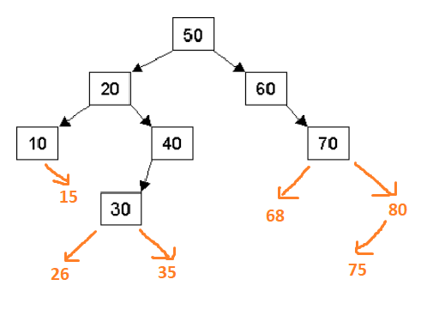

1b

Inorder traversal: 10,15 20, 26, 30, 35, 40, 50, 60, 68, 70, 75, 80

Preorder traversal: 50, 20, 10, 15, 40, 30, 26, 35, 60, 70, 68, 80, 75

Postorder traversal: 15, 10, 26, 35, 30 40, 20, 68, 75, 80, 70, 60 50

1c

After deleting 30 and then 20

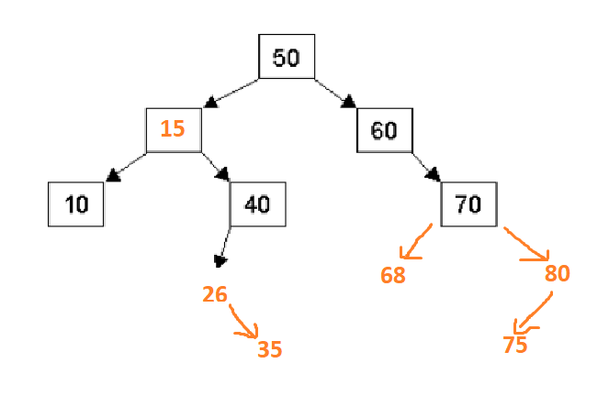

2a

Struct bstNode

{  
int data

bstNode\* leftChild

bstNode\* rightChild

bstNode\* parent

}

2b

void bstInsert(bstNode\* root, int val)

{

If root is nullptr (tree is empty)

*Create a new Node and store val in it*

*Have root node point to the new Node*

*Set the left and right child nodes to nullptr*

*Set the parent to the current node*

While insertion has not finished(can use infinite for loop here)

*If val is equal to current node’s value*

*return*

*If val is less than current node’s value*

*if leftChild is not nullptr then go left*

*Otherwise create a new node and set left pointer to new node,*

*store val in it, point parent to new node, have children point to null*

*If val is greater than current node’s value*

*If rightChild is not nullptr then go right*

*Otherwise create a new node and set right pointer to new node,*

*store val in it, point parent to new node, have children point to null*

}

3a

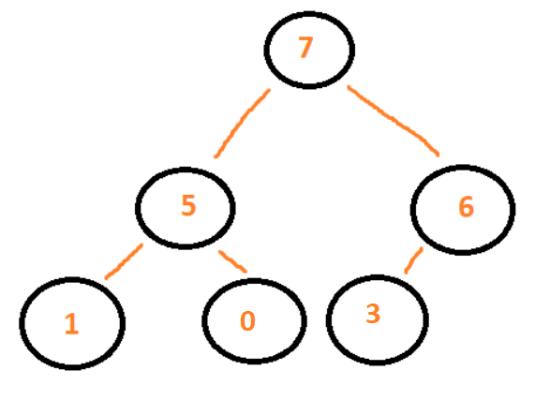

3b

array : 7, 5, 6 ,1 , 0, 3

3c

array : 6, 5, 3, 1, 0

4.

1. O(C+S)
2. O(logC + S)
3. O(logC + logS)
4. O(logS)
5. O(1)
6. O(logC + S)
7. O(SlogS)
8. O(ClogS)