Facial Emotion Recognition
Student Name: Raychel Bright Varghese
Student ID: 21211027
Course: BSc Computer Science (Hons)
Module Code: CO3519
Module Title: Artificial Intelligence
Academic Year: 2025/26

Introduction
Facial emotion recognition (FER) focuses on automatically identifying emotions such as anger, fear, happiness, sadness, surprise, and neutrality from images of human faces. Since facial expressions are a key part of non-verbal communication, developing systems that can interpret them reliably is valuable in areas like human–computer interaction, healthcare monitoring, and affective computing. In this report, a traditional machine learning pipeline was implemented using Histogram of Oriented Gradients (HOG) for feature extraction and a Support Vector Machine (SVM) classifier to predict emotions from six classes, in line with the module requirement to avoid deep learning methods.
The system was evaluated on two widely used FER datasets, Cohn–Kanade (CK+) and JAFFE, were used to assess how dataset characteristics affect model performance. Before evaluation, both datasets were examined for class distribution, expression intensity, and overall image consistency, as these factors directly affect the quality of HOG features. The results show a difference in performance: the model achieved 62.24% accuracy on CK+ and 80.00% accuracy on JAFFE. The higher accuracy on JAFFE suggests that its consistent lighting (e.g. shadows, brightness, contrast) and clear exaggerated expressions produce cleaner and more recognizable gradient patterns. In particular, the fear class proved especially difficult for the model due to the poor recall observed later in the CK+ evaluation. This makes it easier for the SVM to distinguish between emotion classes. These findings also align with the patterns seen in the confusion matrices and class level performance metrics.

Literature Review
Early FER systems used manually designed features and standard machine learning models to recognize emotions. Techniques such as Local Binary Patterns (LBP) (Ojala, Pietikäinen, & Mäenpää, 2002), Gabor filters (Lyons, Akamatsu, Kamachi, & Gyoba, 1998)and Histogram of Oriented Gradients (HOG) (Dalal & Triggs, 2005) were widely adopted due to their ability to capture texture, frequency and gradient based (changes in brightness) information from facial images. HOG captures the edges and gradient structures, making it suitable for modelling different facial emotions that happens when someone changes their face expressions.
Support Vector Machines are widely used in facial emotion recognition because they perform well with images containing thousands of features and remains reliable even when only a small amount of training data is available (Zhao & Pietikäinen, 2007). Many studies show that combining features such as HOG (Dalal & Triggs, 2005) with an SVM classifier can achieve strong results, particularly on controlled datasets like CK+ (Lucey, et al., 2010) and JAFFE (Lyons, Akamatsu, Kamachi, & Gyoba, 1998). These datasets mainly consist of frontal images taken under consistent lighting with clearly posed expressions, which makes it easier for the manually designed features such as HOG to separate the emotion classes. For this reason, methods like HOG with SVM are reliable approaches for FER when working with small, controlled datasets.
Recent studies moved towards deep learning methods such as convolutional neural networks (CNNs). CNNs can automatically learn useful features from images and achieve better accuracy than the existing manually designed features such as HOG and LBP when trained only large and varied datasets (Li & Deng, 2020). But they require a lot of labelled datasets and powerful hardware resources, which makes them less suitable when data is limited or when working in controlled settings (Zeng, Pantic, Roisman, & Huang, 2009). They are also harder to interpret, as it is not always clear which facial areas influence their decisions (Pantic & Rothkrantz, 2000).
Classical methods also have clear limitations. Manually designed features are sensitive to changes in lighting, pose, occlusion ad subtle expressions. This reduces their performance on real world datasets (Tsalera, Papadakis, Samarakou, & Voyiatzis, 2022). Earlier research shows that emotions such as fear and sadness are difficult for feature-based methods like HOG because they produce subtle gradient patterns and high variation within each class which is also highlighted in FER reviews (Zeng, Pantic, Roisman, & Huang, 2009). This is visible in CK+, where expression intensity (strength) varies and is not always exaggerated (Nidhi & Verma, 2023). Previous studies also shows that fear and sadness are consistently weak classes for manually designed feature methods, due to their subtle gradient patterns and strong variability among samples of the same class (Tsalera, Papadakis, Samarakou, & Voyiatzis, 2022). Given these constraints and because deep learning could not be used, this project uses a traditional HOG-SVM approach, which is well supported in FER research ad offers good interpretability and efficiency, The differences between CK+ and JAFFE provides a useful basis for evaluating the strengths and weakness of traditional FER approaches (Nidhi & Verma, 2023).

Datasets

Cohn-Kanade (CK+)
The Extended Cohn-Kanade (CK+) dataset is a widely used standard dataset in Facial expression recognition (FER)research. It contains sets of images from many participants, starting from a neutral face and progressing to a peak emotional expression, with labels for basic emotion classes/categories. In this project, only the peak expression still frames were selected because they offer clear examples of each emotion.
CK+ shows several challenges for traditional feature based FER methods, including differences in facial structure between subjects, variations in lighting and inconsistent expression strength. After preprocessing, the dataset used here comprised 340 training images and 143 testing images across six emotions: anger, fear, happiness, sadness, surprise and neutral. CK+ dataset also suffers from class imbalance, with fewer samples for emotions such as fear, which contributed to the model’s inability to correctly classify any fear instances during testing.

JAFFE
The Japanese Female Facial Expression (JAFFE) dataset consists of posed facial expressions from ten Japanese female participants. The images were taken under highly controlled conditions, with uniform lighting, a fixed background and a consistent frontal viewpoint (Lyons, Akamatsu, Kamachi, & Gyoba, 1998). Although JAFFE is smaller than CK+, it maintains an even distribution of emotion categories and is commonly used to assess traditional FER methods because of its controlled setup.
In this project the dataset was split into training and testing subsets, producing 55 test images across the same six emotion classes as CK+. Its controlled nature makes JAFFE a strong comparison to CK+, allowing a clear comparison of how different dataset characteristics affect model performance.

Preprocessing
To maintain consistency for feature extraction and classification, the same preprocessing pipeline was applied across both datasets:
- All images first converted to grayscale.
- Images processed using Haar Cascade classifiers to detect the face region.
- Cropping of detected facial regions
- Resizing images to 64 × 64 pixels
These steps help standardise the size of the input images and minimise background noise. This makes it easier for HOG to focus on the facial areas that are most important for recognising emotions.

Model Development

Feature Extraction
Histogram of Oriented Gradients (HOG) was used to extract differentiating features from the facial images. HOG is a well-established technique because it captures local gradient directions and edge structures, which align closely with the facial muscle movements and contour changes that define facial expressions (Dalal & Triggs, 2005). The following configuration was used to extract features:
- 8 orientation bins
- 8 × 8 pixels per cell
- 2 × 2 cells per block
- L2-Hys block normalisation
This configuration provides a good choice between feature details and efficiency, producing useful gradient features without creating an overly large feature vector. The use of HOG is consistent with earlier FER studies that rely on manually designed features to capture the facial shape changes to represent different facial expressions.

Classification Model
A Support Vector Machine (SVM) with a radial function (RBF) kernel was used as the classifier. SVMs are commonly applied in FER tasks because they handle high-dimensional feature vectors effectively and perform reliably even when the amount of training data is limited (Cortes & Vapnik, 1995). All HOG features were normalised before training so that each feature had an equal influence on the SVM classifier’s decision function. To ensure that each feature contributed equally to the decision boundary, the HOG features were standardized using StandardScaler within a pipeline before training the SVM.
The SVM hyperparameters (C=7, gamma=scale) were chosen based on preliminary testing to provide stable performance across both datasets. The RBF kernel was selected because it can model complex, non-linear patterns. This allows the classifier to separate facial expressions that look alike or share overlapping visual features.

Justification and Alternatives
The HOG-SVM framework was chosen because it has a proven history of strong performance in traditional feature-based image-analysis approaches and performs well on datasets of limited size, such as CK+ and JAFFE. This approach is consistent with the FER research, where manually designed features combined with SVM classifiers have repeatedly demonstrated strong performance on controlled datasets.
Alternative classifiers such as k-Nearest Neighbours (KNN) and Naive Bayes were considered, but SVMs were chosen because they tend to generalise more effectively in high-dimensional feature spaces and are less sensitive to noisy or irrelevant inputs. Deep learning approaches, including convolutional neural networks, were not used due to assignment restrictions and their dependence on large amounts of training data. As a result, the chosen approach prioritises interpretability, computational efficiency and alignment with established practices in classical FER research.

Model Evaluation

Evaluation Metrics
Model performance was examined using a combination of quantitative and qualitative evaluation methods. Quantitative metrics included:
- Overall classification accuracy
- Precision, recall, and F1-score for each emotion class
- Normalised confusion matrices
In addition, qualitative multi-image prediction visualisations were used to observe how the model behaved on unseen image samples. Together, these metrics provide a thorough understanding of both class-level performance and the model’s generalisation patterns, which is consistent with the evaluation practices in FER research (Zeng, Pantic, Roisman, & Huang, 2009).

Results on CK+
The model achieved an overall accuracy of 62.50% on the CK+ test set, as seen in Table 1. Classification Report of CK+. Performance varied across emotion classes, as seen in Figure 1. Confusion Matrix CK+. Emotions such as happy and surprise were detected with high recall, because their facial patterns were visually strong and easily distinguishable gradient patterns. The neutral class achieved moderate performance, with recall of 0.69 but precision of only 0.41, showing that while many neutral samples were detected, the model often confused other emotions as neutral. In contrast, fear and sadness were the weakest. Fear in particular showed zero recall and is mostly misclassified as sadness or neutral because the model failed to correctly identify any fear samples. Whereas anger showed moderate confusion especially with neutral. Anger was frequently misclassified as Neutral, which reduced its recall despite a decent precision score.
This pattern is consistent with previous research, which highlights fear is one of the most difficult expressions to recognise due to its subtle and ambiguous facial cues (Pantic & Rothkrantz, 2000). Additionally, class imbalance (lower number of samples provided for fear class for training and testing of patterns) in CK+ and differences in expression intensity likely contributed to the weaker results for these categories.

Results on JAFFE
On the JAFFE dataset, the model performed noticeably better, achieving an accuracy of 80.00%, as seen in Table 2. Classification Report of JAFFE. Most emotion categories showed high precision and recall, with anger and sad performing particularly well due to the clear and consistent gradient patterns produced under JAFFE’s highly controlled imaging setup, as seen in Figure 2. Confusion Matrix JAFFE. While happy, neutral and surprise have perfect precision but lower recall, meaning the model is cautious but misses some true samples. Fear, although recall is high, precision is poor because the model over-predicts fear and confuses it with other emotions.
The stronger result on JAFFE reflects the dataset’s uniform lighting, frontal facial orientation, and low variation among samples of same emotion (Lyons, Akamatsu, Kamachi, & Gyoba, 1998). These conditions make HOG features more stable and allow the SVM to form cleaner, more reliable decision boundaries. This demonstrates the suitability of traditional feature based approaches to work effectively on well-structured datasets.

Results Interpretation
A closer look at the class-level performance highlights clear strengths and weaknesses across two datasets.
- CK+ Dataset:
- Happy and Surprise were the strongest classes.
- Neutral achieved moderate performance.
- Anger was frequently misclassified as Neutral.
- Sadness showed poor recognition.
- Fear was the weakest class.
- JAFFE Dataset:
- Angry and Sad were the strongest classes.
- Happy, Neutral and Surprise had the perfect precision but lower recall.
- Fear was the weakest class.
Overall, in CK+ the strongest classes were Happy and Surprise, followed by Neutral and Anger, while Sadness and especially Fear were the weakest. In JAFFE, Angry and Sad were the strongest, Happy, Neutral and Surprise performed moderately and Fear was the weakest.

Comparative Analysis and Limitations
The results indicates that classical machine-learning approaches can still recognise facial emotions well when working with smaller datasets. The HOG-SVM setup performed especially strongly on JAFFE. This shows that the manually designed, gradient based features work reliably when the images are captured under consistent conditions, such as fixed lighting, background and frontal pose. These settings allow HOG features to correctly pick up the important edges and contours that define each expression, without needing deep learning models. This highlights that traditional feature-extraction techniques remain effective and relevant when the data is structured and highly controlled.
The difference in performance between CK+ and JAFFE shows how much a dataset’s properties can affect the model behaviour. The comparison can be seen in Figure 3. Image Test Prediction Comparison CK+ and JAFFE. JAFFE’s controlled setup such as consistent lighting, frontal faces and consistent presentation of expressions creates cleaner gradient patterns and clearer separation between emotion classes, which helps the model achieve higher accuracy. CK+ on the other hand, contains more variation in lighting, facial appearance and expression strength. This makes the model more complex to capture reliable patterns and reduce how well SVM performs on new, unseen. This pattern is consistent with broader FER literature research, which often report that classical machine learning methods perform poorly when expressions are subtle or when the data is more natural and varied (Zeng, Pantic, Roisman, & Huang, 2009). Overall, these results show how crucial dataset characteristics are when assessing classical FER methods and strengthen the methodological decisions made in this project.
Several limitations should be noted. Class Imbalance was found more in CK+, particularly for the CK+, particularly for the Fear category, which had fewer samples and contributed to the model’s inability to classify any fear instances correctly. JAFFE, by contrast, was relatively balanced across classes, so its higher accuracy is explained by the controlled imaging conditions rather than by class distribution. However, because no data augmentation was applied, the model found it difficult to cope with variations in lighting, head pose and subtle expression changes, which limited its ability to generalise to new, unseen images. The evaluation also relied on frontal-face images, this means that there is a possibility that the system may struggle in real-world scenario where faces are rotated, partially occluded or captured under inconsistent lighting or environmental conditions.

Conclusion
This project built a facial emotion recognition system using HOG features and SVM classifier. The model performed very well on the JAFFE dataset but only moderately on CK+. This shows both the strengths and weaknesses of classical machine-learning methods for emotion recognition. The difference in results between the two datasets indicates that manually designed features work well when images are captured in controlled conditions, but their effectiveness drops when there is more variation in facial appearance, lighting or expression intensity.
Overall, the results how that traditional feature-based methods can still work well for smaller, well-controlled datasets. Acheing strong performance on real-world data would require additional techniques. These include applying data augmentation to increase variability, using richer or more advanced feature representations or combining multiple models to capture a wider range of expression cues. This project provides a solid basis for future improvements aimed at making FER systems more generalisable and practical. Future work could extend this by incorporating data augmentation to expand the training set, experimenting with ensembles of classifiers (e.g. SVM + KNN (Cover & Hart, 1967) + Random Forest (Breiman, 2001)) to enhance robustness and develop a real world version of the system to assess its performance in interactive, open environments.

References
Breiman, L. (2001). Random forests. Machine Learning.
Cortes, C., & Vapnik, V. (1995). Support-vector networks. Machine Learning.
Cover, T., & Hart, P. (1967). Nearest neighbor pattern classification. IEEE Transactions on Information Theory.
Dalal, N., & Triggs, B. (2005). Histograms of oriented gradients for human detection. Proceedings of the IEEE Computer Society Conference on Computer Vision and Pattern Recognition.
Li, S., & Deng, W. (2020). Deep facial expression recognition: A survey. IEEE Transactions on Affective Computing.
Lucey, P., Cohn, J. F., Kanade, T., Saragih, J., Ambadar, Z., & Matthews, I. (2010). The extended Cohn–Kanade dataset (CK+): A complete dataset for action unit and emotion-specified expression. Proceedings of the IEEE Computer Society Conference on Computer Vision and Pattern Recognition Workshops.
Lyons, M., Akamatsu, S., Kamachi, M., & Gyoba, J. (1998). Coding facial expressions with Gabor wavelets. Proceedings of the Third IEEE International Conference on Automatic Face and Gesture Recognition.
Nidhi, & Verma, B. (2023). From methods to datasets: A detailed study on facial emotion recognition. Applied Intelligence.
Ojala, T., Pietikäinen, M., & Mäenpää, T. (2002). Multiresolution gray-scale and rotation invariant texture classification with local binary patterns. IEEE Transactions on Pattern Analysis and Machine Intelligence.
Pantic, M., & Rothkrantz, L. J. (2000). Automatic analysis of facial expressions: The state of the art. IEEE Transactions on Pattern Analysis and Machine Intelligence.
Sariyanidi, E., Gunes, H., & Cavallaro, A. (2023). From methods to datasets: A detailed study on facial emotion recognition. Applied Intelligence.
Tsalera, E., Papadakis, A., Samarakou, M., & Voyiatzis, I. (2022). Feature extraction with handcrafted methods and convolutional neural networks for facial emotion recognition. Applied Sciences.
Zeng, Z., Pantic, M., Roisman, G. I., & Huang, T. S. (2009). A survey of affect recognition methods: Audio, visual, and spontaneous expressions. IEEE Transactions on Pattern Analysis and Machine Intelligence.
Zhang, Y., Wang, Z., & Li, X. (2025). Emotion recognition and generation: A comprehensive review of face-based approaches.
Zhao, G., & Pietikäinen, M. (2007). Dynamic texture recognition using local binary patterns with an application to facial expressions. IEEE Transactions on Pattern Analysis and Machine Intelligence.

Supplementary Material
The Google Colab Notebook containing all code: FER-HOG-SVM/AIFinalPolished.ipynb at main · raychelbright-coder/FER-HOG-SVM
Table 1. Classification Report of CK+
precision recall f1-score support
anger 0.70 0.39 0.50 18
fear 0.00 0.00 0.00 7
happy 0.90 0.87 0.88 30
neutral 0.41 0.69 0.52 36
sadness 0.46 0.35 0.40 17
surprise 0.84 0.72 0.78 36
accuracy 0.62 144
macro avg 0.55 0.50 0.51 144
weighted avg 0.64 0.62 0.62 144
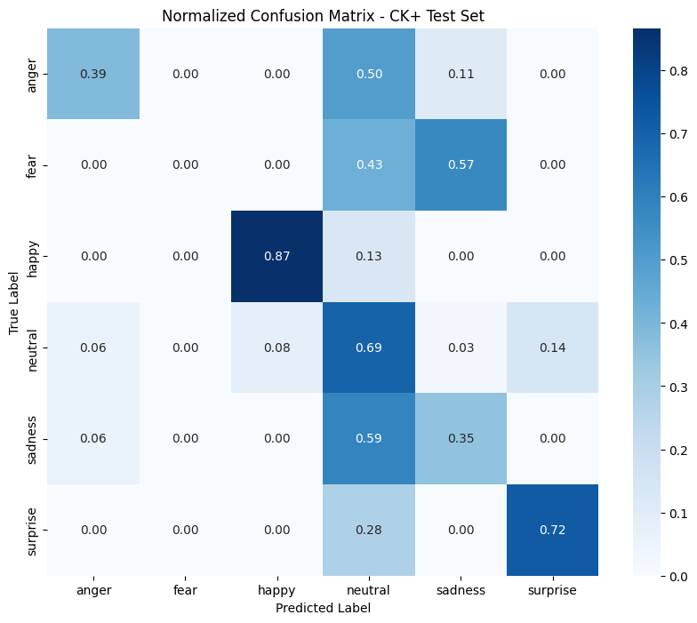
Figure 1. Confusion Matrix CK+

Table 2. Classification Report of JAFFE
precision recall f1-score support
Angry 0.90 1.00 0.95 9
Fear 0.50 0.90 0.64 10
Happy 1.00 0.67 0.80 9
Neutral 1.00 0.67 0.80 9
Sad 0.89 0.89 0.89 9
Surprise 1.00 0.67 0.80 9
accuracy 0.80 55
macro avg 0.88 0.80 0.81 55
weighted avg 0.87 0.80 0.81 55
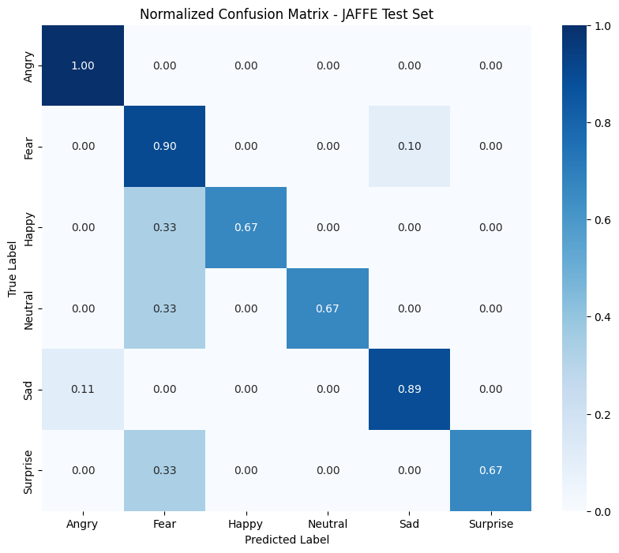
Figure 2. Confusion Matrix JAFFE
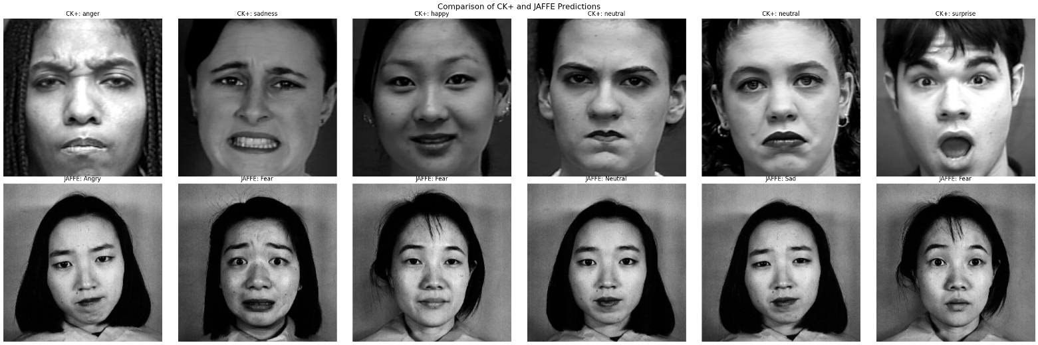
Figure 3. Image Test Prediction Comparison CK+ on top and JAFFE below (class-level)

