Data Science Research Report
BSc Computer Science (Hons)
Raychel Bright Varghese

Introduction
ShopEase E-commerce Ltd. is a digital retail company with nationwide operations in India. They sell products in three main categories: Clothing, Electronics and Furniture. The purpose of this report investigates one-year of transactional data to identify key patterns, obtain meaningful insights and inform future modelling. The dataset comprises three CSV files: Order Details, List of Orders and Sales Target- with 1500 line items before cleaning. After applying data cleaning, pre-processing and merging 1313 valid rows were retained for analysis.
This report follows a complete data science workflow (Provost & Fawcett, 2013): understanding the dataset, cleaning and preparing data, exploring descriptive statistics, performing hypothesis testing, evaluating modelling choices, and considering ethical implications. Visualisations are included in the Appendix and referenced throughout to support statistical conclusions. By combining statistical and visual insights, this report provides practical suggestions to guide the ShopEase’s business strategy and lay foundation for predictive modelling in Assignment 2.

Critical Discussion of the proposed dataset and question Development

Data Selection and Relevance
The dataset originates from ShopEase’s operational transaction system. It is composed of three tables:
- List of Orders – contains customer names, states, cities and order dates.
- Order Details – contains line-level Amount, Profit, Quantity and product Categories.
- Sales Target – contains monthly revenue targets for each category (Furniture, Clothing, Electronics).
The dataset does not include some sensitive information like age, gender, or financial identifiers, only customer names and geographic locations are present. The dataset represents completed transactions captured at the point of sale. Therefore, it is well suited for analysing revenue, profitability and product performance.

Feature Selection and Relevance
The features retained for analysis addresses the key business questions in this report:
- Amount – shows how much revenue each transaction generates. This is useful for comparing category performances and spot monthly variations/trends.
- Profit – shows business margin, helps to understand if the sales are profitable.
- Category/ Subcategory – helps with splitting the data into groups to see which product performs better.
- Month/ Order Data – helps to study seasonal trends and compare original sales against sales targets.
- State/ City – helps identify geographic differences.
- Quantity – shows number of items sold, helps analyse profit by considering number of items sold.

Data Cleaning and Pre-Processing
The dataset was processed through several cleaning and pre-processing:
- Whitespace Removal and Formatting Correction – Some text fields contained extra spaces (e.g. “Kerala ” instead of “Kerala”). These spaces can cause problems when joining data tables. This helps to make the text clean and consistent.
- Date conversion – In the List of Orders table, the Order Date column stored the date of all the orders in text format. They were cleaned by converting them from string to a valid datetime datatype (e.g. “01-04-2018” text to 01-04-2018 date format). A new column called Month of Order Date was then created to match the format in the Sales Target table. This helps in accurate joining of tables and analysis of growth, profit and performance.
- Merging of Datasets –
- List of Orders x Order Details: Merged using OrderID.
- The combined table was left-joined with Sales Target using Month and Category.
- Fields Validation – Numeric fields such as Amount, Profit and Quantity were filtered for invalid or zero entries.
- Handling Outliers – Extreme values that were different from other values were flagged for review. The main dataset (bulk of normal orders) was kept for hypothesis testing, ensuring statistical results are reliable and representative.
These steps ensure that all visual and statistical outputs will give consistent, reliable and comparable information (Kuhn & Kjell Johnson, 2013) (Aggarwal, 2017).

Descriptive Statistics and Summary Insights
To understand the overall structure of the dataset, a summary table was created showing the count of transactions, average order amount, median profit, and total revenue across product categories. This provides a baseline for comparing category performance and guides further statistical testing.

Table 1. Summary Statistics by Product Category
Category | Count | Mean Amount | Median Profit | Total Amount
Clothing | 949 | 146.53 | 8 | 139054
Electronics | 308 | 536.58 | 21.5 | 165267
Furniture | 243 | 523.38 | 13 | 127181

These figures show that Electronics and Furniture generate significantly higher average order amounts than Clothing, which aligns with the patterns later confirmed by ANOVA and visualised in Table 1. Median profit also varies across categories, suggesting differences in margin and profitability.

Visualisations and Early Insights
Some basic visual representations were used to understand trends and patterns to guide the hypothesis testing (Field, 2013). They include:
Electronics and Furniture have much higher average order amounts than Clothing, as seen in Figure 1. This difference is statistically confirmed by the ANOVA test (p<< 0.001), meaning the variation is real and not due to chance. As a result, this finding shows that category-level pricing has a strong impact on revenue.
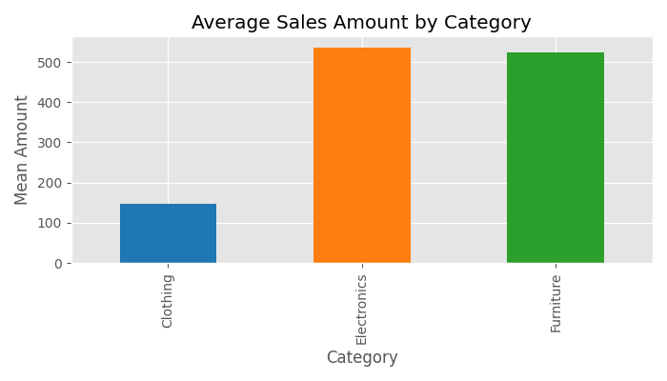
Figure 1. Average Sales Amount by Category
Additionally, sales amounts and profits vary across categories. Clothing shows lower median values and narrower interquartile range, as seen in Figure 2, indicating smaller and more consistent transaction values. Alternatively, Electronics and Furniture show wider spreads, higher medians and more outliers, and larger transaction amount than clothing.
Outliers are present in all categories. Levene’s test confirms that these differences in variance are statistically significant (p<<0.001). As a result, robust or non-parametric modelling methods are recommended to address the unequal differences.
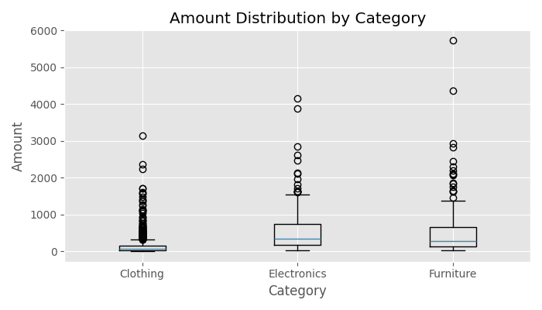
Figure 2. Distribution of Amount by Category
Moreover, the scatter plot shows a weak positive relationship between Amount and Profit (r = 0.242), as seen in Figure 3. While some large transactions also generate high profit, many others only result in moderate margins. The points are widely scattered with no clear straight-line pattern, confirming that a large transaction order does not always guarantee high profit but other factors like discounts, costs, or margins also matter.
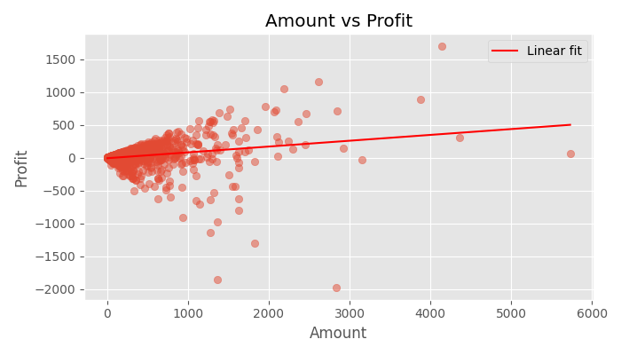
Figure 3. Amount vs Profit
The histogram shows that profit values are strongly not symmetric (Shapiro-Wilk Test p << 0.001), with extreme tails and negative outliers (losses), as seen in Figure 4. This indicates that traditional normality-based methods may be unreliable. As a result, robust or tree-based modelling approaches are better suited to capture the variability in profit outcomes.
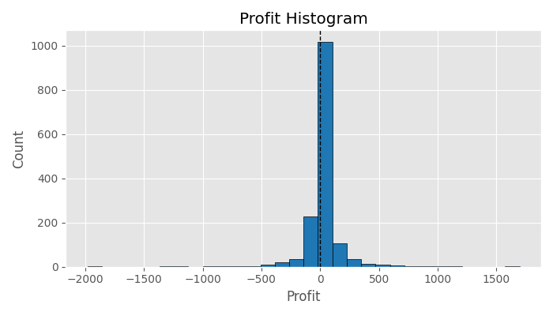
Figure 4. Profit Distribution
Furthermore, Monthly revenue varies against targets. The company had underperformed in the early months and then the revenue improved later in the year, as seen in Figure 5. The pattern shows the importance of seasonal promotions and inventory planning to increase sales and ensure to meet business goals.
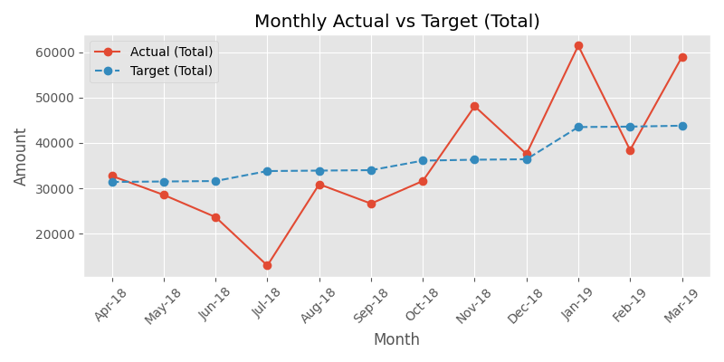
Figure 5. Monthly Actual vs Target

Research Question Development
Based on early insights and business needs:
- Do average sales amounts show meaningful differences across product categories?
- Which categories generate the highest or lowest profit margins?
- Does revenue show recurring patterns across specific months of the year?
- Can transactional variables predict profit or identify profitable customer groups?
These questions guide hypothesis testing and modelling evaluation in the coming sections.

Critical Evaluation of data modelling including its ethical considerations

Hypothesis Testing and Interpretation
The visual insights were validated using formal statistical tests. Each test is explained with its statistical evidence, decision outcome, interpretation and business implication.
- ANOVA – Amount across Categories
The ANOVA test was used to examine whether the average transaction Amount differed across product categories (Montgomery, 2019). Before running the test, the assumptions of independence, normality of residuals, and homogeneity of variances were assessed. Levene’s test indicated a significant result (p < 0.001), meaning the assumption of equal variances was violated (Field, 2013). Despite this, the ANOVA result was highly significant, F(2, n–3) = 144.26, p < 0.001, confirming that mean order amounts differ substantially across categories. Electronics and Furniture show much higher average order values compared to Clothing, demonstrating that category-level pricing strongly influences revenue. These findings are consistent with the patterns observed in Figure 1 (Average Sales Amount by Category) and Figure 2 (Distribution of Amount by Category).
- Shapiro-Wilk – Profit Normality
The Shapiro–Wilk test was conducted to assess whether Profit follows a normal distribution (Field, 2013). The result was significant (p < 0.001), indicating that Profit is not normally distributed and is instead heavily skewed with several outliers. This lack of normality suggests that traditional linear regression models relying on normality assumptions may be inappropriate without transformation. As a result, robust regression or tree-based approaches, such as decision trees, are more suitable for modelling Profit. This conclusion is supported by the distribution shown in Figure 4 (Profit Distribution).
- Pearson Correlation – Amount vs Profit
The relationship between Amount and Profit was examined using Pearson’s correlation coefficient (Field, 2013). The correlation was weak but statistically significant (r = 0.242, p < 0.001), indicating that higher revenue does not strongly predict higher profit. Only around 6% of the variability in Profit is explained by Amount, meaning that other factors—such as discounts, sub-category, or geographic differences—play a more substantial role in determining profitability. This weak association is visually reflected in Figure 3 (Scatter Plot), where the points are widely dispersed with no clear linear pattern.
- Welch’s t-test – Clothing vs Electronics (Amount)
Welch’s t-test was used to compare transaction Amounts between Clothing and Electronics, accounting for unequal variances (Field, 2013). The test showed a significant difference (p < 0.001), with a large effect size (Cohen’s d = 1.10), indicating that Electronics orders are substantially larger than Clothing orders. This confirms the category-level differences in ticket size and highlights the importance of prioritising high-revenue categories such as Electronics in marketing and inventory planning, while still managing lower-revenue segments to maintain overall business balance. These findings are consistent with the trends illustrated in Figure 1.

Suggested Modelling Approaches
Based on the dataset and statistical findings:
- Regression (Profit Prediction)
- Finding: Profit is non-normal (Shapiro-Wilk p << 0.001) and only weakly correlated with Amount (r = 0.24).
- Model Choice: Random Forest/ Gradient Boosting are appropriate because they handle skewed targets, non-linear relationships, and multiple predictors (discounts, sub-category, geography) (Breiman, 2001) (James, Witten, Hastie, & Tibshirani, 2021).
- Connection: This directly addresses the limitation that linear regression without transformation would be inappropriate.
- Classification (High-Profit Order Identification)
- Finding: Electronics orders yield significantly higher revenue per order (Welch’s t-test, Cohen’s d = 1.10).
- Model Choice: Logistic Regression/ XGBoost can classify orders into high-profit vs low-profit segments (James, Witten, Hastie, & Tibshirani, 2021)
- Connection: This builds on the evidence that categories differ in profitability and ticket size.
- Clustering (Customer Segmentation)
- Finding: Profit variability is large across categories, and revenue alone explains only 6% of profit variation.
- Model choice: K-means on Recency-Frequency-Monetary (RFM) features helps identify customer groups beyond simple category averages (James, Witten, Hastie, & Tibshirani, 2021).
- Connection: This responds to the insight that multiple transactional variables (frequency, recency, monetary value) are needed to identify profitable segments.

Ethical Considerations
Ethical Considerations include:
- Data Privacy: Customer names and personal details should be anonymised to safeguard confidentiality before analysis.
- Bias and Fairness: Models need to be checked to ensure they don’t unfairly favour certain regions or categories due to imbalanced data.
- Transparency: Any algorithm used for pricing or promotions must be clear and understandable so that decisions can be justified.
- Compliance: Even though the dataset is straightforward, GDPR rules still apply – including minimising data use, ensuring lawful processing, and respecting customer rights of access (Union, 2016).
- Data minimisation: Use of only relevant fields (Amount, Profit, Category) during modelling.
These rules should guide the modelling process in Assignment 2 to ensure responsible and fair outcomes.

Conclusions and recommendations
The analysis shows clear and statistical differences across product categories. Electronics consistently generates higher transaction amounts, while Clothing generates lower revenue and profit. No evidence of monthly seasonality is present, and profit distributions are skewed rather than normally distributed.
Key Recommendations:
- Category-specific pricing and promotion strategies should be used for each product to maximise revenue.
- Margin improvement initiatives on sub-categories with high sales volumes but weaker profitability should be prioritised.
- Predictive models should be developed to estimate profit and classify customers based on their value contribution.
- Ethical safeguards should be applied before introducing automated decision-making systems.
This report delivers a cleaned dataset, meaningful visualisations, validated statistical insights and clear roadmap for advancing to the next stage of modelling.
Word Count: Report word count is 2022 words.

References
Aalst, W. v. (2016). Process Mining: Data Science in Action. Springer.
Aggarwal, C. C. (2017). Outlier Analysis. Springer.
Breiman, L. (2001). Random forests. Machine Learning, 5-32.
Field, A. (2013). Discovering Statistics Using IBM SPSS Statistics. Sage.
Floridi, L., & Taddeo, M. (2016). What is data ethics? Philosophical Transactions of the Royal Society A.
James, G., Witten, D., Hastie, T., & Tibshirani, R. (2021). An Introduction to Statistical Learning with Applications in R. Springer.
Kuhn, M., & Kjell Johnson. (2013). Applied Predictive Modeling. Springer.
Montgomery, D. C. (2019). Design and Analysis of Experiments. Wiley.
Provost, F., & Fawcett, T. (2013). Data Science for Business: What You Need to Know about Data Mining and Data-Analytic Thinking. O'Reilly Media.
Union, E. (2016). General Data Protection Regulation (GDPR). Official Journal of the European Union.

