CO37722 Data Science
Assignment 2: Data Modelling and Analysis
ShopEase E-commerce Ltd.

Raychel Bright Varghese
Bsc (Hons) Computer Science | Student ID: 21211027

Question Design

Business Context and Stakeholders
ShopEase E-commerce Ltd. is a nationwide digital retail company operating across India, selling products across three categories: Clothing, Electronics and Furniture. The dataset covers a full year of transactional data (April 2018 – March 2019), containing 1,500 order line items from 560 unique customer orders, as examined in Assignment 1.
Three key stakeholder groups will benefit from this analysis:
- Senior Management – need insight into revenue performance and where financial losses are occurring to support strategic decisions.
- Sales and Marketing Team – need to identify which categories and months offer the best promotional opportunities to maximise sales outcomes.
- Operations and Inventory Team – need to understand which orders are likely to be profitable so that fulfilment resources can be prioritised effectively.

Research Questions
The research questions are based on findings from Assignment 1, where ANOVA showed significant differences in transaction amounts across categories (F = 144.26, p < 0.001) and Pearson correlation indicated a weak relationship between Amount and Profit (r = 0.242):
- Can Amount, Quantity, Category and Month predict order-level Profit using Linear Regression?
- Can orders be classified as High-Profit or Low-Profit using Logistic Regression and Decision Tree models?
- Which classification model performs better and at what point does overfitting appear?

Expected Business Impact
Even a basic ability to classify profitable orders could help ShopEase target promotions more effectively and reduce losses. As shown in Assignment 1, over 33% of all orders currently result in a loss, a significant issue that data science modelling can help address.

Program Design

Data Import and Pre-Processing

The dataset consists of three CSV files: List of Orders, Order Details and Sales Target, imported into Python using pandas and merged on Order ID. Order Date was converted to datetime format and a Month_Num column (1–12) was extracted. Sales Target was joined on Month and Category to allow actual vs target comparisons.
Cleaning steps applied:
- Whitespace removed from all text fields using str.strip() to avoid merge issues.
- No null values found in Amount, Profit or Quantity after merging.
- Invalid entries were filtered out, like rows where Amount or Quantity were ≤ 0.
- 36 outlier rows were removed where Profit was more than 3 standard deviations from the mean, leaving 1,464 clean rows.
Two features were engineered:
- Category_Enc – Category encoded as numeric integers (Clothing = 0, Electronics = 1, Furniture = 2).
- High_Profit – binary label where orders above the median profit (₹9.00) = 1 (High Profit), others = 0 (Low Profit).

Descriptive Statistics
Before modelling, descriptive statistics were calculated to get a clearer picture of how the dataset is distributed and to guide the pre-processing steps.
Table 1: Descriptive Statistics for Key Numeric Features
Statistic | Amount (₹) | Profit (₹) | Quantity
Mean | 287.67 | 15.97 | 3.74
Median | 118.00 | 9.00 | 3.00
Std Dev | 461.05 | 169.14 | 2.18
Variance | 212,567.55 | 28,608.53 | 4.77
Min | 4.00 | -1,981.00 | 1
Max | 5,729.00 | 1,698.00 | 14

The high variance in Profit (28,608.53) and Amount (212,567.55) reflects the influence of a small number of very large transactions. The gap between mean profit (₹15.97) and median (₹9.00) indicates a skewed distribution, and the minimum profit of -₹1,981 confirms that some orders generate substantial losses. These patterns justify the outlier removal step and suggest linear models may struggle with this data (Field, 2013).
Table 2: Summary Statistics by Category
Category | Count | Mean Amount | Std Amount | Median Profit | Profit Variance
Clothing | 949 | ₹146.53 | ₹258.96 | ₹8.00 | 6,185.93
Electronics | 308 | ₹536.58 | ₹551.46 | ₹21.50 | 62,002.52
Furniture | 243 | ₹523.38 | ₹674.86 | ₹13.00 | 73,789.78

Electronics and Furniture have much higher mean amounts than Clothing, consistent with the Assignment 1 ANOVA findings. However, their profit variances (62,002.52 and 73,789.78) are far higher than Clothing (6,185.93), meaning high-value orders in these categories carry significantly greater financial risk.

Visualisations
The following visualisations were produced to understand the dataset and help explain the key patterns. Screenshots from Google Colab are included below each figure description.
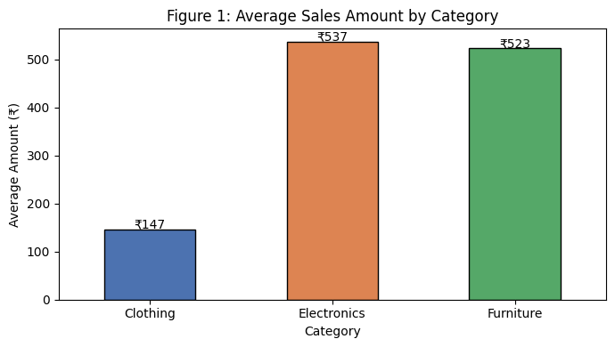
Figure 1: Average Sales Amount by Category – Electronics (₹537) and Furniture (₹523) far exceed Clothing (₹147).
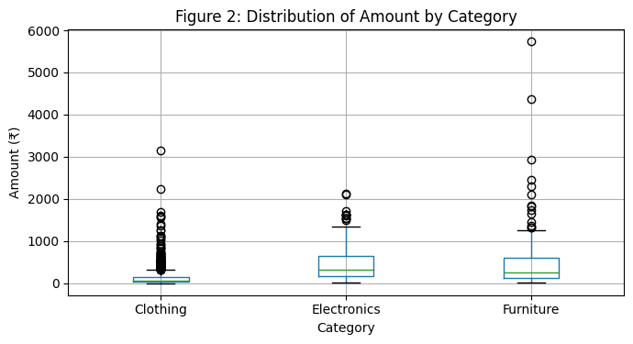
Figure 2: Box Plot of Amount by Category – Electronics and Furniture show wider spreads and more outliers. Clothing is consistent but low value.
Figures 1 and 2 show that although Clothing dominates order volume (949 of 1,500 orders), each transaction generates far less revenue than Electronics or Furniture. The wide interquartile range in higher-value categories confirms a small number of large orders drive most of the revenue.
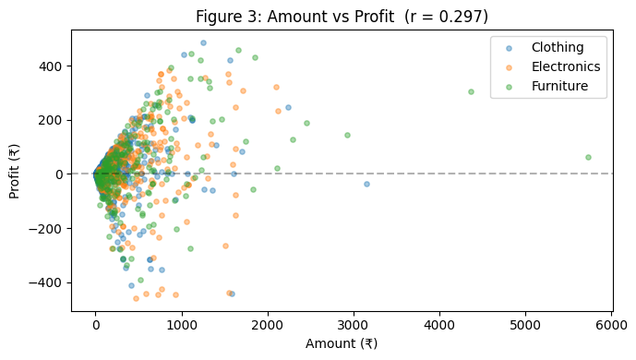
Figure 3:Amount vs Profit (r = 0.297) – Weak positive correlation. High amount does not guarantee high profit.
The scatter plot confirms the weak relationship (r = 0.297, p < 0.001). High-value orders can still produce losses, highlighting that increasing sales value alone will not improve profitability without better margin management.
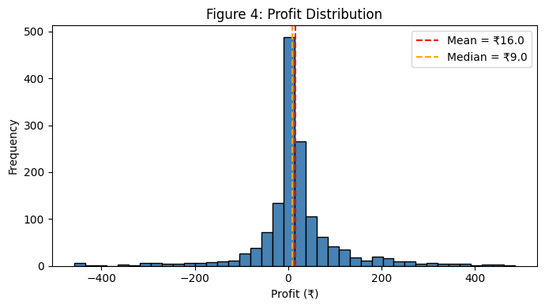
Figure 4: Profit Distribution – Skewed with a long-left tail. Mean (₹16.02) significantly higher than median (₹9.00).
The histogram shows 33.3% of all orders produce negative profit. The gap between mean and median confirms skewness caused by high-profit outliers.
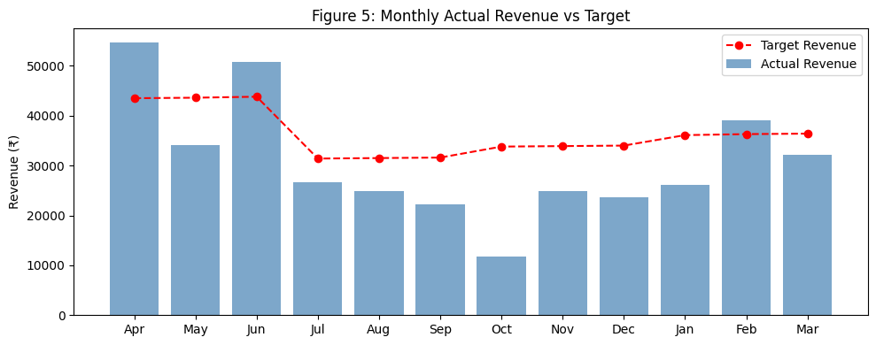
Figure 5: Monthly Revenue vs Target – Underperformance in April–July, recovery from October onwards.
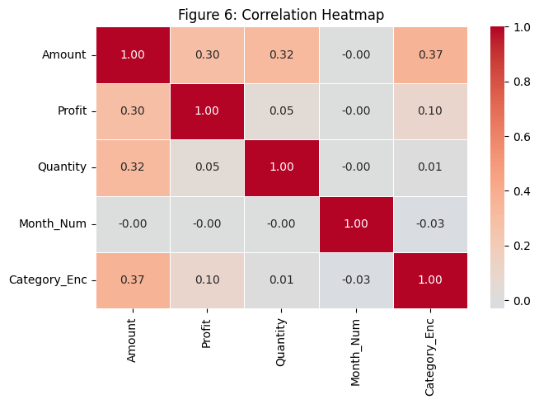
Figure 6: Correlation Heatmap – Amount has the highest correlation with Profit (r = 0.30) but this is still weak. No single feature strongly predicts Profit, suggesting other factors such as supplier costs and discount rates are the main drivers.
The heatmap shows that none of the features have a strong linear relationship with Profit. Although Amount has the highest correlation (r = 0.30), this is still weak. This suggests that other factors such as supplier costs and discount rates are likely the main drivers of profitability.

Model 1: Linear Regression
Linear Regression was applied to predict Profit from Amount, Quantity, Category_Enc and Month_Num using the scikit-learn (scikit-learn, 2024), with a 70/30 train-test split (O'Shea, 2026; James et al., 2021).
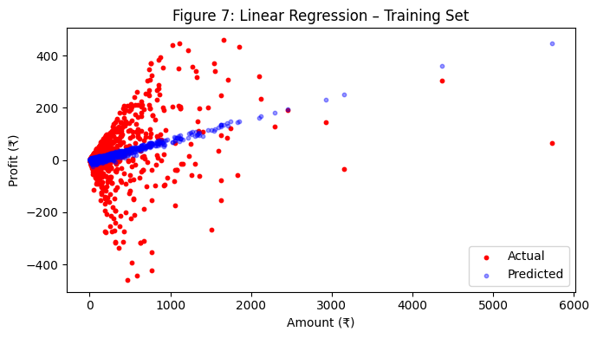
Figure 7: Linear Regression – Training Set results.
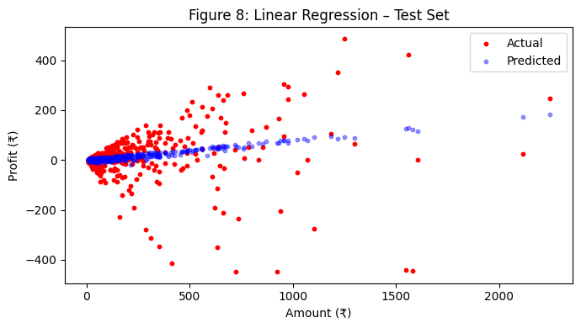
Figure 8: Linear Regression – Test Set results.
Table 3: Linear Regression Evaluation Metrics
Model | MAE | RMSE | R² (Test) | CV R² (5-fold)
Linear Regression | 49.83 | 95.10 | 0.0151 | -0.2957

The model performed poorly with an R² of 0.0151, explaining only 1.5% of Profit variation. The negative CV score (-0.2957) indicates weak generalisation. The gap between training R² (0.1181) and test R² (0.0151) suggests slight overfitting, though both values are extremely low. Linear regression is not suitable for profit prediction with the current features.

Model 2: Logistic Regression (Classification)
Logistic Regression classified each order as High-Profit (above median ₹9.00) or Low-Profit. Features were scaled using StandardScaler before training on the same 70/30 split (O'Shea, 2026).
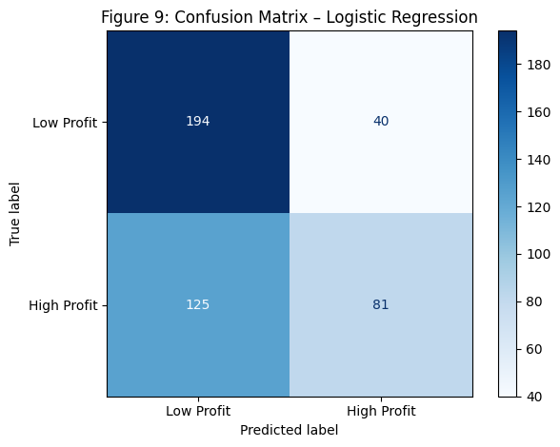
Figure 9: Confusion Matrix – Logistic Regression. TN = 194, TP = 81, FP = 40, FN = 125.
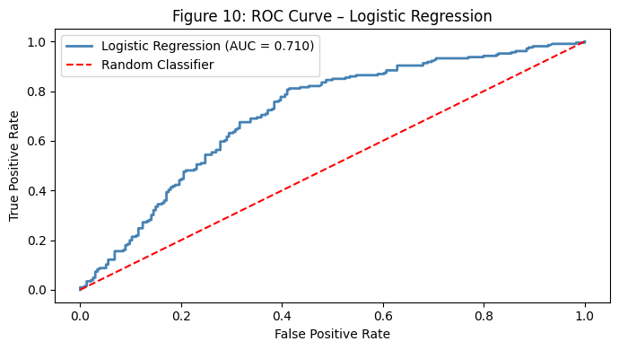
Figure 10: ROC Curve – Logistic Regression (AUC = 0.710). Above the 0.5 random baseline, indicating meaningful discriminative ability.
Table 4: Logistic Regression Classification Results
Model | Accuracy | Precision | Recall | CV Accuracy (5-fold)
Logistic Regression | 62.5% | 0.64 | 0.61 | 48.1% ± 16.7%

The model achieved 62.5% accuracy, above the 50% random baseline, and an AUC of 0.710. However, CV accuracy of 48.1% with high variance (±16.7%) shows unstable generalisation. The model identifies Low-Profit orders well (recall = 83%) but misses many High-Profit orders (recall = 39%).

Model 3: decision Tree Classifier
A Decision Tree with max_depth=5 (pre-pruning) was trained on the same features and split.
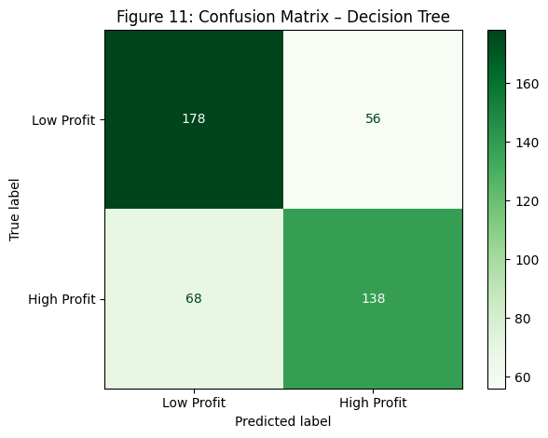
Figure 11: Confusion Matrix – Decision Tree (max_depth=5). TN = 178, TP = 138, FP = 56, FN = 68.
Table 5: Decision Tree Classification Results
Model | Accuracy | Precision | Recall | CV Accuracy (5-fold)
Decision Tree (depth=5) | 71.8% | 0.72 | 0.72 | 41.1% ± 10.8%

The Decision Tree achieved 71.8% accuracy with balanced recall across both classes (76% Low-Profit, 67% High-Profit). However, CV accuracy of 41.1% is significantly lower than the hold-out accuracy, indicating overfitting to the specific test split.

Experiment: Varying Decision Tree Depth
To understand the overfitting issue more clearly, the Decision Tree model was trained using five different max_depth values. This experiment shows how increasing model complexity affects both training and test performance.
Table 6: Decision Tree Depth Experiment – Training vs Test Accuracy
Max Depth | Train Accuracy | Test Accuracy | Difference | Observation
2 | 66.2% | 62.7% | 3.5% | Underfitting
3 | 78.2% | 73.4% | 4.8% | Good balance
5 | 79.6% | 71.8% | 7.8% | Slight overfit
7 | 83.2% | 72.7% | 10.5% | Overfitting
10 | 89.7% | 68.9% | 20.8% | Heavy overfit

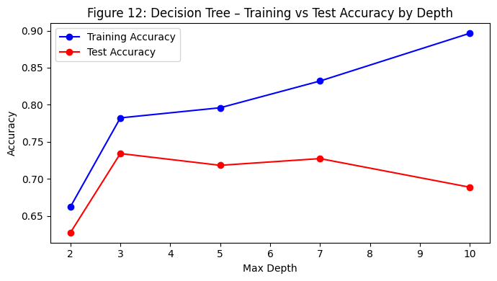
Figure 12: As depth increases, training accuracy rises whilst test accuracy peaks at depth 3 then declines – classic overfitting pattern.
As depth increases, training accuracy rises but test accuracy peaks at depth 3 then declines. Depth 3 provides the best balance (4.8% gap) and is the most suitable setting for deployment. Depths 5, 7 and 10 increasingly overfit as the model becomes too complex.

The Insights

What the Data Tells Us
The data reveals a commercially important issue. Clothing accounts for 64% of orders but produces the weakest margins. Electronics and Furniture generate less volume but much higher revenue per transaction. Despite this, 33.3% of all orders result in a loss. The monthly trend (Figure 5) shows consistent underperformance in April – July, suggesting targeted early-year promotions are needed. Correlation analysis confirms that revenue and profit are not the same and large orders do not guarantee profitability.

What the Model Tells Us
Linear Regression confirmed that profit cannot be reliably predicted from the available features (R² = 0.015). This reflects the missing data in supplier costs, discounts and return rates are absent rather than a flaw in the algorithm. The Decision Tree at depth 3 achieved 73.4% test accuracy, offering real commercial value for flagging unprofitable orders before dispatch (Provost and Fawcett, 2013). However, the gap between hold-out (71.8%) and CV accuracy (41.1%) shows overfitting. Logistic Regression is more stable across folds and its 83% recall for Low-Profit orders is useful when avoiding losses is the priority.

Limitations and Improvements
The dataset covers only one year and is missing key cost variables (supplier costs, discount rates, return rates), limiting model accuracy. The median-split label creates an artificial 50/50 balance that may not reflect real business conditions. Future work should enrich the dataset with cost data and use a business-relevant profit threshold.

Ethical Considerations
Automated classification models carry ethical responsibilities. Deprioritising orders based on historical profitability patterns could unfairly disadvantage customers from certain regions or categories. ShopEase must ensure any deployed model is transparent, auditable and compliant with data protection regulations (European Union, 2016). The model should support human decision-making, not replace it (Floridi and Taddeo, 2016).

Recommendations
The data analysis and modelling results lead to the following recommendations for the ShopEase management team:
- Adopt the Decision Tree (depth 3) as a profit-risk indicator to flag likely unprofitable orders before dispatch (73.4% accuracy).
- Prioritise data enrichment by recording supplier costs, discounts and return rates — the single most impactful improvement available.
- Address the early-year revenue gap with targeted promotions in April–July, especially for Electronics and Furniture.
- Investigate Clothing sub-category profitability to identify and rationalise consistently underperforming product lines.
- Carry out a fairness audit before operational deployment to ensure predictions do not disadvantage particular customer groups or regions.
Python link available via Google Colab: https://colab.research.google.com/drive/1VEGIj1sOGOg-5xnKVM1KRBBADkK2WO_p?usp=sharing

References
European Union (2016). General Data Protection Regulation (GDPR). Official Journal of the European Union.
Field, A. (2013). Discovering Statistics Using IBM SPSS Statistics. Sage.
Floridi, L. and Taddeo, M. (2016). What is data ethics? Philosophical Transactions of the Royal Society A, 374(2083).
James, G., Witten, D., Hastie, T. and Tibshirani, R. (2021). An Introduction to Statistical Learning with Applications in R. 2nd edn. Springer.
O'Shea, K. (2026). CO3722 Data Science – Semester 2 Lectures 1–8. University of Central Lancashire.
Provost, F. and Fawcett, T. (2013). Data Science for Business. O'Reilly Media.
scikit-learn (2024). scikit-learn: Machine Learning in Python. Available at: https://scikit-learn.org (Accessed 19 March 2026).

