Task 2: Core Security Concepts Explainer
The CIA Triad (Confidentiality, Integrity, Availability)
The CIA Triad is the foundational model of information security. It stands for Confidentiality, Integrity, and Availability. Think of it as a three-legged stool: if any leg breaks, the entire security posture collapses. Every security tool, policy, and protocol designed today maps directly back to protecting one or more of these three pillars.
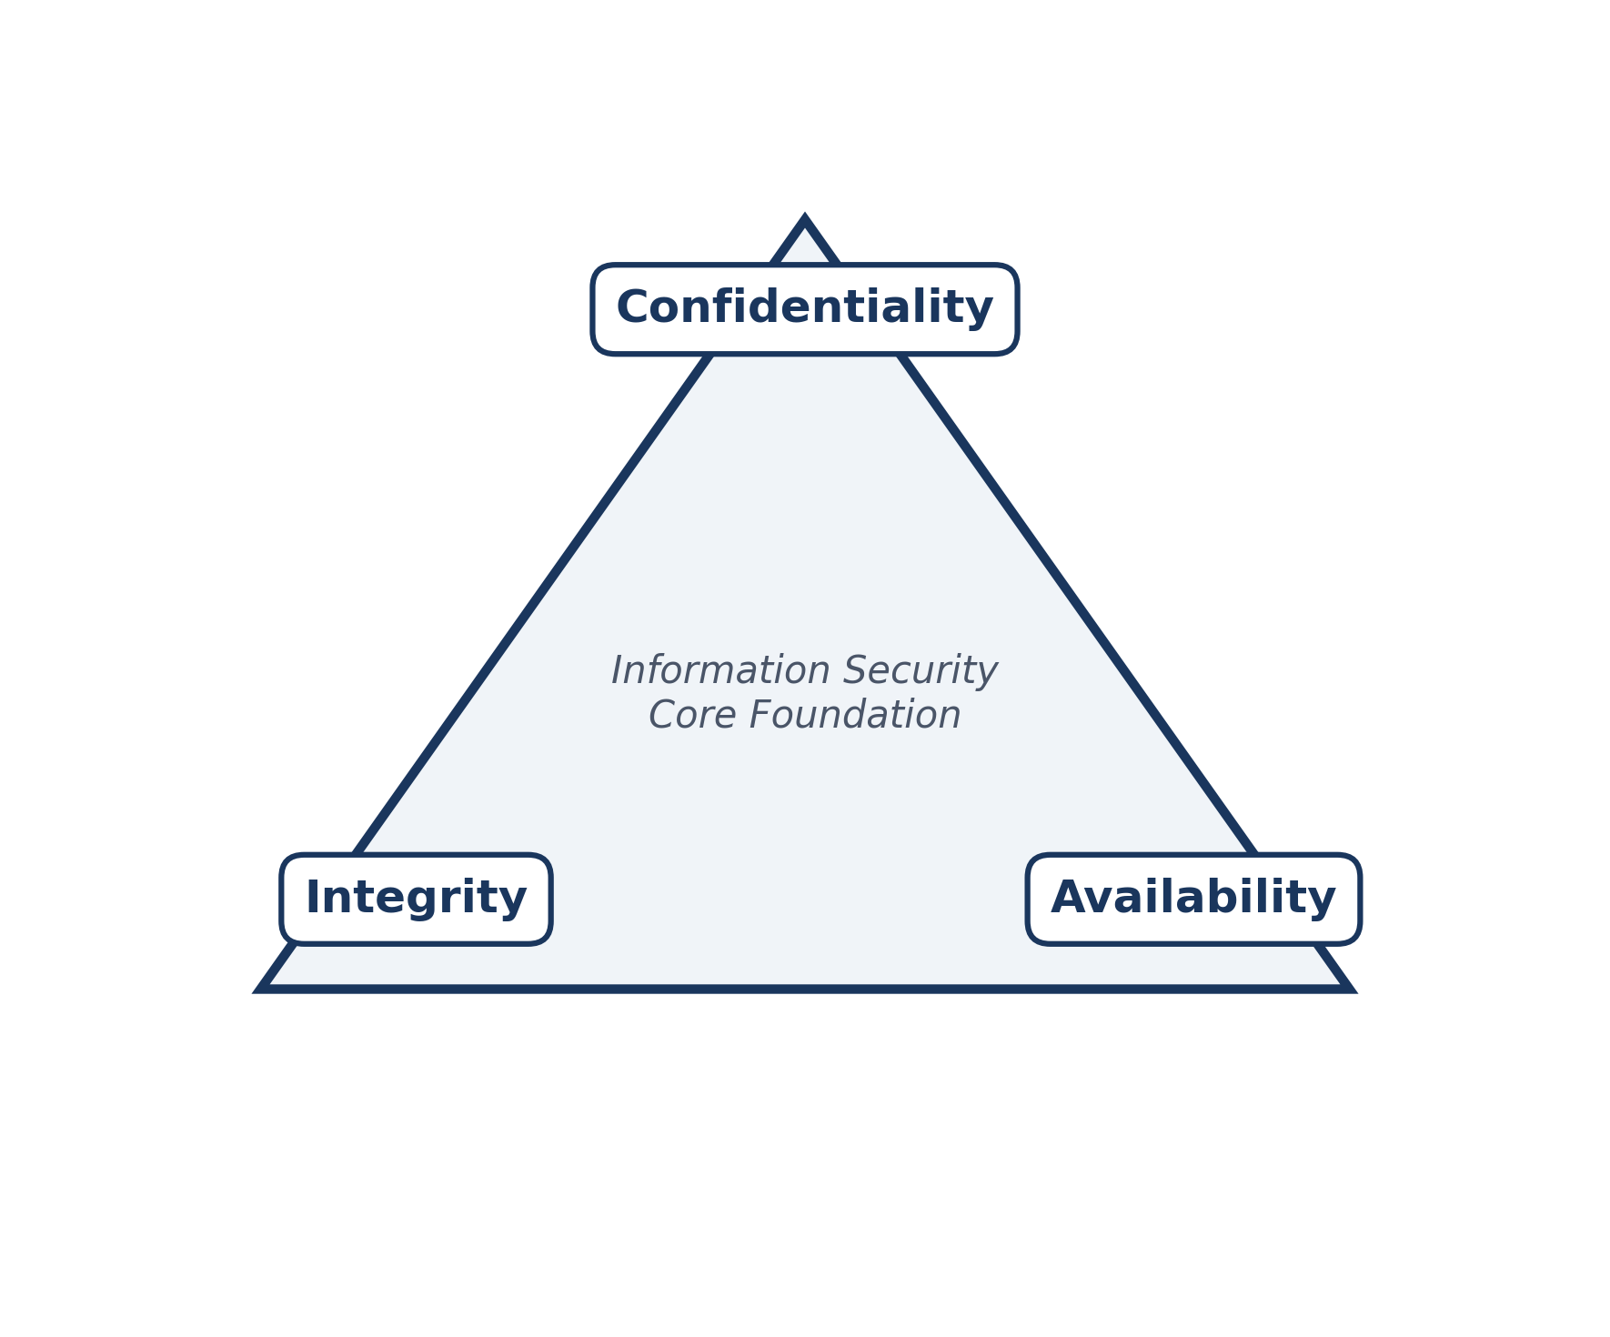
Confidentiality
Definition: Confidentiality ensures that sensitive information is accessed only by authorized individuals, and that unauthorized people are kept out. It is the digital equivalent of locking a diary or sending a sealed letter rather than writing a postcard.
Real-World Scenario: Online Banking & Medical Records.
Imagine you log into your online banking portal to check your account balance. Your bank uses encrypted connections (HTTPS) and secure passwords to ensure that a nosy neighbor sitting on the same coffee shop Wi-Fi network cannot intercept your account number or transaction history. When confidentiality is violated (such as through a data breach where a hacker steals millions of user passwords), private data is exposed, leading to identity theft and financial fraud.
Integrity
Integrity ensures that data remains accurate, complete, and trustworthy. It prevents unauthorized actors from modifying, tampering with, or corrupting information during storage or transmission.
Availability
Availability ensures that information, network resources, and services are accessible to authorized users whenever they need them. Security is useless if legitimate users are locked out of necessary systems.
2. Encryption vs. Hashing
Both encryption and hashing take readable data and scramble it using mathematical algorithms. However, their fundamental purposes are exact opposites: encryption is designed to be reversible (so authorized users can read the original message), whereas hashing is designed to be strictly irreversible (used for secure data verification and password storage).
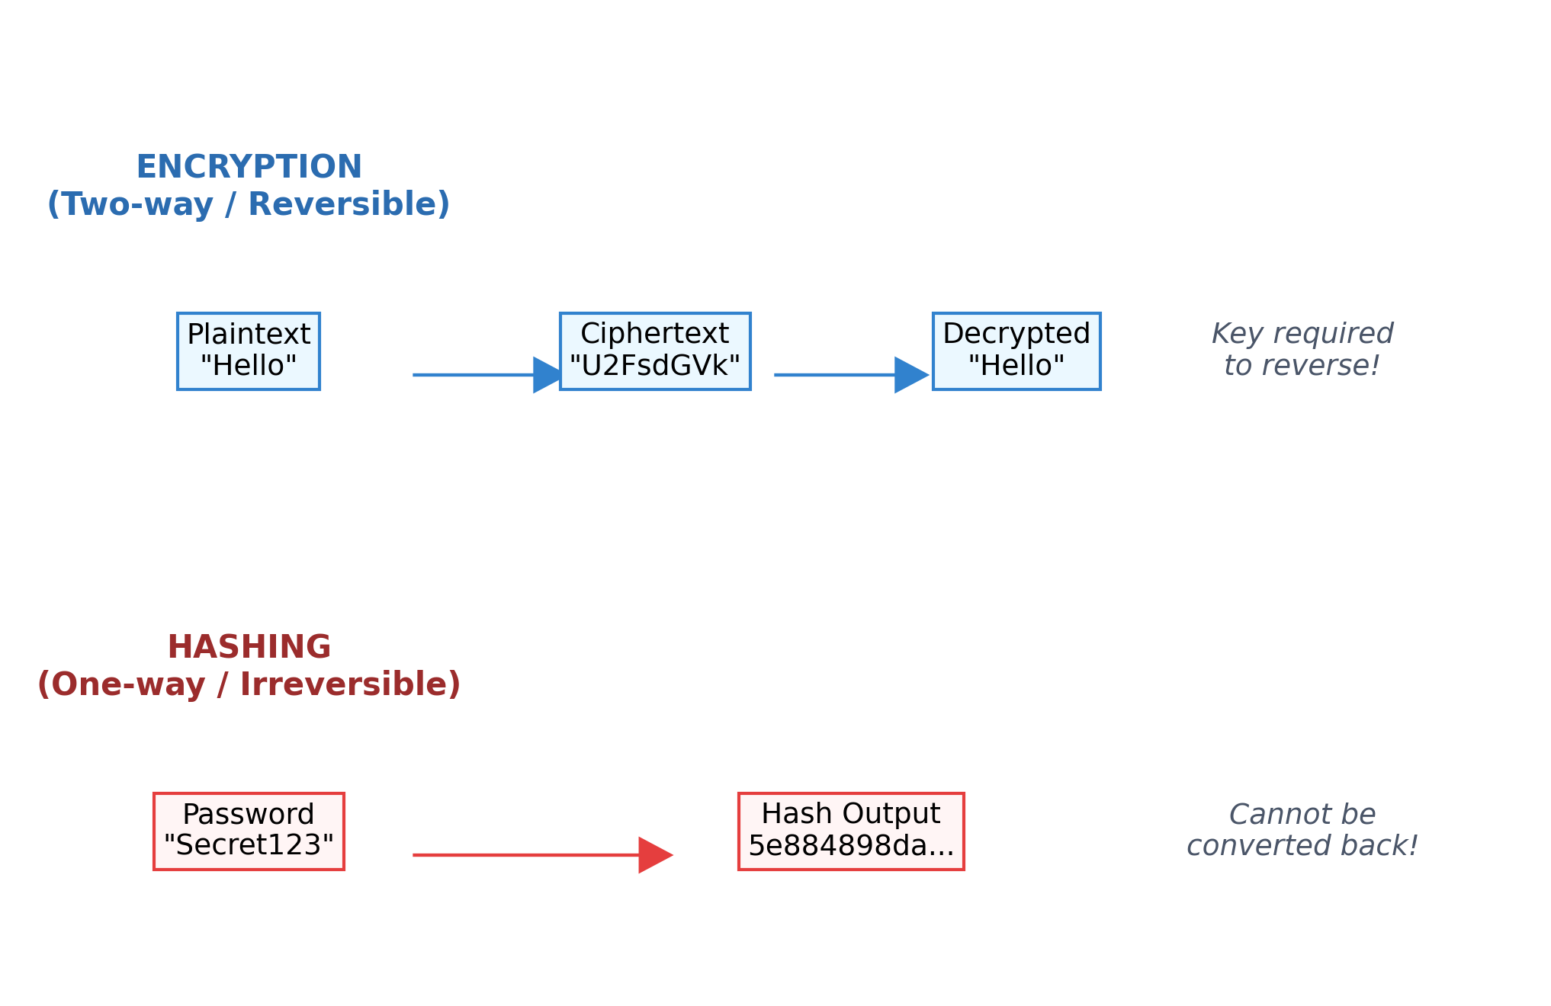
Real-World Scenario: Sending Secret Letters vs. Checking Cargo Seals.
• Encryption Scenario (Encrypted Messaging App): When you send a message on WhatsApp, your phone uses encryption to scramble your text ("Meet me at noon") into gibberish ("U2FsdGVkX1...") while it travels across the internet. When your friend receives it, their app uses a digital key to decrypt it back into readable text. If a hacker intercepts the message in transit, they only see meaningless code.
3. Threat, Vulnerability, and Risk
In cybersecurity risk management, these three terms are frequently mixed up, but they have distinct, precise meanings. Understanding how they interact is essential for protecting any home network or corporate infrastructure.
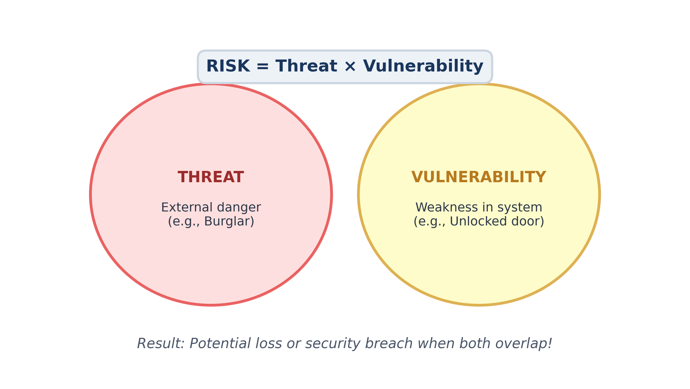
Real-World Scenario: Leaving Your House Front Door Unlocked.
Let's break down these concepts using a physical home security analogy:
1. Threat: A threat is any potential danger that could exploit a weakness and cause harm—such as a burglar walking through your neighborhood looking for easy targets.
2. Vulnerability: A vulnerability is a weakness or flaw in your defense—such as forgetting to lock your front door before going on vacation.
3. Risk: Risk is the likelihood that a threat will exploit a vulnerability and cause damage. If you live in a very safe neighborhood with no burglars (low threat), leaving your door unlocked is a lower risk than if you live in a high-crime area. Cybersecurity professionals evaluate risks continuously to decide where to invest time and money in defense.

