1. Set up php environment

1. Download and install xampp. Before using this payslip application please make sure that php programming environment has been set up in your machine. If not please go to website <https://www.apachefriends.org/download.html>

download the installer based on your operating system. Installation should be similar to a normal software installation you do in your operating system.

Go to the location where you installed XAMPP (usually **C:\Program Files\xampp**) and double click on XAMPP Control Panel (**xampp-control.exe**).

Click on **Start** buttons next to Apache and MySQL for starting them.

2. Unzip the code into the folder to c:\xampp\htdocs\(or whichever directory you installed XAMPP on your computer).

3. Change the configure file for apache

Please refer to

<https://www.centos.org/docs/5/html/Deployment_Guide-en-US/s1-apache-config-ui.html>

4. Modify host file (for windows)

* + Press the Windows key.
  + Type **Notepad** in the search field.
  + In the search results, right-click **Notepad** and select **Run as administrator**.
  + From Notepad, open the following file: **c:\Windows\System32\Drivers\etc\hosts**
  + Make the necessary changes to the file.
  + Click **File > Save** to save your changes.

Please refer to the <https://support.rackspace.com/how-to/modify-your-hosts-file/>.

5) Navigate to localhost/index.html, you should be able to use the application.

1. User Interface design as below.

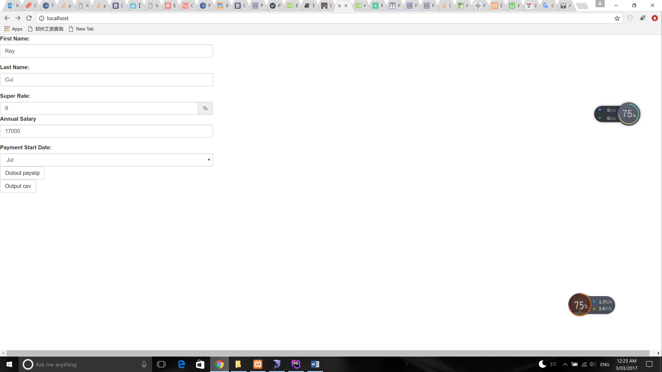

After filling up all the fields , click the Output button -> output payslip like a string

The Output csv button is designed to output the given csv file to testing.csv file.

The example test.csv file should be under the test folder.

3) Class description

1.Employee class is designed to store the employee’s details for example first name, last name, annual salary etc.

2.PayslipInfo class is used to store the payslip information which is employee name, pay period, income tax, net income , super and gross income.

3.PayslipProcessor class can be used to generate the payslip information for example calculate the income tax , gross income , net income and super.

There is an algorithm in generatePayslip function for the income tax calculation,

$incomeTax = *round*((($annualSalary - $taxData[**'from'**] - 1) * $taxData[**'taxRate'**] + $taxData[**'taxBase'**]) / 12);

I defined an array named $taxableIncomeData to store tax rates for 2012 – 2013 which is not ideally. Because now the application only can generate the payslip for 2012 – 2013. That could be get from the database or we may need change this to be a variable passed to the function.

4.PayslipOutter class is designed to output the payslip , there are two methodas one is used to output payslip to string anther one is used to output to a csv file.

5. index.html is a default html file in a browser when a user invoke the payslip application.

6. main.php is used to get the post request from the index.html and then do the logic business.

4) For testing

1. Test emolyee’s super rate, make sure is betwee 0 and 50.
2. A few test cases needed be done later, for example

When the annual salaray value is one of these value 18200, 18201, 37000, 37001, check the income tax can be the value we expected.

1. Need do the form validation before submitting the form. For example make sure all the filed are not blank.