Raymond Dillon

40043298

Raymond’s PC’s

Help guide

# Introduction

The following user guide details all the necessary steps needed to manage the website “Raymond’s PC’s” effectively.

## Website URL

**Front end:** <http://web2.eeecs.qub.ac.uk/40043298/index.php>

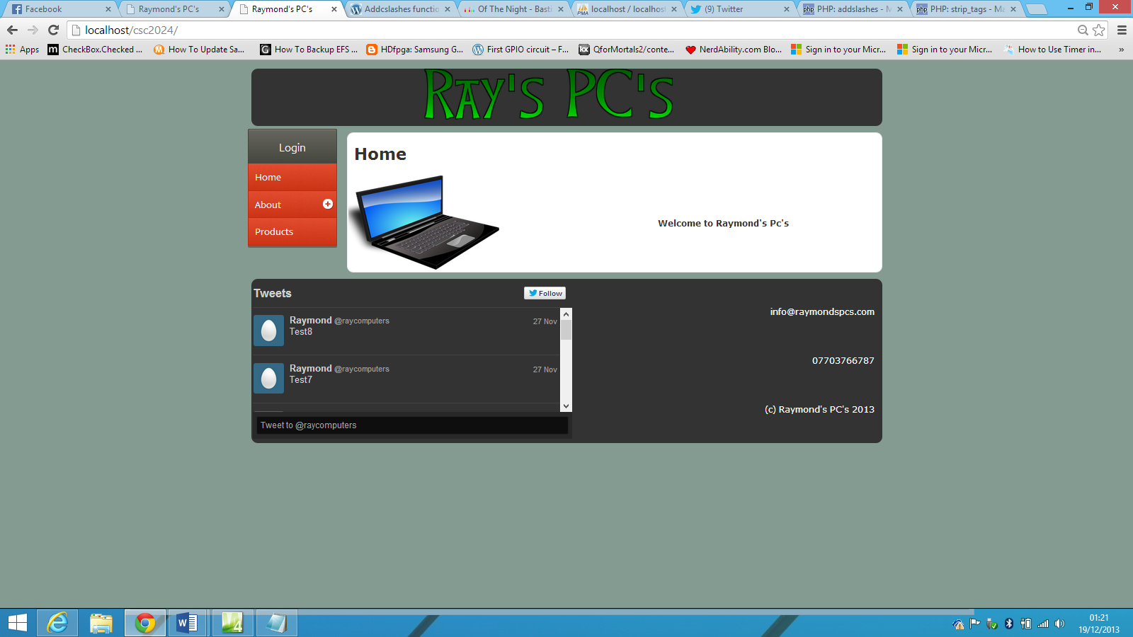

**Back end:** <http://web2.eeecs.qub.ac.uk/40043298/secure/index.php>

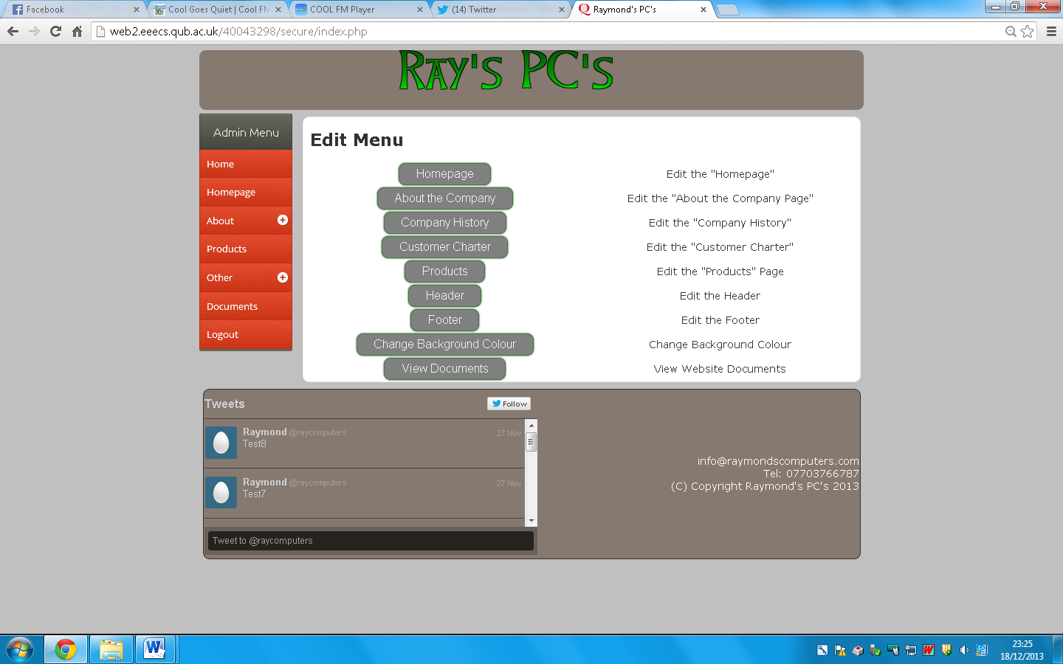

## Logon Credentials

**Username:** admin

**Password:** pass123

# Updating Individual Pages

In order to update the website, you must log into the administration back end. In order to do this, click on “Login” from the side menu.



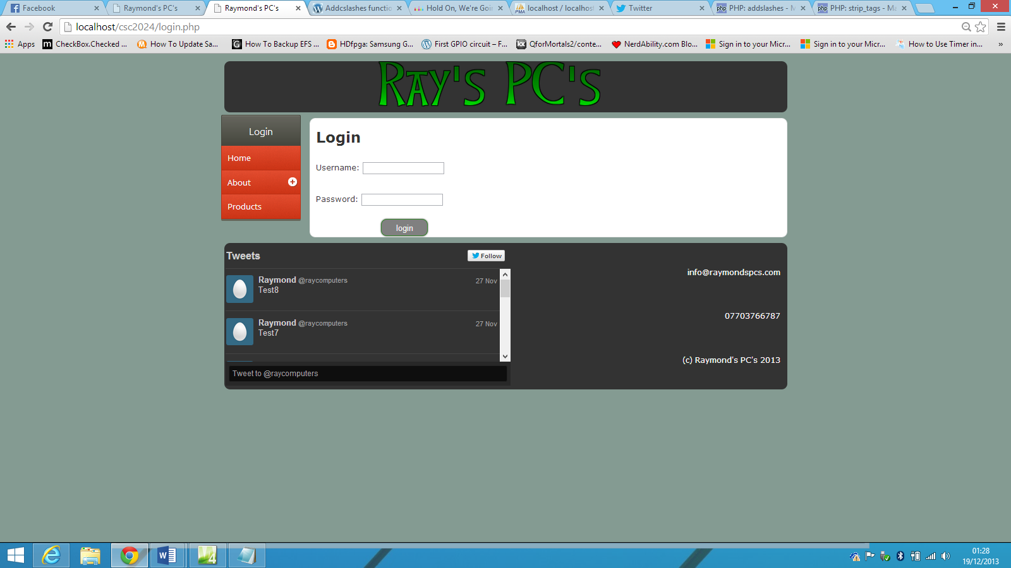

Once logged in, you will be directed to the administration menu for the website.



From this menu, you have the ability to edit almost every aspect of the website. Updating the various is a fairly repetitive process, so in this documentation, we will cover it for one page. We will update the homepage in this documentation. If you have any queries about updating any other page, please contact the website administrator.

### Updating the Homepage

To update the homepage, click on the Homepage button, either on the side menu, or on the main page. You will then be directed to the edit page as shown below.

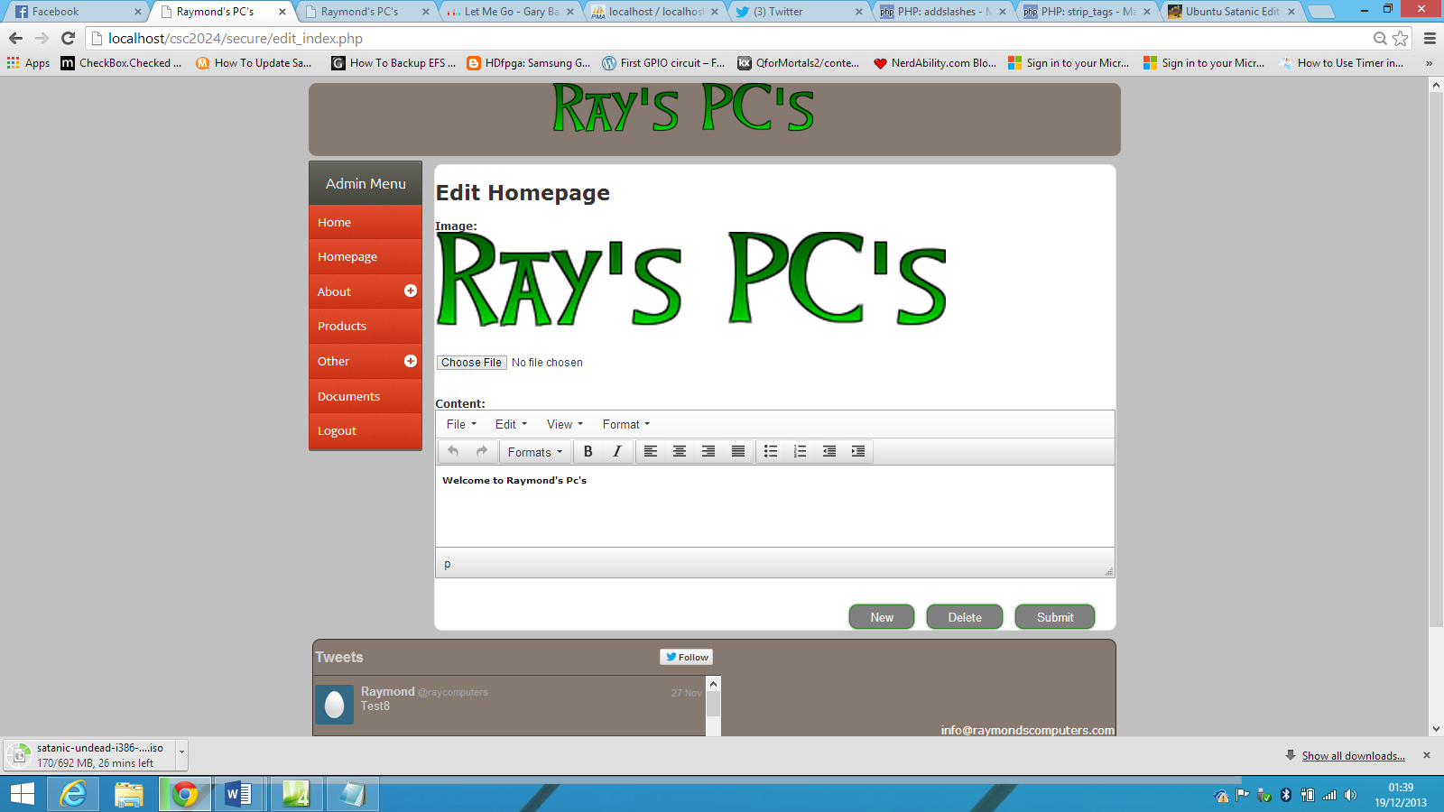

Through the administration menu, you have the ability to “Add”, “Edit” or “Delete” a record for every page. This document will describe the process of doing each of these for the homepage.

#### Adding a Homepage Record

To add a homepage record, click “New” from the menu.



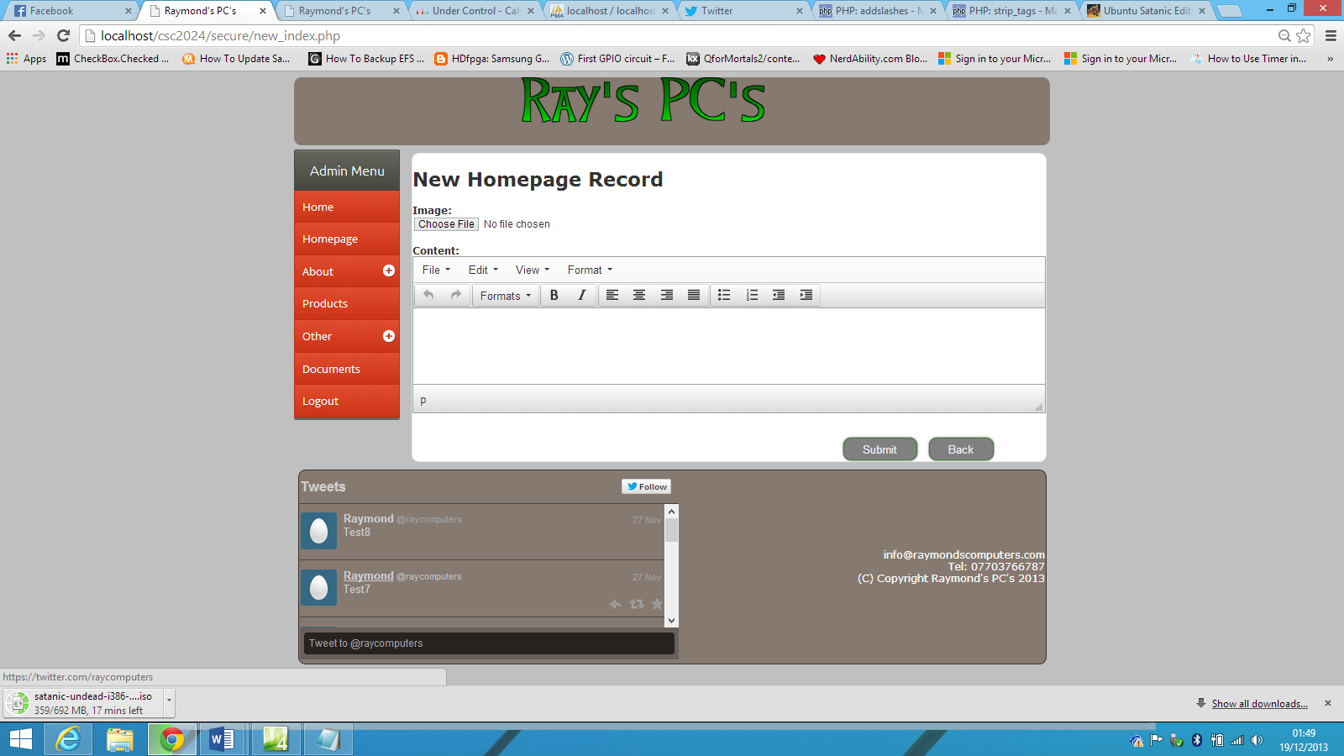You are then directed to a new page, where you can add a new record. The page consists of a button allowing you to upload an image, as well as a text editor which allows advanced formatting of text, such as underlining text and adding bullet points.

Text Editor

Image Upload Button

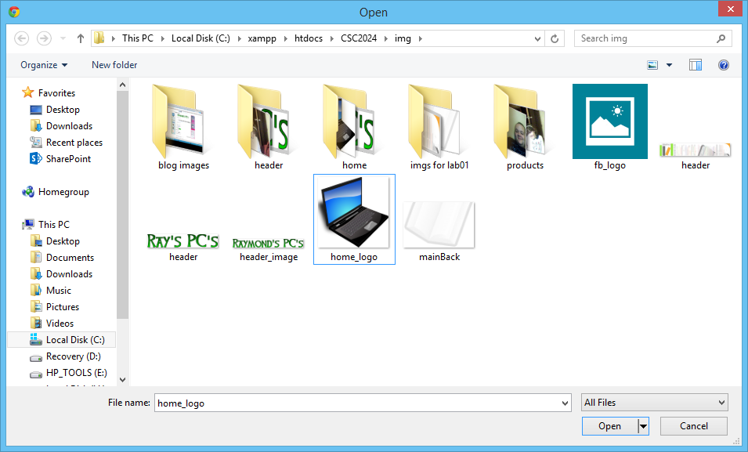We will change the homepage to include a new image and some text using bullet points. To change the image, simply click on the image upload button.

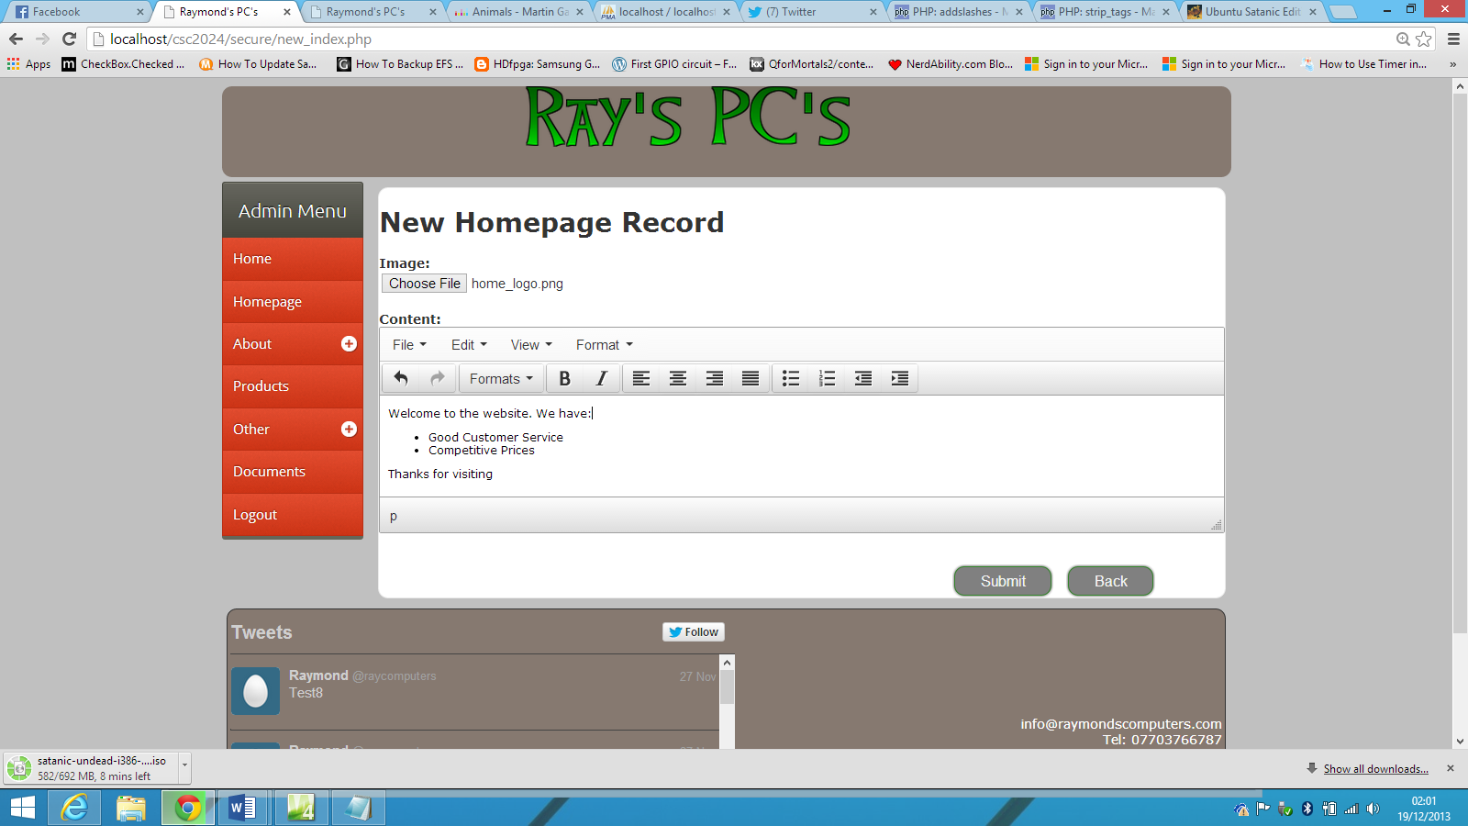From here, you can select what image you wish to upload. Once you are happy with your selection, click open.

Bullet point icon

To add the above text to the webpage, simply type it into the editor and click on the bullet point’s icon when needed. Once you are happy with it,, click “Submit”. You will be informed that the record has been added successfully.

Going back to the homepage, we can see that the new homepage record is appearing successfully on the homepage.

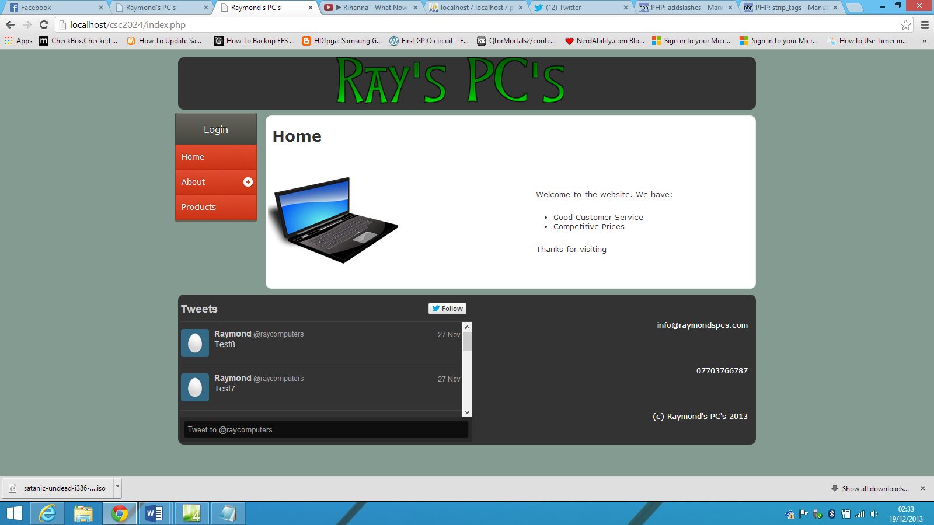

#### Updating the Homepage Record

To update the homepage, we click on the homepage menu.

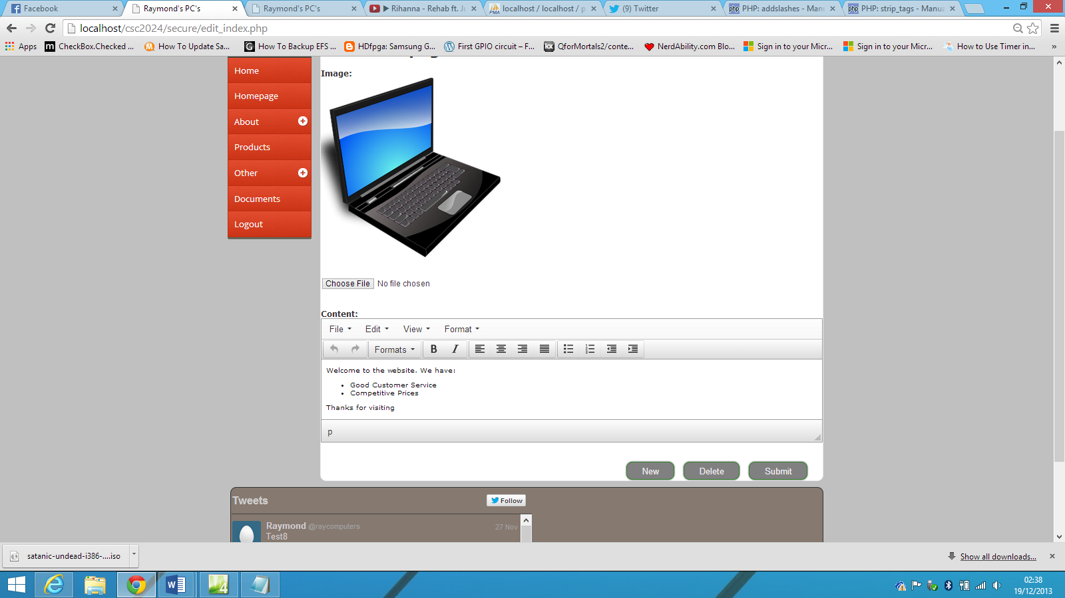

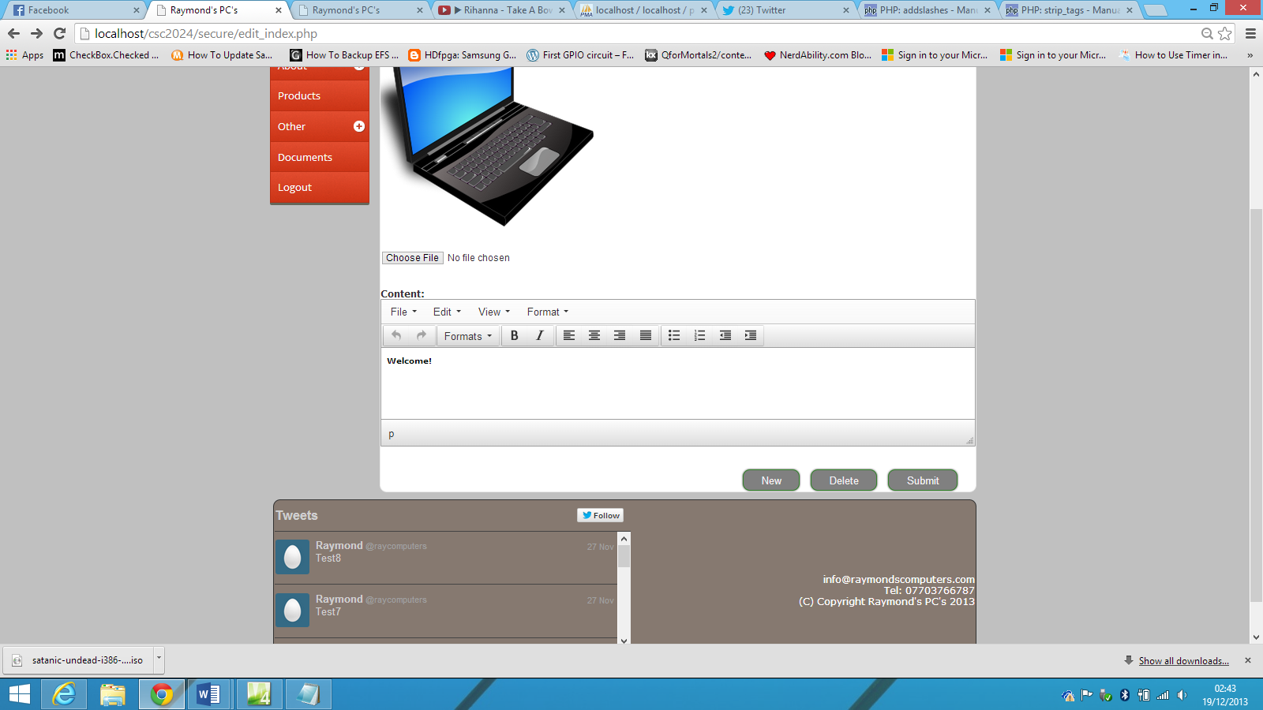The page assumes that you are editing the existing page and loads the current image and text. We will edit the text to simply say “Welcome” in a bold font.

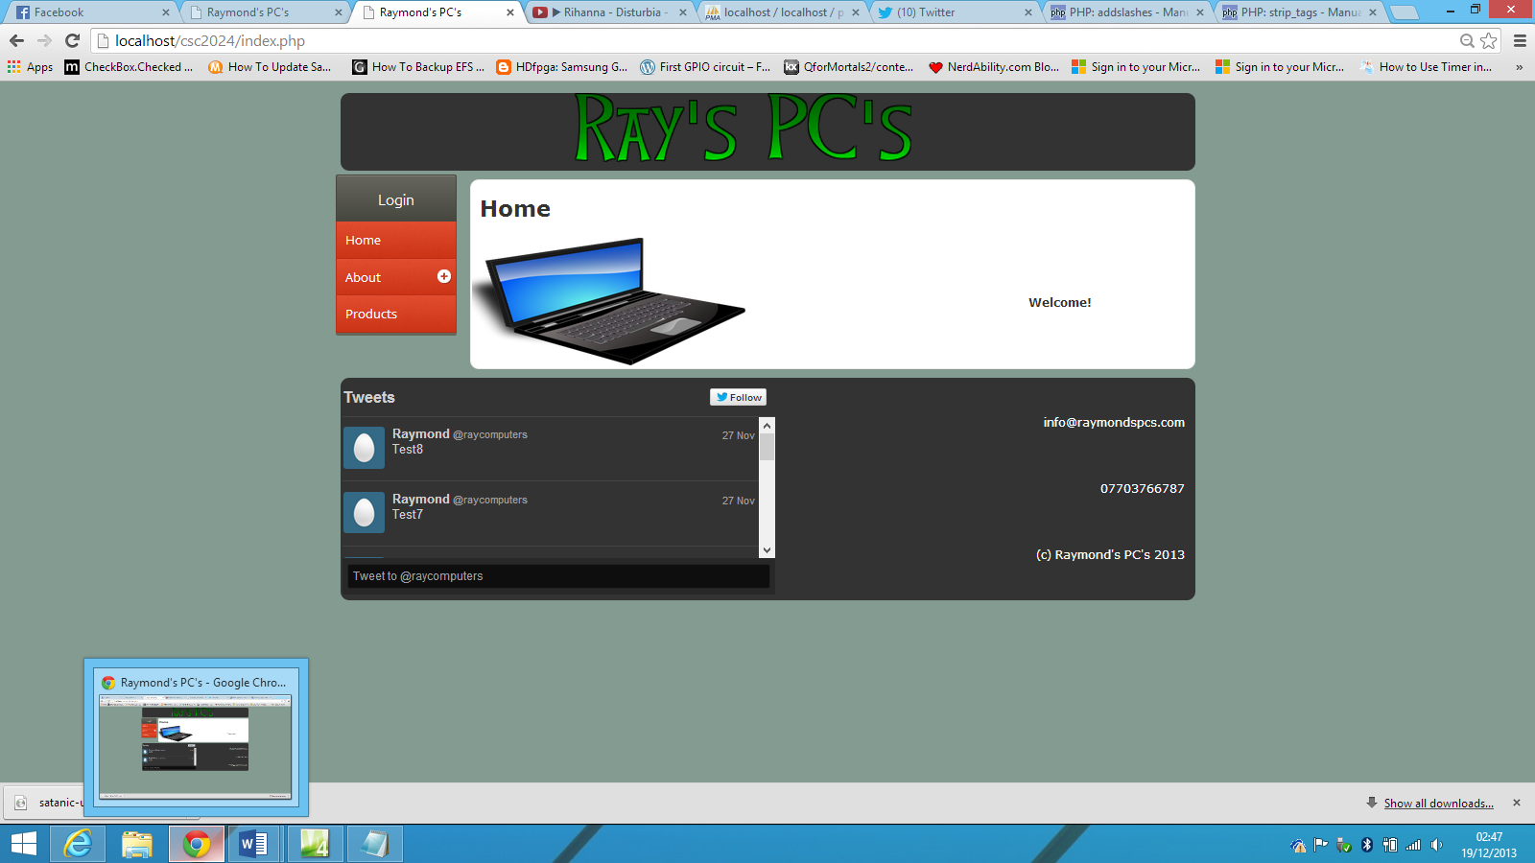Once happy, simply click the submit button. You will be informed by the webpage that the homepage has successfully been updated. From the below image, we can see that this is indeed the case.

#### Deleting a Homepage Record

The website allows you to delete the current homepage record, automatically reverting to the previous record to ensure that there is always something on the webpage.

To delete a homepage, we click on the homepage menu, and then click on the delete button.



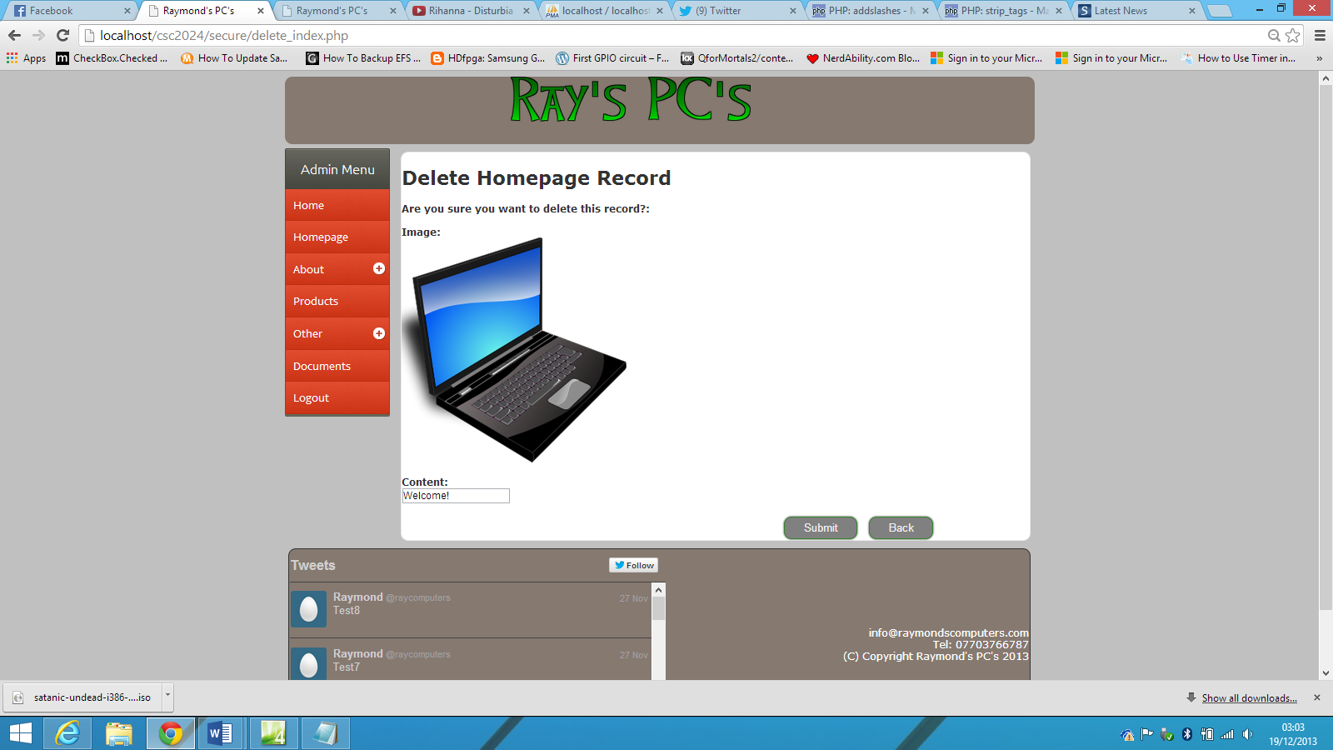The website will then ask you to confirm your choice.

If you are happy with your choice, click on the submit button. You will then be informed that the record has been deleted. This can be confirmed by looking at the homepage.

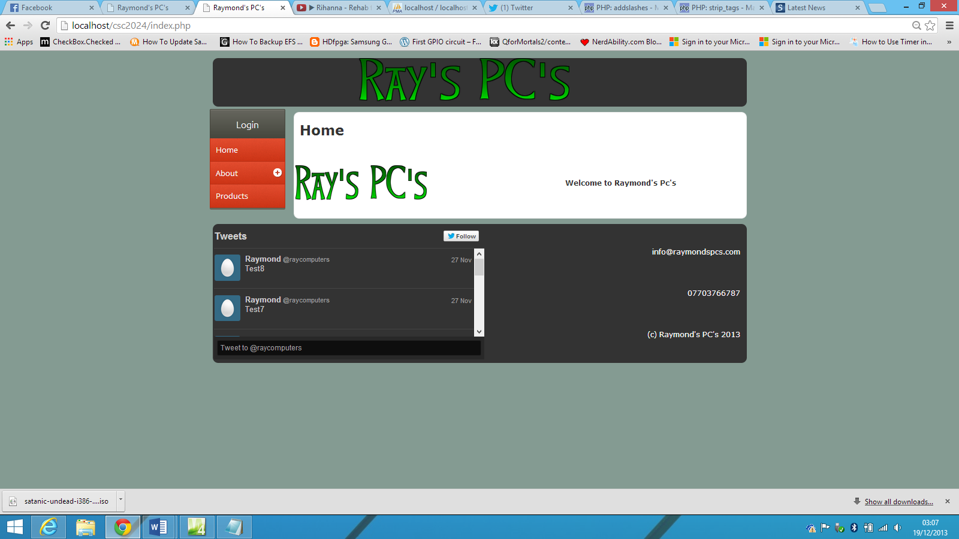

From the above image, we can see that the previous homepage record has been deleted and the system has automatically reverted to the previous record.

The process of adding, amending and deleting records has now been covered. This process is identical for all other pages.

# Changing Background Colour

An advanced feature of the website is the provision for the background colour of the website to be changed. To do this, simply click on “Change Background Colour” from the admin menu or side menu. Clicking on the small button beside the “Submit” button brings up the colour palette.

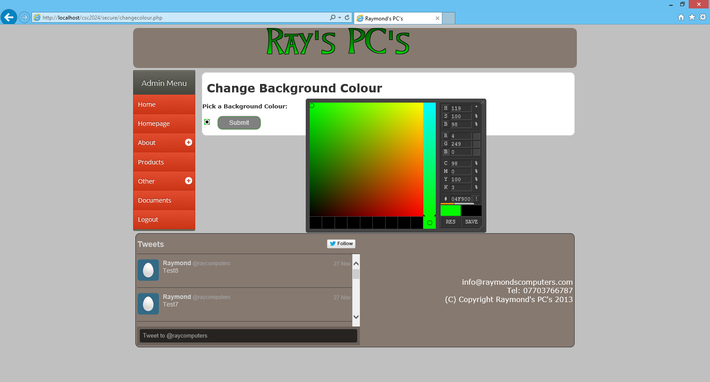

In the above image, we are changing the background colour to a bright green. Once happy with your choice, click on the submit button. You will be informed that the colour of the background has been changed

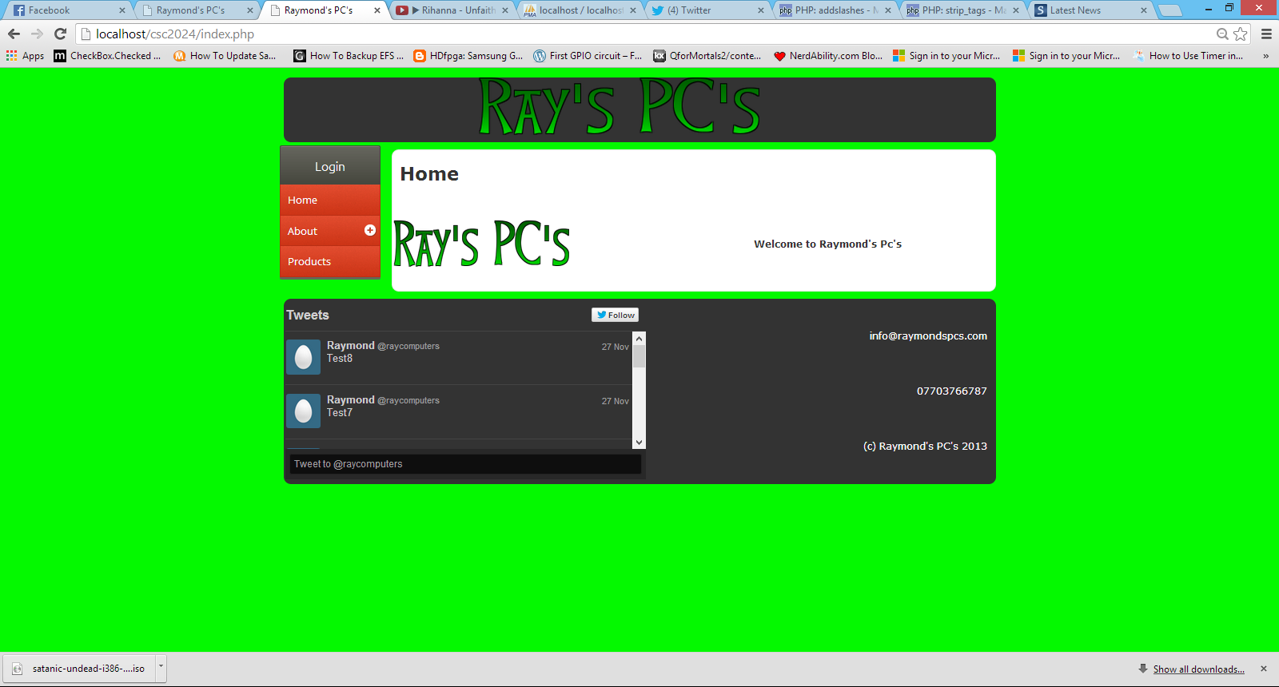

From the above image, we can see that the colour change was successful.

***Any queries on operating the website, contact the website administrator.***