Raymond Dillon

40043298

Raymond’s PC’s

Technical guide

# Introduction

This document details all the technical features of the website “Ray’s PC’s”. The development process has been documented at [www.raymonddillon.com](http://www.raymonddillon.com).

The document details the following technical areas of the website:

* Site map (front end and the admin back end)
* Entity Relationship Diagram (ER Diagram)
* Functionality Checklists (Standard Functionality and Extra Functionality)

# Site Map

## Front End Map

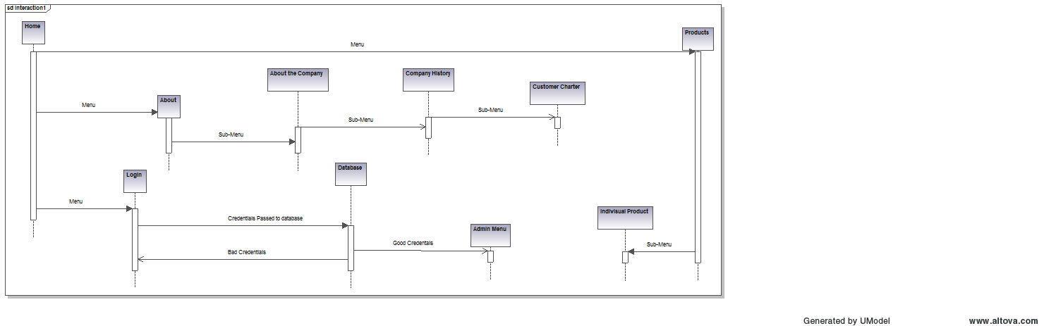

## Back End Map

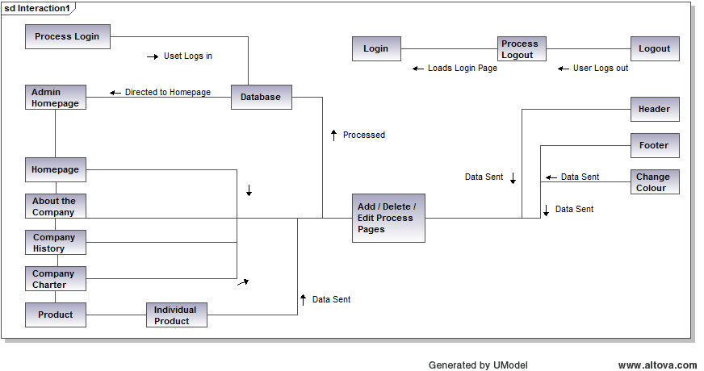

# Entity Relationship Diagram (ER Diagram)

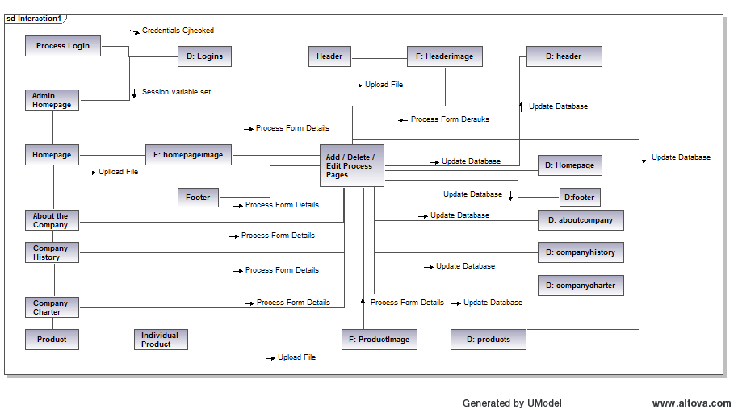

D: Database

F: File

# 

**Diagrams designed using Altova Umodel 2014**

# Functionality Checklists

## Standard Functionality

|  |  |  |
| --- | --- | --- |
| Name | Description | Successful |
|  |  |  |
| Website Renders in IE | All UI elements render successfully. | Successful – however layout of some UI elements are slightly off – possibly a CSS Issue |
| Website Renders in Google Chrome | All UI elements render successfully. | Successful |
| Website Renders in Firefox | All UI elements render successfully. | Successful – however layout of some UI elements are slightly off – possibly a CSS Issue |
| Connect to database | The website successfully connects to the database | Successful |
| Compatible with the latest browsers. | The website is compatible with the latest browsers. | Partially successful – all functionality is operational, but some UI variations between browsers, possibly due to CSS. |
| Front – End Developed | Front end UI developed and pulling data back from the database. | Successful |
| Back – End Developed | Back end UI developed and pulling data back from the database where necessary. | Successful |
| User has ability to update the website using the CMS | The user can add / amend and delete records from the various pages of the website. | Successful |

## Extra Functionality

|  |  |
| --- | --- |
| Name | Description |
|  |  |
| Colour Change Functionality | The user can change the background colour of the website through the back end. |
|  |  |

# Third Party Code

A number of third party plugins where used in the development of the website.

1. **Tiny MCE Editor (www.tinymce.com)** – JavaScript text editor implemented on all back end forms on the website.
2. **Javascript Colour selector (http://dematte.at/colorPicker)** – lightweight java script solution for selecting colours from a colour palette.
3. **JQuery (www.jquery.com) –** Used for animations throughout the website.

These plugins are covered either by the GPL or MIT Licenses.