The “Pirates” board game
“I made attempt to make the translation as close as possible to the original text of the magazine article. Some text parts were a little changed to be more understandable for English reader. Also I divided the text to named sections and brought the “Golden galleon” term. I hope that the game will get interest and among English speaking gamers who like board games” Igor A. Maznitsa, Tallinn, Estonia, 2015

Authors of the original Russian article are Illarion Golitsyn and Vladimir Pertsov. The Article was published in the “Pioneer” magazine #6 1989 (p.31-34)

History
The Game was created and designed very long time ago, in 1934. The Author of the game is Vladimir Mikhailovich Golitsyn, artist-illustrator. He was a sailor in his youth and spent a lot of time in navigations in north seas. As he became an artist, sea became his main theme for creativity.
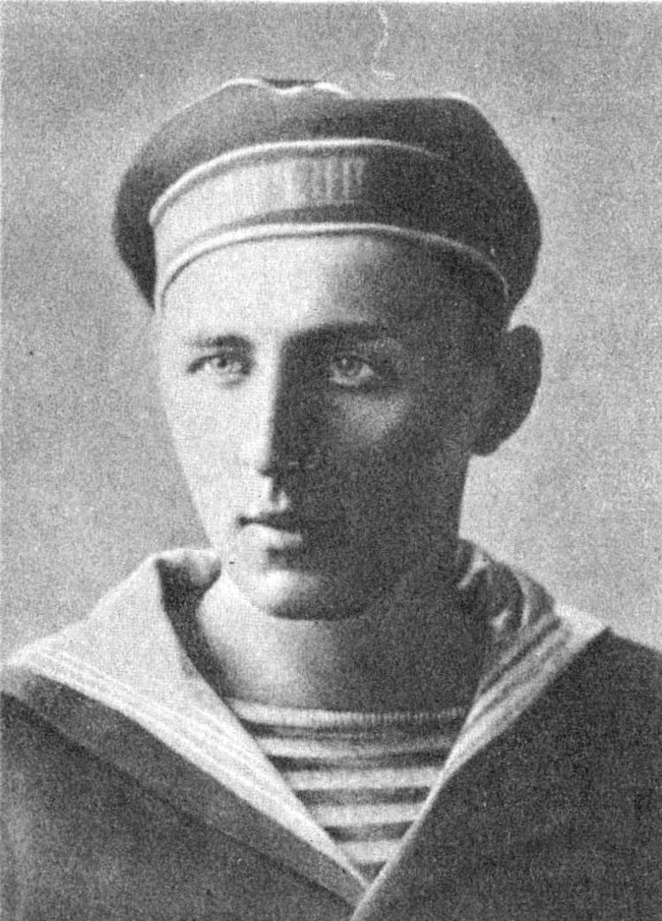
V.M.Golytsin
(1902-1943)
Also Vladimir Mikhailovich loved to create games. One from those games was the “Pirates” game. Once the game was shown to Maxim Gorky (a Great Russian writer). “The Mock-up of the “Pirates” game, created by artist V. Golitsyn for children, looks noteworthy and can be published.”, he wrote.
The “Pirates” game has very hard fate. After the game had been rated highly by Maxim Gorky, the game was sent to N.N. Glagolev , the editor of the “Mosoblsvod” publishing house. He started preparation of the game for publishing. So far everything had been going well and the new 1935 was very close.
But on 1 January 1935, N.N. Glagolev was arrested...
Vladimir Mikhailovich Golitsyn sent the “Pirates” game to another publishing house - “KOIZ”. But 12 editors of the publishing house changed their job position during the year. One from these editors had decided that such title (“Pirates”) for the game was not appropriate one and whole prepared edition was annihilated.
In 1930th, not only games, books and articles were being eliminated but also people, families, fates.
The End of Vladimir Mikhailovich was very tragic one. In 1941 he was also arrested (and he was already very ill man in that time) and soon he died in one of Stalin's prisons.
Today about two million readers of “Pioneer” will become acquainted with the “Pirates” game. Children and adults will be playing the game in thousands of flats, hundreds of pioneer houses, tens of pioneer camps. And everyone, who will like the astonishing game, will understand and believe: there are not horrific things in the game. The Game is about fresh winds, sails, islands and straits of the Atlantic ocean, about dead calm and hurricanes, smart maneuvers and furious battles.

Game rules

Number of players
The Game can be played by several players: two together – one for “Spaniards”, one for “Pirates”; three together – two for “Pirates”, one for “Spaniards”. The Game allows to have up to nine players when everyone has own ship.

Before game
Before game, ships are placed on the map in such manner: all spanish ships placed in the Veracruz port cell; pirate ships placed in pirate's port cells (there are six pirate's ports on the game map). The “Spanish” objective is to deliver the South American treasures to the Spain port "Cadiz". The “Pirate” objective is to capture the Spanish treasures and move the Spanish carrying ship to a pirate's port cell. Only one Spanish galleon can carry the treasure, its name must be recorded by “Spanish” players on a paper just before game session and placed under the game map, “Pirate” players must not know the name of the Spanish ship which plays role of "Golden gallion" during the game session, it is the biggest "Spanish" secret.

Game dice
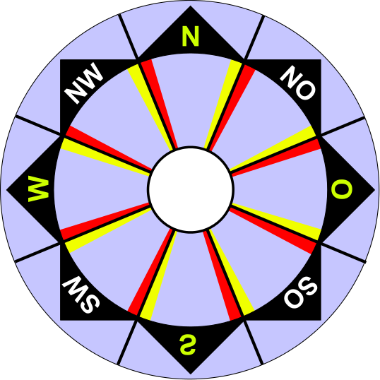
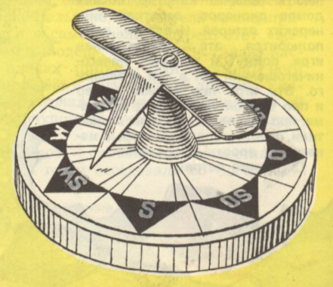
The Game needs special dice with special layout, the dice looks like compass.

Game start
The “Spanish” players start the game and make the first turn. Ships can be moved over cells on the map, but only one ship can be placed over a cell in the same time, but any sea port cell can keep as many ships as you need, there is not any restriction. Players can't move their ships through cells of opposite side's ports.

Game turns and moves
All Players make game turns one by one. The Current player turns the game dice for own ship(s). If the pointer of the dice has stopped in front of a YELLOW AREA, then it is dead calm, Spanish galleons can't move but Pirate brigantines can make an one cell move in any direction, because they are light ships and can use sculls. If the pointer of the dice has stopped in front of a RED AREA, then it is a hurricane and the player's ship is crabbed in the one cell distance (if the ship on a sea port cell, then the ship can't move during hurricane). If the target cell is already filled by another ship, then the player's ship will not leave its square but if the target square is earth, then the ship will be destroyed immediately. The LIGHT_BLUE AREAS of the dice mean fresh wind, think where you will make your move. Player's ships can make move in any of eight directions: North, West, South, East and Nort-West, South-West, South-East, North-East.
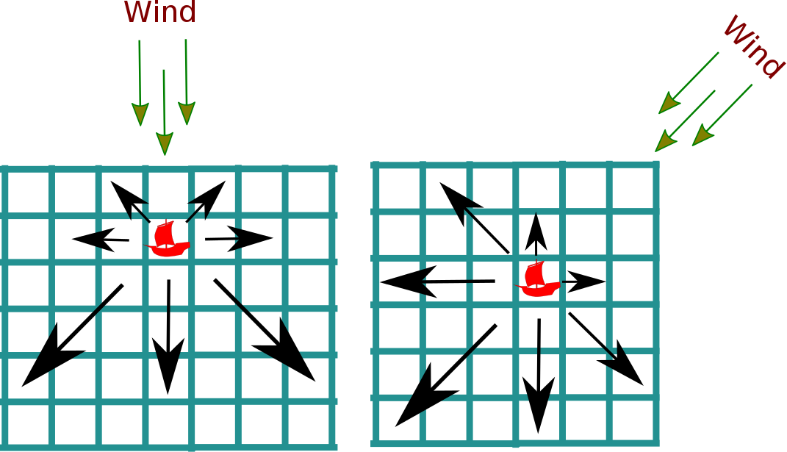
Sailors say that “Wind blows into the compass and a ship moves from the compass”. Direction of ship movement is named a ship's course. If a ship moves before the wind (wind blows into sails) then such course is named the “stern wind” and the ship can be moved up to three cells. If a ship moves under the 45º angle to the wind, then such course is named the “backstay” and the ship also can be moved up to three cells. If a ship navigates under 90º to the wind, then such course is called “wind abeam” and the ship can be moved up to two squares. If a ship navigates under 45º in front of the wind direction, then such course is named the “by the wind” and the ship can make one cell move. It is impossible for sailing ship to be moving against the wind. (There are the scheme on the game map which show how a ship can be moved, keep the sceme in your mind and train yourself because the fate of your ship depends on your right maneuvers).

Sea currents
Also the Game map contains sea currents. If a ship is placed on back part of a sea current arrow, then the ship will be moved to the cell where the arrow spike is placed. A Ship can move against of a sea current only if the ship is placed on a cell where a sea current arrow spike is.

Sea battles and repairing
Both “Spanish” ships and “Pirate” ships make maneuvers, sometime they don't make moves and wait for enemy. “Spaniards” bursts through pirates into Spain and they strongly save their biggest secret – which Spanish ship is the “Gold galleon”. Pirates in opposite to Spaniards, trying to figure out which Spanish ship carries the treasure to capture it. And changeable wind doesn't have objectives but just breaks plans of both fighting sides.
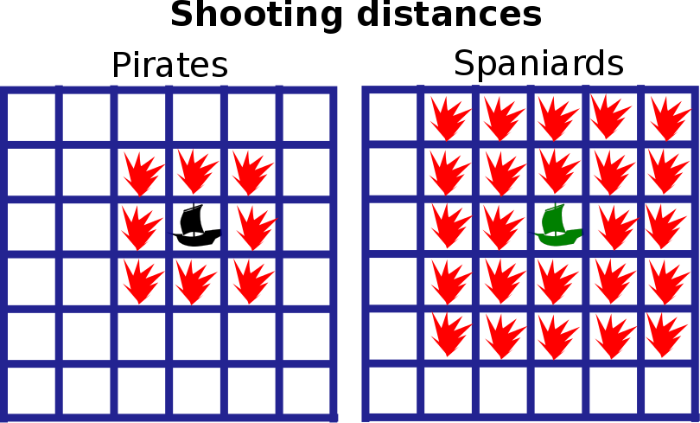
But now ships of fighting sides have rendezvous on the game map and a sea battle is started. Spanish galleons can shoot in all directions up to two cells and pirate brigantines can shoot only up to one cell (also in any direction). For shooting, players use the same game dice: N,S,W,O – a hit, NW, SW, NO, SO – a miss. During a game turn, each ship can shoot only once, before its move or after its move, as you wish and agree before game. If you want, you can use one shooting step for several ships in the same time - “salvo”, but the shooting player should notify opponents about the shooting mode either “salvo” or “ship by ship”. A Galleon will be destroyed if it has three holes and pirate brigantine will be destroyed if it has only two holes. Ships can be repaired ona port cell which belongs to the same side as the repaired ship (Spanish ships only in Spanish ports), in the case the repairing ship skips one game turn. Both firing from a ship staying over a port cell and firing at the ship are disabled. All Destroyed ships have to be removed from the game map. When pirates destroy the “Golden galleon” then the galleon will not be removed from the map, but the pirate player (who has destroyed the galleon) moves the galleon to a pirate port cell and Spanish galleons get a chance to recapture the ship.

Game end
The Game is ended when either the “Golden galleon” reaches Cadiz or it will be captured by pirates and will reach a pirate port cell.

Some extra thoughts
- It is good idea to use a logbook for a game session where make records about hits and repairing and also make notes about interesting events which happened during the game session.
- Ships can be made from a part of rubber, just fix a bit of paper (with painted ship symbol) at it as a sail, also part of a match can be used as a mast.
- It is possible to add other nations to the game and join France and England to the process, the map contains their ports already.

