Table of Contents
Project 2
Create new project 2
Close project in project tree 2
Delete whole project folder 3
Mind map 3
Create mind map 3
Edit mind map 3
Create mind map tree 4
Add file links 4
Add web links 4
Adding text records 5
Jump between nodes 5
Emoticons 6
Images 6
Import of mind map from file 7
TAB-formatted text 7
Mindmup mind map 7
Freemind mind map 7
XMind mind map 7
Coggle mind map 7
Novamind mind map 7
Export of mind map 7
Freemind mind map 7
Mindmup mind map 7
PlantUML mind map 8
Markdown text document 8
PNG raster image 8
SVG vector image 8
Plain text 8
ORG Mode 8
AsciiDoc 8
Work with PlantUML 8

Project
The application initially was created to help ion development of software projects so that it based on Project folders. A project in context of the application is a folder contains files and sub-folders united by some common idea and context. Also, a project folder is used as the root to build relative file paths during save file links in its mind map files, so please use internal tools of the application to rename, move or delete project files.

Create new project
It is possible to create new project through menu File → New project. In opened dialog just select name and location for new project and its folder will be created and automatically added into project tree.
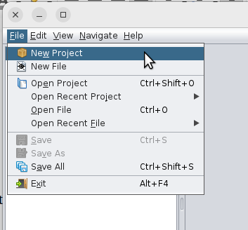

Close project in project tree
If you want just remove a project from project tree but not remove it from disk, then call pop-up menu for the project and select Close menu item. The project will be removed from project tree but without any effect for project files and folders and can be re-opened in any moment.
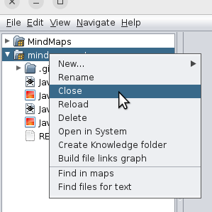

Delete whole project folder
It is possible to remove a project from disk with menu item Delete in project tree. If activate the menu item then whole project folder with its content will be removed both from disk and project tree.
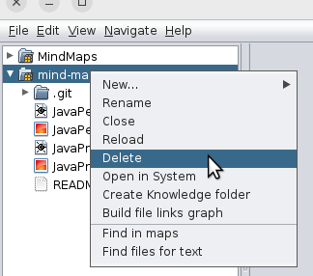

Mind map
Mind maps are graph structures where records represented in tree like semantic format. All information content growing from its root node and can’t have loops (i.e. acyclic graph).

Create mind map
There are two ways to create mind map in the application. The first one is to select main menu item File → New file and select mind map as the type for new file or open pop-up menu in project tree and select menu item New→Mind map in a project folder.
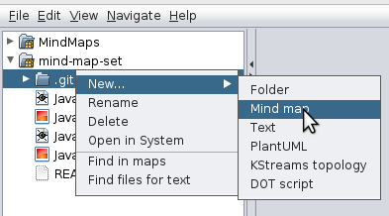

Edit mind map
Either by mouse double click or by project tree pop-up menu item Open, mind map file can be opened for edit.

Create mind map tree
Forming of mind map starts from its root node (the root node can’t be removed from map), you're just adding new level and child nodes into map. New nodes can be added either by pop-up menu New topic or by keyboard hot key TAB (by default). Selected nodes can be removed through either menu item Remove or by hot key DEL. After create new node, edit mode for its title started automatically. Pressing ENTER key ending edit mode. If multi-line text needed then SHIFT+ENTER can be used (by default). Nodes are draggable and sub-tree will be moved with dragged parent node.

Add file links
Every node can contain a file link. Such link can be added through pop-up menu item Add file. In opened dialog, a file should be selected from project folder or from some disk location. Also file link can be added through dragging a file from either project tree or external application. To remove file link just open pop-up menu item Edit file and clear file path manually or by Clear button.
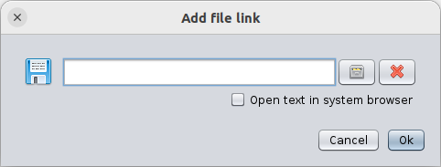
After file link added to a node, the link can be activated. If click twice on the file link icon then the file will be opened either in the application or in system by external associated application.

Add web links
A mind map node can contain URL pointing some web resource or any another resource which address can be represented through URI. There is pop-up menu item Add URI. URI link should be entered in opened dialog also URI link to a web resource can be added through dragging selected link from a web browser. There is probability that application may not recognize dropped link format and link will not be added. There is indicator on the right side of text field, the indicator shows that entered URI has correct syntax. URI can be removed through cleaning text in text field manually or with Clear button.
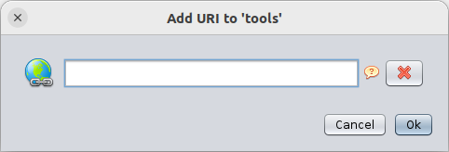
URI icon can be activated through mouse double click and the link will be opened by system web browser.

Adding text records
Sometimes it is not enough to have only title at a node and some big text piece or comment required. To create big number of child nodes for it is no so good idea. Big text pieces can be added into a node through pop-up menu item Add note. In opened dialog you can enter some required text or even import it from a text file. Removing of text record works like file and URI links – just open the dialog again and clear whole text.
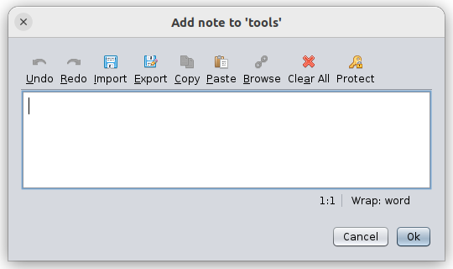
Entered text note can be protected by password. If turn on protection then text will be saved as AES-256 encrypted one. Some non-encrypted hint can be provided for password to provide way to keep password in mind, such hint saved in non-protected way. If you don’t know password for text in node then it will be impossible for you to remove the text note from node, only whole node.

Jump between nodes
In big mind maps sometime needed quick routing between non-directly associated nodes. For such cases it is possible to provide jump from one node to another one. Such jump will be shown as icon on source node and some arrow will be pointing the target node. To make jump just select Add jump and select target node in opened node tree. To remove existing jump, open the dialog again and select none. Also, it is possible to make jump through dragging target node to source one with pressed CTRL key. Jumps between nodes can be shown or hidden through pop-up menu item Show jumps.
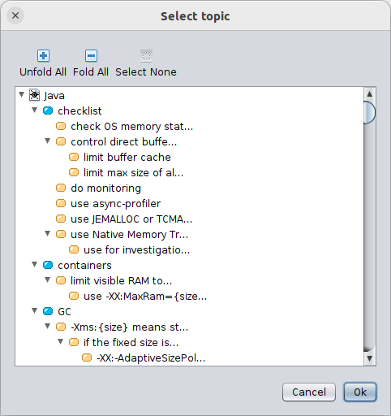

Emoticons
For better show and highlight nodes sometime small images called emoticons very useful ones. The application contains predefined set of many icons and one of them can be shown on a node. An emoticon can be added to a node through pop-up menu item Emoticons. In opened list of icons you should select appropriate one or empty cell if you want to remove assigned emoticon from node.
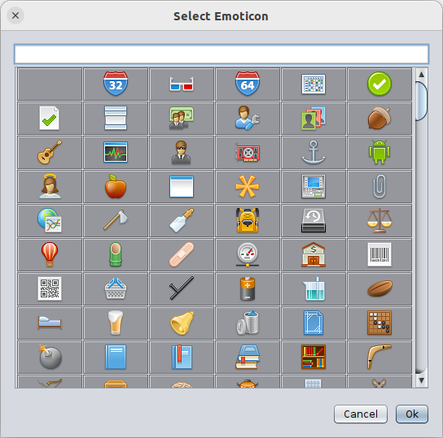

Images
There is way to load raster image file from disk and add its image to a node. An image can be assigned to a node through pop-up menu item Add image. Because images can be big ones, there is some limit and such images scaled to appropriate size and in such scaled format saved and shown in nodes. During assigning, it is possible to provide link to original image file and open it through mouse double click on saved node image.

Import of mind map from file
The application allows import of mind maps from number of formats of 3rd side applications and text formats. Import allowed only for opened mind map through pop-up menu item Import from.

TAB-formatted text
As source a tabbed text file can be used where element hierarchy provided through tabs for each line. During import line hierarchy will be converted into mind map nodes and links.

Mindmup mind map
It allows import files created with Mindmup application.

Freemind mind map
It allows import files created with Freemind application.

XMind mind map
It allows import files created with XMind application.

Coggle mind map
It allows import files created with Coggle application.

Novamind mind map
It allows import files created with Novamind application.

Export of mind map
Opened mind map can be exported into one of supported formats through sub-menu activated by pop-up menu item Export as. For some export formats there will be shown dialog with extra settings for result file.

Freemind mind map
The command start export of mind map into file compatible with Freemind mind map editor.

Mindmup mind map
The command start export of mind map into file compatible with Mindmup mind map editor.

PlantUML mind map
The command start export of mind map into PlantUML script file. Mind map very restricted in PlantUML so that some elements like file links or notes will not be saved.

Markdown text document
The command start export of mind map into UTF-8 encoded markdown formatted file. All elements and hierarchy will be converted into paragraphs and chapters with saving of hierarchy through headings.

PNG raster image
The command creates raster image from current mind map and saved it as PNG raster image.

SVG vector image
The command creates vector image from current mind map and saved it as SVG vector image document.

Plain text
Save mind map content into plain UTF-8 encoded text file.

ORG Mode
Export mind map into ORG formatted text.

AsciiDoc
Export mind map as AsciiDoc formatted text.

Work with PlantUML
The application contains embedded PlantUML library allows both generate and draw scrip based UML diagrams. The application provides special editor and viewer. Also, it is possible to export generated diagram into misc formats. By default, the script editor is hidden, but it can be opened through either Edit script button or mouse dragging top border. During script edit, changes will be automatically shown in viewer with some delay if Auto-refresh is turned on.
