Homework #2

Aesthetic Mappings and Facets

Due: 13 Jan 2020

## Concepts

Explain how aesthetics, scaling, and mapping are related to each other within the context of the grammar of graphcs and ggplot.

Here is my answer

## Interpretation of code

ggplot(data = mpg, mapping = aes(x = displ, y = hwy, color = drv)) +  
 geom_point(show.legend = FALSE) +  
 geom_smooth(mapping = aes(linetype = drv), method = "lm", se = FALSE, show.legend = FALSE) +  
 facet_wrap(vars(drv))

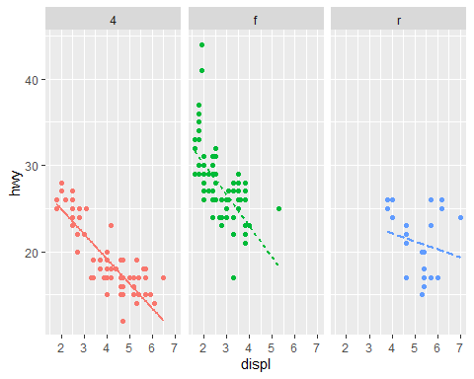

Write your answer here.

## Write your own code

Draw a scatterplot of linear regressions of city mileage on displacement

1. Put displ on the x-axis
2. Put cty on the y-axis
3. Color the plot symbols by class
4. Draw a simple regression line for each car class without a confidence interval
5. Use facet_wrap to create a graph for each class
6. Suppress the legend

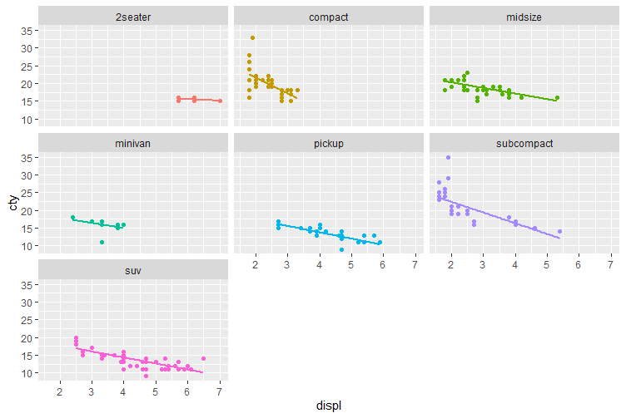

Desired shown above

# Put your code here