Homework #4

R Markdown

Due: 22 Jan 2020

## Concepts

Explain the sequence whereby a word file is created from a R Markdown document. What is the purpose of the YAML header?

## Interpretation of R Markdown code

### New lines and paragraphs can be very confusing. This is one of the most inconsistent and confusing parts of R Markdown.

When using R Markdown, you insert a new line by putting two spaces and a carriage return at the end of your text.  
A new paragraph requires two carriage returns.

R Markdown allows you to have italics, bold, and code

* *italics*
* **bold**
* code. (A monospaced font is usually used for code.)

### Include graphics

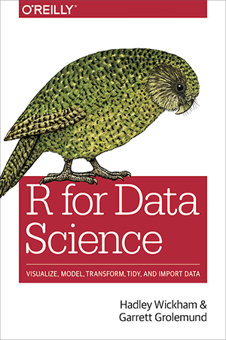

You can insert graphics from the web:

### You can create your own graphics like this one that compares highway mpg for different class and drive train combinations.

ggplot(data = mpg, aes(x = class, y = hwy, fill = class)) +  
 geom_boxplot(show.legend = FALSE) +  
 coord_flip() +  
 facet_grid(rows = vars(drv))

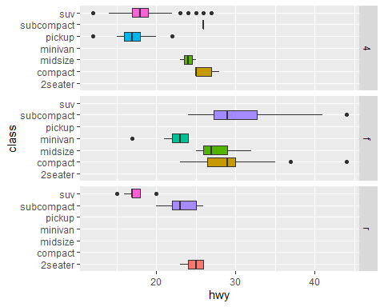

You can also use include tables

# Number of Students in *MPA 634: Data Science for Managers*

|  |  |
| --- | --- |
| Department | Students |
| MBA | 2 |
| MISM | 6 |
| MPA | 8 |

## Write your own code

Write RMarkdown code that creates the following document. You don’t need another YAML header and setup R chunk because they are already part of this R Markdown document.

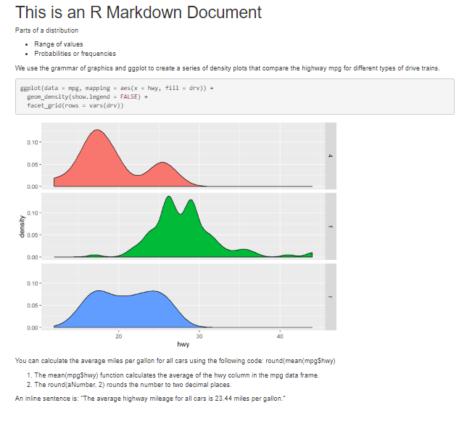

Write code that creates the above document.