Homework #14

Dates and Times

## Concepts

1. Software packages often use a reference date for their date-time functions. Excel uses January 1, 1990. One alternative for R is “Unix Epoch”, which is 1970-01-01. Explain how these systems represent date and date-time values as numbers.
2. Time spans can be measured as durations, periods, or intervals. Compare and contrast these three ways of considering time.

## Interpretation of code

Interpret the following two R code chunks:

### Code chunk #1

# Create a Function  
make_datetime_100 <- function(year, month, day, time){  
 make_datetime(year, month, day, time %/% 100, time %% 100)  
}  
# Convert departure and arrival times into date-time variables  
flights_dt <- flights %>%  
 filter(!is.na(dep_time), !is.na(arr_time)) %>%   
 mutate(  
 dep_time = make_datetime_100(year, month, day, dep_time),  
 arr_time = make_datetime_100(year, month, day, arr_time),  
 sched_dep_time = make_datetime_100(year, month, day, sched_dep_time),  
 sched_arr_time = make_datetime_100(year, month, day, sched_arr_time)  
 ) %>%   
 select(origin, dest, ends_with("delay"), ends_with("time"))  
  
flights_dt %>% print()

## # A tibble: 328,063 x 9  
## origin dest dep_delay arr_delay dep_time sched_dep_time   
## <chr> <chr> <dbl> <dbl> <dttm> <dttm>   
## 1 EWR IAH 2 11 2013-01-01 05:17:00 2013-01-01 05:15:00  
## 2 LGA IAH 4 20 2013-01-01 05:33:00 2013-01-01 05:29:00  
## 3 JFK MIA 2 33 2013-01-01 05:42:00 2013-01-01 05:40:00  
## 4 JFK BQN -1 -18 2013-01-01 05:44:00 2013-01-01 05:45:00  
## 5 LGA ATL -6 -25 2013-01-01 05:54:00 2013-01-01 06:00:00  
## 6 EWR ORD -4 12 2013-01-01 05:54:00 2013-01-01 05:58:00  
## 7 EWR FLL -5 19 2013-01-01 05:55:00 2013-01-01 06:00:00  
## 8 LGA IAD -3 -14 2013-01-01 05:57:00 2013-01-01 06:00:00  
## 9 JFK MCO -3 -8 2013-01-01 05:57:00 2013-01-01 06:00:00  
## 10 LGA ORD -2 8 2013-01-01 05:58:00 2013-01-01 06:00:00  
## # ... with 328,053 more rows, and 3 more variables: arr_time <dttm>,  
## # sched_arr_time <dttm>, air_time <dbl>

### Code chunk #2

# Uses the flights_dt from the first code chunk  
flights_dt %>%   
 filter(dep_time >= ymd(20131225)) %>%  
 filter(dep_time < ymd(20131226)) %>%   
 ggplot(aes(dep_time)) +  
 geom_freqpoly(binwidth = 900, color = "blue") +  
 labs(  
 title = "Flights Departing from New York City",  
 subtitle = "Number every 15 seconds on Christmas Day 2013",  
 x = "Departure Time",  
 y = "Number of Flights"  
 )

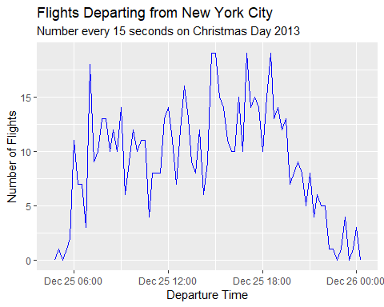

## Write code

Problem 1

1. Remove observations with missing values for dep_time
2. Select origin, year, month, day, and dep_time from the flights data set
3. Convert dep_time into a time-date variable using the make_datetime function
4. Use the hour function to create a new hour variable from the dep_time
5. Draw a bar chart for the new hour variable
6. Use faceting to create a chart for each airport

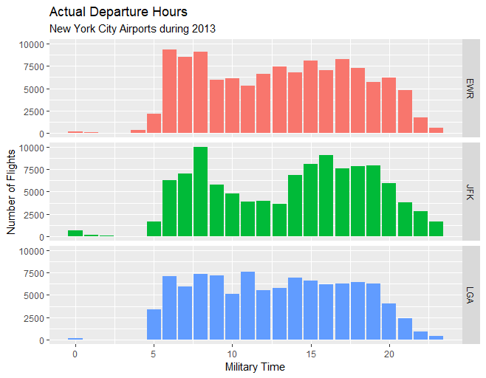

Problem 2

Use durations, periods, and spans to calculate your age today. The functions as.duration, as.period, years, and the %–% operator will be helpful.