**Article Title**

President’s Handling of the Economy and Consumer Sentiment Dataset

**Authors**

Rodrigo Caputo1, Raymond Duch2

**Affiliations**

1. CESS Nuffield Oxford USACH

2. Nuffield College Oxford

**Corresponding author(s)**

Raymond Duch (raymond.duch@nuffield.ox.ac.uk)

**Abstract**

There are three distinct data modules that make up this dataset. Data module 1 consists of the principal dependent variable in Caputo and Duch (2019) [1]: the President’s Handling of the Economy – the index constructed is based on 895 surveys conducted over the period 1981.04 to 2018.06. The variable is unique because the authors create a single index (based on Stimson 1999 [2]) using similarly worded survey items from different studies over time. It will be of interest for the research of economists and public opinion scholars. A second module consists of four different extensive time series measure of consumer sentiment from University of Michigan, the Conference Board, and the OECD. A third module consists of secondary data that are control variables in the Caputo and Duch (2019) [1] analyses: time series of macro-economic variables, the Economic Policy Uncertainty measure from Baker et al (2016) [3], an alternative measure of macro-economic policy management from the University of Michigan, and a time series of U.S. Presidential Approval.

**Keywords** Consumer Sentiment; Macroeconomics; Uncertainty Shocks; Economic Policy

**Specifications Table**

|  |  |
| --- | --- |
| **Subject** | Economics and Econometrics |
| **Specific subject area** | The subject area is the explanation of variations in consumer sentiment with variables measuring public approval of the U.S. President’s handling of the economy, Presidential Approval, and Economic Policy Uncertainty. |
| **Type of data** | Time Series |
| **How data were acquired** | The data were acquired entirely from secondary sources. The macro-economic indicators were obtained primarily from St. Louis FED and the Bureau of Labor Statistics. The measures of the President’s handling of the economy were obtained from six national U.S. surveys. The consumer sentiment indices were obtained from the University of Michigan, the Conference Board, and OECD. Economic Policy Uncertainty was obtained from its authors, Baker et al [3]. |
| **Data format** | Raw: Excel file |
| **Parameters for data collection** | For the consumer sentiment measures we tried to identify all sources that measured consumer sentiment over an extended time series – at least since 1980. For the President’s Handling of the Economy survey questions we searched for all U.S. surveys that asked this type of question – we conducted searches on iPoll at the Roper Center for Public Opinion Research. For Presidential Approval we identified an extensive time series asked by one survey house, U.S. Gallup. |
| **Description of data collection** | The collection of the survey items for the President’s Handling of the Economy was conducted by searching for relevant questions on the iPoll at the Roper Center for Public Opinion. Our point of departure was the data published in DeBoef and Kelstedt [4]. The consumer sentiment series were obtained from their host organizations – Michigan University [http://umich.edu/~umsurvey/], Conference Board [https://www.conference-board.org/data/consumerconfidence.cfm] and the OECD. The Presidential Approval survey series was provided by Gallup [https://news.gallup.com/]. The economic indicators from the St. Louis FED [https://fred.stlouisfed.org/series/].  Once properly cleaned and analysed these data were assembled in the three excel files attached:  Raw_DATA_MODULE1.xls  Raw_DATA_MODULE2.xls  Raw_DATA_MODULE3.xls |
| **Data source location** | Country: USA |
| **Data accessibility** | With the article |
| **Related research article** | Author’s name: Caputo, Rodrigo and Duch, Raymond  Title: U.S. Economic Policy and Consumer Sentiment  Journal: Under Review  DOI |

**Value of the Data**

* These data are useful because they provide measures of the President’s Handling of the Economy (PHE) that are currently unavailable to the public (the raw data and the generated PHE values). The dataset also assembles measures of Presidential approval and different measures of consumer sentiment from various secondary sources and makes them available in one format and location which is currently not the case.
* Social science researchers who include measures of consumer sentiment or measures of the public’s evaluation of economic policy management will be interested in these data.
* These data can provide further insights into what shapes consumer sentiment – a concern of many academic and practicing economist.
* The additional value of these data is that they bring together multiple measures of consumer sentiment in one dataset – they also provide measures of the public’s assessment of economic policy management that have not been available to researchers.

**Data**

All of the data can be found in three excel files. The different variable modules are the following along with variable names:

Raw_DATA_MODULE1.xls: Contains PHE, the survey question average responses that are used to construct PHE, and the R code used to generate the PHE index.

Raw_DATA_MODULE2.xls: Contains alternative consumer sentiment series.

Raw_DATA_MODULE3.xls: Contains EPU, Presidential Approval (PA), PHE_MICHIGAN, unemployment (U), stock market price index (STOCK), output proxy (Y), twelve-month inflation (INF12) and real wage (WR).

*Module 1 Variable: Presidents Handling of the Economy Constructed Variable (PHE)*

The measure of the President’s Handling of the Economy (PHE) is based on analysing 895 opinion surveys that asked the public to evaluate the President’s handling of the economy. We constructed the measure using Stimson (1999) [2] and present the R code for this in the Module 1 dataset. The constructed index is represented by the PHE variable in the dataset. In Module 1 we also include the raw data from each of the 895 opinion surveys – we report the percent approving the President’s handling of the economy.

*Module 2 Variable: Michigan Consumer Confidence Index*

A widely-employed metric for consumer sentiment is the Michigan consumer sentiment index (CM). The index is constructed from five survey questions concerning personal finances, the country's overall economic performance and the respondent's household expenditures. The index is employed to forecast future spending and saving behavior.

The dataset contains 1) the actual Consumer Confidence Index as constructed and reported by the University of Michigan (CM in the dataset); 2) the current conditions index (CC in the dataset); 3) future conditions index (CE in the data set); and 4) E5Y based on responses to one of the expectation questions in CE.

*Module 2 Variable: Conference Board's Consumer Confidence Index*

The Conference Board's Consumer Confidence Index is CCI_Board in the dataset.

*Module 2 Variable: OECD Consumer Confidence Index*

The OECD Consumer Confidence Index is C_OECD variable in the dataset.

*Module 3 Variable: Economic Fundamentals*

The set of economic fundamental variables in Module 3 are: unemployment (U), stock market price index (STOCK), output proxy (Y), twelve-month inflation (INF12) and real wage (WR).

*Module 3 Variable: President’s Handling of the Economy – Michigan Survey*

The measure of the public’s approval of the Presidents Handling of the Economy from the University of Michigan survey is variable PHE_MICHIGAN. This is based on question A9 of the survey: “As to the economic policy of the government–I mean steps taken to fight inflation or unemployment–would you say the government is doing a good job, only fair, or a poor job?”.

*Module 3 Variable: Economic Policy Uncertainty (EPU)*

The measure of Economic Policy Uncertainty (EPU) and labelled EPU in the data set is from Baker et al (2016) [3]. Details of the construction are below.

*Module 3 Variable: Presidential Approval*

Our Presidential Approval measure is based on the monthly Gallup question and is the PA variable in the dataset.

**Experimental Design, Materials, and Methods**

*Michigan Consumer Confidence Index (CM)*

Details on the index construction are available at https://data.sca.isr.umich.edu/fetchdoc.php?docid=24770. Ludvigson (2004) [5] has an excellent overview of USA consumer sentiment indices based on survey questions.

* CM: five questions are used for CM index construction – this is labelled ICS in the University of Michigan methodology presented below. It uses all five questions: X1 (PAGO_R), X2 (PEXP_R), X3 (BUS12_R), X4 (BUS5_R), and X5 (DURO_R).
* CC: two questions are used for CC index construction method – this is called ICC in the University of Michigan methodology presented below. It uses two questions: X1 (PAGO_R) and X2 (DURO_R)
* CE: three questions used for CE index construction method – this is called ICE in the University of Michigan methodology presented below. It uses three questions: X2 (PEXP_R), X3 (BUS12_R), X4 (BUS5_R)
* E5Y: this is one of the CE questions -- The exact wording of the $E5Y$ survey question is: ``Turning to economic conditions in the country as a whole, do you expect that over the next five years we will have mostly good times, or periods of widespread unemployment and depression, or what?'' The variable is constructed as the percentage giving a favorable answer minus the percentage giving an unfavorable answer plus 100. This is X4 (BUS5_R) from the University of Michigan methodology presented below.

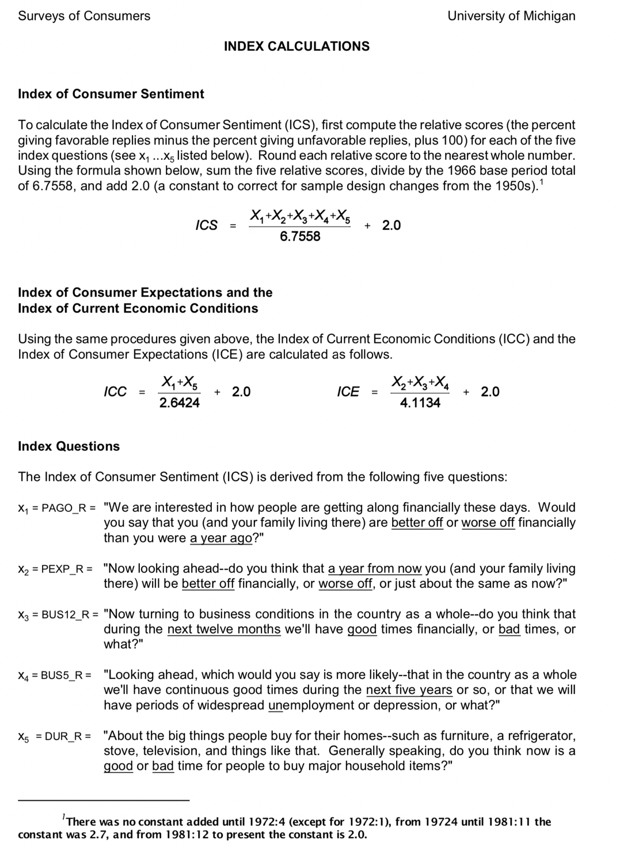

*Conference Board's Consumer Confidence Index*

The Conference Board's Consumer Confidence Index (C_Board) (Lahiri et al2016) [6] began in 1967 as a bi-monthly survey; since June 1977, the survey has been administered monthly. Similar to the Michigan Consumer Confidence Index, the C_Board can also be separated into two components: the present situation component and the expectations component. Each month, a mail survey is sent out and approximately 3000 completed questionnaires are collected. Preliminary estimates are based on survey responses collected before the 18th of each month. Final estimates are published with the release of the following month’s data, scheduled on the last Tuesday of each month.

*OECD Consumer Confidence Index*

The OECD also produces a consumer confidence index for several countries, including the U.S.. This index, C_OECD, is standardized in three steps: period conversion, smoothing and amplitude-adjustment. In terms of period conversion, quarterly indicators are first converted to monthly frequency. Such a conversion is achieved through linear interpolation of quarterly series followed by an alignment to the most appropriate month of the quarter. Most series are aligned to the central month of the quarter; quarterly series based on surveys conducted in a given month of the quarter are aligned to the month itself. In order to remove irregular roughness, seasonal adjusted series are smoothed by applying the Hodrick-Prescott filter. Fluctuations with periodicity below 6 month are cut-off, which corresponds to setting the multiplier lambda to 1. In so doing, the OECD preserves the trend-cycle component of the time series.

*President’s Handling of the Economy Variable Measurement*

To measure the President’s Handling of the Economy (PHE), we use the same public opinion-based approval measurement strategy employed by De Boef et al (2004) [4]. The measure is based on surveys of the general public. A typical phrasing of the survey question is: ``Do you approve or disapprove of the way (Reagan/Bush/Clinton/Bush/Obama/Trump) is handling the nation's economy?'' In total we identified 895 public opinion survey items asking the U.S. general public to evaluate the President's management of the economy. These questions were asked by six different polling organizations: Gallup, ABC News, ABC/NBC, CBS, CBS/NYT, and the LA Times.

Table 1 presents the questions and identifies the survey organizations. The questions are very similarly worded; there is considerable time-period overlap for each of the six series; and the response sets are comparable.

Table 1. Approval of U.S. President’s Handling of the Economy

|  |  |  |  |  |
| --- | --- | --- | --- | --- |
| Poll | Period | Typical Question Wording | N | Corr. |
| Gallup | 2/93- | Now thinking about some issues, do you | 179 | 0.918 |
|  | 2/18 | approve or disapprove of the way Pres- |  |  |
|  |  | ident (Ronald Reagan/George Bush/Bill |  |  |
|  |  | Clinton/George Bush Jr./Barack Oba- |  |  |
|  |  | ma/Donald Trump) is handling the econ- |  |  |
|  |  | omy? |  |  |
| ABC | 9/81- | Do you approve or disapprove of the | 23 | 0.956 |
|  | 4/03 | way (Reagan/Bush/Clinton/Bush |  |  |
|  |  | Jr./Obama/Trump) is handling the  nation’s economy? |  |  |
| ABC/WP | 10/81- | Do you approve or disapprove of the | 240 | 0.906 |
|  | 4/18 | way (Reagan/Bush/Clinton/Bush |  |  |
|  |  | Jr./Obama/Trump) is handling the  economy? |  |  |
| CBS | 1/92- | Do you approve or disapprove of the way | 165 | 0.873 |
|  | 6/18 | President (Ronald Reagan/George Bush/- |  |  |
|  |  | Bill Clinton/George Bush Jr./Barack |  |  |
|  |  | Obama/Donald Trump) is handling the |  |  |
|  |  | economy? |  |  |
| CBS/NYT | 4/81- | How about the economy – do you ap- | 221 | 0.949 |
|  | 7/16 | prove or disapprove of the way (Ronald |  |  |
|  |  | Reagan/George Bush/Bill Clinton/Ge- |  |  |
|  |  | orge Bush) is handling the economy? |  |  |
| LATIMES | 4/83- | Generally speaking, do you approve or dis- | 66 | 0.924 |
|  | 5/08 | approve of the way (Reagan/Bush/Clin- |  |  |
|  |  | ton/Bush Jr./Obama/Trump) is handling |  |  |
|  |  | the nation’s economy? |  |  |

We combine, as did De Boef et al (2004) [4], the approval marginals from the six time series employing the method developed by Stimson (1999) [2]. Each of the survey questions and the average marginal responses can be found in Raw_DATA_MODULE1.xls. The resulting PHE index score is available in Raw_DATA_MODULE1.xls. The R code for generating the PHE index can be found in Raw_DATA_MODULE1.xls.

President’s Handling of the Economy – Michigan Survey

Question A.9 in the Michigan Survey asks: “As to the economic policy of the government--I mean steps taken to fight inflation or unemployment--would you say the government is doing a good job, only fair, or a poor job?”. We measure this variable as the share of respondents who answered ‘1’, indicating that they thought that the government was doing a ‘good job’ in its economic policy.

*Economic Policy Uncertainty*

Economic policy uncertainty is widely recognized as contributing to recent economic shocks such as the 2008 financial crisis. Baker et al (2016) [3] provide persuasive evidence to this effect by constructing a measure of economic policy uncertainty (EPU). The measure is a count, from the ten leading newspapers in the U.S., of the frequency with which three trios of terms appear in news stories: ``economic'' or ``economy''; ``uncertain'' or ``uncertainty''; and one or more of ``Congress'', ``deficit'', ``Federal Reserve'', ``legislation'', ``regulation'' or ``White House''.

These data and more details on methodology are available at [www.policyuncertainty.com](http://www.policyuncertainty.com).

*Presidential Approval*

Gallup asks the following question on a monthly basis: “Do you approve or disapprove of the way that Donald Trump is handling his job as president?” The percent of respondents in each monthly sample responding “Approve” is the value reported for Approval in the dataset. These data are available from <https://news.gallup.com/poll/116677/presidential-approval-ratings-gallup-historical-statistics-trends.aspx>.

**Acknowledgments**

We are grateful to Mats Ahrenshop who provided outstanding programming assistance and to Jim Stimson who advised on the PHE series.

**References**

[1] Caputo, Rodrigo and Raymond Duch, 2019. “U.S. Economic Policy and Consumer Sentiment” Manuscript.

[2] Stimson, J. (1999): *Public Opinion in America: Moods, Cycles, and Swings, 2nd Edition*, Westview Press.

[3] Baker, S. R., N. Bloom, and S. J. Davis (2016): “Measuring Economic Policy Uncertainty*,” *The Quarterly Journal of Economics*, 131, 1593–1636.

[4] De Boef, S. and P. M. Kellstedt (2004): “The Political (and Economic) Origins of Consumer Confidence,” *American Journal of Political Science*, 48, 633–649.

[5] Ludvigson, S. C. (2004): “Consumer Confidence and Consumer Spending,” *Journal of Economic Perspectives*, 18, 29–50.

[6] Lahiri, K., G. Monokroussos, and Y. Zhao (2016): “Forecasting Consumption: the Role of Consumer Confidence in Real Time with many Predictors,” *Journal of Applied Econometrics*, 31, 1254–1275.