Wandering in the Woods Game: Agile Project Documentation

Rachael Morrison, Benjamin Ayirifa, Shivasai Priyatham Kota, and Siva Prasad Polisetty

College of Aviation, Science, and Technology, Lewis University

FA22-CPSC-60500-004 Software Engineering

Dr. Fadi I. Wedyan

December 14, 2022

Table of Contents

1.0 Introduction 2

1.1 Purpose 2

1.2 Description 2

2.0 Process Model

3.0 Use Cases

3.1 Use Case 1:

3.2 Use Case 2:

3.3 Use Case 3:

3.4 Use Case 4:

3.5 Use Case 5:

3.6 Use case 6:

4.0 UML Model

4.1 Use Case Diagram

4.2 Class Diagram

4.3 Activity Diagram

5.0 Personas

6.0 UI Mock-up

7.0 User Guide

7.1 Teachers

7.2 Students

# Introduction

## Purpose

The purpose of the program is intended to educate students about computation and mathematics. This is fun game design to simulate the performance of students in computer knowledge.

As a component of the instructive utilization of ICT, computerized games can be learning devices, inspirations, and generators of interest and subsequently a compelling method for enhancing understudy learning and execution in everyday instructive practice. The positive connection among learning and understudies' commitment while utilizing computerized games has been affirmed by different free investigations throughout the long term. Accordingly, the coordination of computerized games at various degrees of schooling for showing numerous learning objects shocks no one. In spite of the many examinations on the learning and persuasive impacts of computerized games, educating with advanced games isn't yet broad in optional training. Ebb and flow research stresses that most of these elements seem to originate from challenges with the execution of games in homeroom settings. Issues with innovation, the expense/cost of games/gear, the absence of specialized help are characterized as a portion of the hindrances to the expansion of games and reenactments in schooling.

## Description

The game application was designed to simulate difficult based on the level of the student. This program was designed for students in basic schools and hence has being partitioned into 3 levels. The level in this program includes:

1. K2 level: - In this level, 2 players are strictly allowed by the program. The player has no option to select more players. The program is reset anytime the two players get in to the same grid. Music will play when two players bump into each other.
2. Grade 3-5 Level: - This is the intermediate level. Four players are display on the screen when the user starts the program. The program gets restarted anytime any of the two players bump into each other. When two players get into the same grid, then performance is climaxed; celebration music will play and the program will continue until all players are found in the same grid. The can set the size of the grid and number of players. The minimum number of players is 2 and the maximum number of players that can be selected from this level is 4.
3. Grade 6-8 Level: This is the most difficult level; it is the most flexible level. The user has the chances to choose the number of players and grid size. The user has all the functionalities for the levels discussed above. There is a maximum of eight players allowed by the program.

The game application is compatible with windows and MAC OS operation systems. The program is to install and easy to use. User can copy it from one computer to another by using flash drives and other portable system. Users have to double on the program to start and can close the program by clicking on the exit button.

# Process Model

The software development team will use the evolutionary process model as show in Figure 1. The model the team selected is based on the desire to allow for rapid prototyping and iteration of design. The model is based on agile and spiral model principals in order to encapsulate feedback and risk management in to the decisions making for continuous evolution of the game.

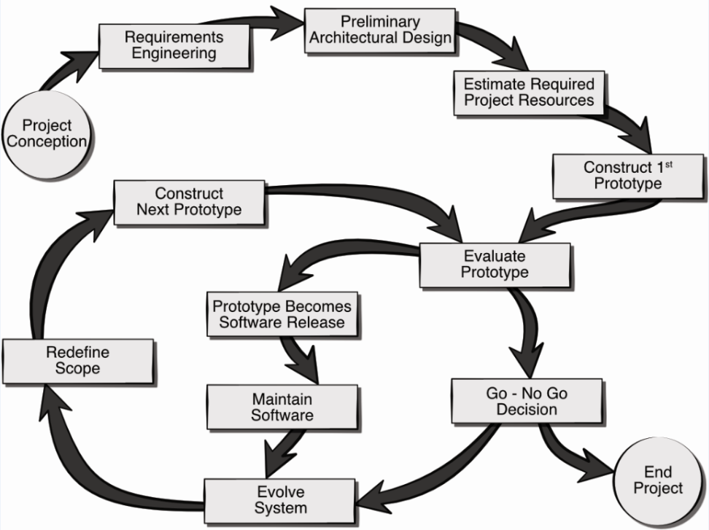

The cycle-based administration is controlled with the progression of execution to show the total coordinated administration as the Light-footed based capabilities for the application has been utilized as for the total practical and nonfunctional methodical prerequisites being arranged and outlined with the essential area of usage.

Light-footed is a gradual strategy for venture and programming building that assists groups with offering worth to their clients faster and with less troubles. Rather than placing everything in one "huge explosion" debut, a deft group gives work in unobtrusive, yet consumable, increases. Necessities, procedures, and results are inspected consistently so organizations have a characteristic technique for responding to changes quick.

In nimble, an item is delivered in various fixed-length adjusts called runs, offering light-footed groups a construction for creating code consistently to ensure. Figure out how the scrum strategy impacts customary venture the board.

Kanban is an unmistakable spry strategy that demands constant data of gathering's ability and complete exposure of work. Figure out how the Kanban technique for dexterous programming improvement could benefit for your group.

Nimble venture the executives is a steady technique to overseeing programming projects that spotlights on incessant deliveries and client criticism. Begin here now for your spry progress.

Directions for joining a coordinated group as a brand chief or item proprietor. Find the intricate details of making item guides, defining highlight boundaries, composing item prerequisites papers, and pursuing informed choices with item investigation.

Scrum of scrums, otherwise called the Scaled Deft System, is a strategy for extending the extent of a current nimble task (Ferrag, 2018). Both are fantastic leaping off areas as you grow spry all through your organization.

Both It and Deft address social patterns that rouse firms to accomplish higher. Peruse here now to realize precisely exact thing dexterous and DevOps interconnect.

While the ordinary "cascade" model has one discipline input toward the errand, then, at that point "toss it to the wall" the following member, spry requests cooperative buries groups. Open correspondence, collaboration, variation, and trust among individuals from the group are all heart of lithe. Be that as it may, even though the foreman or item proprietor regularly focuses on the work to simply be conveyed, their group starts to lead the pack on choosing how it work would get achieved, self-coordinating around unambiguous undertakings and obligations (Konsky, 2007).

*Figure SEQ Figure \* ARABIC 1. The AR Room Designer evolutionary process model.*

# Use Cases

The following uses cases were defined by the team as the core system requirements for the delivery of working prototype. Note, this baseline functionality can be easily extended through the inclusion of more use cases as the project progresses. Each use case lists the name of the use case, primary actors, preconditions, description, and acceptance criteria.

## Use Case 1:

**Primary Actor:** K2 Student/User

**Preconditions:** Program must be compatible with user’s operating system

**Description:** Student double clicks on the application icon

Application starts

Application ask student to select level, then the games starts

**Acceptance Criteria:** users must be able to start the program on their own with little with little or no help

## Use Case 2:

**Primary Actor:** Grade 3-5 Student

**Preconditions:** Program must be installed on a compatible operating system

**Description:** Students double click on the program to start the program. The program prompts the user to select the grid size and number of players.

Game then starts using the requirements of the user selections

**Acceptance Criteria:** Grade 3-5 students must be able to modify the number of players and size of the grid.

## Use Case 3:

**Primary Actor:** Grade 6-8 Student

**Preconditions:** Program must be compatible with OS on the user computer

**Description:** User double clicks on the game icon to that the program.

Program prompts user to select level based on the grade

After selection of the 6th-8th grade, application grants permission to user to modify grid size, number of players and run experiments

**Acceptance Criteria:** Student should be able to monitor performance at anytime

## Use Case 4:

**Primary Actor:** Student

**Preconditions:** Program must be compatible with OS on the user computer

**Description:** The student starts decides to play the game by double clicking on the desktop icon for the program.

The student decides not to place once the on main menu of the game screen.

Student clicks on the exit button or the Microsoft close button or the exit button.

Program ask user if user wants to close the game, user confirms and program terminates

**Acceptance Criteria:** The program should be able to close at any time the user changes his/her mind not to play the game.

# UML Model

## Use Case Diagram

In the analysis of the software application, we determined that the student to be the primary actor in all the cases discussed above. The system is made up of modules and classes. The game user interacts with the software application in this pattern.

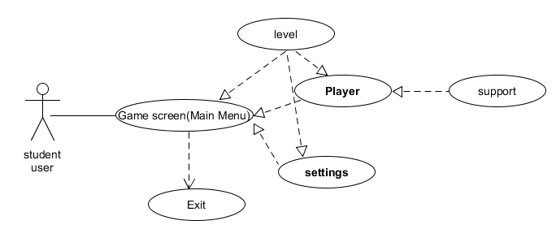

The significant reason for application is to foster the center level comprehension to use the course of execution in light of which the controlled preparation and the board of the help level outcomes in light of which the administrative model and controlled particular could be arranged to show the total perspective on help based administration according to the reproduction game advancement to finish the whole course of understanding and the executives of end-product.

## Class Diagram

The class diagram for the core system of the Wandering in the Woods game is depicted in Figure 4. The classes in the diagram are described below the figure.

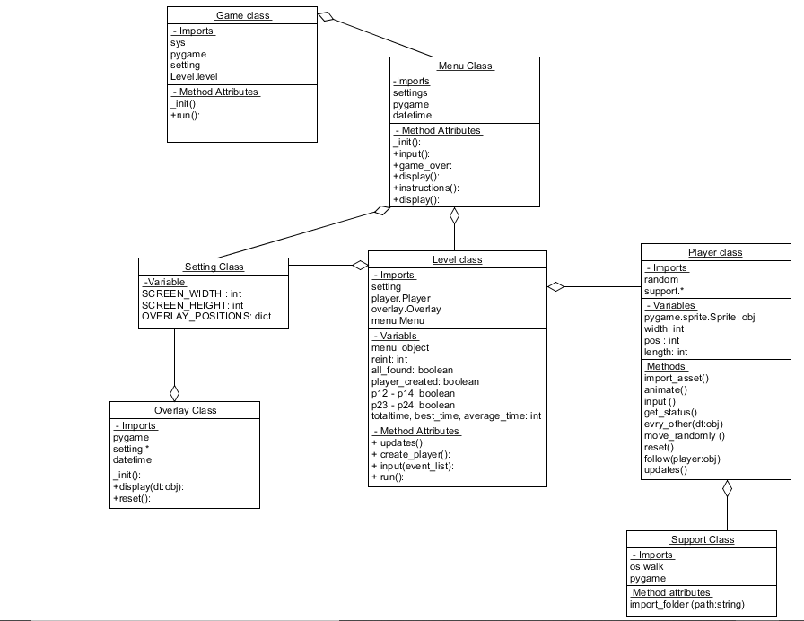

I have a game with different levels where we can multiple users at certain way as per the requirements for the in level of games we can the menu in the to choose a game to play according to our own way which is available to select you should go with level of game accor

## Activity Diagram

The activity diagram shown in Figure 5 presents a more detailed description of the high-level behavior of the Wandering in the Woods game.

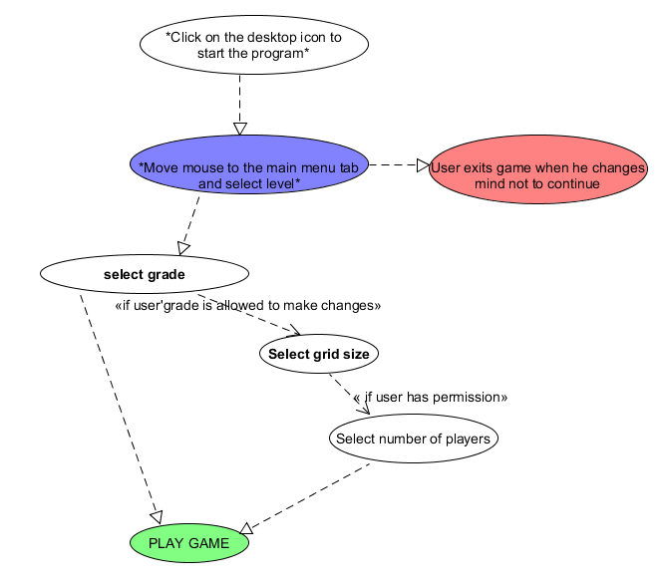

players are completely permitted by the program. The player has no choice to choose more players. The program is reset whenever the two players get in to a similar network. Music will play when two players catch one another.

This is the moderate level. Four players are show on the screen when the client begins the program. The program gets restarted whenever any of the two players catch one another. At the point when two players get into a similar matrix, then execution is peaked; festival music will play and the program will go on until all players are tracked down in a similar framework. The can set the size of the matrix and number of players. The base number of players is 2 and the most extreme number of players that can be chosen from this level is 4.

Level: This is the most troublesome level; it is the most adaptable level. The client gets the opportunities to pick the quantity of players and framework size. The client has every one of the functionalities for the levels examined previously. There is a limit of eight players permitted by the program.

## Conclusion:

It is presumed that total insights regarding reenactment game advancement have been made sense of for measure the total necessities of the framework to foster the setting of examination as for deal with the total improvement of the application. A total item situated approach has been utilized to quantify the coordinated examination as for the help level execution of useful framework prerequisites. All classes and UML demonstrating are very much planned to show the total deliberate prerequisites of projects